Part 1: Run and Assess the Python Application

Task 1:

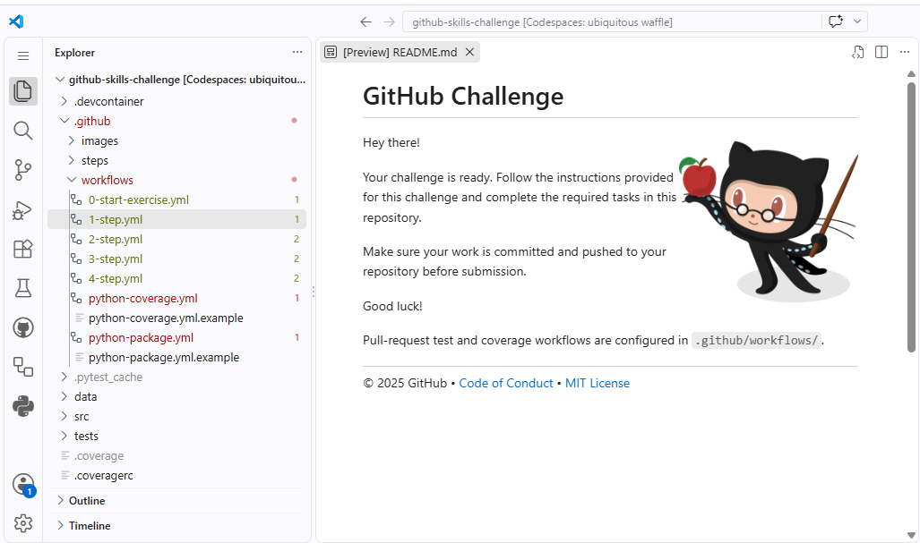

Task 2:
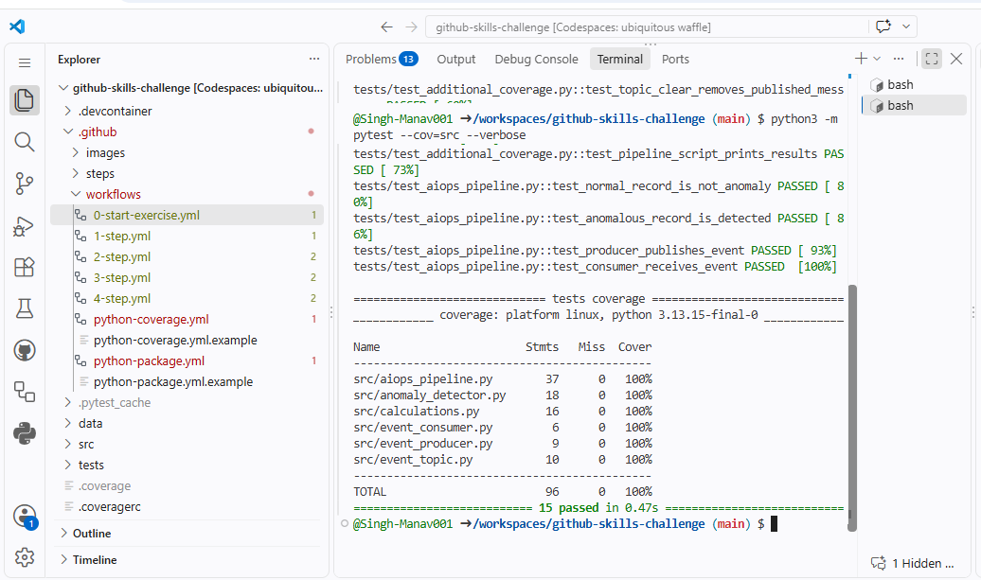

Part 2: CI Test Workflow

Task3:
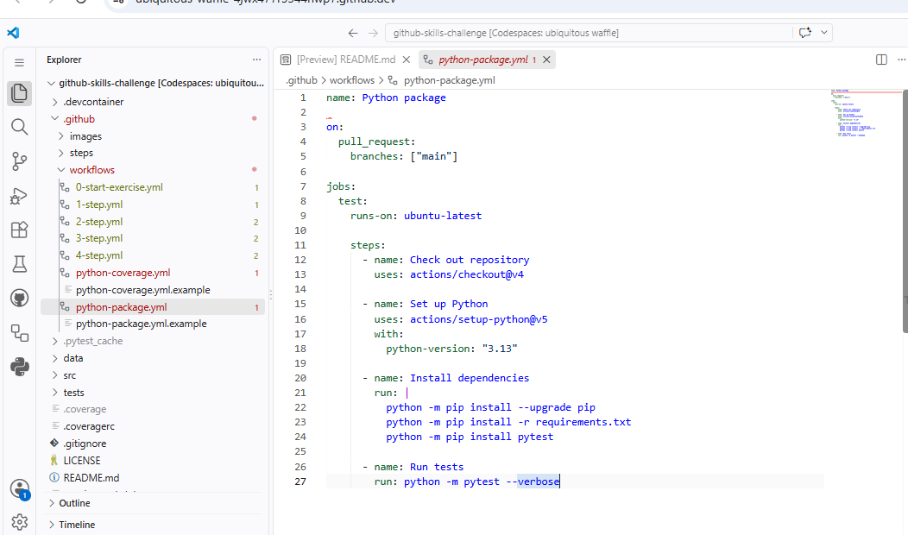

Task 4:
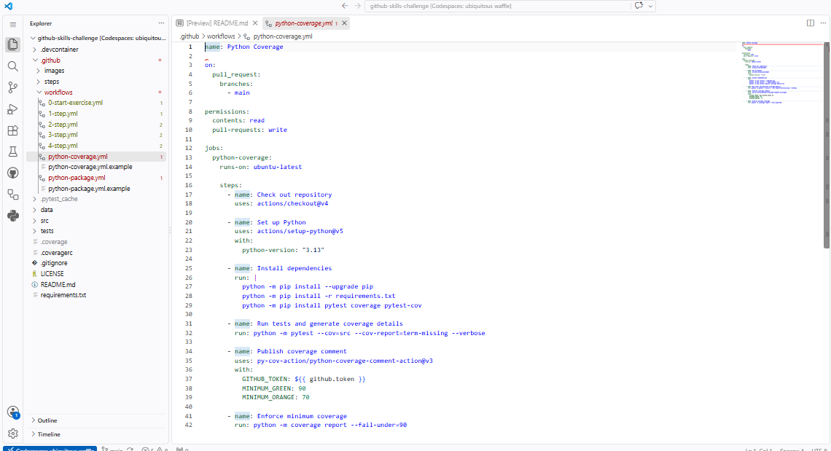

Task 5:
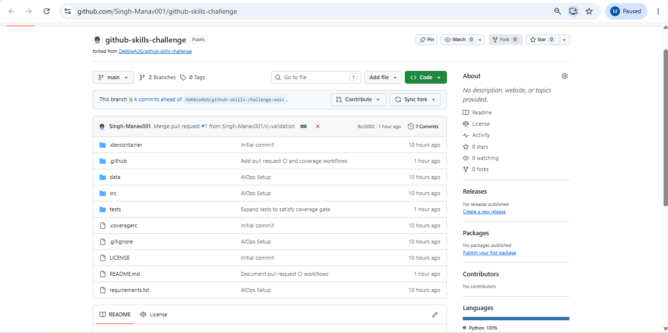

Task 6:
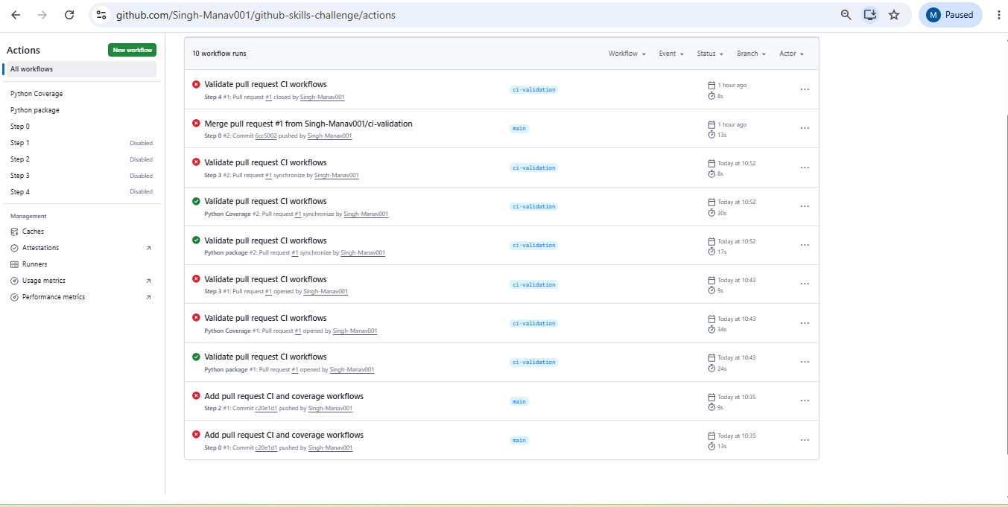

- Repository: https://github.com/Singh-Manav001/github-skills-challenge
- PR: https://github.com/Singh-Manav001/github-skills-challenge/pull/1

