**DELHI TECHNOLOGICAL UNIVERSITY**

(Formerly Delhi College of Engineering)

Shahbad Daulatpur, Bawana Road, Delhi 110042

**DEPARTMENT OF ELECTRONICS AND COMMUNICATION ENGINEERING**

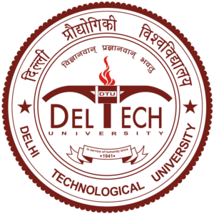

**CO327: MACHINE LEARNING**

**LAB FILE**

**Submitted To: Submitted By:**

**Mr. Nipun Bansal ARINDAM SINGH**

**Assistant Professor B.Tech ECE IIIrd Year**

**Department of 2K22/EC/49**

**Computer Science Engineering Section-3, Group-2**