

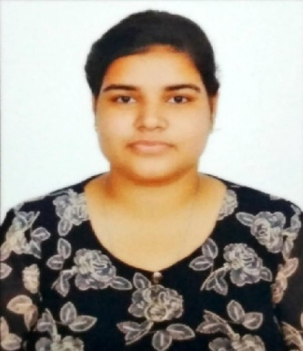

Rishika Thakur

**Address:** 205HH/EB NANGAL TOWNSHIP (ROOP NAGAR)-140124

**E-mail:** [*rishikathakur1166@gmail.com*](mailto:rishikathakur1166@gmail.com)

Phone: +916283587057

**PROFESSIONAL SUMMARY**

Looking forward to be a part of an esteemed organization and work hard so as to enhance my skills to achieve the goals as well as contribute towards the growth of the organization.

**INTERPERSONAL SKILLS**

Time Management **|** Team Coordination

**|** Decision Making **|** Leadership **|**

Creativity.

**INTERESTS & HOBBIES**

Watching Movies **|** Dancing **|**

**|** Listening music.

**LANGUAGES KNOWN**

English **|** Hindi **|** Punjabi

**PERSONAL DETAILS**

**EDUCATION**

Masters of Computer Application | Chandigarh University

*Session: 2021-2023* | *CGPA: 8.0*

Bachelor of Computer Application |Dayanand Academy of Management Studies| *Session: 2017-2020 | Percentage: 57.38%*

Intermediate (10+2) | SRNIC RANKI SANGIPUR PRATAPGHAR

*Session: 2015-2017* | *Percentage: 67.2%*

High School | B S S Public School Amol Vihar Rae Bareli|

*session: 2013-2014* | *Percentage: 66.5%*

**TRAINING & PROJECTS**

**Projects.**

* **E-Commerce Website** Using HTML, CSS, JavaScript
* **Calculator** Using HTML, CSS, javaScript.
* **Image Gallery** Using React.js

**TECHENICAL COMPETENCIES**

HTML |CSS | Javascript | React.js beginner

**ACADEMIC ACHIEVEMENTS**

* Active participant at all types of technical and cultural events at university and department level.
* Class Representative, Chandigarh University

**Mother’s Name:** Mrs.Surinder

**Father’s Name**: Mr. Rakesh Kumar

**D.O.B:** 09 November 2000