SUGANSHU PATEL

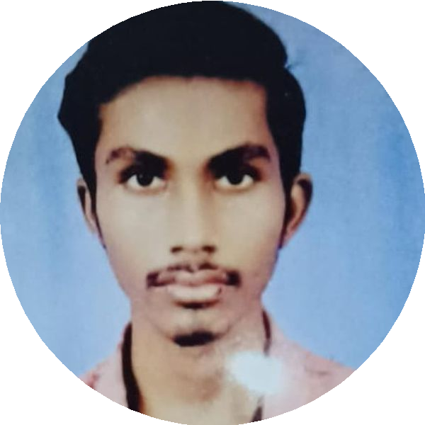

**✆ +91 7405022625**

**✉ sudhanshusingh8295@gmail.com**

**🏠 26/A, Shaktinagar, Udhna, Surat - 394210**

# CAREER OBJECTIVE

As a mechanical engineer with three years of hands-on experience, I am eager to secure a position where I can effectively contribute to company production processes. I am committed to applying the skills and knowledge acquired during my education to establish myself financially, professionally, and socially within the organization.

# EXPERIENCE

## Laser Machine Operator

### Aadiyogi Engineering

 07/2021 - Present  Surat, Gujarat

* Typical laser cutting operations, AutoCAD nesting and programming.
* Proper cutting programs, and proper fixtures.
* Install proper stop location, adjust laser beam focal point.
* Parameter set-up for mantle cutting operations.
* Scheduled maintenance as needed.
* Do all dimensional inspections.
* Detect and report defective materials or questionable conditions to supervisor.
* May perform a variety of other tasks as production needs require.

# EDUCATION

Diploma in Mechanical Engineering

### Gujrat Technological University

 2017 - 2021  Surat, Gujarat

## SSC

### GSEB Board

 2017 - 2018  Surat, Gujarat

CGPA

7.29 / 10

Percentage

58.00 / 100

# SKILLS

### Soft Skills - Communication Adaptability Leadership Teamwork Time Management

**Technical Skills - Computer Electrical Instruments Knowledge**

# 

# PROJECTS

### Saudi Aramco Oil & Refinery

* HP separator
* Dry gas knockout drum Inlet
* knockout drum

### SUEZ - Oil Processing Company

* Coke drums

# INTERESTS

* Playing cricket
* Listening to music

# DECLARATION

Name: Suganshu Patel

DOB: 05/06/2002

Languages: Hindi, English, Gujarati

Address: 26/A, Shaktinagar, Udhna, Surat - 394210

**I hereby declare that the above-mentioned information is true to the best of my knowledge.**

**Suganshu Patel**

**___________________**