**DAY 1**

**Assessment 1**

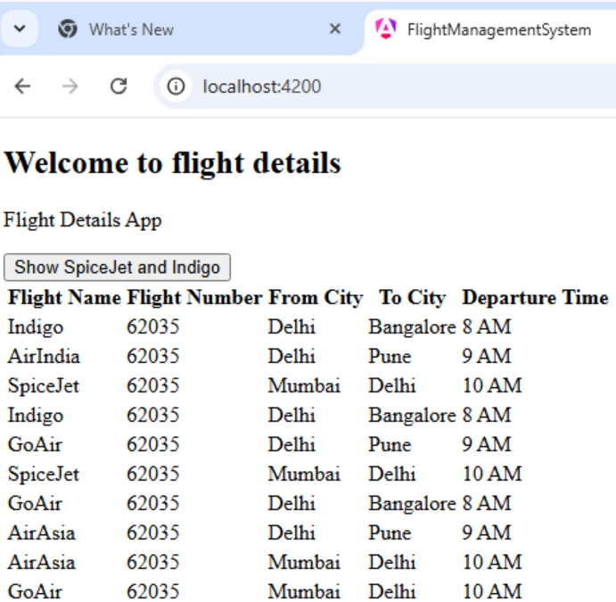

**Assessment 2**

**DAY 2**

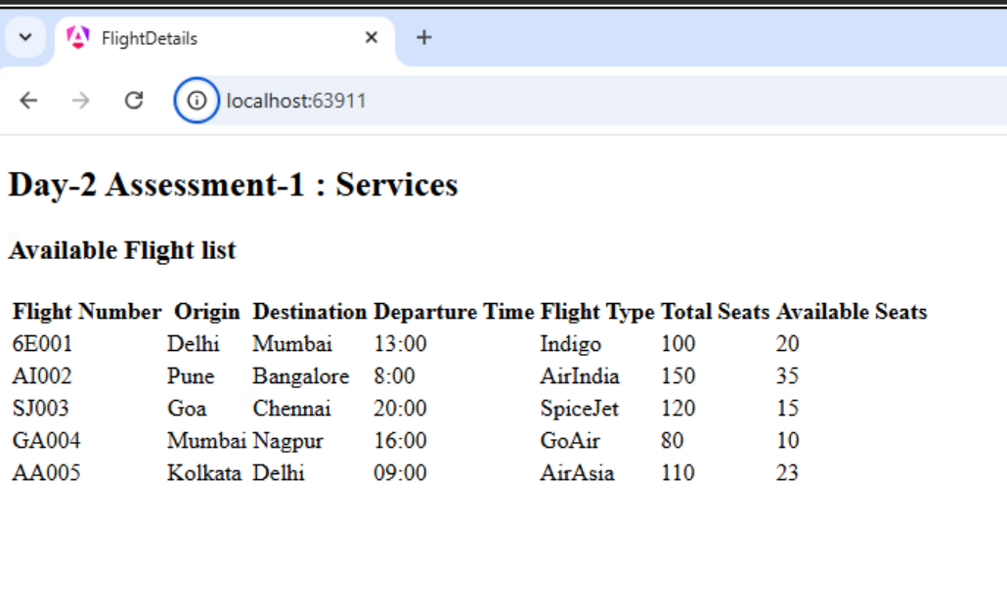

**DAY 3**

**Assessment1**

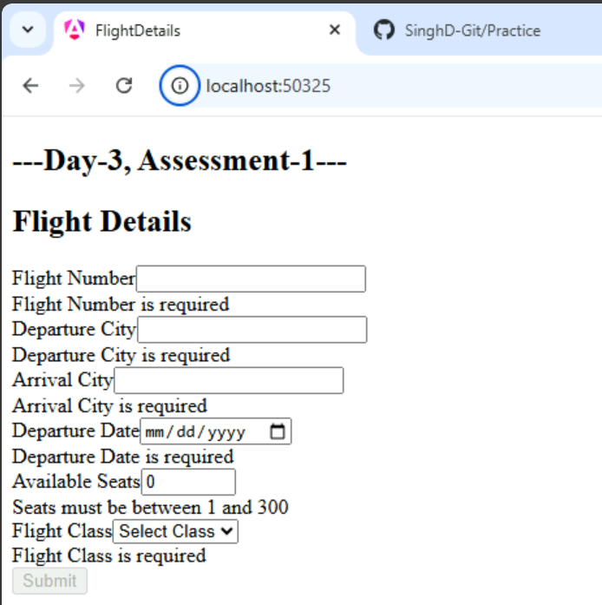

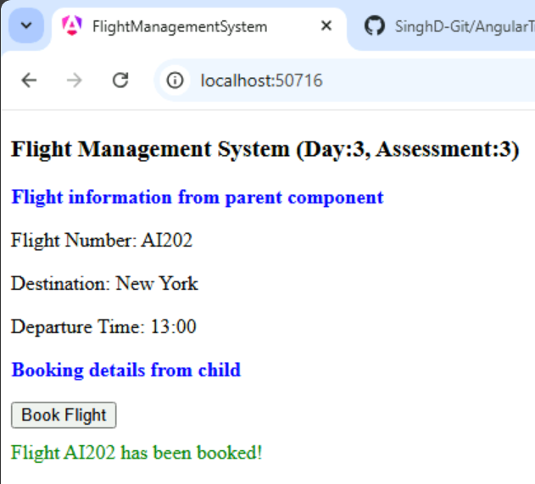

**Day 4**

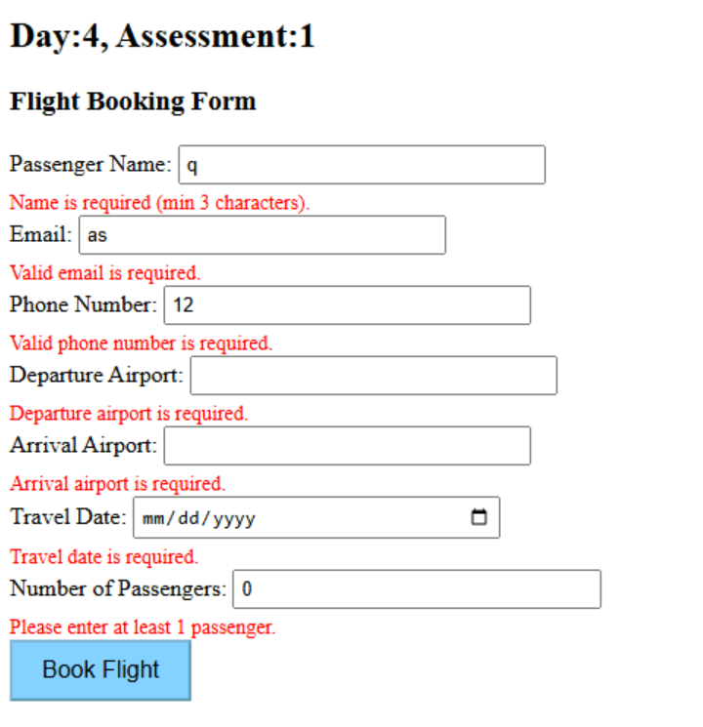

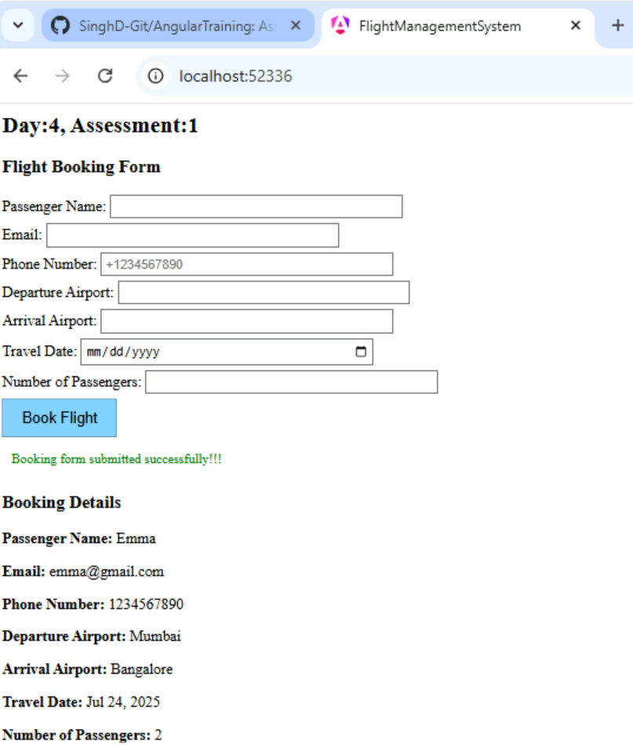

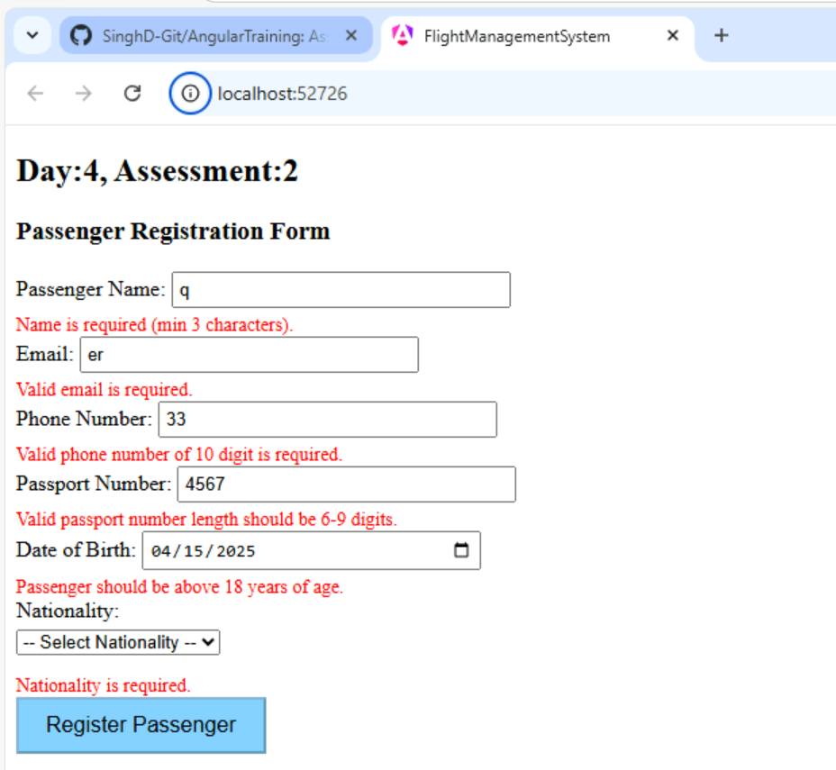

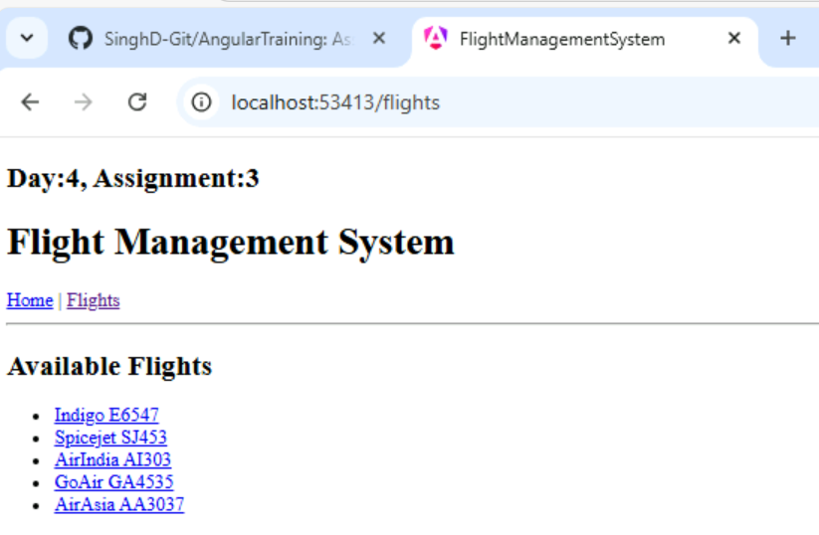

**Day 5 Assessment**

