AI Usage DISCLOSURE FORM

1. Team Details
Team Name: SRM_Team Ctrl Alt Elite_1
Project / Product Name: Agentic Code Intelligence
Organization / Institution (if any): SRM Institute of Science and Technology
Submission Date: 30 September 2026

2. AI Usage Declaration
Did your team use any Artificial Intelligence (AI) in developing this project? Yes / No
Yes

3. Purpose of AI Usage ( Brief Details)
Idea generation / brainstorming: Helped discuss implementation approaches.
Code generation or assistance: Assisted with integration, debugging and refinement of existing code.
UI / UX design: Helped refine the search interface.
Content creation: Helped revise technical documentation.
Data analysis: Helped check and present existing evaluation results.
Testing / debugging: Helped debug and test search routes and runtime behavior.
Other: The application uses pretrained embedding models for code retrieval.

4. Feature Origin Classification ( Please add/delete based on the number of the feature)
1. Feature Name : Code search
2. Self-Generated/AI-Generated/Both : Both
3. Description (AI tools/platform used, prompt used, output summary, modification):
AI tool: OpenAI Codex.
Prompt used (summary): Help integrate the existing code-search backend, improve runtime compatibility and test the search routes.
Output summary: Suggestions and targeted code assistance for integration, compatibility, testing and verification.
Modification: We reviewed, adapted and tested the assisted changes before using them.

1. Feature Name : Search interface
2. Self-Generated/AI-Generated/Both: Both
3. Description (AI tools/platform used, prompt used, output summary, modification):
AI tool: OpenAI Codex.
Prompt used (summary): Help implement and refine the search interface, connect it to the API and display retrieved code and results.
Output summary: Assistance with interface implementation, API integration and UI refinement.
Modification: We reviewed the interface and refined it based on our requirements.

5. Ethical & Compliance Confirmation
AI usage complies with guidelines and policies. Yes
No proprietary or copyrighted data misused. I Agree

6. Declaration & Sign-Off
Name of Team Representative: Devansh Singh
Role: Team Lead
Signature: 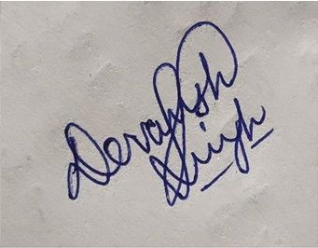
Date: 30 September 2026

