Simple CNN:

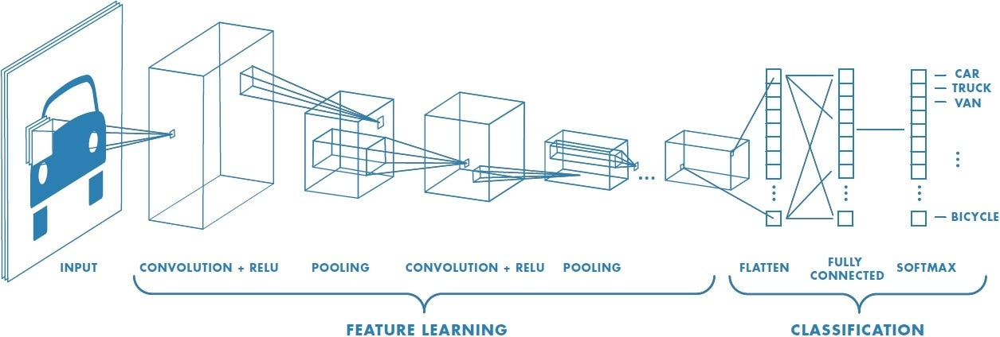

Depth refers to the number of layers in the neural network.

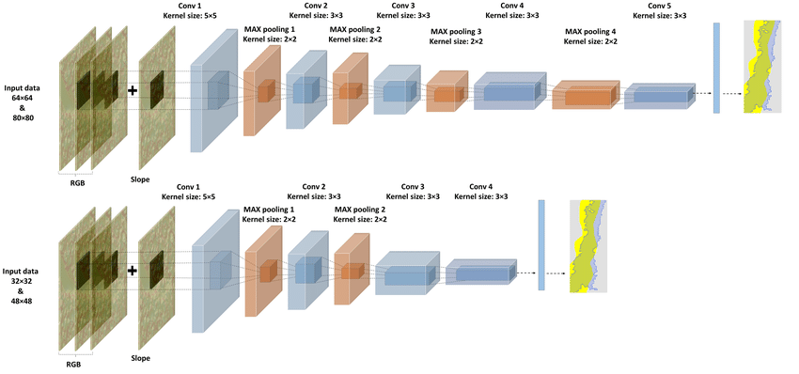

Example:
Model | Number of Layers
Shallow CNN | 5 layers
Medium CNN | 20 layers
Deep CNN | 50+ layers

Example models:
- ResNet50 → 50 layers
- ResNet101 → 101 layers

Why more layers help
Each layer learns more complex features.
So deeper networks can learn more complex patterns.
Simple analogy
Think of layers like levels of analysis.
Doctor diagnosis example:
- Layer 1 → basic symptoms
- Layer 2 → patterns in symptoms
- Layer 3 → disease detection
More layers → deeper understanding.

Width : Width refers to the number of filters (kernels) in a convolution layer.
Example:
Layer | Filters
Small model | 32 filters
Medium model | 64 filters
Large model | 256 filters

Each filter detects a different pattern.
Simple analogy
Think of filters like specialists.
Hospital example:
- Doctor 1 → heart
- Doctor 2 → lungs
- Doctor 3 → brain
More specialists → better diagnosis.
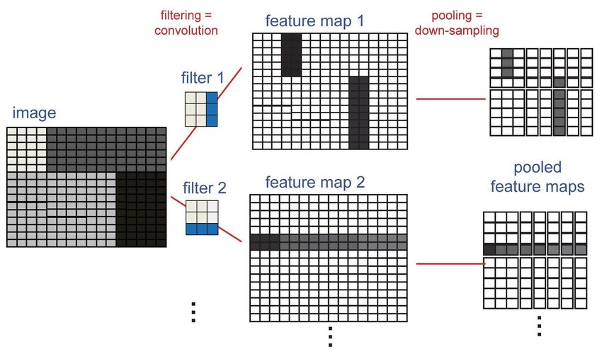

Resolution is the size of the input image.
Example:
Resolution | Image Size
Low | 128 × 128
Medium | 224 × 224
High | 512 × 512

Simple analogy for Resolution
Think of resolution like the quality of a photograph.
Example:
📷 Low resolution photo
You can see the person but details are unclear.
📷 High resolution photo
You can see eyes, wrinkles, texture of clothes.
More resolution → more information for the model.
Example:
- medical imaging
- satellite images
- defect detection
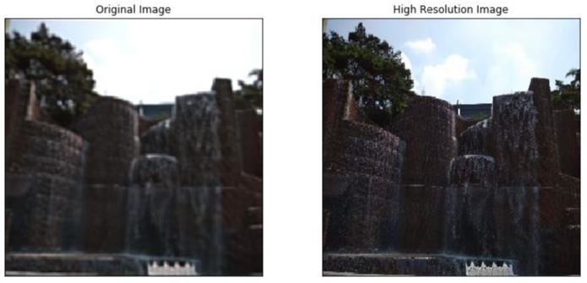
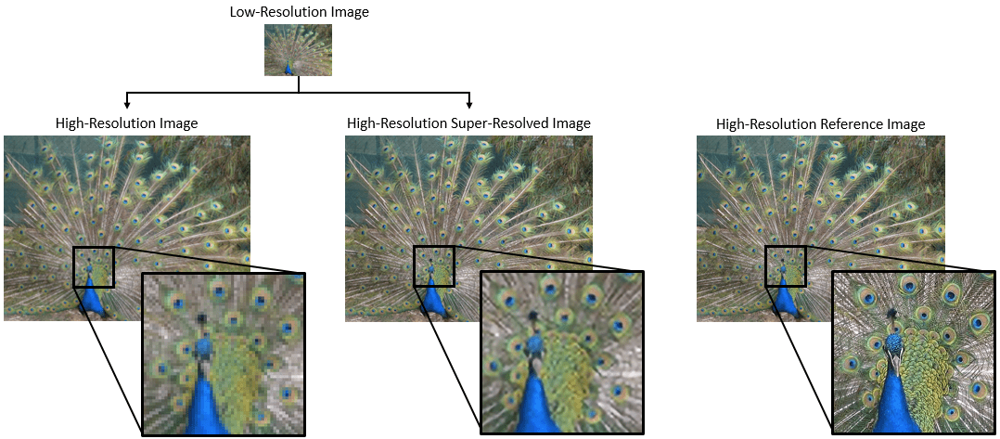

Think of building a research team.
Concept | Analogy | Meaning
Depth | Levels of analysis | More layers
Width | Specialists | More filters
Resolution | Photo quality | More image detail

✅ Very simple memory trick
Depth → how deep the thinking goes
Width → how many experts analyze the image
Resolution → how clear the image is

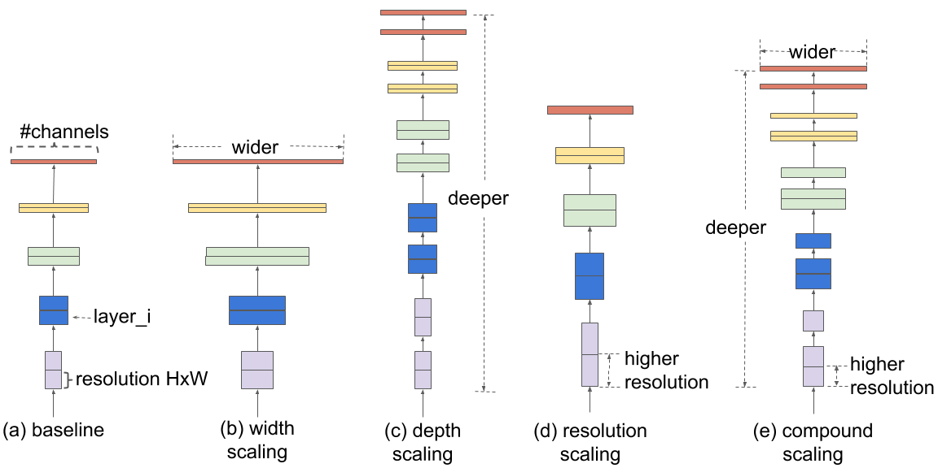

1. Simple CNN

When to Use
Use a Simple CNN when:
- You are learning CNN concepts
- Dataset is small
- Problem is simple
- You want to build a custom architecture
Example Cases
- Student learning CNN
- Small research dataset
- Binary classification (cat vs dog)
- Proof-of-concept models
Why
Simple CNNs are:
- Easy to understand
- Easy to train
- Good for experimentation
But they cannot capture very complex patterns.

2. ResNet mainly improves performance by increasing the number of layers (depth).
Key Idea
Output = F(x) + x
Main Goal
✔ Train very deep networks
Key Feature
- Skip connections prevent vanishing gradients
This allowed training networks with 50+ layers.
Use ResNet when:
- Dataset is large
- Task is complex
- Need high accuracy
- Training deep neural networks
Example Cases
- Medical image classification
- Autonomous driving vision
- ImageNet competitions
- Industrial AI systems
- So the main idea is:
This makes ResNet very powerful for complex image tasks.

3. EfficientNet
Key Idea: EfficientNet uses compound scaling.
Scale depth + width + resolution together
Use EfficientNet when:
- Need very high accuracy
- Want efficient computation
- Limited GPU resources
- Want the best accuracy vs computation balance
Example Cases
- Medical AI systems
- Satellite image analysis
- Industrial quality inspection
- Production AI systems

4. MobileNet
Key Idea: MobileNet reduces computation using Depthwise separable convolution
Use MobileNet when:
- Deploying AI on mobile phones
- Running models on IoT devices
- Need real-time inference
- Hardware resources are limited
Example Cases
- Smartphone apps
- Smart cameras
- Drones
- Wearable devices
✅ summary:
- Simple CNN → learning / small problems
- ResNet → deep networks / large datasets
- EfficientNet → best accuracy with efficiency
- MobileNet → mobile and edge devices
Quick Decision Guide
Situation | Best Model | Parameters | Speed | Accuracy
Mobile / IoT / Edge device | MobileNet | ~4M | Very Fast | Moderate
Very deep network / large dataset | ResNet | ~25M | Fast | High
Best accuracy + efficiency balance | EfficientNet | ~5–30M | Medium | Very High

ResNet mainly improves performance by making the network deeper (adding more layers), while EfficientNet scales depth, width, and resolution together.
Very Simple Memory Trick
Think of building vehicles:
Model | Analogy
Simple CNN | Bicycle (basic learning)
ResNet | Powerful sports car
EfficientNet | Fuel-efficient modern car
MobileNet | Lightweight scooter

