RNN Pen-and-Paper Calculation Example

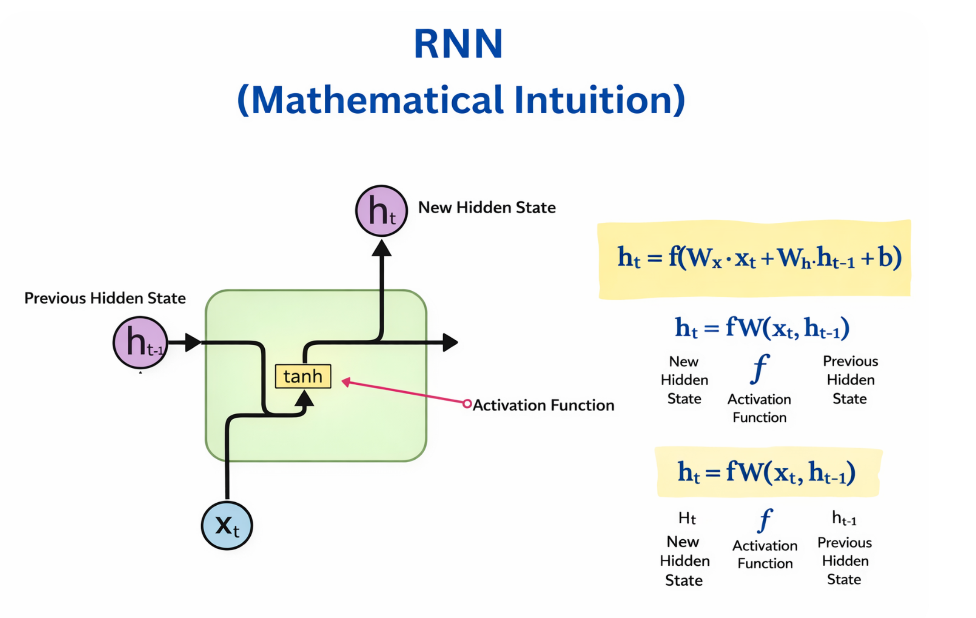
Sentence:
"I am happy"
Vocabulary:
["I", "am", "happy"]
One-hot Encoding:
I -> [1, 0, 0]
am -> [0, 1, 0]
happy -> [0, 0, 1]

Inputs
x1 = "I" = [1, 0, 0]
x2 = "am" = [0, 1, 0]

Weights
Input-to-hidden weights (Wi):
[[0.5, 0.1],
[0.3, 0.2],
[0.4, 0.6]]
Hidden-to-hidden weights (Wh):
[[0.2, 0.1],
[0.4, 0.3]]
Initial hidden state:
o0 = [0, 0]

Time Step 1 Calculation
x1Wi = [1, 0, 0] × Wi = [0.5, 0.1]
o0Wh = [0, 0]
Sum = [0.5, 0.1]
o1 = tanh([0.5, 0.1]) ≈ [0.462, 0.100]

Time Step 2 Calculation
x2Wi = [0, 1, 0] × Wi = [0.3, 0.2]
o1Wh = [0.462, 0.100] × Wh ≈ [0.1324, 0.0762]
Sum = [0.4324, 0.2762]
o2 = tanh([0.4324, 0.2762]) ≈ [0.408, 0.269]

Final Outputs
o1 ≈ [0.462, 0.100]
o2 ≈ [0.408, 0.269]
✅ Final Results
Time step | Word | Output
t = 1 | "I" | [0.462, 0.100]
t = 2 | "am" | [0.408, 0.269]

⭐ Key intuition (very important)
- x₁, x₂ are words
- o₁ carries meaning of "I"
- o₂ carries meaning of "I am"
- RNN builds context step-by-step

