Advanced Unix Programming Lab 7

111403050 Abhijeet Kale
111403067 Sagar Panchmatia
111403076 Nikunj Singh

Q1)“The child “exec” call inherits the file descriptors of parent if Close_on_exec is not set“. Demonstrate with an example

Code for the parent pocess :

#include<stdio.h>
#include<unistd.h>
#include<sys/types.h>
#include<stdlib.h>
#include<fcntl.h>

int main(){
int fd, pid;
fd = open("input.txt", O_RDONLY);
int n = fcntl(fd,F_SETFD,FD_CLOEXEC);
if((pid = fork()) < 0) {
perror("fork");
exit(1);
}
char buf[10];
sprintf(buf,"%d",fd);
if(pid == 0)
execl("child","child",buf, NULL);
return 0;
}

Code for execed process :

#include<stdio.h>
#include<unistd.h>
#include<stdlib.h>
#include<fcntl.h>
#include<errno.h>
#include<string.h>

extern int errno;

int main(int argc, char *argv[]){
int fd, pid;
char buf[6];
fd = atoi(argv[1]); /*File descriptor opened in parent*/
int n = read(fd, buf, 5);
buf[5] = '\0';
if(n == -1){
fprintf(stderr, "Error opening file : %s\n", strerror(errno));
}
else
printf("%s\n",buf);
return 0;
}

Execution :

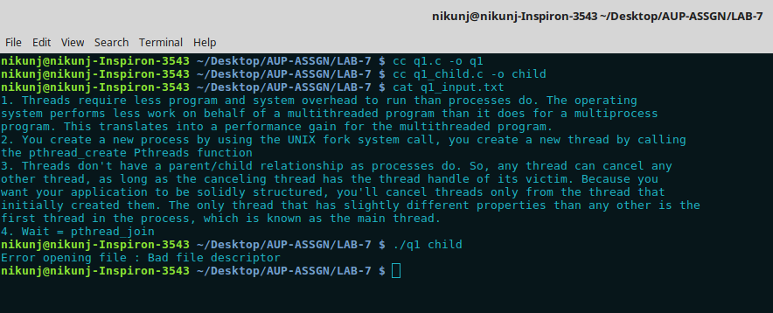

When the file is opened using close on exec flag set, the child process which does an exec cannot play around with this file descriptor. These file open descriptors are not accessible in the execed process. The execed process in this case is named as “child”.
q1.c is the main process where the file has been opened with FD_CLOEXEC flag set using fcntl.

Q2) Write a program that takes a file name as an argument, opens the file, reads it and closes the file. The file should contain a string with the name of another application (e.g., 'ls' or 'ps' or any of your own applications) and the program forks a new process that executes the application named in the file.

Code:

#include <stdio.h>
#include <sys/types.h>
#include <sys/stat.h>
#include <sys/wait.h>
#include <fcntl.h>
#include <unistd.h>
#include <stdlib.h>
#include <errno.h>

int main(int argc, char *argv[]) {
int fd, i, ret, rete;
char prog[256];
char *arg[2];
pid_t child;
if(argc != 2) {
printf("Usage:\nash <filename>\n");
return 1;
}

if((fd = open(argv[1], O_RDONLY)) == -1) {
perror("ash: Unable to open file");
return -1;
}

i = 0;
while(read(fd, &prog[i++], sizeof(char)));
prog[i - 2] = '\0';
arg[0] = prog;
arg[1] = NULL;
if((child = vfork()) < 0) {
perror("ash: Unable to fork new process");
return -1;
}
if(child == 0) {
if((rete = execvp(prog, arg)) == -1) {
perror("ash: Error while executing process");
_exit(-1);
}
}
else {
wait(&ret);
if(WIFEXITED(ret)) {
printf("ash: Process exited with return status %d\n", WEXITSTATUS(ret));
}
}
return 0;
}

Execution:

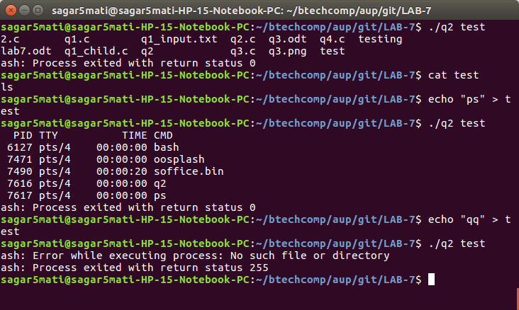

Q3) Implement cat < hw.txt > hw-copy.txt

Code :

#include <stdio.h>
#include <unistd.h>
#include <sys/types.h>
#include <sys/stat.h>
#include <fcntl.h>
#include <sys/wait.h>

int main(int argc, char *argv[]) {
int fd1, fd2, num;
fd1 = open(argv[1], O_RDONLY);
fd2 = open(argv[2], O_WRONLY|O_CREAT|O_APPEND|O_TRUNC, 0644);

// hw.txt becomes the standard input
if(dup2(fd1, 0) == -1) {
printf("Error\n");
return -1;
}
// integer is taken from hw.txt instead of standard input
scanf("%d", &num);

// hw-copy.txt becomes the standard output
if(dup2(fd2, 1) == -1) {
printf("Error\n");
return -1;
}

printf("This will go to hw-copy.txt and not standard output\n");
printf("This is this integer taken as input from hw.txt %d\n", num);
return 0;
}

Execution :

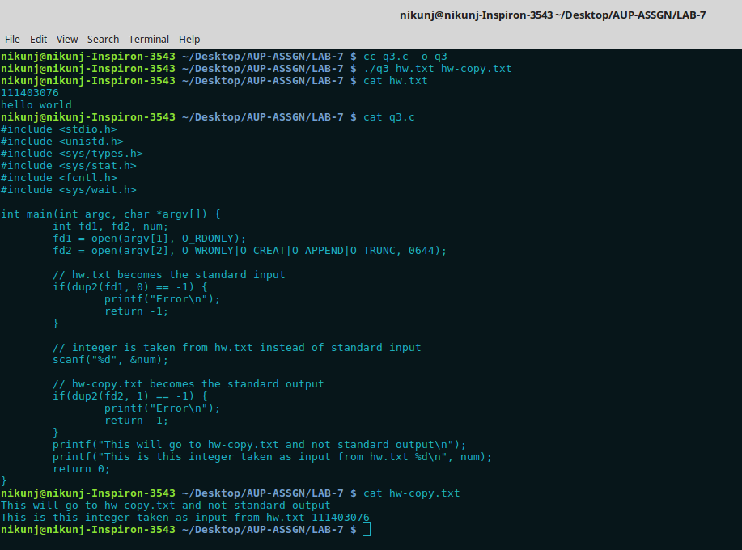

Here fd1 is the file descriptor for file hw.txt. fd2 is the file descriptor for file hw-copy.txt
dup2 function is used here to duplicate file descriptors.
hw.txt acts as standard input (STDIN – 0). Therefore the integer taken as input is taken from hw.txt rather than STDIN.
Hw-copy.txt acts as standard output (STDOUT – 1). Therefore whatever we print from this file we write into hw-copy.txt instead of STDOUT.

Q4) Bob works for an auditing agency needs to be able to read all the files in the system. The system admin has to protect the integrity of the system and should not allow Bob to modify or delete any file. Write a special SETUID program for the admin so that he can gave the executable permission of it to Bob. This program requires Bob to type a file name at the command line and then it will run /bin/cat to display the specified file. Can Bob compromise the integrity (by adding/modifying/deleting files) of this system? How?

Code:

#include <sys/types.h>
#include <unistd.h>
#include <stdio.h>
int main(int argc, char *argv[]) {
if(argc < 2) {
printf("Arguements are insufficient\n");
return 1;
}
setuid(2000);
execv("/bin/cat", argv);
return 0;
}

Execution:

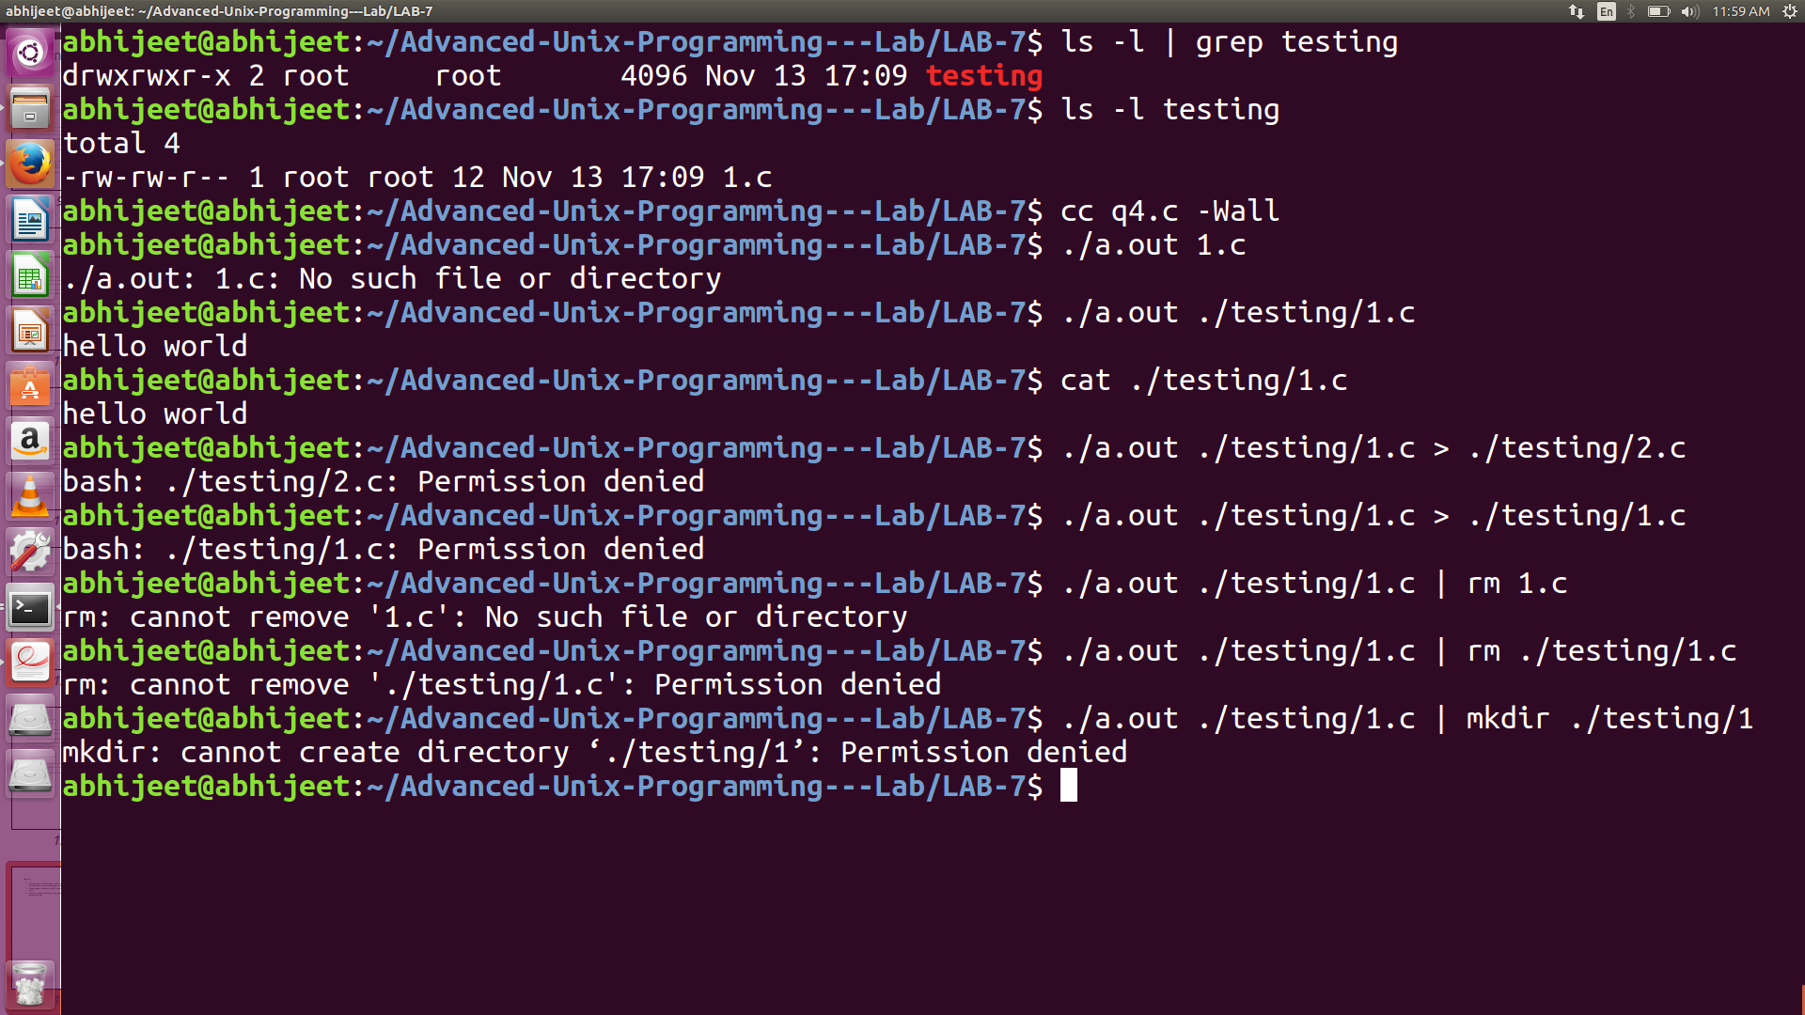
In the above screenshot we can see that there exists a directory namely testing. The owner and the grouop owner of this directory is root. There exists a file 1.c inside testing with the root as owner and group owner. When we compile and run our program to read this 1.c, it executes and reads the data “hello world” from 1.c. As we can see above no other operation can be performed such that a file can be added /modified or deleted from this directory. This happens because a call to setuid function has been made with uid = 2000. The current owner of the directory and the file is root and the real uid of the process is 1000 (myuid).So with thsi program the system admin can ensure integrity of the system.

