Advanced Unix Programming Lab : Assignment 2

Abhijeet Kale 111403050 BtechComp
Sagar Panchmatia 111403067 BtechComp
Nikunj Singh 111403076 BtechComp

Solution 1)

Code :

Could not upload the screenshot due to upload limit on moodle of 2MB.

Here is the code :

#include <stdio.h>
#include <pwd.h>
#include <grp.h>
#include <stdlib.h>
#include <sys/stat.h>
#include <fcntl.h>
#include <sys/types.h>
#include <dirent.h>
#include <unistd.h>
#include <errno.h>
#include <time.h>
#include <string.h>

#define BUFF 5

/*make directory api function call*/
int mkdir_aup(char *pathname) {
int fd =-1;
fd = mkdir(pathname, 0777);
return fd;
}
/*printing the date with the structure of tm, returned by localtime()
Called in the ls_l function to print the date of last modification
of a file/directory.
*/
void print_date_time(struct tm *time_info) {
switch(time_info->tm_mon) {
case 0:
printf(" Jan");
break;
case 1:
printf(" Feb");
break;
case 2:
printf(" Mar");
break;
case 3:
printf(" Apr");
break;
case 4:
printf(" May");
break;
case 5:
printf(" Jun");
break;
case 6:
printf(" Jul");
break;
case 7:
printf(" Aug");
break;
case 8:
printf(" Sep");
break;
case 9:
printf(" Oct");
break;
case 10:
printf(" Nov");
break;
case 11:
printf(" Dec");
break;
}
printf(" %d %d:%d", time_info->tm_mday, time_info->tm_hour, time_info->tm_min);
}
/*Used to print permissions of file/directory in the ls_l function*/
void print_permissions(mode_t st_mode) {
putchar(st_mode & S_IRUSR ? 'r' : '-');
putchar(st_mode & S_IWUSR ? 'w' : '-');
putchar(st_mode & S_IXUSR ? 'x' : '-');
putchar(st_mode & S_IRGRP ? 'r' : '-');
putchar(st_mode & S_IWGRP ? 'w' : '-');
putchar(st_mode & S_IXGRP ? 'x' : '-');
putchar(st_mode & S_IROTH ? 'r' : '-');
putchar(st_mode & S_IWOTH ? 'w' : '-');
putchar(st_mode & S_IXOTH ? 'x' : '-');
}
/*This function simulates the ls -l function and returns a similar output with the same format
as that of ls -l command.
*/
void ls_l(char *pathname) {
DIR *dir;
struct tm *time_info;
struct group *grp;
struct passwd *pwd;
time_t tt;
struct dirent *entry;
struct stat sb = {0};
char filepath[512];
uid_t usr_id;
gid_t grp_id;
dir = opendir(pathname);
if(dir == NULL) {
printf("No such directory exists.\n");
return;
}
while((entry = readdir(dir)) != NULL) {
if(!strcmp(entry->d_name, ".") || !strcmp(entry->d_name, "..")) {
continue;
}
sprintf(filepath, "%s/%s", pathname, entry->d_name);
if(!stat(filepath, &sb)) {
if(S_ISDIR(sb.st_mode)) {
putchar('d');
}
else if(S_ISREG(sb.st_mode)) {
putchar('-');
}
print_permissions(sb.st_mode);
printf(" %lu", sb.st_nlink);
usr_id = sb.st_uid;
pwd = getpwuid(usr_id); //username
printf(" %s", pwd->pw_name);
grp_id = sb.st_gid;
grp = getgrgid(grp_id); //group owner
printf(" %s", grp->gr_name);
printf(" %ld", sb.st_size);
tt = sb.st_mtim.tv_sec;
time_info = localtime(&tt);
print_date_time(time_info);
printf(" %s\n", entry->d_name);
}
else {
perror("Cannot fetch data");
}
}
closedir(dir);
}
/*The chmod_aup calls the api function chmod. Here mode are the permissions to be modified for the file.
If the flag is set to zero then the permissions will be removed. If the flag is set to a number > 0 then
the permissions will be added.
*/
void chmod_aup(char *path, mode_t mode, int flag) {
struct stat sb;
mode_t file_mode;
if(stat(path, &sb)) {
perror("Cannot fetch data");
return;
}
file_mode = sb.st_mode;
if(flag == 0) {
file_mode = file_mode & (~mode);
}
else {
file_mode = file_mode | mode;
}
if(chmod(path, file_mode) == -1) {
perror("Cannot change mode");
}
}
int main(int argc, char *argv[]) {
if(argc < 2) {
printf("Too less arguments.\n");
return 1;
}
int count, fd;
char path[256], str[] = {'h', 'e', 'l', 'l', 'o', '\0'};
fd = mkdir_aup(argv[1]); /*mkdir junk*/
if(fd == -1) {
perror("Could not make directory");
return 1;
}
for(count = 1; count <= BUFF; count++) {
/*for i in 1 2 3 4 5 do*/
sprintf(path, "%s/%d", argv[1], count);
fd = open(path, O_WRONLY | O_CREAT, S_IWUSR | S_IRUSR);
write(fd, str, 5);
/*echo hello>junk/$i*/
close(fd);
}
/*done*/
ls_l(argv[1]); /*ls -l junk*/
printf("\n*************************************\n");
chmod_aup(argv[1], S_IRUSR | S_IROTH | S_IRGRP, 0); /*chmod -r junk*/
ls_l("."); /*ls -l*/
printf("\n*************************************\n");
chmod_aup(argv[1], S_IRUSR | S_IROTH | S_IRGRP, 1); /*chmod +r junk*/
ls_l(argv[1]); /*ls -l junk*/
printf("\n*************************************\n");
chmod_aup(argv[1], S_IXUSR | S_IXOTH | S_IXGRP, 0); /*chmod -x junk*/
if(chdir(argv[1]) == -1) { /*cd junk*/
perror("Could not change directory");
}
chmod_aup(argv[1], S_IXUSR | S_IXOTH | S_IXGRP, 1); /*chmod +x junk*/
if(chdir(argv[1]) == -1) { /*cd junk*/
perror("Could not change directory");
}
return 0;
}

Execution Screenshot :

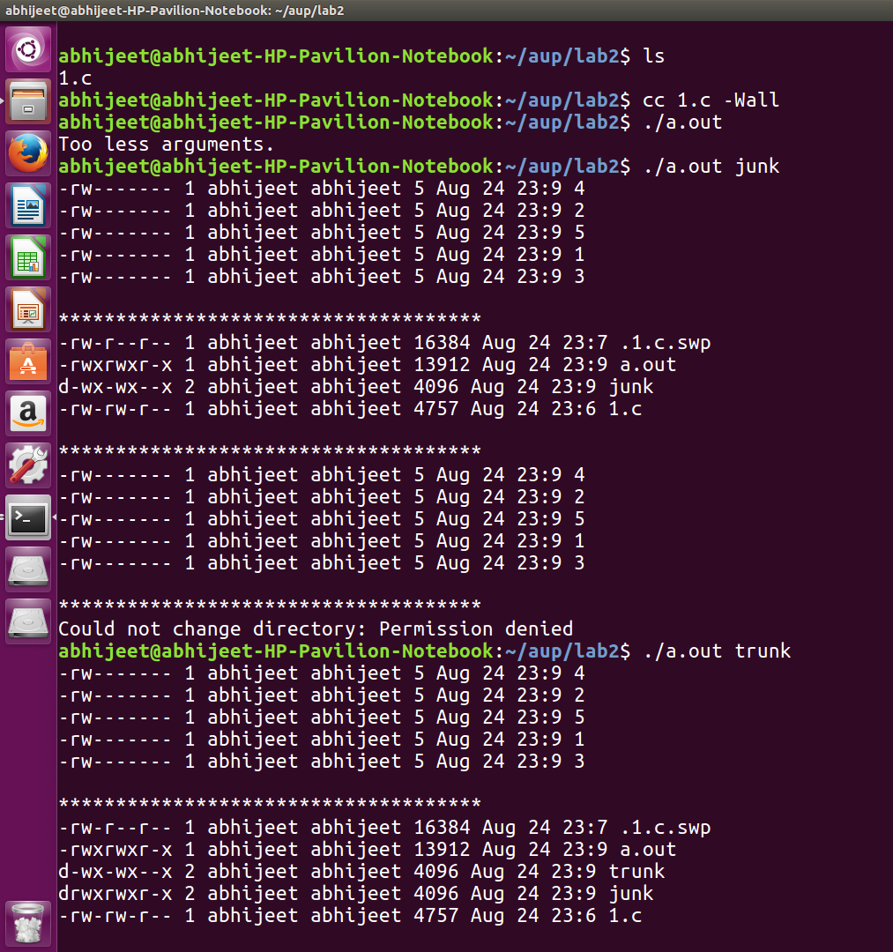

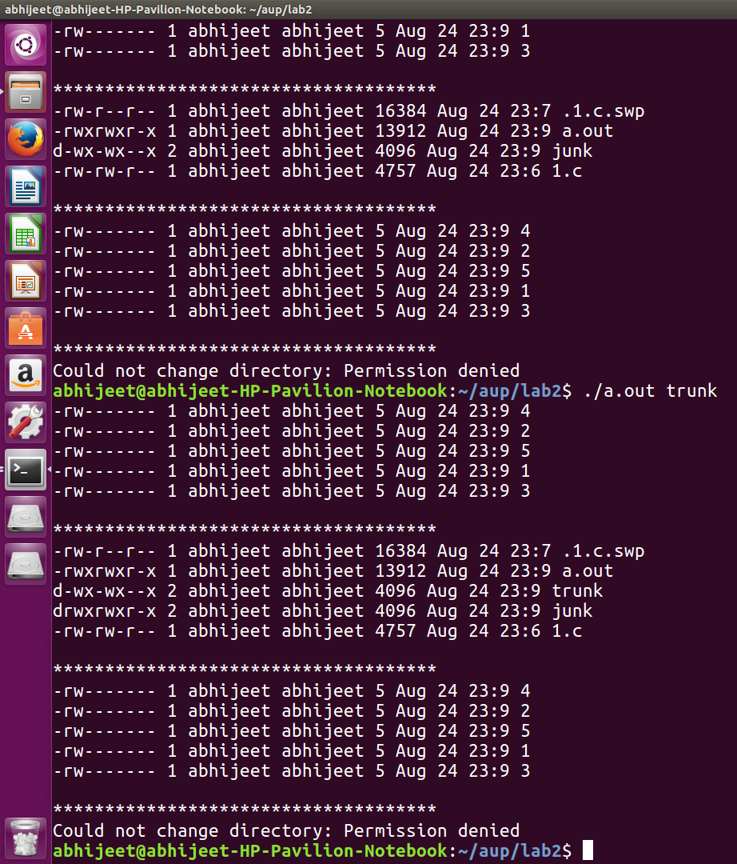

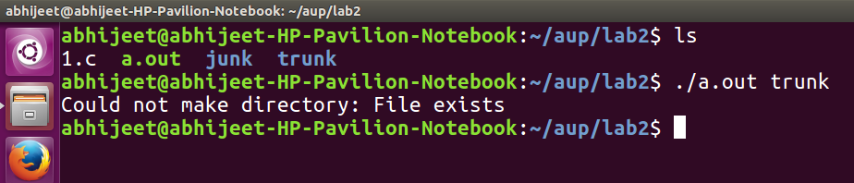

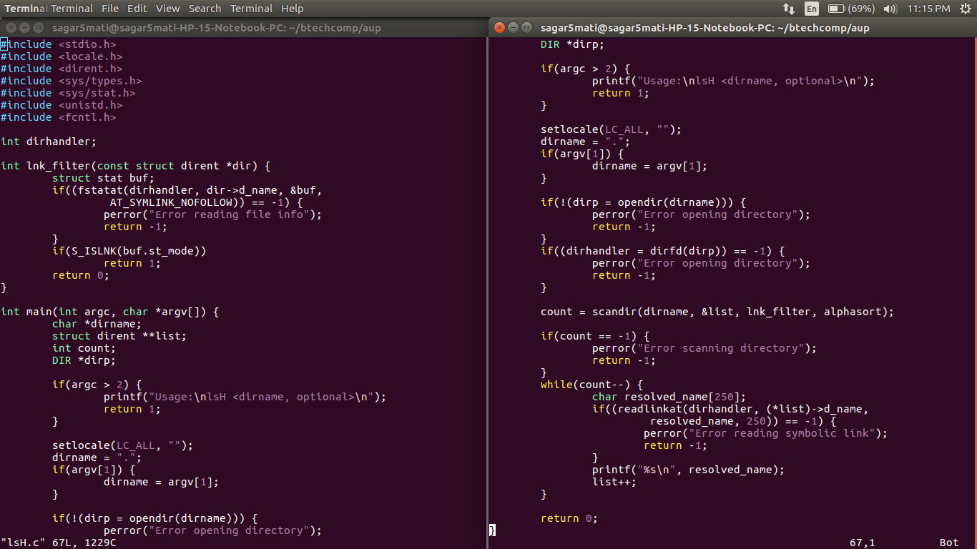
Solution 2
Code:

Explanation :

The readlink() function reads the content of the symbolic link file which gives us the path of the target file. We use scandir() function to read the contents of a directory. The filter function pointer required here was a function which used stat() to check if the file is a symbolic link. The files retrieved are passed through readlink(). The code works properly as can be seen from the outout.

Execution :

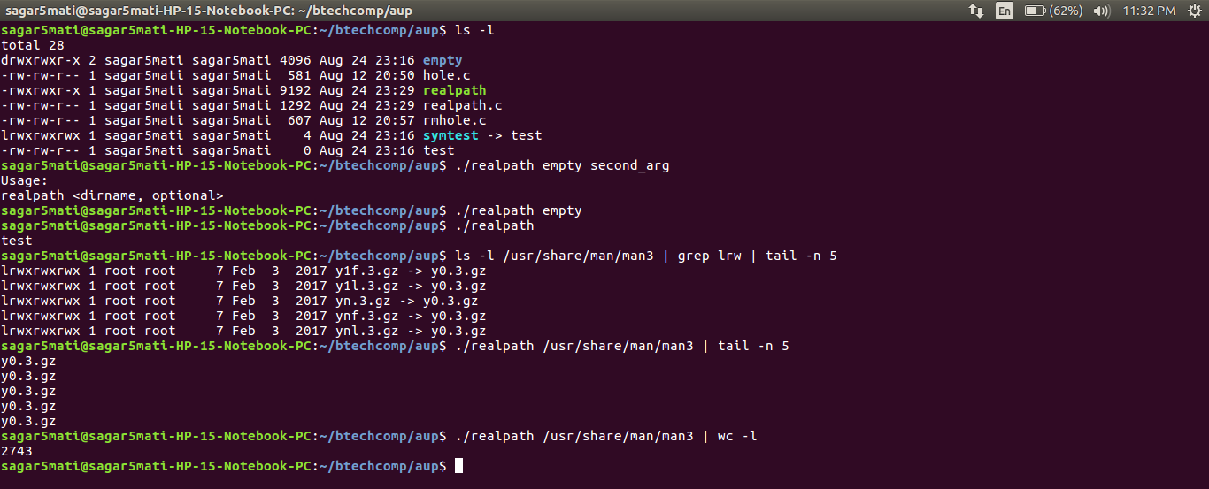

Solution 3 :

Code :

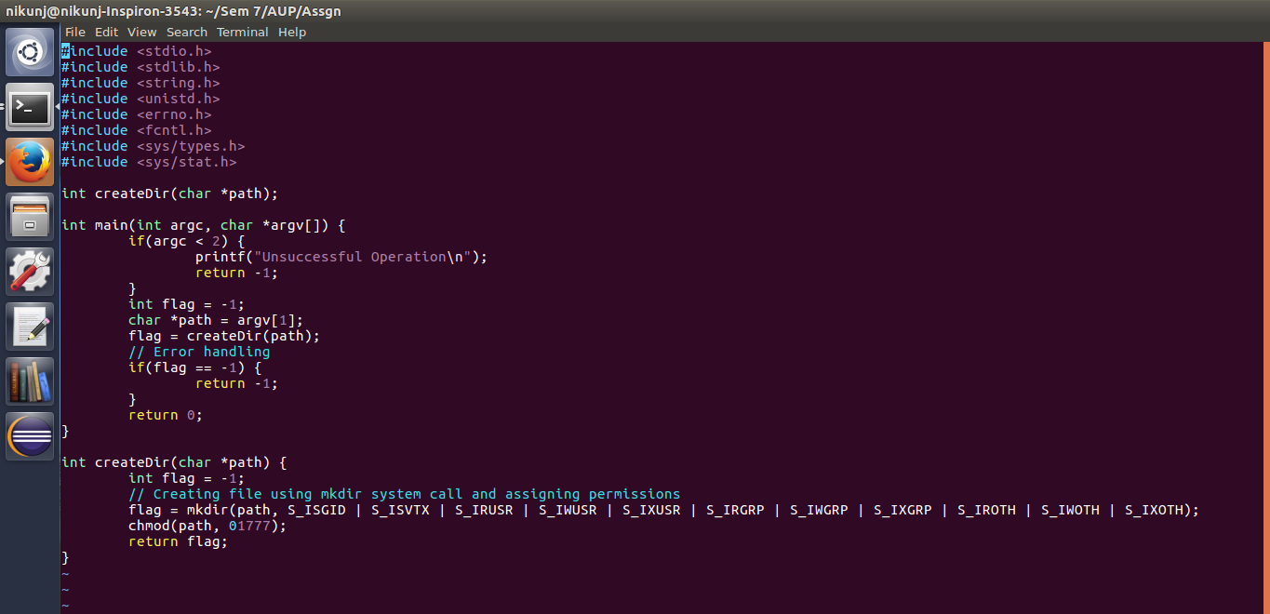

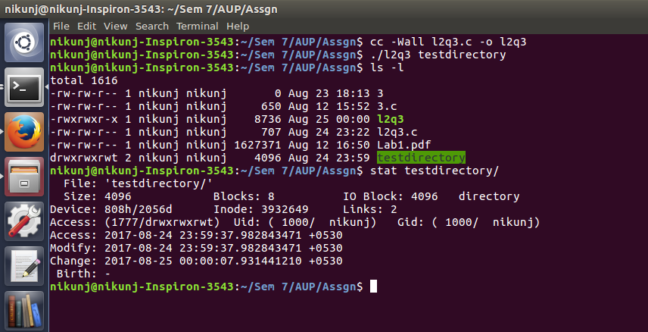

Explanation :

Here the permissions in decimal is 1777 which is uid = 0, gid = 0, stickybit = 1
This shows that instead of setting gid bit to 1 linux sets it to 0 again
Hence the permissions are not inherited by the group.

Instead for group being able to inherit the permissions access should be
3777 which is (011) -> the gid bit will be set along with sticky bit

This can be achieved by : chmod g+x testdirectory

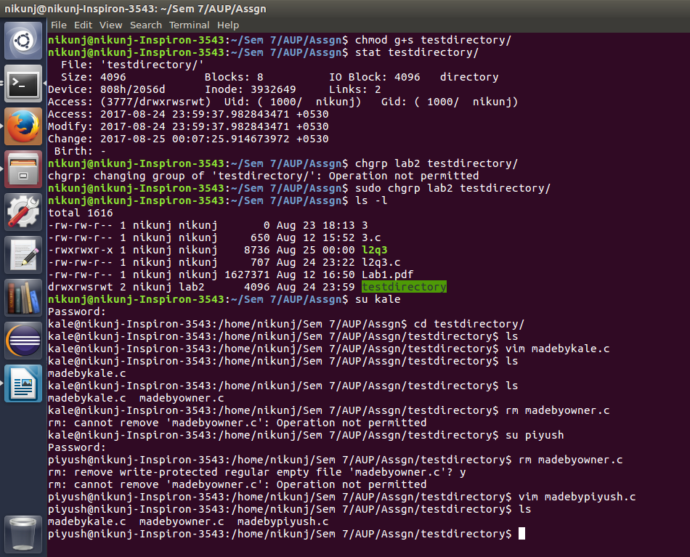
Hence :
Kale belongs to lab2
Piyush is other user
Both can create files by cannot delete the file madebyowner.c

