Advanced Unix Programming Lab 5

Abhijeet Kale 111403050
Sagar Panchmatia 111403067
Nikunj Singh 111403076

Question 1 )
A child process inherits real user id, real group id, effective user id and effective group id of the parent process, while process id and parent process id are not. Demonstrate

Code :
#include <stdio.h>
#include <unistd.h>

int main(int argc, char *argv[]) {
pid_t pid;
if((pid = fork())< 0) {
perror("Fork Failed");
return -1;
}
else if(pid == 0) {
// child process
printf("Child Process\n");
printf("\tReal user id %d\n\tReal group id %d\n\tEffective user id %d\n\tEffective group id %d\n", getuid(), getgid(), geteuid(), getegid());
printf("\tProcess id %d\n\tParent Process id %d\n", getpid(), getppid());
}
else if(pid > 0) {
// parent process
sleep(5);
printf("Parent Process\n");
printf("\tReal user id %d\n\tReal group id %d\n\tEffective user id %d\n\tEffective group id %d\n", getuid(), getgid(), geteuid(), getegid());
printf("\tProcess id %d\n\tParent Process id %d\n", getpid(), getppid());
}
return 0;
}

Execution :

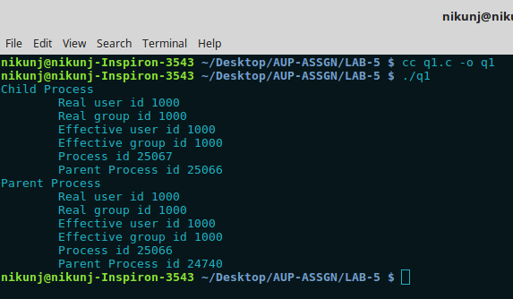

As it can be seen from the execution of the above program that
Real UserID, Real Group Id, Effective UserId, Effective GroupID is inherited by the child process
But the process Id and ParentProcessId aren’t.

Question 2)
Verify whether it is possible for a child process to handle a file opened by its parent Immediately after the fork() call?

Code:
#include <stdio.h>
#include <unistd.h>
#include <sys/types.h>
#include <sys/stat.h>
#include <sys/wait.h>
#include <fcntl.h>

int main() {
pid_t child;
int fd1, fd2, status;
char c[] = "This was written from the parent process\n";
if((fd1 = open("filefork_test1.txt", O_WRONLY | O_CREAT, S_IRUSR |
S_IWUSR | S_IRGRP | S_IWGRP | S_IROTH)) == -1) {
perror("filefork.c: Error while opening file");
return 1;
}
if((write(fd1, c, sizeof(c))) == -1) {
perror("filefork.c: Error while writing to file");
return 1;
}
if((child = fork()) < 0) {
perror("filefork.c: Error while forking");
return 1;
}
if(child == 0) {
char d[] = "This was written from the child process\n";
sleep(3);
if((write(fd1, d, sizeof(d))) == -1) {
perror("filefork.c: Error while writing from child process");
return 1;
}
if((write(fd2, d, sizeof(d))) == -1) {
perror("filefork.c: Error while writing from child process");
return 1;
}
return 0;
}
else {
if((fd2 = open("filefork_test2.txt", O_WRONLY | O_CREAT, S_IRUSR | S_IWUSR | S_IRGRP | S_IWGRP | S_IROTH)) == -1) {
perror("filefork.c: Error while opening file");
return 1;
}
if((write(fd2, c, sizeof(c))) == -1) {
perror("filefork.c: Error while writing to file");
return 1;
}
wait(&status);
close(fd1);
close(fd2);
if(status > 0) {
printf("filefork.c: Some error occured. Please refer logs above\n");
return 1;
}
else {
return 0;
}
}
return 0;
}

Execution:

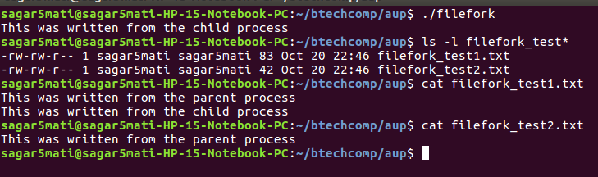
Conclusion:

A child process is passed all the open file descriptors from its parent. Therefore any files opened by the parent process before calling fork can be accessed by the child as well. This is evident from the file filefork_test1.txt.
After the parent has called fork if it opens any file then this data is not shared by the child so it cannot these files. This can be seen by the behaviour of the filefork_test2.txt file and stdout.

Question 3)
The parent starts as many child processes as to the value of its integer command line argument. The child processes simply sleep for the time specified by the argument, then exit. After starting all the children, the parent process must wait until they have all terminated before terminating itself.

Code:
#include < stdio.h>
#include <ctype.h>
#include <sys/types.h>
#include <sys/wait.h>
#include <unistd.h>
#include <limits.h>
int charToInt(char *str) {
int result = 0, count = 0;
while(str[count]) {
if(isdigit(str[count])) {
result = result * 10 + (str[count] - '0');
}
else {
return INT_MIN;
}
count++;
}
return result;
}
int main(int argc, char *argv[]) {
if(argc < 3) {
printf("Arguments not valid\n");
return 1;
}
int children_, sleep_, count, pid;
children_ = charToInt(argv[1]);
sleep_ = charToInt(argv[2]);
if(children_ == INT_MIN || sleep_ == INT_MIN) {
printf("Incorrect arguments\n");
return 1;
}
for(count = 0; count < children_; count++) {
pid = fork();
if(!pid) {
break;
}
}
if(!pid) {
sleep(sleep_);
printf("Child %d terminated \n", count + 1);
}
else {
while(wait(NULL) > 0);
printf("Parent terminated\n");
}
return 0;
}
Execution:
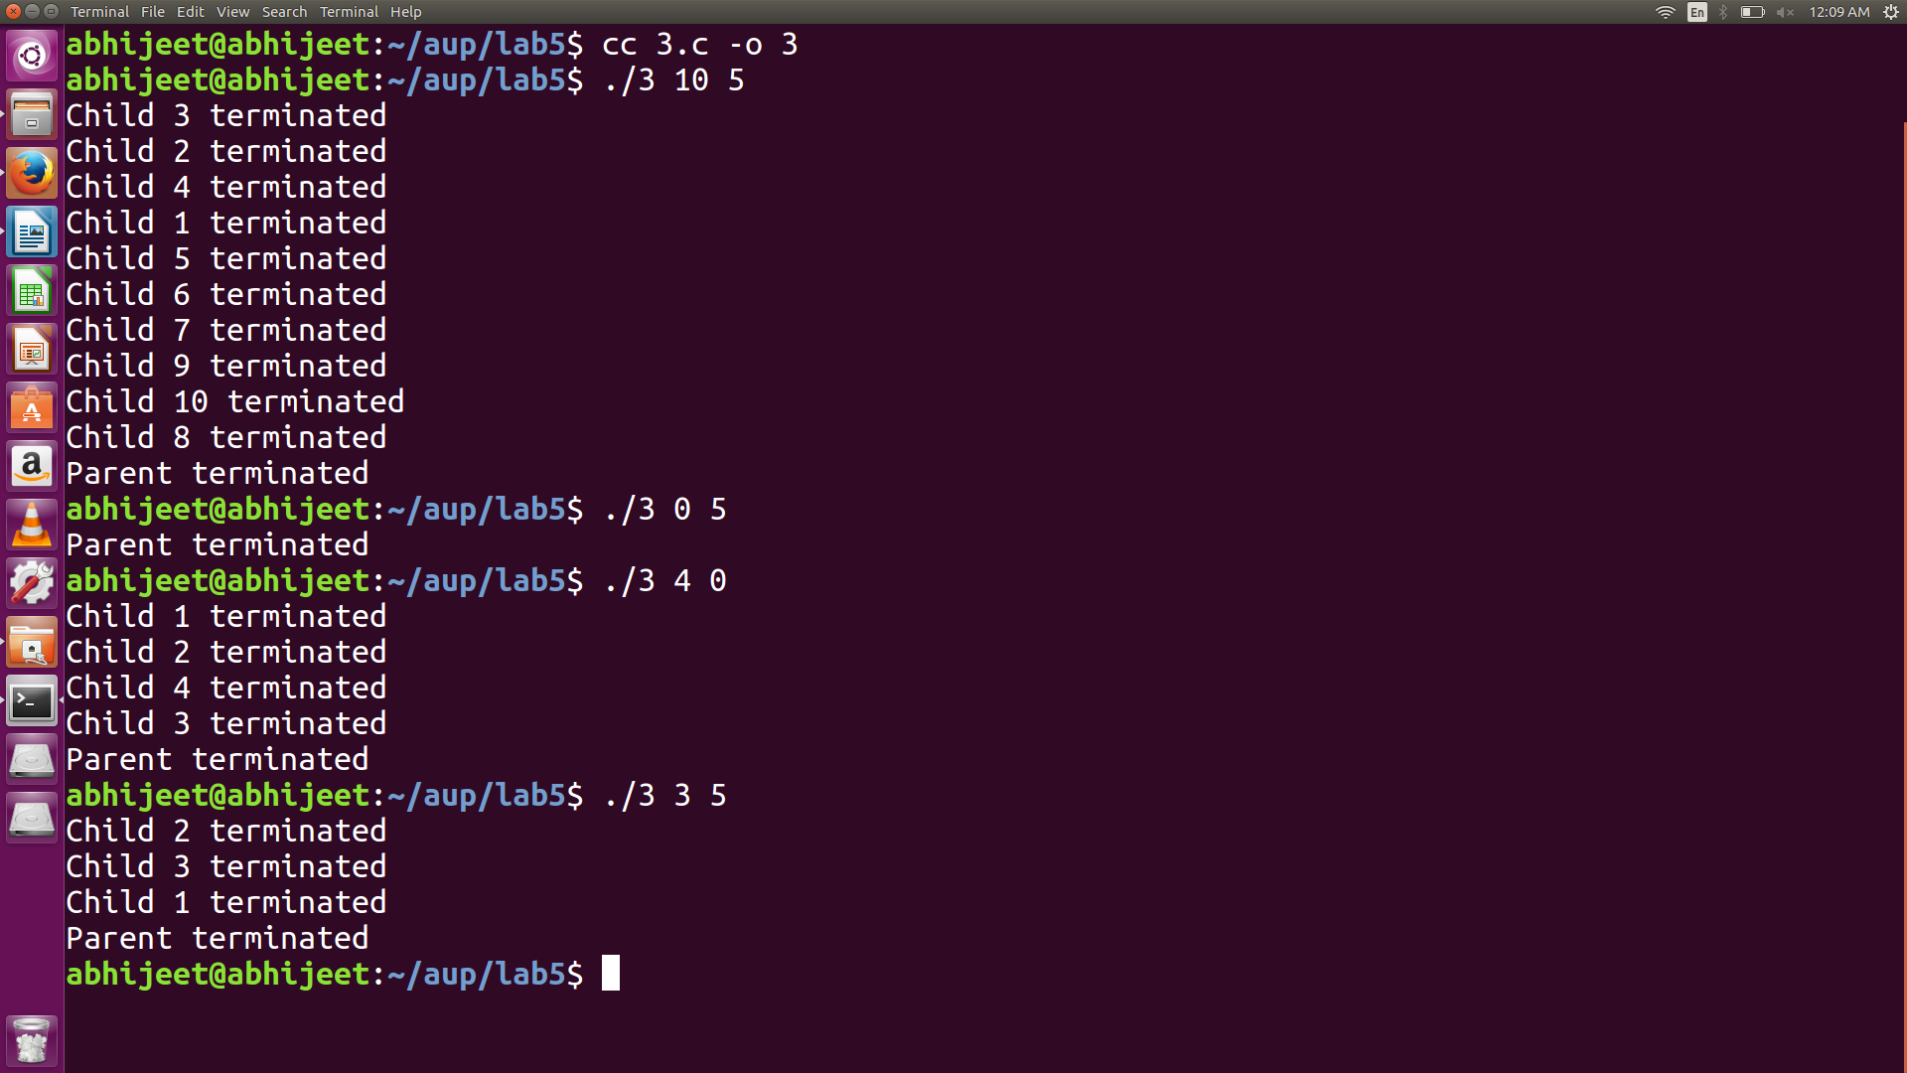
Number of child processes to be forked is sent in as the first argument to the program and the time to sleep for the processes as the second argument. As you can see the parent waits in a while loop until all the processes are over.

