Q1)
A pipe setup is given below that involves three processes. P is the parent process, and C1 and C2 are child processes, spawned from P. The pipes are named p1, p2, p3, and p4. Write a program that establishes the necessary pipe connections, setups, and carries out the reading/writing of the text in the indicated directions.

Figure :
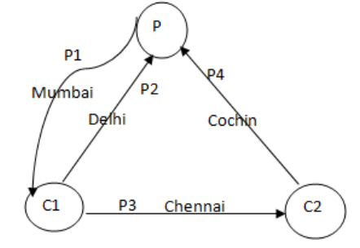

Code :

#include <stdio.h>
#include <unistd.h>
#define MAXLINE 1024

int main() {
int p1[2], p2[2], p3[2], p4[2], n;
pid_t pid;
char line[MAXLINE];

if(pipe(p1) < 0) {
printf("Pipe 1 creation failed\n");
return -1;
}
if(pipe(p2) < 0) {
printf("Pipe 2 creation failed\n");
return -1;
}
if(pipe(p3) < 0) {
printf("Pipe 3 creation failed\n");
return -1;
}
if(pipe(p4) < 0) {
printf("Pipe 4 creation failed\n");
return -1;
}

if((pid = fork()) > 0) {
if(fork() > 0) {
// Parent p
close(p1[0]);
close(p2[1]);
close(p4[1]);
write(p1[1], "Mumbai", 6);
n = read(p2[0], line, sizeof(line));
printf("Reading at parent from pipe 2 %s\n", line);
n = read(p4[0], line, sizeof(line));
printf("Reading at parent from pipe 4 %s\n", line);
}
else {
// Child c2
close(p4[0]);
close(p3[1]);
write(p4[1], "Cochin", 6);
n = read(p3[0], line, sizeof(line));
printf("Reading at c2 from pipe 3 %s\n", line);
}
}
else if(pid == 0) {
// Child c1
close(p1[1]);
close(p2[0]);
close(p3[0]);H
write(p2[1], "Delhi", 5);
write(p3[1], "Chennai", 7);
n = read(p1[0], line, sizeof(line));
printf("Reading at c1 from pipe 1 %s\n", line);
}
else if(pid < 0) {
printf("Fork Failed\n");
return -1;
}
return 0;
}

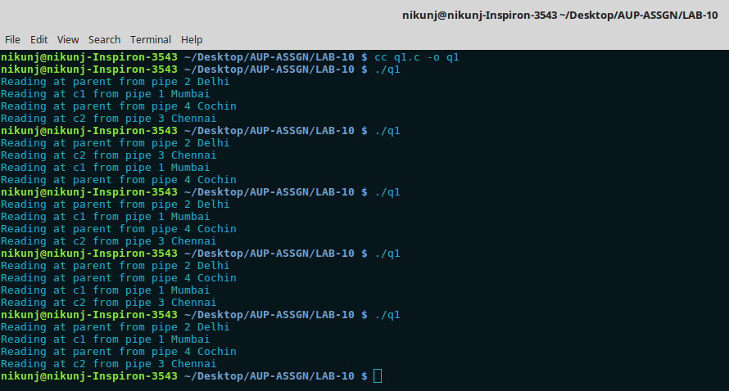
Execution :

Here p1, p2, p3, p4 are four pipes. P is the parent process. C1 and C2 are the child process spawned from P. Pipe has been created using pipe() function. p1[0] indicates the read descriptor and p1[1] indicates the write decriptor. Here the ends of the pipes are closed according to the flow of data.
The read and write system calls are used and data is written as given in the figure between the processes through the pipes.

