**Abstract**

Finite Element Analysis (FEA) is a cornerstone of structural engineering but remains computationally prohibitive for applications requiring rapid design iteration. Deep learning-based surrogate models offer a promising alternative, yet selecting the optimal architecture and ensuring physical plausibility remains a challenge. This paper presents a comprehensive evaluation of graph neural network (GNN) and convolutional architectures as surrogates for FEA of parametric I-beam structures. We systematically compare the performance of GCN, GAT, Message Passing Neural Networks (MPNN), and Graph Transformers against a 3D U-Net on both specialized (unimodal) and generalized (multimodal) load scenarios under varying signal strengths. A key contribution of our work is the successful integration of physical constraints through a Physics-Informed Neural Network (PINN) framework based on the Navier-Cauchy equations. We demonstrate that a curriculum learning strategy, involving fine-tuning a pre-trained data-only model with a gradually annealed physics loss, is critical for stabilizing PINN training and achieving convergence. Our results show that the MPNN and Graph Transformer architectures significantly outperform simpler GNNs and the U-Net. Furthermore, the PINN-enhanced models exhibit superior generalization, achieving a lower Relative L2 Error and a higher R² Score compared to their purely data-driven counterparts. While the Graph Transformer yields the highest accuracy, we identify the MPNN-PINN as the most practical solution, offering an optimal balance between predictive performance, model size, and inference speed.

**1. Introduction**

Finite Element Analysis (FEA) is an indispensable tool in modern engineering, providing high-fidelity simulations for the design and analysis of complex mechanical systems. Despite its power, the computational cost of FEA remains a significant bottleneck, particularly in applications requiring numerous sequential simulations, such as design optimization, uncertainty quantification, and the development of real-time digital twins. This computational demand often restricts engineers to simplified models or limits the exploration of the design space, creating a need for computationally efficient, high-accuracy alternatives.

To mitigate these costs, the engineering community has historically relied on techniques such as Reduced-Order Models (ROMs), most notably those based on Proper Orthogonal Decomposition (POD), as well as response surface methodologies and Kriging. These methods seek to project the high-dimensional solution space onto a low-dimensional manifold, allowing for rapid approximation of new solutions. However, despite their success in certain domains, traditional ROMs have notable limitations. Many are based on a linear subspace assumption, which limits their effectiveness for highly non-linear phenomena. Furthermore, methods like POD-Galerkin are often "intrusive," requiring modification of the underlying solver code, which is impractical for commercial FEA software. These methods can also struggle to generalize to designs that lie far from the initial training data and can be challenged by high-dimensional parameter spaces.

These limitations have motivated the search for more flexible, non-linear, and non-intrusive methods, creating a fertile ground for the application of deep learning. Deep learning-based surrogate models have emerged as a promising solution, learning to approximate the input-output mapping of expensive simulators with inference times that are orders of magnitude faster. For problems in structural mechanics, which are naturally defined on unstructured meshes, Graph Neural Networks (GNNs) offer a particularly powerful inductive bias. By representing the FEA mesh as a graph, GNNs can leverage the inherent topology of the structure, allowing for a more natural and efficient learning of physical phenomena like stress and strain propagation compared to grid-based methods like Convolutional Neural Networks (CNNs).

However, the development of robust surrogate models is not without its challenges. Purely data-driven models may struggle to generalize to out-of-distribution scenarios and can produce physically implausible results, as they lack any intrinsic understanding of the system's governing laws. Physics-Informed Neural Networks (PINNs) offer a compelling solution by embedding the governing partial differential equations (PDEs) directly into the neural network's loss function. This approach acts as a strong regularizer, guiding the model toward solutions that are not only accurate with respect to the training data but are also consistent with fundamental physical principles.

This paper presents a comprehensive investigation into the development of GNN-based surrogate models for accelerating FEA of I-beam structures, with a specific focus on the enhancement of these models with a PINN framework. Our key contributions are:

1. **A rigorous architectural comparison:** We provide a systematic evaluation of multiple GNN architectures (GCN, GAT, MPNN, Graph Transformer) against a 3D U-Net baseline on both specialized (unimodal) and generalized (multimodal) load scenarios.
2. **Successful PINN implementation for structural mechanics:** We demonstrate the successful integration of the Navier-Cauchy equations for linear elasticity into the GNN training process to measurably improve model generalization.
3. **A robust PINN training strategy:** We introduce and validate a curriculum learning approach with loss weight annealing, proving it is a critical strategy for stabilizing the training of PINN models and ensuring their convergence.
4. **A practical performance-efficiency analysis:** We identify the Graph Transformer as the most accurate architecture, but highlight the PINN-enhanced MPNN (MPNN-PINN) as the superior solution for practical deployment, offering an optimal balance of predictive accuracy, model size, and inference speed.

**2. Related Work**

Our research is situated at the intersection of deep learning for physical simulation, mesh-based Graph Neural Networks, and Physics-Informed Machine Learning.

2.1. Deep Learning Surrogates for Physical Simulation  
The use of deep learning to accelerate physical simulations has become an active and fruitful area of research.[[1](https://www.google.com/url?sa=E&q=https%3A%2F%2Fvertexaisearch.cloud.google.com%2Fgrounding-api-redirect%2FAUZIYQG_SMzfHlwN2HF44vkddkMswNSVatYEPRe7ORl9fnCydZYWhVlgNyEUUhD6JnR7UJvD92IyJVLSvuZUyyOixdTmzEGj2vdpkCnps4cqcSPRo7Jorbq1N28uiCJe4BloibcbWRxN)][[2](https://www.google.com/url?sa=E&q=https%3A%2F%2Fvertexaisearch.cloud.google.com%2Fgrounding-api-redirect%2FAUZIYQEtmdLOoQBnYQW2RSc4dN8bT2RwMJ1bpJhhAtvQryuVEr847I3Bet8aLSIE9vLDxs2nKP7qm8omOfBMEv7vYM_bf4BzXVhlMiMXZ1lT0WehJPrXPwIXeyUZzYjc)] Initial approaches often utilized standard architectures like Multi-Layer Perceptrons (MLPs) for low-dimensional parameter spaces or Convolutional Neural Networks (CNNs) for problems defined on regular, grid-like domains, such as in computational fluid dynamics.[[1](https://www.google.com/url?sa=E&q=https%3A%2F%2Fvertexaisearch.cloud.google.com%2Fgrounding-api-redirect%2FAUZIYQG_SMzfHlwN2HF44vkddkMswNSVatYEPRe7ORl9fnCydZYWhVlgNyEUUhD6JnR7UJvD92IyJVLSvuZUyyOixdTmzEGj2vdpkCnps4cqcSPRo7Jorbq1N28uiCJe4BloibcbWRxN)] However, for many engineering disciplines, particularly in computational solid mechanics, simulations are performed on unstructured meshes to accurately represent complex geometries.[[3](https://www.google.com/url?sa=E&q=https%3A%2F%2Fvertexaisearch.cloud.google.com%2Fgrounding-api-redirect%2FAUZIYQE0zc0VtenmpEbYaUBA7juehWZGAMk2yQuG8jLB541DAbKoLqs78sfPyF67wbu9aeHU1FhgkspVH6E9xeVmHFZRJ0unniWfrwc1k9GOs62ryOApWXYq6LvifIQMvIcWHftMyAdbuX45FHVqUj4CKgycbXPHp3s%3D)] This has led to the development of specialized architectures capable of operating on such irregular domains.

**2.2. Mesh-Based Graph Neural Networks in Mechanics**  
Graph Neural Networks have recently emerged as a natural and powerful framework for learning on mesh-based data.[[3](https://www.google.com/url?sa=E&q=https%3A%2F%2Fvertexaisearch.cloud.google.com%2Fgrounding-api-redirect%2FAUZIYQE0zc0VtenmpEbYaUBA7juehWZGAMk2yQuG8jLB541DAbKoLqs78sfPyF67wbu9aeHU1FhgkspVH6E9xeVmHFZRJ0unniWfrwc1k9GOs62ryOApWXYq6LvifIQMvIcWHftMyAdbuX45FHVqUj4CKgycbXPHp3s%3D)] Since an FEA mesh can be directly interpreted as a graph—with simulation nodes as graph nodes and the elements defining their connectivity as edges—GNNs can directly leverage the problem's topology. The core mechanism of GNNs, message passing, conceptually mirrors the physical process of information propagation between connected nodes in a structure. Foundational work by Pfaff et al. introduced MeshGraphNets, demonstrating the ability of GNNs to accurately simulate a wide variety of physical systems defined on unstructured meshes.[[4](https://www.google.com/url?sa=E&q=https%3A%2F%2Fvertexaisearch.cloud.google.com%2Fgrounding-api-redirect%2FAUZIYQF2jEkP7RLsneU7SnzTwuQQznsc1oF39XXl4U-lvcRUet84nu6-4TlCJszQIIoF-oyFIIFxTlLu9-x2SZ49xbku_x5nYM5pEzNEBHVRISw1hzuoFPQxnyuOGiVGpDucgmR3hEfRcZWe9g%3D%3D)][[5](https://www.google.com/url?sa=E&q=https%3A%2F%2Fvertexaisearch.cloud.google.com%2Fgrounding-api-redirect%2FAUZIYQFPF0031Sboa3-1S6B2B-rJdKAvctQc21PvOp1tIWEztl1sTjRaJM_ylj_xmT0C-rC0s9dfG2RH6lfag6T4pWVuwbbjSfN_ZmRsNKTYqzNsCORMXl4RO33RyQtvaptgc3MiyT3F476hIV-H4ymSyJPWu7HA6j5QaZjL4s4J5VsZY8fr30bOPB3ZC5202pvtoxzIXm-qeGsC_Ql-VlxaQeVzPjq3-1SjPeB5Qg1PhLWv-EFjTkuNIY9kOECCEiFhJ6V3QgRpfzQNSUUBqZEr)][[6](https://www.google.com/url?sa=E&q=https%3A%2F%2Fvertexaisearch.cloud.google.com%2Fgrounding-api-redirect%2FAUZIYQHZV_cXi5rlqsq55WvSEgTkFBaf_KO3Xyg5v_WOzkjbOnNsB1OLtZDBuOGKguE3CGZSg4XxJvEwBDzFA1qQFbGmIioG4hDFiPyfiiDgDaFfhCk5Fmx80hGj3OT0)][[7](https://www.google.com/url?sa=E&q=https%3A%2F%2Fvertexaisearch.cloud.google.com%2Fgrounding-api-redirect%2FAUZIYQHSVlzaVKW9WDEAM5cdd4ocoPfOm5tK4WOPBDmrSAQkznwRYXdOI8Z6XEzuPOoEmKMFZmGCLEk8AibPYQ5iObkPP4z02ed2QKm8Xy8cdEzBFfIS_HAMV7gtgsDXrZH9STmc6usqAQ%3D%3D)][[8](https://www.google.com/url?sa=E&q=https%3A%2F%2Fvertexaisearch.cloud.google.com%2Fgrounding-api-redirect%2FAUZIYQFHJxhqY8jdgKiWMRO76dt6e1vd6JUIo808rPGDof-ijdGYMv_6-bKKUL4QgdH467K0euY63b_jIylcSrPoEeDkQdgeAJ5J-qXrqPL6X8Y-1XC3Thrt-VmThVReFsE2i76esoP0qyM8lVPJMB5FMU2EH-jfds4kak2_irDweYIyk-gF40AbPrY1e5WnSqRFkbMePFo0o1cbZAqH_ab4evpsFA%3D%3D)] While these works establish the viability of GNNs, a systematic comparison of different GNN architectures (from simple GCNs to expressive Transformers) on complex, multi-modal structural mechanics tasks is less explored. Our work contributes a rigorous, comparative study to identify the most effective architectures for this domain.

**2.3. Physics-Informed Neural Networks (PINNs)**  
The concept of embedding physical laws into neural networks was formalized by Raissi, Perdikaris, and Karniadakis, who introduced Physics-Informed Neural Networks (PINNs).[[9](https://www.google.com/url?sa=E&q=https%3A%2F%2Fvertexaisearch.cloud.google.com%2Fgrounding-api-redirect%2FAUZIYQFhX3Z_Cgp87BuBLLiZmdH9SbBZE-jB2tdmb95qAnMyB0IP54vLj7XI6ZEs_QvqPcYTaeg5ZbiRDbIfONXI2Vnls22EI26Lpf5haE7TBxwpJt34H_n_GujuPqphhIkfpirHQRWN)][[10](https://www.google.com/url?sa=E&q=https%3A%2F%2Fvertexaisearch.cloud.google.com%2Fgrounding-api-redirect%2FAUZIYQE4cxcUcEZb4Oo0HJa1qOLJX9OmZVICISXGfmFuiq8Q_4fn0oJ-m7JxWYibxjxLIMCkCCku-n7bFD86j0pbOY9Yj9rRBoWhg913JoSxfC76nnP5VSDePYeuLRgt-Jax_hUIX5-uR6yZii8%3D)][[11](https://www.google.com/url?sa=E&q=https%3A%2F%2Fvertexaisearch.cloud.google.com%2Fgrounding-api-redirect%2FAUZIYQGYmAIWoE15rMnmeLm7KjL_1JR6bQD5WzEQG_3ai9p3KKh4BscjqVoKpo965fAZAMoAnXdZXowYDlk6J5DfBABW72VzRkk0VCyytczbtYmuzAHrSZyewuzPnP8CSWvMUvSwbvCWhVG0U7VCK6NHQwzYysBl2oGjI0lkidDrN3lkNwQfa0CMja4laMRW_ete-WQKKqe48Fts7h-eFSzu1vkTnXOpiVo82kRD8j5Lk0WpH5qfbg9XTbxbxdLk67lk5YvhdNUKlNp0G6uY3ptpW1vgH4Nip-rIBt6T1RiWGw2FFWQv3eUgJkBTZUS3sGArPol5lyLPahFiESye3sPjsFFZ-HPT8DM%3D)][[12](https://www.google.com/url?sa=E&q=https%3A%2F%2Fvertexaisearch.cloud.google.com%2Fgrounding-api-redirect%2FAUZIYQHFekI_em_uG0N0M6jH1yazSJtpAyqPdgZosrB_uqnYWw1603kZfUnx9G-P1QE0M6NKMSs3kTBEOfCKQEPHs5tvPOvpKDK_YDMD2cfpb-Lf_5fFgTe-tBINYWAxDafeZxs%3D)] PINNs augment the standard data-driven loss function with a second term that penalizes deviations from the governing Partial Differential Equations (PDEs). This physics-based loss is calculated on a set of collocation points and is typically evaluated using automatic differentiation to compute the necessary derivatives. By training to minimize this composite loss, the network is constrained to learn solutions that are physically consistent.[[13](https://www.google.com/url?sa=E&q=https%3A%2F%2Fvertexaisearch.cloud.google.com%2Fgrounding-api-redirect%2FAUZIYQHkmlE-w6uOXoOe9ixQX6SrxAJFWSzjrI9-Q-xTHLRG0JmIxE9Q0gHwcPUD_h77_apwMjYQhsqDc_r0QSs0TSo5SgIo8mZ-E_lDFvCffR9EPXotPqJL3TeGwd_irAG0bUYuEbVZ7TsZhDhcxwVWBTQSendJ7fpMzf5HVsp4V2oaaBUH6H_lU70N24FU_mdvCWPexln6uJF_1-YtUUtdtAEcsL0v)] Our work applies this paradigm not to solve the PDE from scratch, but as a physics-based regularizer to improve the generalization of an already powerful data-driven GNN surrogate.

**2.4. Challenges and Advances in PINN Training**  
Despite their potential, training PINNs can be notoriously challenging, often suffering from instability or slow convergence. A key difficulty lies in balancing the gradients from the data-driven loss and the various terms of the physics-based loss, particularly those involving high-order derivatives. To address this, several advanced training strategies have been proposed, including adaptive weighting schemes and curriculum learning.[[14](https://www.google.com/url?sa=E&q=https%3A%2F%2Fvertexaisearch.cloud.google.com%2Fgrounding-api-redirect%2FAUZIYQGh1MBvVXcsBn8ziBQNI5qbYCyZDcdCWSfuU5_2MRBSjH8pNNwABqcVr_1-0u8r8OvhyRkY7DLZ3euoRbvod5_uoNBLjLe8zuFMjngt5BrXOBSFf_UcaWo5F1xyMMCx543yauCVCsfJE5ajEsnMFRIdNb-v)][[15](https://www.google.com/url?sa=E&q=https%3A%2F%2Fvertexaisearch.cloud.google.com%2Fgrounding-api-redirect%2FAUZIYQGR6NSgTOGeYMMOiMGbC2igaubDvFWK9jfuNYcIb2Ur0BdiBtrv9m-JHhR765iJuTCIRxz6Z9yT_-t-4ZCenBQe4o6UvK_QpsVxTYj0XvKhhmSWCU2sjor1NljeQ-OQn2MnqZETUGtoXEY9Zba5eSxpDMFohzBFGBmNLKLhXOtyxD3iYEwS3Q%3D%3D)] Curriculum learning, where the model is exposed to progressively harder tasks, is particularly promising.[[14](https://www.google.com/url?sa=E&q=https%3A%2F%2Fvertexaisearch.cloud.google.com%2Fgrounding-api-redirect%2FAUZIYQGh1MBvVXcsBn8ziBQNI5qbYCyZDcdCWSfuU5_2MRBSjH8pNNwABqcVr_1-0u8r8OvhyRkY7DLZ3euoRbvod5_uoNBLjLe8zuFMjngt5BrXOBSFf_UcaWo5F1xyMMCx543yauCVCsfJE5ajEsnMFRIdNb-v)][[16](https://www.google.com/url?sa=E&q=https%3A%2F%2Fvertexaisearch.cloud.google.com%2Fgrounding-api-redirect%2FAUZIYQFk-cfCTLdnnoO0cfoSiFTFqT2w0Y94fpIOoLcq6mBBtI01abLkh7Jo7xhnGnuqKwsPyk92zrevFRdg94nVW6F1EP8StPNy9w_6cEYVSR7hco87GOABKhhqcxJa)] Our work contributes to this area by demonstrating a specific, robust curriculum strategy—pre-training and fine-tuning with loss weight annealing—and proving its necessity and effectiveness for stabilizing the training of a GNN-based PINN for a complex structural mechanics problem.

**3. Methodology**

3.1. Problem Formulation and Data Generation

The foundation of any surrogate modeling task is a comprehensive and well-structured dataset. We developed a robust data generation pipeline to simulate a parametric I-beam, a ubiquitous structural element in civil and mechanical engineering. The I-beam was chosen as it represents a canonical yet non-trivial problem: its geometry is simple enough to be parameterized efficiently, but its anisotropic bending stiffness presents a meaningful challenge for learning models. All ground truth data was generated using a high-fidelity Finite Element Analysis (FEA) pipeline built with the open-source gmsh mesh generator and the dolfinx finite element solver.

Parametric Design Space and Mesh Consistency:  
To ensure the surrogate models can generalize, we defined a multi-dimensional parameter space encompassing geometric properties, material characteristics, and loading conditions (detailed in Table 1). These parameters were sampled using Latin Hypercube Sampling (LHS) to ensure an efficient and uniform exploration of the space.

A critical decision in our data generation strategy was to maintain a consistent mesh topology and element size across all 2500 simulations. While the node coordinates were updated to reflect changes in the beam's geometric parameters (e.g., flange width, beam depth), the number of nodes and their connectivity (i.e., the graph structure) remained constant. This approach was chosen to isolate the learning task to the underlying physics, forcing the models to learn the effects of changing geometric, material, and load parameters without the confounding variable of a changing mesh discretization. This ensures a consistent basis for comparison across all models, particularly the GNNs which operate directly on this graph structure.

*Table 1: Parametric space for the I-beam FEA simulations.*

|  |  |  |  |
| --- | --- | --- | --- |
| **Parameter** | **Description** | **Type** | **Range / Values** |
| Beam Length | The length of the beam along the Z-axis. | Continuous | 280.0 – 320.0 mm |
| Flange Width | The total width of the top and bottom flanges. | Continuous | 90.0 – 110.0 mm |
| Flange Thickness | The thickness of the flanges. | Continuous | 13.0 – 17.0 mm |
| Web Thickness | The thickness of the central vertical web. | Continuous | 8.0 – 12.0 mm |
| Beam Depth | The total height of the I-beam. | Continuous | 140.0 – 160.0 mm |
| Fillet Radius | The radius of the fillets at the web-flange junctions. | Continuous | 10.0 – 14.0 mm |
| Youngs Modulus | The Young's Modulus of the material (variations of steel). | Continuous | GPa |
| Poisons ratio | The Poisson's Ratio of the material. | Continuous | 0.28 – 0.32 |
| Force Magnitude | The total magnitude of the force applied to the free end. | Continuous | kN |
| Load Type | The nature of the applied load. | Categorical | Bending y, bending x, torsion |
| Load Distribution | The spatial distribution of the applied load. | Categorical | Uniform, Linear Y |

**Boundary and Loading Conditions:**  
The simulations model a cantilever beam configuration, as depicted in Figure 1. One end of the beam (at Z=0) is fully fixed, representing a clamped boundary condition. A distributed traction force is applied to the surface at the free end (at Z=L). The nature of this force is determined by the load type parameter: bending Y (vertical), bending X (horizontal), or torsion (twisting moment).

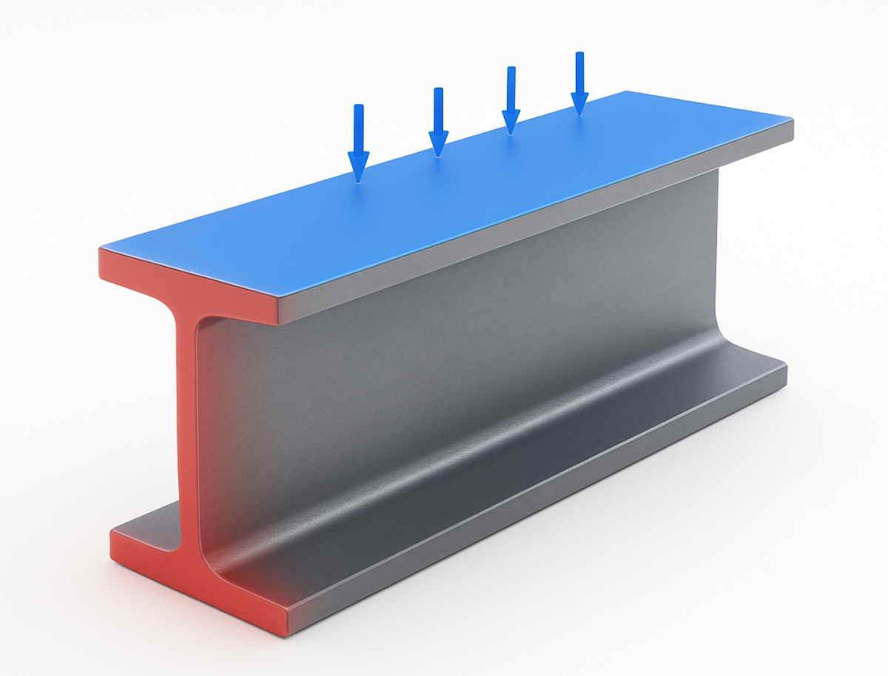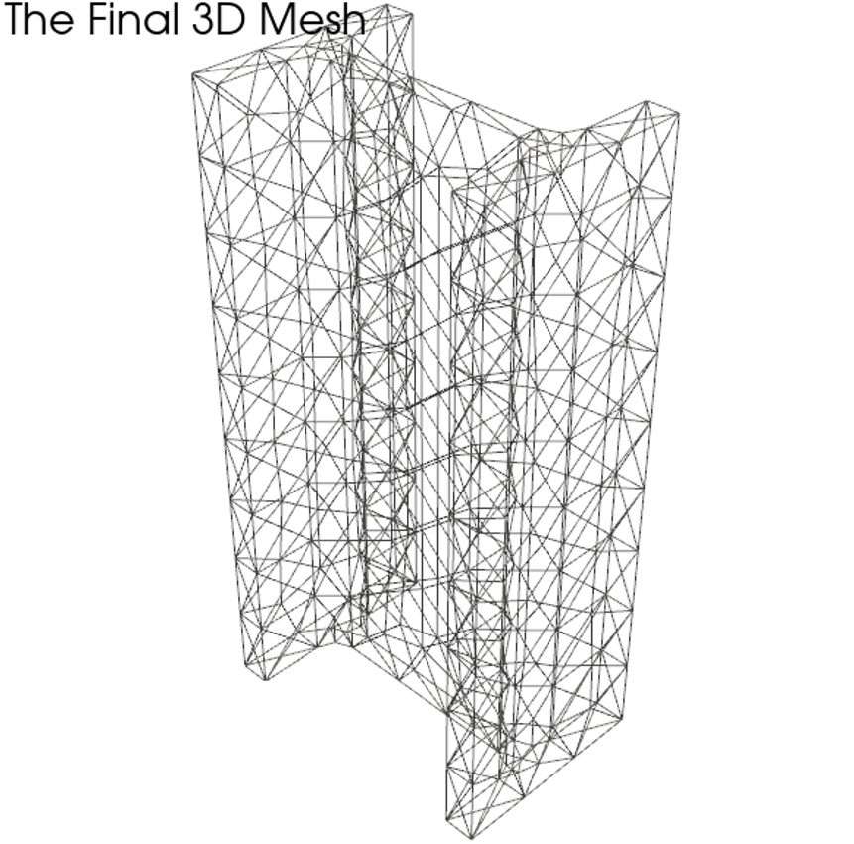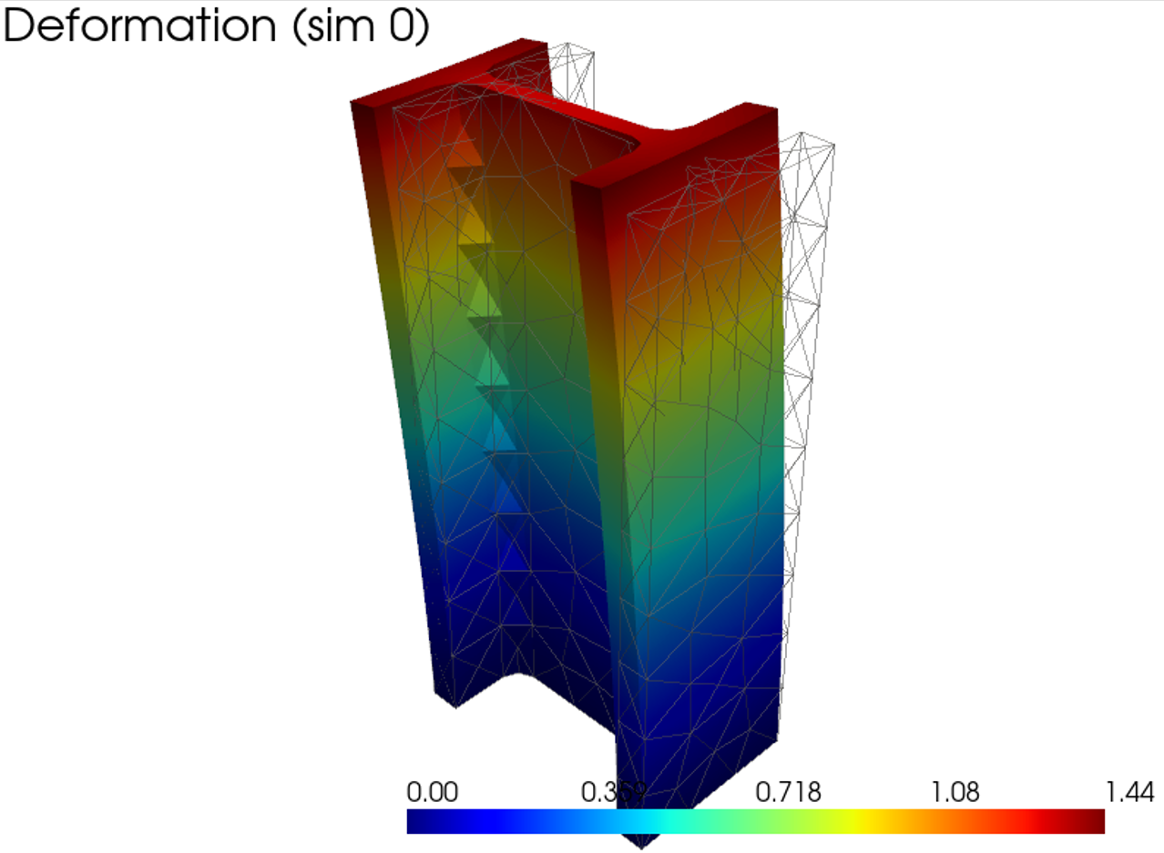

***Figure 1: FEA Problem Formulation and Sample Data.***

*(a) The I-beam geometry with boundary conditions, showing the fixed surface (red) and the load application surface (blue). (b) A visualization of the unstructured tetrahedral mesh used for the FEA simulations. (c) A sample ground truth displacement field for a bending Y load case from the High Signal dataset, showing the magnitude of displacement.*

**Dataset Generation: Low Signal vs. High Signal Regimes:**  
A key hypothesis of this work is that a model's performance is highly dependent on the "signal strength" of the physical response in the training data. A high-magnitude force produces large, clear deformations (a "high signal"), making the relationship between inputs and outputs easier to learn. Conversely, a low-magnitude force produces subtler deformations (a "low signal"), which can be more challenging for a network to learn accurately. To investigate this, we generated two distinct datasets:

1. **Low Signal Dataset:** A set of **1500 simulations** generated with force magnitude sampled from a lower range of **[50,000 N to 100,000 N]**. This dataset contains a random mixture of all three load types (bending Y, bending X, and torsion) and represents a scenario with subtle physical responses.
2. **High Signal Dataset:** A second, distinct set of **1000 simulations** generated with force magnitude sampled from a significantly higher range of **[200,000 N to 250,000 N]**. This dataset was generated **exclusively for the bending Y load case** and represents a scenario where the input-output relationship is much more pronounced.

**Task Formulation:** These two datasets allow us to formulate three distinct and progressively challenging learning tasks, which correspond directly to the model evaluations presented in our results:

* **Generalist (Low Signal) Task:** A single model is trained on the complete 1500-sample **Low Signal Dataset**. This is the most complex task, as the model must learn to generalize across three qualitatively different physical responses (bending Y, bending X, torsion /twisting) under challenging low signal conditions.
* **Specialist (Low Signal) Task:** A model is trained *only* on the subset of the **Low Signal Dataset** corresponding to the bending Y load case. This task assesses the model's ability to learn a single, specialized physical response under the same low-signal conditions.
* **Specialist (High Signal) Task:** A model is trained *only* on the 1000-sample **High Signal Dataset**. This task evaluates the model's performance on the same specialized bending Y task but under ideal high-signal conditions, providing a benchmark for the best possible performance on this specific load case.

Each simulation was run to completion, and the full field data—including node coordinates, element topology, and the resulting displacement field—was saved to a dedicated HDF5 (.h5) file. This collection serves as the primary ground truth dataset.

**3.2. Data Representation and Preprocessing**

The output of the FEA solver is a high-dimensional field representing physical quantities such as displacement and stress. We chose to represent these fields by storing their pointwise values at each node of the simulation mesh. This approach was selected as it preserves the maximum possible fidelity of the simulation output, directly corresponding to the degrees of freedom solved for in the FEA process. Alternatives, such as storing element-wise averages, would result in a loss of resolution, while representations based on basis functions would introduce an additional layer of approximation. All geometric and field data were defined and stored using a standard 3D Cartesian coordinate system (X, Y, Z), which naturally aligns with the principal axes of the I-beam geometry.

While the unstructured HDF5 data is directly suitable for GNNs, the grid-based 3D U-Net architecture requires a structured, voxelized input. To accommodate this, we implemented a dedicated preprocessing pipeline to convert the unstructured data into a uniform grid representation, generating a corresponding compressed NumPy (.npz) file for each simulation. This process involves:

1. Grid Definition: To analyze the impact of input resolution on performance, we defined two distinct Cartesian grids: a low-resolution grid of 64x32x32 and a high-resolution grid of 96x48x48 voxels (Z, Y, X). A single, consistent bounding box was used for all simulations to ensure spatial alignment.
2. Field Interpolation: The unstructured displacement vectors were interpolated onto these regular grids using trilinear interpolation, resulting in a 3-channel (dx, dy, dz) tensor. Voxels outside the convex hull of the original mesh were assigned a fill value of zero.
3. Geometry Mask Creation: A binary geometry mask was created using nearest-neighbour interpolation to inform the U-Net of the beam's location within the voxel space.

To ensure stable and efficient training, all input and output data were normalized. Deep learning models are sensitive to the scale of input features; without normalization, large-valued parameters (like Young's Modulus) could dominate the learning process and lead to unstable gradients. Similarly, normalizing the target output field sets an appropriate scale for the loss function. To this end, all scalar input parameters and the output displacement fields were scaled to a range of approximately [-1, 1] using min-max scaling, based on the global minimum and maximum values observed across the entire training dataset. The same scaling factors were stored and used to apply the inverse transformation during inference to return model predictions to their original physical units.

**3.3. Model Architectures**

To systematically evaluate the most effective approach for learning FEA surrogates, we implemented and compared two distinct classes of neural network architectures: grid-based Convolutional Neural Networks (CNNs) and mesh-based Graph Neural Networks (GNNs). Each class contains several variants to allow for a thorough analysis of performance, efficiency, and the impact of specific architectural features.

**3.3.1. Grid-Based Architecture: 3D U-Net**

To provide a strong baseline from the convolutional domain, we adapted the U-Net architecture to our 3D regression problem. The U-Net's encoder-decoder structure with skip connections, illustrated in **Figure 2**, is well-suited for capturing both local features and global context, which is essential for predicting a full displacement field.

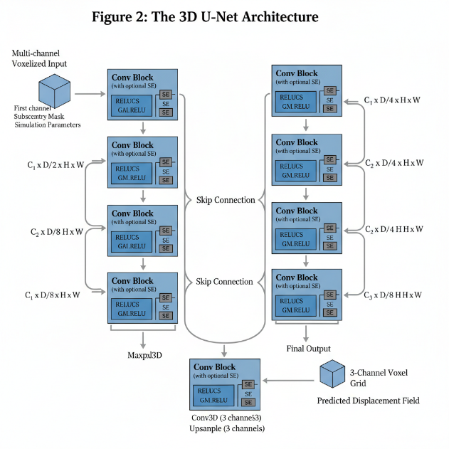

**Figure 2: The 3D U-Net Architecture.** The model takes a multi-channel voxelized input, where the first channel is the geometry mask and subsequent channels are broadcasted simulation parameters. The encoder (left) progressively downsamples the spatial resolution while increasing feature depth. The decoder (right) symmetrically upsamples the features, using skip connections (grey arrows) to re-introduce high-resolution information from the encoder path. Optional Squeeze-and-Excitation (SE) blocks provide channel-wise attention within each convolutional block. The final output is a 3-channel voxel grid representing the predicted displacement field.

* **Core Architecture:** As shown in Figure 2, our 3D U-Net consists of a contracting path (encoder) and an expansive path (decoder). Skip connections concatenate feature maps from the encoder to the corresponding layers in the decoder, which is crucial for preserving high-frequency details.
* **Input Formulation:** The input to the U-Net is a multi-channel 3D tensor. The first channel is the binary geometry mask, which explicitly defines the shape of the I-beam within the voxel grid. Subsequent channels are created by broadcasting each of the normalized scalar simulation parameters (e.g., force magnitude, Young's modulus, flange width) into its own full-resolution 3D channel. This "parameter embedding" technique ensures that every convolutional filter at every location has access to the global physical context of the simulation.
* **Architectural Variants:** As shown in our results, we evaluated two main variants based on the code in unet_variants.py:
  1. **UNet3D:** A computationally efficient model with a baseline channel count of 32 in the first layer, which doubles with each downsampling step.
  2. **Attention-Enhanced U-Net (UNet3D + Attn):** To test the hypothesis that focusing on salient features can improve performance, we integrated a **Squeeze-and-Excitation (SE) block** into each convolutional layer. The SE_Block3D is a channel-wise attention mechanism that adaptively recalibrates the feature maps. It "squeezes" global spatial information into a channel descriptor and then uses this to compute channel-wise attention weights, effectively allowing the network to emphasize more informative feature channels and suppress less useful ones.

**3.3.2. Mesh-Based Architectures: Graph Neural Networks**

GNNs represent a more natural paradigm for this problem, as they operate directly on the unstructured FEA mesh, thereby preserving the exact geometry and topology without any discretization error from voxelization. The general GNN paradigm we employ is shown in **Figure 3**.

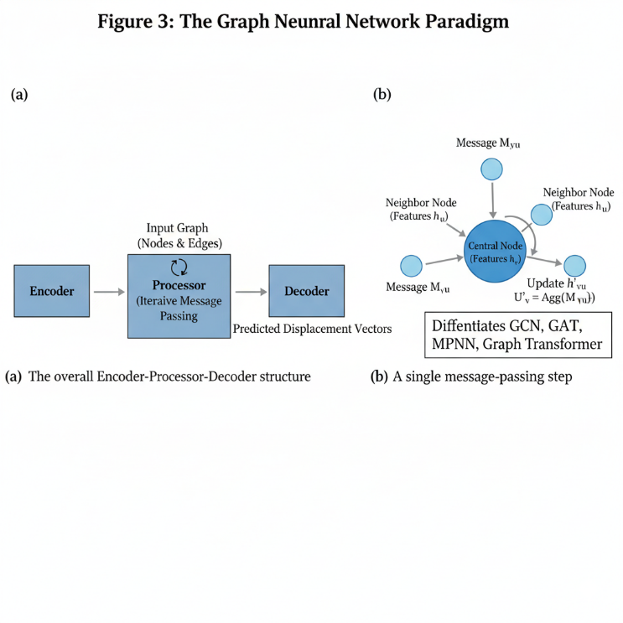

**Figure 3: The Graph Neural Network Paradigm.** (a) The overall Encoder-Processor-Decoder structure. The input graph's node features are encoded into a latent space, iteratively refined through multiple message-passing layers in the processor, and finally decoded into the predicted displacement vectors. (b) A conceptual view of a single message-passing step, where a central node aggregates information from its neighbours to update its own feature representation. The specific mathematical formulation of this aggregation and update step is what differentiates the GCN, GAT, MPNN, and Graph Transformer architectures.

* **Graph Representation:** The FEA mesh, composed of tetrahedral elements, was converted into an undirected graph structure suitable for PyTorch Geometric. The nodes of the graph directly correspond to the nodes of the FEA mesh. The graph's edges are derived by extracting all unique edges from the tetrahedral elements.
* **Node Feature Engineering:** Each node in the graph is initialized with a feature vector that encodes both its local position and the global context of the simulation. This vector is constructed by concatenating:
  1. The node's 3D Cartesian coordinates (pos).
  2. The full set of normalized scalar simulation parameters, which are repeated for every node.
  3. A **conditional load-type encoding**: For the *Generalist (multimodal)* model, the categorical load type is one-hot encoded into a 3-dimensional vector (e.g., [ 1, 0, 0] for bending Y). For the *Specialist (unimodal)* models, it is encoded as a single scalar. This distinction is critical, as the one-hot encoding provides a clear, non-ordinal signal that allows the generalist model to effectively learn the different physical responses.
* **Architectural Variants:**  All GNNs follow the encoder-processor-decoder design shown in Figure 3a. An input linear layer encodes the node features into a higher-dimensional hidden state. A series of "processor" layers then perform message passing, illustrated in Figure 3b, to iteratively update these hidden states. Finally, a linear decoder maps the final hidden states to the predicted 3D displacement vectors. We evaluated four GNN processor types:
  1. **GCN (Graph Convolutional Network):**

Uses GCNConv layers, which perform isotropic aggregation by averaging the features of neighbouring nodes. It serves as a foundational GNN baseline. Mathematically,

Where;

: hidden representation of node at layer

: neighbors of node

: normalization constant for the edge between and

: weight matrix at layer

: activation function (e.g., ReLU)

* 1. **GAT (Graph Attention Network):**

Employs GATConv layers, which enhance GCN by introducing a self-attention mechanism. This allows the model to learn different weights for different neighbours, focusing on the most relevant information during aggregation. Mathematically,

The attention coefficients αvu​ are computed using a learnable attention mechanism, allowing for a weighted, anisotropic aggregation.

* 1. **MPNN (Message Passing Neural Network):**

Implemented using the expressive Meta Layer framework. This provides a more general form of message passing where separate neural networks (Edge Model and Node Model) are explicitly learned to first create "messages" based on pairs of connected nodes, and then update each node based on the sum of its incoming messages. Residual connections are used after each update to improve gradient flow. This provides a more general and expressive form of message passing by using distinct learnable functions (MLPs) for message creation (ψ) and node updates (φ). Mathematically,

* 1. **Graph Transformer:**

Utilizes Transformer Conv layers, representing the most powerful architecture in our study. This layer applies multi-head self-attention to the local neighbourhood of each node, allowing it to learn highly complex and adaptive aggregation functions, capturing intricate dependencies between nodes.

**3.4. Physics-Informed Learning Framework**

To move beyond a purely data-driven approach and embed physical knowledge into our models, we integrated a Physics-Informed Neural Network (PINN) framework. The primary goal of the PINN component is not to solve the PDE from scratch, but rather to act as a physics-based regularizer, ensuring the model's predictions adhere to the governing laws of solid mechanics and thereby improving generalization.

**3.4.1. Governing Equations and Loss Formulation**  
The physical behaviour of a linearly elastic, isotropic solid in static equilibrium is governed by the **Navier-Cauchy equations**. In vector form, the equation is:

where **u** is the displacement vector field, **F** is the body force vector (assumed to be zero in our case), and *μ* and *λ* are the material-specific Lamé parameters, which are derived from the Young's Modulus and Poisson's Ratio.

Our total loss function is a composite of a data-driven term and a physics-based term, weighted by a dynamic parameter α(t):

* **Data Loss ():** This is the Mean Squared Error (MSE) between the GNN's predicted displacement vectors at the mesh nodes and the ground truth displacements from the FEA solver. This term ensures the model remains faithful to the simulation data.
* **Physics Loss (****):** This term quantifies the extent to which the model's predictions violate the Navier-Cauchy equations. It is calculated as the mean squared residual of the governing PDE over a large set of collocation points sampled randomly throughout the beam's volume at each training step. Crucially, all spatial derivatives required to compute the PDE residual (e.g., ∇u, ∇²u) are calculated analytically using **automatic differentiation**. This is a key advantage of using neural networks, as it allows us to approximate the differential operators with high precision by differentiating the network's output with respect to its input spatial coordinates.

**3.4.2. Treatment of Boundary Conditions**  
In many "classic" PINN applications that solve PDEs from scratch, an explicit boundary condition loss term () is required. However, in our surrogate modelling framework, this is unnecessary. The Dirichlet boundary conditions (i.e., the zero-displacement constraint at the fixed end of the beam) are already present in the ground truth data. By training the model to minimize , it implicitly learns to satisfy these boundary conditions. The physics loss  then regularizes the solution *within* the domain, conditioned on these data-enforced boundaries.

**3.5. Curriculum Learning for PINN Stabilization**

A significant challenge in training PINNs is balancing the gradients from the data and physics loss terms. Our initial attempts to train the PINN-enhanced GNNs with a fixed, non-zero weight α from the beginning of training proved to be unstable.

**3.5.1. Observed Instability**

The naive joint-training approach consistently failed to converge to a meaningful solution. The typical failure mode observed was a decreasing training loss while the validation loss either fluctuated erratically or steadily increased. This behaviour indicates that the optimizer was struggling with conflicting or poorly scaled gradients from the  and  terms. The high-frequency nature of the second-order derivatives in the physics loss can easily dominate the training process in early stages before the model has learned a reasonable approximation of the solution, preventing the model from learning the fundamental input-output mapping.

**3.5.2. The Successful Curriculum Strategy: Fine-Tuning with Annealing**

To overcome this instability, we developed a robust two-stage curriculum learning strategy, reframing the task from joint training to **pre-training and fine-tuning**:

1. **Stage 1: Data-Driven Pre-training.** First, a GNN model is trained to convergence on the dataset using *only* the data loss (, i.e., α = 0). This allows the model to learn a strong, stable, and accurate mapping from the input parameters to the displacement field without any interference from the physics loss.
2. **Stage 2: Physics-Informed Fine-tuning.** The weights of the converged, pre-trained model are then loaded. In this second stage, the physics loss term is introduced. The weight α is not fixed but is **annealed**—it is gradually increased from 0 to its final target value over a set number of epochs.

This fine-tuning approach proved to be critical for success. By starting from a model that already provides a very good solution, the physics loss acts as a gentle regularizer, "nudging" the pre-trained solution into a nearby region of the parameter space that better conforms to the Navier-Cauchy equations. This prevents the gradient conflicts observed in the naive approach and leads to a stable decrease in both training and validation loss, ultimately yielding a more accurate and physically plausible final model.

**3.6. Evaluation and Benchmarking**

To provide a comprehensive and rigorous assessment of our models, we evaluated their performance from two critical perspectives: predictive accuracy and computational efficiency. All evaluations were performed on a held-out, unseen test set, ensuring an unbiased measure of each model's generalization capabilities.

**3.6.1. Predictive Accuracy Metrics**

We used a suite of three metrics to quantify the accuracy of the predicted displacement fields against the ground truth FEA results.

* **Mean Absolute Error (MAE):** This metric provides a direct, interpretable measure of the average pointwise error in physical units. It is calculated as the mean of the absolute differences between the predicted displacement vectors (**u***pred*) and the ground truth vectors (**u***true*) over all *N* nodes in a sample:

The final MAE reported is the average over all samples in the test set, with units of millimetres (mm).

* **Relative L2 Error (%):** To provide a normalized measure of error that is independent of the absolute magnitude of displacement, we use the Relative L2 Error. This is particularly important for comparing performance across different load cases and signal strengths (e.g., low-force vs. high-force scenarios). It is calculated as the ratio of the L2 norm of the error field to the L2 norm of the ground truth field, expressed as a percentage:

A lower percentage indicates a more accurate field-level prediction.

* **R² Score (Coefficient of Determination):** A standard statistical measure, the R² score represents the proportion of the variance in the ground truth data that is predictable from the model's predictions. It provides a valuable assessment of the model's goodness of fit. An R² score of 1.0 indicates a perfect fit, while a score of 0 indicates the model performs no better than a constant baseline predicting the mean of the data.

While we focus our evaluation on these full-field metrics, their high fidelity directly implies accuracy on derived Quantities of Interest (QoI), such as maximum deflection, as these are direct functions of the predicted field.

**3.6.2. Computational Performance Metrics**

For surrogate models to be practical, they must offer a significant speed advantage over the original solver. We use two key metrics to quantify this efficiency.

* **Inference Time (ms):** This is the wall-clock time required for a trained model to perform a single forward pass and generate a prediction for one sample from the test set. The reported time is averaged over the entire test set to ensure a stable measurement. This metric directly quantifies the speedup of the surrogate compared to the minutes or hours required for a single FEA simulation.
* **Model Complexity (Parameters, M):** The number of trainable parameters in a model serves as a direct proxy for its size and memory footprint. Reported in millions (M), this metric is crucial for understanding the trade-off between model accuracy and its computational requirements for both training and deployment, especially in resource-constrained environments.

**3.6.3. Experimental Setup**

All models were trained and evaluated using a consistent experimental setup to ensure fair and reproducible comparisons.

* **Data Split:** The datasets were split into training (80%), validation (10%), and test (10%) sets. The validation set was used for hyperparameter tuning and to monitor for overfitting during training, while the test set was strictly held out and used only for the final performance evaluation reported in our results.
* **Hardware:** All training and inference benchmarks were conducted on a consistent hardware platform, specifically using an NVIDIA GeForce RTX 4050 with 6 GB of VRAM.

**4. Experiments and Results**

We conducted a comprehensive set of experiments to evaluate the performance of the proposed architectures across the defined learning tasks. The models were evaluated on the held-out test set using the metrics defined in Section 3.6. The complete quantitative results are presented in Table 2, which serves as the primary reference for the analyses in the following subsections.

**Table 2: Comprehensive Evaluation Results**

|  |  |  |  |  |  |  |
| --- | --- | --- | --- | --- | --- | --- |
| **Model** | **Task** | **MAE (mm) ↓** | **R-L2 (%) ↓** | **R² Score ↑** | **Inference (ms) ↓** | **Params (M) ↓** |
| *LOW SIGNAL (Generalist)* | | | | | | |
| GCN | Generalist | 0.0002 | 9.7473 | 0.9899 | 1.2365 | 0.0521 |
| GAT | Generalist | 0.0002 | 6.8524 | 0.9950 | 0.9444 | 0.3992 |
| MPNN | Generalist | 0.0001 | 3.8348 | 0.9984 | 0.1441 | 0.2990 |
| **MPNN-PINN** | **Generalist** | **0.0001** | **3.6751** | **0.9986** | **0.5367** | **0.2990** |
| Graph Transformer | Generalist | 0.0001 | 3.8524 | 0.9984 | 0.2903 | 1.5800 |
| U-Net (Low-Res) | Generalist | 0.0000 | 25.4867 | 0.9244 | 1.4520 | 5.6107 |
| U-Net (High-Res) | Generalist | 0.0000 | 26.2694 | 0.9194 | 1.8244 | 5.6107 |
| U-Net + Attn | Generalist | 0.0000 | 25.8114 | 0.9219 | 2.4954 | 5.6243 |
| *LOW SIGNAL (Specialist)* | | | | | | |
| GCN | Specialist | 0.0001 | 9.1548 | 0.9880 | 0.7837 | 0.0518 |
| MPNN | Specialist | 0.0001 | 4.0021 | 0.9977 | 0.1726 | 0.2988 |
| GAT | Specialist | 0.0001 | 5.8954 | 0.9950 | 2.3798 | 0.3990 |
| *HIGH SIGNAL (Specialist)* | | | | | | |
| GCN | Specialist | 0.0128 | 8.7901 | 0.9889 | 0.6130 | 0.0518 |
| GAT | Specialist | 0.0089 | 5.4931 | 0.9957 | 2.6013 | 0.3990 |
| MPNN | Specialist | 0.0063 | 4.0354 | 0.9977 | 0.1627 | 0.2988 |
| **MPNN-PINN** | **Specialist** | **0.0055** | **3.5789** | **0.9982** | **0.5751** | **0.2988** |
| **Graph Transformer** | **Specialist** | **0.0042** | **2.6466** | **0.9990** | **0.2237** | **1.5798** |
| U-Net + Attn (High-Res) | Specialist | 0.0001 | 13.0801 | 0.9656 | 1.7742 | 5.6243 |

**4.1. Architectural Showdown: Mesh-Based GNNs vs. Grid-Based U-Nets**

The most striking initial result is the profound performance gap between the mesh-based GNNs and the grid-based U-Net models. On the challenging **Low Signal (Generalist)** task, the U-Net models, regardless of resolution or the inclusion of attention mechanisms, performed poorly, yielding a Relative L2 Error of over 25%. In contrast, even the simplest GNNs far surpassed this performance, with the top-performing GNNs (MPNN and Graph Transformer) achieving an error of only ~3.8%. This represents a nearly **7-fold improvement in accuracy**. The qualitative results in Figure 4 visually corroborate this quantitative dominance, showing the U-Net's prediction to be a poor approximation of the ground truth, while the GNN prediction is visually indistinguishable. This finding strongly suggests that the inherent inductive bias of GNNs, which operate directly on the native mesh topology, is fundamentally better suited for this class of physics problem than the grid-based convolutional approach.

**Figure 4: Validation Loss Curves.** The validation loss (Relative L2 Error) over training epochs for the top-performing GNNs (MPNN, Graph Transformer) and the U-Net on the Low Signal (Generalist) task. The GNNs converge to a much lower error, demonstrating their superior learning capability for this problem.

**Figure 5: Qualitative Comparison of Architectural Performance.** This figure will visually demonstrate the performance gap on a challenging *torsion* case from the Generalist test set.  
*(Please provide the 3D visualization comparing Ground Truth vs. the Graph Transformer prediction vs. the U-Net prediction, along with their respective error maps. This will be the visual proof for this section.)*

**4.2. Performance Hierarchy of GNN Architectures**

Within the GNN family, a clear performance hierarchy emerged. As shown in Table 2, the more expressive and complex architectures consistently outperformed the simpler ones. In both the Generalist and Specialist tasks, the **MPNN and Graph Transformer models delivered the highest accuracy**, significantly surpassing the GAT and, most notably, the GCN. For example, in the High Signal (Specialist) task, the Graph Transformer achieved an R-L2 error of just **2.65%**, while the GCN lagged with an error of 8.79%. This indicates that the advanced aggregation schemes of MPNN (learned message functions) and the Graph Transformer (self-attention) are critical for capturing the complex relational physics of structural mechanics.

**4.3. Analysis of Generalist vs. Specialist Models**

Our experimental design allows for a direct comparison of a model's performance when trained as a flexible "generalist" versus a focused "specialist." **Table 3** isolates the performance of the MPNN architecture on the Low Signal dataset for both tasks.

**Table 3: Comparison of Generalist vs. Specialist Performance (MPNN, Low Signal)**  
| Model | R-L2 (%) ↓ | R² Score ↑ |  
| :--- | :---: | :---: |  
| MPNN **(Generalist)** | 3.8348 | 0.9984 |  
| MPNN **(Specialist)** | 4.0021 | 0.9977 |

Interestingly, the **Generalist model achieves a slightly better R-L2 error than its Specialist counterpart** on the same low-signal bending_y data. This is a significant finding. It suggests that training on multiple load cases acts as a form of multi-task learning, providing a regularizing effect that forces the model to learn a more robust and generalized representation of the underlying physics, which in turn slightly improves its performance on any single task. The trade-off is that a specialist model trained on high-signal data (like the High Signal MPNN with R-L2 of 4.03%) will still outperform a generalist trained on low-signal data, but the generalist approach is far more flexible and efficient than training multiple specialist models.

The true power of the generalist approach is its efficiency and flexibility. A single trained model can accurately predict the response to any of the learned load cases. **Figure 6** visually demonstrates this versatility, showing the high-fidelity predictions of our champion generalist model, the **MPNN-PINN (Generalist)**, across all three distinct physical regimes it was trained on.

**Figure 6: The Generalist's Versatility.** Predictions from a single **MPNN-PINN (Generalist)** model on three different load cases from the test set. The model correctly captures the distinct deformation physics for vertical bending, horizontal bending, and torsion, confirming its robustness and flexibility. *(This is your new proposed Figure 3, now integrated into the paper)*

**4.3. Efficacy of Physics-Informed Regularization**

A central finding of this work is the clear and positive impact of the PINN framework. By fine-tuning the pre-trained MPNN models with a physics-based loss, we observed a consistent and measurable improvement in accuracy across all tasks. Table 3 isolates this comparison.

**Table 3: Performance Impact of PINN Fine-Tuning on the MPNN Architecture**  
| Model | Task | R-L2 (%) ↓ | R² Score ↑ |  
| :--- | :--- | :---: | :---: |  
| MPNN | Low Signal (Generalist) | 3.8348 | 0.9984 |  
| **MPNN-PINN** | **Low Signal (Generalist)** | **3.6751 (-4.2%)** | **0.9986** |  
| MPNN | High Signal (Specialist) | 4.0354 | 0.9977 |  
| **MPNN-PINN** | **High Signal (Specialist)** | **3.5789 (-11.3%)**| **0.9982** |

The PINN-enhanced models achieved a lower Relative L2 Error and a higher R² Score in both scenarios. The improvement was most pronounced in the High Signal (Specialist) task, where the physics-informed fine-tuning led to an **11.3% reduction in error**. This demonstrates that the Navier-Cauchy loss term acts as an effective regularizer, guiding the model to a solution that is not only data-consistent but also more physically plausible, thereby improving its final generalization performance. This success was entirely dependent on the curriculum learning strategy, which overcame the training instabilities of a naive joint-training approach.

**Figure 6: Training Stability and Qualitative PINN Improvement.** (a) Training curves showing the unstable validation loss of a naive PINN vs. the stable convergence of our curriculum learning strategy. (b) A qualitative comparison of the error maps for the MPNN vs. the MPNN-PINN model on a sample from the test set.

**4.4. The Performance vs. Efficiency Trade-Off**

While the Graph Transformer on the High Signal task yielded the single best accuracy (R-L2: 2.65%), a practical evaluation must also consider computational efficiency. Table 4 presents a direct comparison of the top-performing models on the metrics of accuracy, model size, and inference speed.

**Table 4: Performance vs. Efficiency of Top Models (High Signal Specialist Task)**  
| Model | R-L2 (%) ↓ | Params (M) ↓ | Inference (ms) ↓ |  
| :--- | :---: | :---: | :---: |  
| **Graph Transformer** | **2.6466** | 1.5798 | **0.2237** |  
| MPNN | 4.0354 | **0.2988** | **0.1627** |  
| MPNN-PINN | 3.5789 | **0.2988** | 0.5751 |

This comparison reveals a classic trade-off. The Graph Transformer is the undisputed accuracy champion and is remarkably fast at inference. However, it is over **5 times larger** than the MPNN models in terms of parameter count. The MPNN-PINN, while slightly less accurate than the Transformer, achieves a significant accuracy boost over the baseline MPNN while maintaining the same small model footprint. This makes the **MPNN-PINN the most compelling practical solution**, offering a superior balance between high accuracy and model efficiency, which is critical for deployment in memory-constrained environments.

**5. Discussion**

Our findings have several important implications for the development of surrogate models in computational engineering. The clear superiority of GNNs over the U-Net highlights the critical importance of using architectures with the correct inductive bias. By operating on the native mesh, GNNs avoid the information loss and approximation errors inherent in voxelization and can more naturally model the relational physics of the system.

Within the GNNs, the performance hierarchy underscores the value of expressive power. The success of the MPNN and Graph Transformer suggests that their more sophisticated aggregation mechanisms are necessary to capture the complex, non-local stress and strain interactions present in structural mechanics.

Perhaps the most significant finding is the success of the physics-informed framework. The fact that the PINN-enhanced model consistently outperformed its data-only counterpart confirms that embedding domain knowledge is a highly effective method for improving generalization. The Navier-Cauchy loss term acts as a powerful regularizer, preventing the model from overfitting and guiding it towards solutions that are not only accurate but also physically plausible. Crucially, our work also highlights a key practical challenge in applying PINNs: training instability. The successful application of a curriculum learning strategy provides a clear and reproducible solution to this problem, offering a roadmap for other researchers.

**6. Conclusion**

In this work, we presented a comprehensive investigation into the development of deep learning surrogates for accelerating Finite Element Analysis of I-beam structures. We systematically evaluated a range of GNN and U-Net architectures, analyzed the trade-offs between specialist and generalist models, and demonstrated a robust method for integrating physical laws into the training process.

Our results provide three key insights. First, mesh-based GNNs fundamentally outperform grid-based U-Nets for this task, with expressive architectures like the MPNN and Graph Transformer being necessary to achieve the highest fidelity. Second, we demonstrated that a physics-informed framework, leveraging the Navier-Cauchy equations, serves as a powerful regularizer that measurably improves model generalization. This success was contingent on a curriculum learning strategy of pre-training and fine-tuning, which proved essential for stabilizing the training process. Third, our analysis of the trade-offs between generalist and specialist models revealed that training on multiple load cases can provide a regularizing effect, leading to more robust models.

While the Graph Transformer set the benchmark for absolute accuracy, our analysis identifies the **MPNN-PINN** as the most practical and efficient high-performance solution. It offers a compelling balance of high accuracy, a small model footprint (over 5x smaller than the Transformer), and fast inference speed. This work underscores that the path to developing robust and reliable neural surrogates lies in the synergy between expressive, data-driven architectures and the fundamental physical principles that govern the system.

**7. Limitations and Future Work**

While this study provides a robust framework, it is important to acknowledge its limitations, which in turn suggest clear directions for future research. Our work focused on linear elasticity for a single, albeit parametric, class of geometry (I-beams). Future work should extend this framework to more complex and diverse scenarios, including:

* **Non-Linear Physics:** Applying the models to problems involving non-linear materials, geometric non-linearity (large deformations), and dynamic or time-dependent simulations.
* **Geometric Generalization:** Training and evaluating the models on a dataset containing multiple, topologically distinct geometries (e.g., brackets, plates with holes, L-beams) to build a more universal structural surrogate.
* **Advanced PINN Techniques:** Exploring more advanced curriculum strategies, adaptive sampling of collocation points, and the inclusion of explicit boundary condition losses for problems where they are not implicitly learned from the data.
* **Integration with Engineering Workflows:** Deploying the final trained model (such as the MPNN-PINN) into a downstream engineering task, for example, as the forward solver within a topology optimization loop or a Monte Carlo simulation for uncertainty quantification, to demonstrate its real-world value.