Indravash Chowdhury, Ravinder Singh, Christopher Kluse, and Mohammad Mayyas^{Ϯ}
eFactory Laboratory, Mechatronics Engineering Technology, Bowling Green State University, OH.
43402 USA. ^{Ϯ} Corresponding author: (mmayyas@bgsu.edu).

Obstacle Design Approach to Improve the Safety of Free Ranging AGVs in a Shared Work Environment
Abstract— As robots in use age, and their components wear down, downtime may increase. Through the use of Random Walk style failsafe’s, it may be not only possible to rescue robots that lost their path planning capability, but also help improve safety by designing better workspace layout that uses a probability of collision map. This paper investigates the ability of a mobile vehicle to find its destination based on random walk locomotion. More particularly, the goal is to investigate the probability of collision and the average number of steps it takes with large number of randomized walk in a confined two dimensional space which encompasses static or dynamic spatial obstacles. The proposed simulation algorithm illustrates human robot interaction where an Automated Guided Vehicle system freely ranging within crowed of moving or stationary workers and obstacles in a confined workspace. More specifically, the study is concerned with a worst-case scenario when a robot loses its path planning capability, due to communication or processing malfunction. Therefore, the question becomes what is the cost of sending robot to its safe “home” position with minimum inboard navigation sensor and reduced risk of collision. To answer, a novel ‘Obstacle Design’ approach has been introduced to study the effect of obstacles on an un-navigable robot with no path planning capability so that it can reach its final position with maximum efficiency. This study evaluates the effect of workspace obstacles and in future can facilitate engineers to help design and understand the risk and design of a human- robot workspace.

Index Terms— Random Walk, Human-Robot Interaction, Manufacturing Safety, Facility design, Automated Guided Vehicles.

INTRODUCTION
Automated Guided Vehicle systems (AGVs), provide manufacturing, production and logistic facilities with added flexibility thereby increasing the overall rate of production. These AGVs are appropriately outfitted with appropriate safety equipment and sensors to make them safe [1] . The main advantage of an AGVs is that “if guided”, they do not hurt people and damage infrastructures. It is generally accepted that AGVs are safer than manual equipment such as conventional forklifts. The introduction of collaborative AGVs or robots has initiated the concept of fencing and now in this advanced technology era, the combined work effort between humans and robots has become efficient and productive. However, the coexistence of robots and humans in the same workspace has created a threat to the humans making safety a primary priority in a shared human-robot workspace. According to OSHA records, industry related injuries indicated that from 2015 to 2019, 76% of injuries (4 injuries total) were severe and 3 fatalities occurred throughout the USA [2]. These injuries are attributed to autonomous cars, mobile cars, and AGVs. OSHA states that there were 30 casualties in Human-Robot workspace from 1987 to 2019 [3]. Due to a significant increase in robot induction worldwide and the increasing amount of human-robot interaction it has become important to investigate the relationship between the robot and the workspace, examine the probability of accidents, and determine a solution to minimize unsafe interaction.

AGV’s in Working Environments
AGVs are internal based transport system that utilizes automated guided machinery and provides its services in warehouses, trans-shipment terminals, manufacturing plants and distribution centres. Automated guided vehicles have also an important role in the transportation of materials that are associated with manufacturing processes. About 20,000 automated guided vehicles were utilized for industrial applications[4]. The use of the automated guided vehicle has increased dramatically since their introduction. The variations and number of areas of applications in types have improved at a larger scale. Automated guided vehicles can be used in outside as well as in inside environments such as manufacturing, distribution, transhipment and (external) transportation areas [5].
According to Cardarelli et al., a unique interface can allow the users to communicate and interact with a vast fleet of AGVs fully [6]. This HMI, human-machine interfaces, are highly helpful for logistical activities within industrial environments. However, using these intelligent approaches, there are technologies that are more novel and discoveries made on how robots can get used to support and assist the human argue that the use of human-centered intelligent robots is among the leading discoveries that have helped in more embrace of robots, even in AGVs [7]. This significant research is now applied in intelligent control, navigation, human-robot interaction, and pattern recognition. Prusak and the rest of the researchers raised the same argument. In their discussion, a PMD-camera (Photonic Mixer Device camera) is used in sensing the obstacles within the path of an AGV. In addition, the same technique is used when there is a need to monitor the area where an industry robot is working [8].
The PMD-camera acts as an interactive technique that records the video images of various objects and scenes in both 2-D and 3-D greyscales and deep-data images, respectively. According to Liu and Tomizuka [9] , HRI systems design considers the formation of multiagent framework, thus taking care of safety and possible conflict. Such interfaces have the ability to mimic behaviors socially, uncertainties, and norms. Regardless of the hindrances and shortcomings, Sabattini and the rest of the researchers feel that AVG systems can be improved for factory logistics [10]. They major on the ways through which more of the human activities can get interpreted through artificial machine intelligence. The main goal is to act more like humans, with advanced efficiencies, and minimize human errors.

AGV Path Planning Approaches
It is important to provide insight to the research regarding AGVs routing via transhipment, transportation along with the scheduling of various material handling equipment in large AGV system are limited. The integration of routing and scheduling is a challenging problem. Therefore, it is important to conduct a study in which these particular characteristics should be addressed. The advantage of multi-objective problems in scheduling plays a significant role in scheduling operation and planning of a flexible manufacturing system. For example, Heuristic based approaches include evolutionary algorithms adopted to address the multi-objective scheduling problems in a flexible industrial environment by analysing the vehicle and machine scheduling features in FMS, moreover, elucidated the mutual problem for the minimization of the mean flow time as well as for the mean tardiness objectives [11]. In contrast, differential evolution has used as one of the most influential tools and [12] depicts the synchronised scheduling for both material handling system as well as for machines with different machines for the make span minimization objective. In order to minimize the cycle time, a combination of vehicle assignment heuristic and machine selection heuristic is very useful. Jerald et al discussed Artificial Intelligent based approaches explains that the total penalty cost can be minimized by generating the optimum schedule including simulated annealing (SA), genetic algorithm (GA), swarm algorithm (PSA), and memetic algorithm (MA). These mechanisms help to overcome the idle time as well [13] . While solving the optimization problems, the objective is often achieved by involving wide-ranging computational resources. Heuristic Approaches are employed to overcome the routing problems by minimizing transportation time [14].

Safety based on Collision Avoidance Approaches
Countless inventions have been developed to accomplish the “guided” portion of AGV operation. One such patented invention enables an autonomous vehicle to adjust its pre-programmed path in order to avoid obstacles [15]. This type of system works with several different types of guided vehicles from single cargo units to ones that tow a train of connected carts. Typically, a system is comprised of a computer that receives an input signal from a detection sensor such as a laser scanner. The computer, rather than stopping the vehicle when an obstacle is detected, calculates a safe offset from its normal path and navigates the vehicle around the obstacle according to this temporary safe path. This type of collision avoidance is preferable because the vehicle navigates safely without having to stop.
Avoidance between Multiple AVGs is developed by Emanuel et al [16]. This method works in several steps. First, the vehicle’s computer tracks the position of all other vehicles in its detection area at regular intervals. Next the computer calculates the trajectory of each surrounding vehicle from collected velocity and direction data and predicts where it, and the other vehicles will collide. The computer then sends a warning signal to the other vehicles and maneuvers itself to avoid the predicted collision. This type of system is useful because it allows an AGV to avoid dynamic obstacles that are constantly moving.
Another way to avoid dynamic collisions is to allow each AGV to know where each other vehicle is located before it is assigned a path. This is achieved by a host computer that sends signals to all AGVs in the operating area that tell them whether to move along a path or avoid the path[17]. The computer assigns a path for the next vehicle, checks if there are other vehicles moving on that path, and sends the next vehicle along that path if no other vehicles are in the way. This method is proactive since it assigns clear paths before the vehicle starts to move.
While steering clear of obstacles is important, the vehicle must be able to follow a determined path. Kondo has invented a system that better controls the path of an automated guided vehicle [18]. This system is composed of several magnetic sensors underneath the vehicle that detect magnetic tape on the floor of the operating area. The main sensor is positioned in the middle of the vehicle, and several small sensors are positioned to the left and right of the main one. The side sensors allow the vehicle to better detect when it deviates left or right from the guide tape and adjust accordingly. Accurate movement and paths are essential for AGVs to work properly and efficiently; having more sensors means being able to calculate small movements and deviations.
Another way of determining a vehicle’s location has been developed by Hong et al [19] . Unlike the previous invention that was guided by the floor, this invention has vehicles navigate by the building’s ceiling. This is beneficial when light conditions vary across the vehicle’s operating area. The vehicles locate themselves by taking an image of the ceiling that are covered with numerous unique markers. The marks have areas that are infrared reflective and areas that are non-reflective. Based on the shape of the mark and the orientation of the reflective and non-reflective sections, the vehicle’s computer calculates its position and orientation in the workspace. This invention has several benefits. As mentioned previously, this system works in difficult lighting conditions because the ceiling markers reflect unique patterns of light sent by the vehicle. This system also allows for a vehicle to know its orientation in the space as well as its current location.
To ensure a safe human robotic environment before installing a mobile robot, safety assessment of the workspace is considered a best practice. There has been a significant amount of work relative to safety in Human-Robot Interaction. Lasota et. al surveyed various methods that have been used for the same Human- Robot Interaction [20]. The survey covered areas taking safety through control, robotic motion planning, prediction, and psychological factors. The survey also includes pre collision and post collision methods which has been analyzed by predicting natural human action and motion. Other methods included operator’s safety on assembly production line for collaborative robots [21], hazard operability analysis to identify the hazards and risks for risk assessment in a human-robot collaborative environment [22], Human-robot interaction guided by operator gesture [23]. Draganjac et.al presented an algorithm for autonomous path planning and motion coordination for multiple AGV to determine the shortest feasible path by using reliable detection and prioritized conflict resolution in the shared workspace [24].
In 1987, Miller and Subrin wrote about the essentials for the safe operation of AGVs [25]. Part of this was their analysis on the merit of then-modern optic and ultrasonic technologies for sensing. Today, many of the problems they pinpointed have been dealt with, though they still warrant considering. Their primary concerns for both technologies were in false positives and inaccuracy when used on curved paths. With modern lenses and filtering technologies, these problems are minimized for optic technology. Safety being a complex issue, there are many ways to solve safety problems. Some authors have advocated for a full system to represent realized process for solving these problems, all the way from discovery to continuous improvement. According to Möller and Niklas [26], there are four “metaprinciples”, as they put it: inventorize, capacitate, prioritize, and integrate. Inventorize, in this case, means to catalog anything that is considered a safety issue. This includes the nature and severity of systems either planned or existing. Capacitate entails determining how certain features of the system (as planned/built) can be used to help minimize those issues, as well as improving the efficacy of those features when used in this way. Prioritize simply means to ensure that the most important improvements are focused on. Integrating extends the envelope of responsibility beyond the product itself, through education of the workforce and management involved in the use of the product.
The research performed by T. Helmer in Development of a Methodology for the Evaluation of Active Safety using the Example of Preventative Pedestrian Protection is extensive [27] . Using millions of simulations, they provided a great deal of data on the efficacy of three basic systems used in preventative safety measures. These systems were: warnings, brake assist, and automatic braking. During their research, they looked at the main influencers for the results of each system.
In order to fulfill with safety rules, AGVs must include some safety sensors and devices to prevent risks. AGVs should contain sensors in the direction of travel covering the maximum moving width and length provided to prevent contact between the load and any possible obstacle. In Industry 4.0, human risks mitigation through various safety measures has become paramount. Laser scanners has been recently used in obstacle recognition and personnel safety. Other sensing methods include cameras, radar, and ultrasound sensors where the latter has been favored since the late 80’s [28]. The main AGV active safety devices and AGV safety sensors are collision avoidance system, contact bumpers emergency, stop buttons, and safety PLC. The collision avoidance system on the AGV can apply several different laser sensors set up on the front, rear, side, and upper locations of the AGV. When the AGV is moving on a guided path, this system will detect an obstacle (such as a human) in any of the coverage locations. When the obstacle is within the warning field of any of these sensors, the AGV will decelerate to a slower speed in anticipation of a full stop. If the obstacle is still detected within protective field of the sensor, the AGV will apply its brakes so that it comes to a complete stop before contact is made. The AGV will resume automatic operation approximately three seconds after the obstacle is removed from the protective field [29].
The safety area must be designed depending on many factors, such as surrounding area, vehicle speed, payload, floor conditions. Every point of the path followed by an AGV must have its own safety area to ensure that time and distance to vehicle stoppage will avoid any contact with obstacles. According to Bostelman, recent information about AGV accidents demonstrates that even with onboard sensors these vehicles did not detect nearby workers [30]. Additional complications involving operator safety will happen as AGVs work in more free environments or when robot arms are added to AGV platform. These safety risks can be alleviated with the use of new technologies, such as three-dimensional sensors and algorithms that provide industrial vehicles with information about potential collisions in their paths. However, the capabilities of new sensors need to be well-categorized and their strengths and weaknesses need to be understood before they can be incorporated onto AGV that are deployed on work floors.
Researchers studies various algorithms to improve safety of robotic through motion planning techniques and sensing fusion. For example, Frese et. al. proposed a novel method for extrinsic calibration of sensors to track arbitrary obstacles around the robot [31]. Chen et. al has utilized KinectV2 depth cameras to track dynamic obstacles which are moving objects around the workspace [32]. On the other hand, optimizing the layout of obstacles in workspace is essential for safety. Wenger and Chedmail presented a geometrical analysis of the free workspace of a collaborative robot by characterizing the effect of obstacles using Constructive Solid Geometry (CSG) Computer Aided Design (CAD) description of robots and obstacles [33]. The paper also uses an octree model of the free workspace for geometrical analysis. Vahrenkamp et. al introduced task specific interaction for both robots and human to determine suitable location for human robot interaction tasks [34]. Rezazadegan et. al proposed risk-based framework for Human- Robot Interface through safety control system which includes proximity detection, collision avoidance systems and docking & compliance control [35].
Safety measures with probabilistic approach are imminent to avoid these collisions. There are a range of approaches to calculate the probability of collisions in Human- Robot distributed workspace. The analyses of the probability of risk due to intrusion use several factors such as the safety function of robot, human and robots relative velocity and position [36]. Lambert et. al presented a probabilistic Monte Carlo algorithm to reduce risk from Gaussian integrals with vehicle volume and obstacle volume taken into consideration [37]. Berg et.al. proposed an approach which decreases the probability of collisions based on linear quadratic Gaussian- motion planning [38] . The algorithm uses rapid random trees model to minimize the collision by sensing the uncertainty. Applying sampling-based algorithms such as Monte Carlo sampling strategy model, collision probabilities are estimated by extrapolating the ratio of the number of collision free simulated executions [39].
Several collision avoidance approaches have been proposed in the field of robotics research. Flacco et. al discussed Human-Robot Collision avoidance approach through potential field method where the repulsive command for the robot is generated to avoid obstacles. The distance between the robot and the moving obstacle is calculated and repulsive vector is used to control the generic motion of the robot [40]. Path finding methods such as artificial potential field, particle swarm optimization and Ant colony optimization are also used to research safe mobile robot path planning. Liang, Lee used artificial bee colony algorithm on motion planning of multiple mobile robots in a dynamic environment [41]. Pedrochhi, et al. indicated that most robots in manufacturing plants follow sense and avoid approach with a camera mounted on a robot which computes the distance where if an obstacle comes within a minimum distance the sense and avoid algorithm is applied and it stops [42].
Researchers have also studied safety measures through collision detection algorithm. For example, multi robot collision avoidance based on velocity obstacle paradigm is used in a dynamic workspace to reduce collision probability [43]. Collision probabilities of high definition robots in a dynamic environment is used with Gaussian distribution where the obstacles are represented in the workspace as a probability distribution[44]. Cho et al. introduced and implemented obstacle- dependent Gaussian potential field method for autonomous vehicles to avoid obstacle collision [45]. Mathematical models are present to facilitate the optimization of motion planning in a dynamic workspace. Example of models based analytical model include Gaussian distribution [37][38][44] , random tree [38] and Monte Carlo sampling strategies [37][39]. Current researches [46][47][48][41][39][38] show that the focus is primarily on the improvement on robotic path planning using different mathematical models but there is no substantial evidence of any mathematical form that can be used to calculate a process of creating random motion such as Simple Random Walk (SRW) for studying the effect of static and dynamic obstacles.
In recent researches Random Walk model has been used in robot motion planning such as swarm robotics area exploration strategy where the random walk methods based on Brownian motion and levy flight method are used as the direction moved by a robot after each step is stochastic[48]. New approaches based on Monte Carlo random walk such as bidirectional Arvand and optimizing planner Arvand are used to improve better motion planning performances by using simple random walk to sample the workspace by measuring the distance between the goal point and the sampled states [49]. Fast random walk approach that determine diverse and efficient path from different homotopy class has also been proposed to improve robotic path planning [47]. For better motion planning proposed better and effective robotic motion with adaptive random walk [46].
While the previously aforementioned path planning methods require navigation capability based on distributed sensors that can realize and analyze the surrounding environment in real-time by using in board computational capability, however this paper presents a failsafe method for controlling the path of AGVs or robot during worst case scenario particularly when only two sensing capabilities are presents: sense and avoid, and robot knows its final state upon arrival but not intermediate states. The method expands on Random Walk theory to include simulation of freely ranging robot in confined comingling with static and dynamic obstacles. This modified process uses random step to steer AGV randomly until it reaches an end point. While robot performance to go to a safe home position without any guidance remains unknown. The merit of this paper is pertained on the need to understand how the distribution of obstacles within a workspace could affect the ability of robot to achieve a simple task and how marching locomotion could help in deign layout of a safe working environment.
This paper is organized as follow: section II introduces ‘Obstacle Design’ approach method…. Based on probabilistic approach through simulation on the effect of obstacles using the Simple Random Walk (SRW) model in a shared workspace.

Roaming based on Random walk Method

When the navigation systems on an AGV or a robot fail, the best their users can hope for is to send a signal to shut it down or to task it to go safely to a home position. The use of simple and robust sensors, such as inductive sensors, could be a viable solution to report whether a free ranging AGV has arrived onto a desired state. This analogy is similar to sending a robot on planet Mars and then task it to find its way to a command station without use of navigation system. Or having a blind person randomly navigates his way in a room to an exit door. These free marching walks whether applied to a blind person or robot can be modeled by SRW principle that randomize steps during a journey to a desired location. This sensor less roaming method when combined with obstacle avoidance could be a replacement in absence of navigation system. On the other hand, with increase of installation of AGVs in manufacturing plants, and with demand for inclusion of collaborative human robot interaction, it is desired to understand the risk of such collaboration at worst case scenario when robot or worker are randomly and carelessly roaming around. The question that one could ask, what is the accidence chance within manufacturing workspace area, and what should be done better to improve facility layout in such away if a layout is reconfigured the accident probability reduces.
Random Walk is a stochastic process where the path consists of a succession of random steps. Therefore, this method is not truly a stochastic process, as the direction the AGV moves is restricted by the presence of obstacles and workers. Conditional probabilities were used in formulating the probability expression that we are testing. They are commonly used in situations with some complexity that make the use of a single simple probability calculation inaccurate.
SRW is a stochastic process which involves the collection of identical independent random variables where each of those random variables represent the next move [50]. An AGV undergoing SRW in a rectangular gridded area moves discretely at probability of 25%. When repeated n times, the probability becomes ${(25\%)}^{n}$. For example, for a robot moving in a grid workspace, at any given position, has chance of moving along each of the adjacent grid points. In one dimensional SRW, the walk state X₁ jumps left or right equally likely at each time along X-direction. Similarly, in two dimensional, each step will have an equal probability bounded by a rectangular wall defined by two-end corners $〈0,0〉$ and $〈a,b〉$. A step is defined by the displacement unit made by AGV in x and y coordinates. The average steps per walk are used to account for the uncertainties in the robotic motion and to avoid outliers. The average step of an AGV roaming in a finite plane with obstacles, with an initial point “i” and end point “f” has no analytical form. Therefore, numerical simulation has been being adopted in this research to investigate several case studies related to ability of AGV to succeed in completing a mission in presence of obstacles. Pseudo code algorithms will be used to analyze the probability and the success to arrive at the desired location simulated for different environments.
The relationship between robots and obstacles will be examined through a novel obstacle design approach. In real time workspace, an automated guided vehicle may malfunction and lose its navigational capability that may lead to robot- robot collisions or human injuries and fatalities. To avoid these undesirable circumstances, the relation between the variables in the workspace must be studied and evaluated. This research develops an environment and a model for a number of robots stepping randomly around a number of obstacles within a specified boundary. An array of static and dynamic obstacles are populated randomly and deterministically within the workspace introducing various obstacle design approaches to evaluate the success which is determined by the average number of steps taken by the robot to reach its final position.
The simulated algorithms attempt to answer the following research questions:
- How does the distance D measured between an initial and a final position relate to the success of the robot to reach its final position when m number of obstacles are placed randomly in a confined workspace?
- Would such success be improved if the obstacle is determinately arranged in pattern such as L-shape, passage, and Zig-Zag?
- What is the success of the robot in the workspace where obstacles are undergoing Markov chain states or random walk?

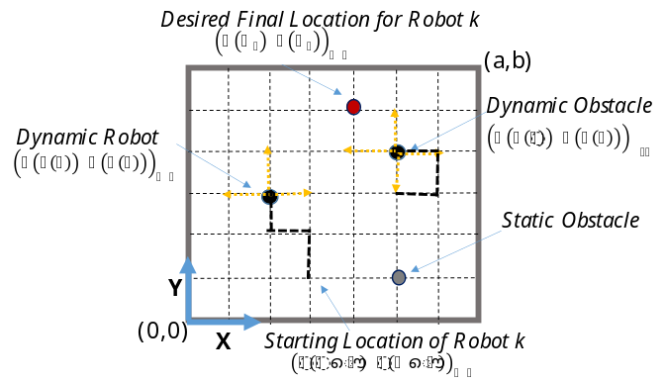
Fig. 1 Robots and obstacles marching in confined work space with stationary obstacles.

In the simulation examples that follow, the workspace is defined by a rectangular area whose size is (a, b) as shown in Figure 1. n number of swarming robots are comingling with m number of stationary obstacles and with h number of obstacle in motion. All robots and obstacles in motion or “dynamic obstacles” follow SRW properties. The location of static obstacle does not change with time. Let $s\left(t\right)$ define the step count at time or discreet event t. The location of an object in the Cartesian coordinates can then be defined by the value of their components for a given step count $\left(x(s(t)),y(s(t))\right)$. For example, robot k and dynamic obstacle w march simultaneously under SRW algorithm. The walk stops when all robots in a subset reaches their desired locations. Let’s say that the subset has one robot at zero step with initial position $\left(x(s(0)),y(s(0))\right)$, then it requires $s(t_{f})$ steps to reach the final location $\left(x(s(t_{f})),y(s(t_{f}))\right)$. During one walk journey, a robot could collide with workspace boundary, obstacle, or another robot.
Multiple walks will be simulated to average the number of steps it takes a robot to reach final destination starting from same initial condition. In one walk, a success is defined as the average number of steps taken by the robot to reach its final position. However, not all walks could lead to a reasonable success. Therefore, a cut- off step of 10⁶ is applied to limit the maximum number of steps within one walk.
It is assumed that the robot has a defense mechanism -simple obstacle avoidance such as bumper switch- that instruct it to try to move away by repeating step again hoping it doesn’t land on boundary or another object. Such overlap is counted as a step and it will weight on the robot’s success to find its desired location. On the other hand, obstacles are assumed to have least intelligence; therefore, they don’t change the coarse of motion when overlaps occur. An example of that could be a worker wondering in workspace and not paying attention to surrounding.
In practice, AGVs or in general, most programmable mobile robots are equipped with basic obstacle avoidance sensors such as low range ultrasonic sensor or spring-loaded switch. The mobile robot could know its final position by means of magnetic, color, inductive, or capacitive sensors mounted on the floor. The examples discussed in the simulation section assume all navigation sensors are turned off except for the obstacle detection sensor and final state sensor.
In this paper, simulations of AGVs are studied for several environments defined in the following subsections.

Random Walk Roaming amidst Static Obstacles
The static obstacles are defined as non- moving objects which are randomly and deterministically structured within the workspace. The obstacles(s) are placed in such a way to mimic various kinds of ‘obstacle regions’ in real time workspace. To perform a Random Walk amidst an array of static obstacles, an algorithm has been proposed which will be explained in Algorithm 1 in Figure 2.

Random Walk amidst Random Obstacles
The dynamic obstacle(s) are defined as moving objects under constant change in motion. The obstacle(s) can move either on a preprogrammed path or on a random walk which abides by any real-world human robot workspace which contains different interactions such as robot- robot and human- robot. Algorithm 2 in Figure 3 describes the boundary conditions of
dynamic obstacles similar to Algorithm 1. The Dynamic Obstacles are simulated into Markov Chain obstacle and Random Walk obstacle. The Markov Chain obstacle design is based on the Markov Property which states that “Future is independent of the past given the present” [51].

Algorithm (2) – Dynamic Obstacles
S = 0
B ← workspace boundaries
O ≡(X_{oj}, Y_{oj}) ← j obstacle(s) performing independent random motion
C ← cutoff
W ← number of journeys robot takes from (X_{i}, Y_{i}) to (X_{f}, Y_{f})
For w = 1:W
(X_{r}, Y_{r}) ← (X_{i}, Y_{i})
O ← random initial positions to all obstacles
While (X_{r}, Y_{r}) ≠ (X_{f}, Y_{f})
S = S + 1
(R_{x}, R_{y}) ← randomly generated ± 1
X_{r} = X_{r} + R_{x}
Y_{r} = Y_{r} + R_{y}
For j ɛ O
(Q_{xj}, Q_{yj}) ← randomly generated ± 1
X_{oj} = X_{oj} + Q_{oj}
Y_{oj} = Y_{oj} + Q_{oj}
If (X_{r}, Y_{r}) = B
robot pushes back into workspace
If O = B
obstacle(s) pushes back into workspace
If (X_{r}, Y_{r}) = O
robot takes a step back or forward away from O
If S >= C
loop breaks
Average Steps = mean S over all w
Fig. 2. Random walk of a robot within confined environment with static obstacles.

Mathematically this statement can be expressed as

$P_{r}\left(S_{t+1 }|s_{t}\right)=P_{r}\left(S_{t+1 }|s_{1},….,s_{t}\right)$ (1)
Where in the above equation, $s_{t}$ or $S\left(t\right)$ denotes the current state and $S\left(t+1\right)$ or $s_{t+1}$ denotes the next state. The transition state of the Markov Chain obstacle is entirely independent of the past states. An obstacle such as (ow) in the workspace (a,b) in Figure 1 is based on Markov Chain model. In this obstacle design the obstacle changes its positions on n fixed number of states with the probabilities from a fixed transition matrix. The Markov Chain in this study is assumed to be known absorbing.
Algorithm (1) – Static Obstacles

S = 0
B ← workspace boundaries
O ← randomly placed obstacle(s) positions or deterministic boundaries
C ← cutoff
W ← number of journeys robot takes from (X_{i}, Y_{i}) to (X_{f}, Y_{f})
For w = 1:W
(X_{r}, Y_{r}) ← (X_{i}, Y_{i})
While (X_{r}, Y_{r}) ≠ (X_{f}, Y_{f})
S = S + 1
(R_{x}, R_{y}) ← randomly generated ± 1
X_{r} = X_{r} + R_{x}
Y_{r} = Y_{r} + R_{y}
If (X_{r}, Y_{r}) = B
robot pushes back into workspace
If (X_{r}, Y_{r}) = O
robot takes a step back or forward away from O
Or, robot pushes back into the obstacle region
If S >= C
loop breaks
Avg_Step = mean S over all w

On the other hand, The Random Walk Obstacle design mimic assumes a free-ranging AGV roaming between random obstacles. In this study the robot such as (Rk) and obstacle(s) such as (Ow) both are moving on Random Walk model. The obstacles are independent entities moving around the workspace (a,b) generating random initial positions with no destinations. The random walk concept is related to the Hamiltonian cycle. A Hamiltonian cycle is a path along a set of points that passes through every point exactly once before returning to the original start point. In the context of an AGV, a Hamiltonian cycle would allow the vehicle to pass through every point on a grid that defines its working zone. Generating a Hamiltonian cycle ensures that the robot reaches the end point, but at the cost of moving efficiently. While this method will not be used directly, the results of the random walk can be compared to the Hamiltonian cycle of the operating space.

Probability of Presence
The “Probability of Presence” of a robot for a specified obstacle region are also simulated to present long-term chances of a robot to be in a certain position. To pursue a long-term probability of presence, the robot is performing infinite SRW with no destination within the obstacle region [52]. The theorem stipulates that the long-term stationary probability matrix P of random walk is computed from a matrix degree of freedom D
$P=\left(\frac{1}{∑D_{ij}}\right)$ (2)
Where$D_{ij}$ is the number of directions the robot can move when at the position (i,j) and $D_{ij}$= 0 for $(i,j)$ at obstacle’s position [53]. It is important to note that here the P is basically an invariant or stationary distribution vector written in form of a matrix since we have a 2D workspace grid.

Proposed Approaches
The proposed approach is to ensure safety through probabilistic “Obstacle Design” approach in a workspace are composed of mainly six types of structured static obstacle designs, Diagonal Design, Passage Design, L-shaped Design, Zig Zag Design and Dynamic Obstacles Design. The dynamic obstacle contains two types (i) Markov Chain Obstacle (ii) Obstacles performing Simple Random Walk. The main emphasis behind making different obstacle designs is to cover the geometry of real-world workspaces and study their tradeoff. In this paper our null hypothesis is that there is no effect of obstacles on the success of an AGV. This study presents an alternative hypothesis which concludes that effect of various obstacle designs has a significant effect on the success of a freely moving AGV.
Both Algorithms (1) and (2) simulate the step movements of AGV randomly within workspace. The AGV pushes back when it hits a static or dynamic obstacle (such as another AGV) or workspace boundary, and recalculate its walk again. These steps are still counted in the measuring the efficiency of the AGV.
Fig. 3. Random walk of a robot within confined environment with dynamic obstacles.

Algorithm (1) deals with structured static obstacles which are configured through various design approaches. Meanwhile, Algorithm (2) is deployed for randomly moving dynamic obstacles.

Simulation and Discussion

AGV Roaming in Structured obstacles
The first simulation of this study examines the relation between a free ranging AGV and m number of obstacles arranged diagonally between initial position at $\left(x_{i},y_{i}\right)$ =(1,1) and final desired location at $\left(x_{f},y_{f}\right)$=(25,25) within confined workspace area of (50,50) as shown in Figure 4. Algorithm (1) is implemented and coded in MATLAB to compute and plot the average number of successful steps it takes the robot to travel from initial point to a final point. According to the ‘Law of Large numbers’ theorem [54], it is sufficient to simulate 300 random “walk” in order to compute the average number of successful steps.
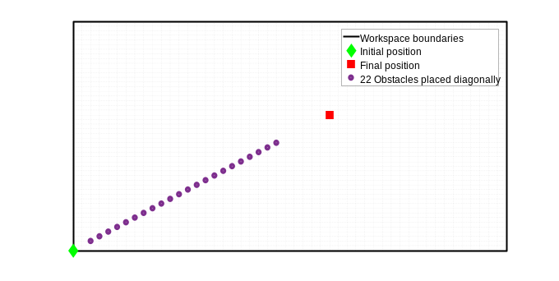Fig 4. m number of obstacles are alighned diagonally between an initial starting location of a randomly ranging AGV with desired location at (25,25). Plot shows an example of m=22 obstacles.

The average successful steps for m number of obstacles are calculated and plotted against linear accumulative distance $D$ index, which is define by
$D=\sum_{j=1}^{m}{\sqrt{{(x_{j}-x_{i})}^{2}+{(y_{j}-y_{i})}^{2}}+\sqrt{{(x_{j}-x_{f})}^{2}+{(y_{j}-y_{f})}^{2}}}$ (3)
where $\left(x_{j},y_{j}\right)$ is the location of the ij^{th} obstacle. A simulation experiment is conducted for above conditions where the average steps and D are evaluated for every $m∈\left\{1,2,…22\right\}$.
The results of the simulation in Figure 5 concludes that as more linear diagonal obstacles are added between the start and final positions, the lesser steps will be taken by the AGV to find its desired location. I
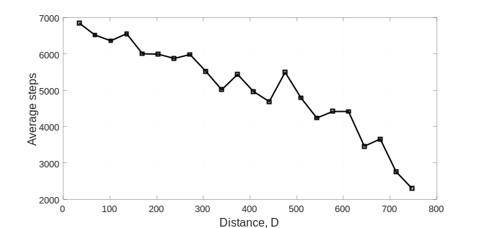
Fig 5. The effect of installing diagonal obstacles on the success of a ranging AGV to finds its destination.

The probability of occurrence or long-term probability in Equation (2) is simulated for a reduced size problem in order to reduce the computation cost. Figure 6 shows sample simulation of workspace area of size (20,20) with 8 obstacles located between initial point (1,1) and final point (10,10). While it is trivial to conclude that the probability of occurrence of robot nearby obstacle increases, but the chance to find AGV elsewhere would be small and uniform as shown in Figure 6. Therefore, in real-world, an AGV exhibiting a random walk would find its destination faster by creating a physical or virtual diagonal obstacle design as it was suggested by Figure 5.
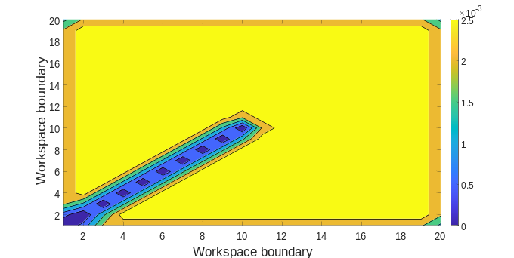
Fig 6. Probability of Occurrence for the Diagonal Design.

The second simulation experiment deals with obstacle configured in L-shaped design of fixed width, W, with initial and final desired position of a free ranging AGV being (1,1) and $\left(a-1,b-1\right)$, respectively, as shown in Figure 7. Algorithm (1) is implemented to study the relationship between the average number of successful steps and the width.
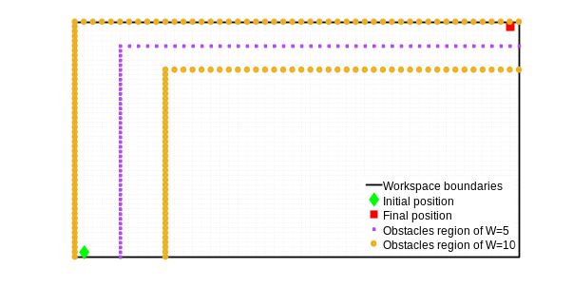
Fig 7. Example of ‘L- shaped’ obstacle containining the initial and desired locations.

The above sample design is proposed to keep the longest distance of the workspace in mind. The simulation is carried out for widths at $W=\left[1,20\right]$ at increment $∆W=1$, and three set of workspaces sizes (50,50), (75,75) and (100,100). The average success vs. width of L-shape is computed and plotted in the (left) of Figure 8, and then normalized to the area size of the workspace, ab, with results shown in the (right) of the figure.
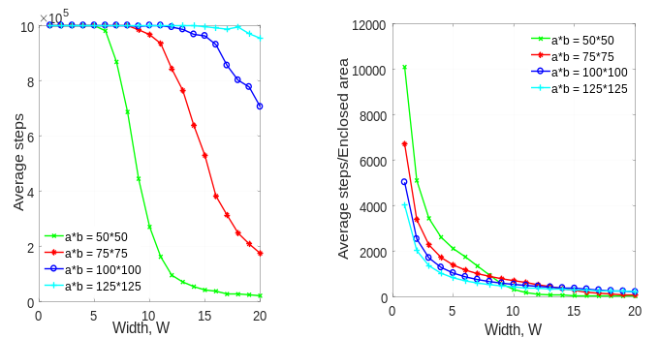
Fig 8. (Left) The effect of installing L-shaped obstacle region on the success of a ranging AGV to finds its destination. (Right) normalized plot.

The above simulation concludes that an AGV takes lesser no of steps to reach its desired point as the obstacle region decreases. Fig 9 shows the long-term probability of L-shaped Obstacle design with Width=5 in a (20,20) workspace. It is observed that there is less probability of a robot to be present near the obstacle region boundary while it is evident that the AGV have the same probability to be in the rest of the workspace.
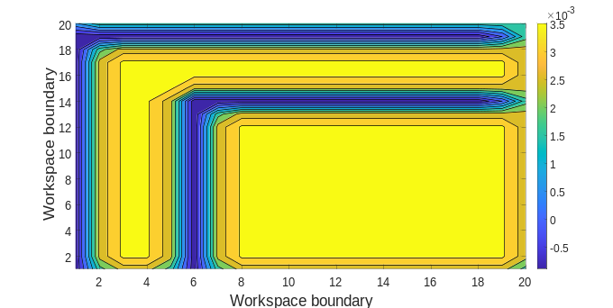
Fig 9 L- shaped Design Probability of Occurrence.

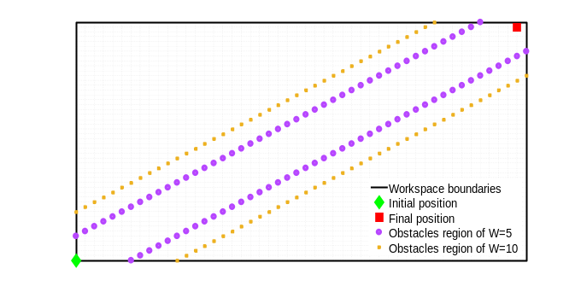
Fig 10. Passage Design is created encompassing the initial and desired location of AGV. Design shows an example of W=5 and W=10. 1 ≤ W ≤ 20 of the region is simulated.

Fig 10 is the sample simulation design that studies obstacle configured in Passage Design with initial and final position of a free ranging AGV being (1,1) and (a-1, b-1) respectively. Algorithm 1 is executed where average number of successful steps of AGV to reach from initial point $\left(x_{i},y_{i}\right)$ to a final point $\left(x_{f},y_{f}\right)$ is plotted against Width (W) of the obstacle region.

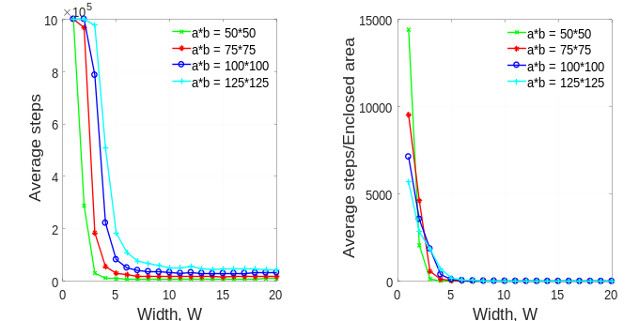
Fig 11a. The effect of installing Passage Design Obstacle region on the success of a free AGV to find its destination

Fig 11a shows Passage Design simulation of an AGV ranging freely in a steadily increasing workspace dimension. It can be observed that there is no significant change in average steps in surging width across increasing dimensions however it can be concluded that with increasing obstacle regions the AGV takes lesser no of steps to reach its desired location with a significant drop in average steps when the width ranges from 0 to 5.

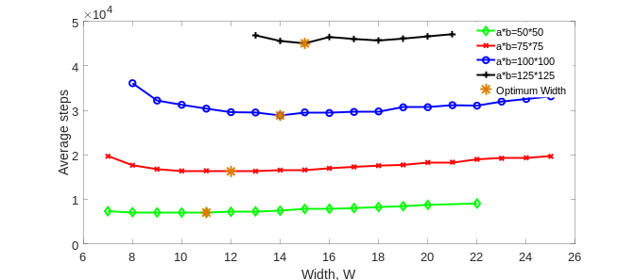
Fig 11b. Optimum widths for Passage design

Fig 11b takes a closer look at the success of an AGV in passage design. Across different workspace sizes, the average steps concave up after attaining its lowest possible value. In order to make this result more robust, a higher walk values of 9600 is chosen, as it is highly likely to converge to the true value. It is evident that the corresponding optimum width increases with increasing workspace size. It is, however, important to note that the increase in the optimum width is very small with respect to the increase in workspace sizes.

Defectivity in Passage Design
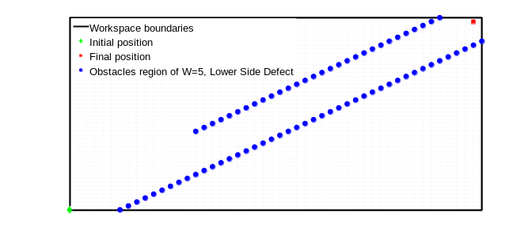
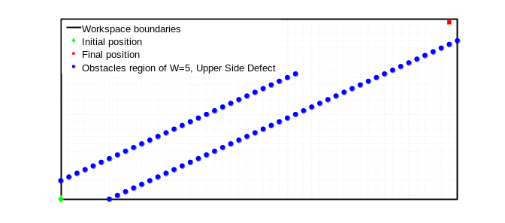
Fig 11c. Schematic of Lower type and Upper type Defects
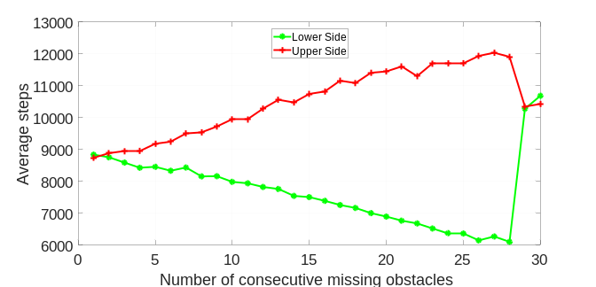
Fig 11d. AGV success in the realm of defective obstacle design

Fig 11d shows the plot for Average Steps VS Number of consecutive missing obstacles across the Lower and Upper region of defect along the left side of the region. Since the configuration is symmetric with respect to the line joining initial and final point, it is sufficient to study the defect along either left or right (we chose left without any loss of generality). However, the same argument doesn't follow for Lower or Upper sides (referring to Fig 11c) because the configuration is not symmetric with respect to the line joining initial and final points, and that is why we chose to study them individually in order to see their effect on an AGV success. It is clearly evident that in case of defect in Lower region, with increasing number of consecutive holes, we have better success of an AGV (decreasing average steps), whereas an exactly opposite effect is observed for the defect in the Upper region. There is definitely a clear effect of the defect region on the AGV success. This is a very powerful result because if we notice in the plot above, at m=28, we have a huge difference in the average steps between lower and upper sides defect types. Even though essentially in both cases there are exactly 2 obstacles on left side but the difference in configuration (kept near initial point i.e., upper OR kept near final point i.e., lower) changes the success of the AVG drastically.

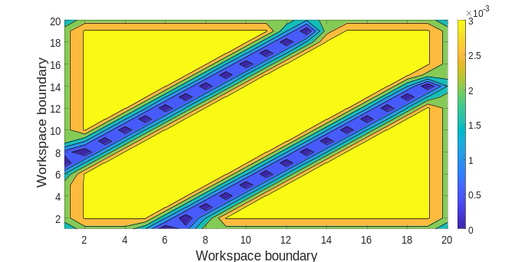
Fig 12. Passage Design Probability of Occurrence.

The above contour plot depicts that the ‘Passage’ obstacle region with width 5 and it is evident from the plot that the AGV is avoiding the obstacle region boundaries and have more probability of presence within the obstacle region and away from obstacle region boundaries.
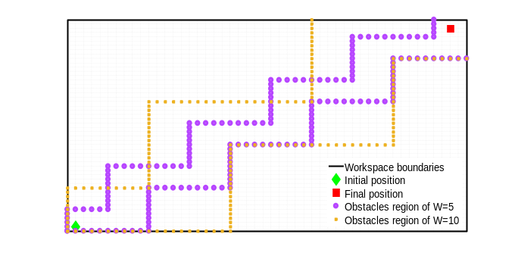
Fig 13. ‘Zig- Zag’ Obstacle Design is created encompassing the initial and desired location of AGV. Design shows an example of W=5 and W=10. 1 ≤ W ≤ 30 of the region is simulated.

Fig 13 is the simulation design of a ‘Zig- Zig’ Obstacle which is placed in a zig- zag manner across the workspace to mimic a certain complexity of an industrial workspace. An AGV performing SRW is being initialized from $\left(x_{i},y_{i}\right)$ to its final point $\left(x_{f},y_{f}\right)$ encompassing a virtual ‘Zig- Zag’ boundary. Algorithm 1 is executed where average number of successful steps of AGV to reach from $\left(x_{i},y_{i}\right)$ to $\left(x_{f},y_{f}\right)$ is plotted against Width (W) of the obstacle region on a constant increase of workspace dimensions.

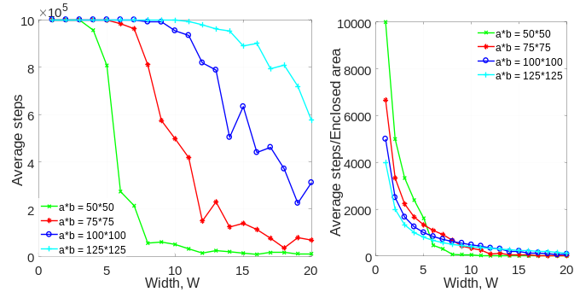
Fig 14 The effect of installing ‘Zig- Zag’ Obstacle Design on the success of a free AGV to find its destination.

It is evident in the simulation graph of Zig- Zag Obstacle design (Fig 14) that with decreasing width of the obstacle region and workspace dimensions, the average steps taken by the AGV to reach its final position also decreases. The depiction of long- term probability plot (Fig 15) says that the AGV is more likely to be present inside the workspace than near the boundaries of the workspace and the boundaries of the obstacle region.

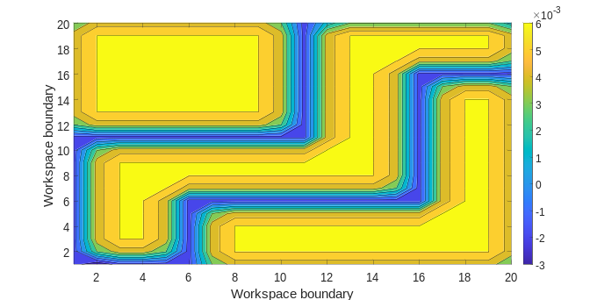
Fig 15. Zig- Zag Design Probability of Presence.

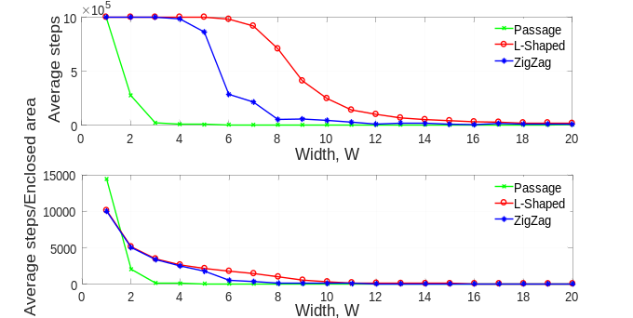
Fig 16. Comparison Study is simulated between Passage, L-shaped and Zig-Zag design.

Fig 16 shows the comparison study of the average no of steps taken by the AGV to reach its final location $\left(x_{f},y_{f}\right)=(a-1, b-1)$ from initial point $\left(x_{i},y_{i}\right)=(1,1)$ between Passage, L-shaped and Zig-Zag designs in a (50,50) workspace with 1 ≤ W ≤ 20 obstacle region. The comparison plot shows that in a human- robot collaborative workspace if an AGV performing Random Walk motion loses its navigational capability then creating a virtual ‘Passage’ obstacle design is the most efficient way to reach its desired location. The above plot evaluates that the Passage design is much more efficient as the average steps decreases with increasing width of obstacle regions eventually flattening the curve.

AGV Roaming Random obstacles
The first simulation of this study examines the relation between a free ranging AGV and m number of random static obstacles between initial position at (1,1) and final desired location at (25,25) within confined workspace area of (50,50). Algorithm 1 is implemented in MATLAB code where the average number of successful steps it takes the robot to travel from initial point $\left(x_{i},y_{i}\right)$ to a final point $\left(x_{f},y_{f}\right)$ is plotted against scattered distance which is computed in Equation 4. This simulation has been done for 300 walks to compute the average number of successful steps or called later by average steps.
$Ds=\sum_{(Xj,Yj)}{\{(Xj,Yj) – \left(\bar{X}, Ȳ\right)* \{(Xj,Yj) – (X̄, Ȳ)\}' }$ (4)

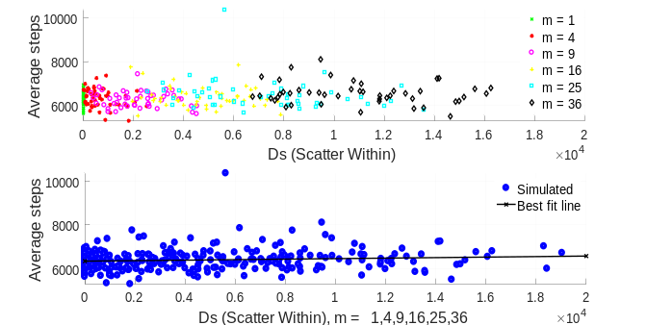
Fig 17. The effect of randomly placed static obstacles on the success of a free ranging AGV to finds its destination.

The above plot depicts that randomly placed static obstacles is having a negative impact on the average steps taken by the robot to find its way from initial to final position. It can be concluded that with increasing ‘m’ no of random static obstacles (thus, equivalently also increasing the Ds) within the workspace the average steps of the AGV also increases.

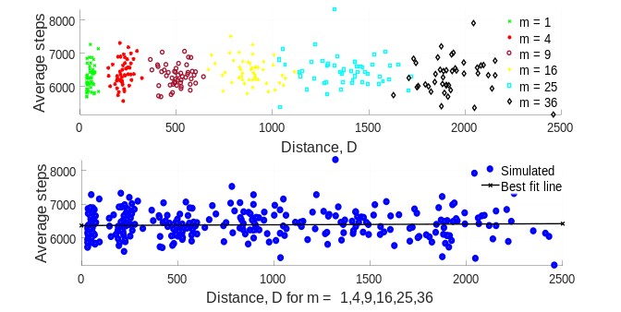
Fig 18. The effect of randomly placed static obstacles on the success of a free ranging AGV to finds its destination.

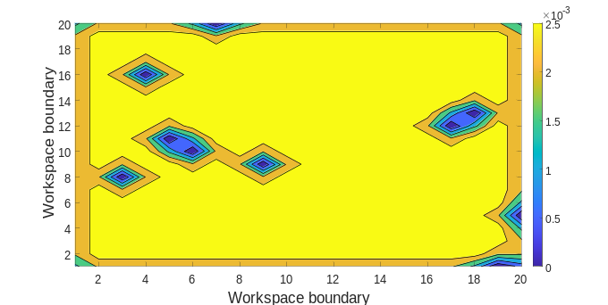
Fig 19. Randomly Placed Static Obstacles Probability of Presence.

The above figure is the long-term probability simulation of an AGV performing Random Walk in a workspace (20, 20) amidst 10 randomly generated static obstacles. The above plot says that there is long term likelihood of the AGV to be present in the yellow region whereas the blue regions depict the occurrence of the obstacles which is avoided by it. It can also be observed that the AGV is more likely to be present inside the workspace and less near the obstacles as well as the workspace boundary.

AGV Roaming Another AGV
This study mimics a real-world collaborative workspace where human- robot and robot- robot interactions co-exist and all the objects in the workspace are in independent SRW motion. The first simulation of this study involves when an AGV roams amidst of other fellow AGVs in a (50,50) workspace. Algorithm 2 is implemented in MATLAB code for this study where the average number of successful steps it takes the robot to travel from initial point $\left(x_{i},y_{i}\right)=(1,1)$ to a final point $\left(x_{f},y_{f}\right)=(49, 49)$ is studied against the Collision Probability. This study is set up on 300 Random Walks where the average steps and collision probability is evaluated on each occasion. This simulation is based on AGV performing SRW motion from initial point to final point in the presence of another independent AGV which is in 5 state Markov Chain motion.

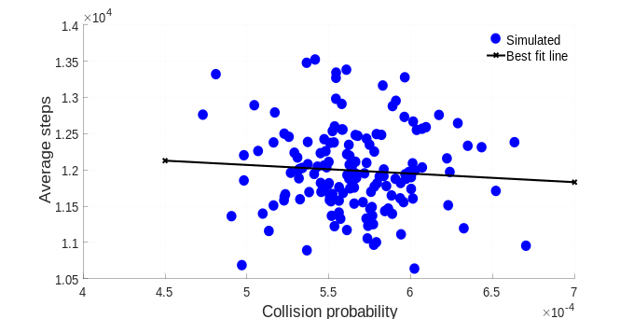
Fig 20. Collision Probability of an AGV and a ‘5 state Markov Chain’ AGV.

From fig 20, it can be observed that with increase in collision probability there is a decrease in average steps taken by the AGV to reach its final position which concludes that Markov chain motion for obstacle have a positive impact on the average no of steps.
The second simulation of this study involves when an AGV roams amidst of other fellow AGVs in a (50,50) workspace. The simulation is based on an AGV performing SRW motion from initial point $\left(x_{i},y_{i}\right)=(1,1)$ to final point $\left(x_{f},y_{f}\right)=(49, 49)$ in the presence of ‘m’ no of AGVs executing independent SRW motion.

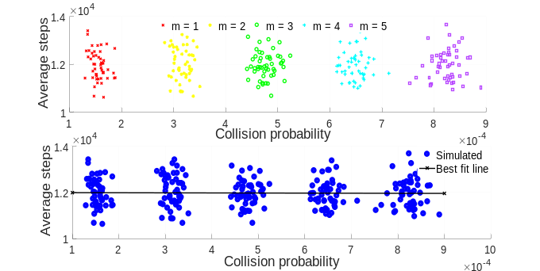
Fig 21. Collision Probability of an AGV performing SRW with ‘m’ no of SRW AGV posed as dynamic obstacles.

Fig 21 depicts a constant slope of average steps saying random dynamic obstacles have no impact on the average steps taken by the AGV to reach its desired location. The plot is based on 5 fellow SRW AGVs posing as obstacles to an AGV trying to reach its final point. From the above plot it can be concluded that in a real-world collaborative workspace if ‘m’ no of free ranging AGVs co-exist there will be no effect on each other’s performance and efficiency to reach their respective final positions.
The third and final section of this study explains if the distance between initial and final points of SRW AGV under observation has any effect on the average steps taken by it to reach its desired location when ‘m’ no of dynamic obstacles are present. Algorithm 2 is applied where $\left(x_{i},y_{i}\right)$ and $\left(x_{f},y_{f}\right)$ are assigned randomly to AGVs posing as independent dynamic obstacles in a workspace of (100,100). The AGV under observation has $\left(x_{i},y_{i}\right)=(1,1)$ and $\left(x_{f},y_{f}\right)=(49, 49)$.

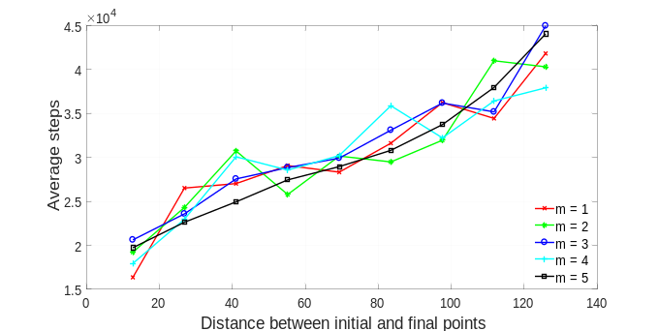
Fig 22. The effect of distance between initial and final points on the success of a free ranging AGV to finds its destination.

Fig 22. shows 5 plots of AGV under observation w.r.t to m = 1,2,3,4 and 5 present independently in the same workspace. It can be observed that trend is very similar for across different values of m. However, it can also be observed that as the distance between initial and final position increase, average steps by the AGV to reach its desired location also increases linearly. This concludes that in an industrial workspace, increasing random dynamic obstacles has no impact on average no of steps of the AGV.

Conclusion

The distance measured between an initial and a final position relate to the success of the robot to reach its final position when a number of obstacles are placed randomly in a confined workspace. More specifically, randomly placed obstacles have a negative effect on the success of the AGV to find its way from initial to final position. With increasing number of randomly placed obstacles, the average number of steps taken by the AGV to reach its final position increases. Method based on the fixed design pattern of obstacles are studied with goal to improve success of robot to travel randomly between two points by using L-shape, passage, and Zig-Zag. For example, increasing width of an ‘L’ shaped obstacle region has a negative impact on the success of the AGV. It can be concluded that with increasing size of obstacle region the AGV takes greater number of steps to reach its final position. Increasing width of a ‘Passage’ obstacle region has negative impact on the success of the AGV. In other words, the AGV takes greater number of steps to reach its final position. In this study, it can also be concluded that after a certain increased width of the obstacle region, there is no effect on the success of the robot. Increasing width of a ‘Zig- Zag’ obstacle region has a negative effect on the success of an AGV. The robot takes greater number of steps to reach its final position as the width of the region increases. In general, it was found that the success of the robot to reach its final position increases if J^{th} obstacle is near to the robot’s final position. If an AGV encounters J^{th} obstacle near its final position it will reach its final point in less time.

In the other hand, the success of the robot in the workspace where obstacles are undergoing Markov chain or random walk is studied. The success of an AGV has a positive impact if ‘m’ number of obstacles in Markov chain states are placed within the workspace. It can be concluded that the collision probability increases with decrease of average number of steps. The success of the AGV has no effect if ‘m’ number of obstacles performing random walk coexist in the same workspace.
The study can be concluded by stating that if an AGV loses its navigational capability, ‘Passage Design’ is the most efficient way to reach its final position. On the case of dynamic obstacles, if the obstacles are in Markov chain, the lost AGV will reach its final position in minimum average number of steps. From the all the contour plots it is clearly seen that robot performing random walk inside the workspace is not moving beyond the region as soon as it hits the boundary it pushed itself inside the workspace. The contour plots address the chances of collision of the robot with the obstacle boundaries. The Probability of Presence can help future engineers to choose an appropriate facility layout in terms of best location of equipment. It can also help the engineers to predict the robot path and warn the facility workers about which area to avoid during work.

Extension of our work to Brownian motion of a dye/perfume particles in a fluid in a pipe.

The 2D Brownian motion of a single particle is similar to a simple 2D random walk (that we considered in our paper), except for a change that each step in each direction is not just either -1 or +1, but any random number between -1 and +1. As a result, the Brownian motion looks much more irregular than random walk because of the possibility of a particle to move in 2 directions with more variable steps and not just integer steps.
Furthermore, if we want to compare our simulations to the Brownian motion of a dye/perfume particles in a fluid in a pipe, then we would have to make the following extensions in our current simulations; first, we would have to consider a 3 dimensional motion; second, we would have to add in infinitely large number of obstacles (particles of fluid); third, we would have to let all those obstacles to have a random motion (like collection of independent random walks, as we did in dynamic obstacles); fourth, we would have to consider obstacle's size much smaller than the particle in consideration because fluid particles are generally much smaller than the dye/perfume particle's size; fifth, if we have to make it even more realistic, then we would also have to consider more than just one particle in consideration because usually dye/perfume are not just one single particle but bunch of many (and then let them also collide with each other). Once we make these changes, then only we say something rigid and robust about the Brownian motion of a dye/perfume in a fluid in a pipe.

The results from this study can help future Human- Robot workspace designer’s engineers to evaluate the risks of designing an industrial workspace. This study also serves a platform for a more efficient way to place obstacles in a shared workspace for effective mobile robotic path planning.

References

[1] SICKUSAblog, “Additional Solutions for Collision Avoidance with Indoor AGVs,” SICKUSAblog, Jul-2019.
[2] “No Title.” [Online]. Available: https://www.osha.gov/recordkeeping/.
[3] OSHA, “Robot Accident Search Results.”
[4] A. P. Vancea and I. Orha, “A survey in the design and control of automated guided vehicle systems,” Carpathian J. Electron. Comput. Eng., vol. 12, no. 2, pp. 41–49, 2020.
[5] T. L.-A. (Tuan) and J. R. van der M. (Robert) M.B.M. de Koster (René), “Testing and classifying vehicle dispatching rules in three real-world settings,” J. Oper. Manag., vol. Volume 22, no. Issue 4 SPEC. ISS, pp. 369–386, 2004.
[6] E. Cardarelli, L. Sabattini, V. Digani, C. Secchi, and C. Fantuzzi, “Interacting with a multi AGV system,” Proc. - 2015 IEEE 11th Int. Conf. Intell. Comput. Commun. Process. ICCP 2015, no. March 2016, pp. 263–267, 2015.
[7] W. He, Z. Li, and C. L. P. Chen, “A survey of human-centered intelligent robots: Issues and challenges,” IEEE/CAA J. Autom. Sin., vol. 4, no. 4, pp. 602–609, 2017.
[8] and T. N. (Germany) A. Prusak, J. Bernshausen, H. Roth, J. Warburg, C. Hille, H.-H. Gtting, “Applications of Automated Guided Vehicle (AGV) and Industry Robots with PMD-Camera,” Robot. Appl. Telemat. - 2007, 2007.
[9] M. T. Changliu Liu, “Designing the Robot Behavior for Safe Human–Robot Interactions,” in Trends in Control and Decision-Making for Human–Robot Collaboration Systems, 2017, pp. 241–270.
[10] L. Sabattini et al., “Technological roadmap to boost the introduction of AGVs in industrial applications,” Proc. - 2013 IEEE 9th Int. Conf. Intell. Comput. Commun. Process. ICCP 2013, no. September, pp. 203–208, 2013.
[11] B. S. P. Reddy & C. S. P. Rao, “A hybrid multi-objective GA for simultaneous scheduling of machines and AGVs in FMS,” Int. J. Adv. Manuf. Technol., vol. 31, pp. 602–613, 2006.
[12] M. V. S. Kumar, R. Janardhana, and C. S. P. Rao, “Simultaneous scheduling of machines and vehicles in an FMS environment with alternative routing,” Int. J. Adv. Manuf. Technol., vol. 53, no. 1–4, pp. 339–351, 2011.
[13] J. Jerald, P. Asokan, G. Prabaharan, and R. Saravanan, “Scheduling optimisation of flexible manufacturing systems using particle swarm optimisation algorithm,” Int. J. Adv. Manuf. Technol., vol. 25, no. 9–10, pp. 964–971, 2005.
[14] N. N. Krishnamurthy, “Developing Conflict-Free Routes for Automated Guided Vehicles Author ( s ): Nirup N . Krishnamurthy , Rajan Batta and Mark H . Karwan Published by : INFORMS Stable URL : https://www.jstor.org/stable/171602 All use subject to https://about.jstor.org/terms ,” vol. 41, no. 6, pp. 1077–1090, 2018.
[15] G. A. koff David W. Zeitler, Matthew L. Werner, “DYNAMIC OBJECT AVOIDANCE WITH AUTOMATED GUIDED VEHICLE,” 2005.
[16] R. M. T. David C. Emanuel, Robert S. Kunzig, “Method and Apparatus for Collision Avoidance,” 2013.
[17] S. Tae-Eun Park, “AGV CONTROL SYSTEM AND METHOD,” 2007.
[18] K. (JP) Jun Kondo, “TRAVEL CONTROL DEVICE FOR UNMANNED CONVEYANCE VEHICLE,” 2013.
[19] Sun-Gi Hong,Seokwon Bang,Dong Ryeol Park, “pparatus and method for estimating a position and an orientation of a mobile robot,” 2010.
[20] P. A. Lasota, T. Fong, and J. A. Shah, “A Survey of Methods for Safe Human-Robot Interaction,” Found. Trends Robot., vol. 5, no. 3, pp. 261–349, 2017.
[21] G. Michalos, S. Makris, P. Tsarouchi, T. Guasch, D. Kontovrakis, and G. Chryssolouris, “Design considerations for safe human-robot collaborative workplaces,” Procedia CIRP, vol. 37, pp. 248–253, 2015.
[22] R. Inam et al., “Risk Assessment for Human-Robot Collaboration in an automated warehouse scenario,” IEEE Int. Conf. Emerg. Technol. Fact. Autom. ETFA, vol. 2018-Septe, no. September, pp. 743–751, 2018.
[23] E. Magrini, F. Ferraguti, A. J. Ronga, F. Pini, A. De Luca, and F. Leali, “Human-robot coexistence and interaction in open industrial cells,” Robot. Comput. Integr. Manuf., vol. 61, no. July 2019, p. 101846, 2020.
[24] I. Draganjac, D. Miklic, Z. Kovacic, G. Vasiljevic, and S. Bogdan, “Decentralized Control of Multi-AGV Systems in Autonomous Warehousing Applications,” IEEE Trans. Autom. Sci. Eng., vol. 13, no. 4, pp. 1433–1447, 2016.
[25] R. S. Richard Kendall Miller, Automated Guided Vehicles and Automated Manufacturing. Society of Manufacturing EngineersP.O. Box 930 One SME Drive Dearborn, MIUnited States, 1987.
[26] C. R. Niklas Möller, Sven Ove Hansson, Jan-Erik Holmberg, Handbook of Safety Principles. Wiley, 2018.
[27] T. Helmer, Development of a Methodology for the Evaluation of Active Safety using the Example of Preventive Pedestrian Protection. Springer, Cham, 2015.
[28] MMH Staff, “AGVs enhance automotive powertrain production,” Modern Material Handling, Oct-2018.
[29] AGV TECHNOLOGY, “Understanding AGV Safety Systems,” AGV NETWORK, Jun-2020.
[30] R. Bostelman, “AGMs and Forklifts Gaining Sight for Safety,” Mater. Handl. Logist., vol. 68, no. 1, pp. 34–37, 2013.
[31] C. F. Christian Frese, Angelika Fetzner, “Multi-Sensor Obstacle Tracking for Safe Human-Robot Interaction.”
[32] J. H. Chen and K. T. Song, “Collision-Free Motion Planning for Human-Robot Collaborative Safety under Cartesian Constraint,” Proc. - IEEE Int. Conf. Robot. Autom., pp. 4348–4354, 2018.
[33] P. Wenger and P. Chedmail, “Ability of a robot to travel through its free work space in an environment with obstacles,” Int. J. Rob. Res., vol. 10, no. 3, pp. 214–227, 1991.
[34] N. Vahrenkamp et al., “Workspace analysis for planning human-robot interaction tasks,” IEEE-RAS Int. Conf. Humanoid Robot., pp. 1298–1303, 2016.
[35] F. Rezazadegan, J. Geng, M. Ghirardi, G. Menga, and G. Camuncoli, “Politecnico di Torino Porto Institutional Repository Risked-based Design for the Physical Human-Robot Interaction ( pHRI ): an Overview,” vol. 43, pp. 1249–1254, 2015.
[36] E. Kim, R. Kirschner, Y. Yamada, and S. Okamoto, “Estimating probability of human hand intrusion for speed and separation monitoring using interference theory,” Robot. Comput. Integr. Manuf., vol. 61, Feb. 2020.
[37] Alain Lambert ; Dominique Gruyer ; Guillaume Saint Pierre, “A fast Monte Carlo algorithm for collision probability estimation,” 2008.
[38] J. Van Den Berg, P. Abbee, and K. Goldberg, “LQG-MP: Optimized path planning for robots with motion uncertainty and imperfect state information,” in International Journal of Robotics Research, 2011, vol. 30, no. 7, pp. 895–913.
[39] S. Patil, J. Van Den Berg, and R. Alterovitz, “Estimating Probability of Collision for Safe Motion Planning under Gaussian Motion and Sensing Uncertainty.”
[40] Institute of Electrical and Electronics Engineers., “ICRA 2012 : 2012 IEEE International Conference on Robotics and Automation : St. Paul, Minnesota, USA, May 14-18, 2012.,” 2012.
[41] J. H. Liang and C. H. Lee, “Efficient collision-free path-planning of multiple mobile robots system using efficient artificial bee colony algorithm,” Adv. Eng. Softw., vol. 79, pp. 47–56, 2015.
[42] N. Pedrocchi, F. Vicentini, M. Malosio, and L. M. Tosatti, “Safe human-robot cooperation in an industrial environment,” Int. J. Adv. Robot. Syst., vol. 10, Jan. 2013.
[43] D. Claes and K. Tuyls, “Multi robot collision avoidance in a shared workspace,” Auton. Robots, vol. 42, no. 8, pp. 1749–1770, Dec. 2018.
[44] C. Park, J. S. Park, and D. Manocha, “Fast and Bounded Probabilistic Collision Detection for High-DOF Robots in Dynamic Environments.”
[45] J. H. Cho, D. S. Pae, M. T. Lim, and T. K. Kang, “A Real-Time Obstacle Avoidance Method for Autonomous Vehicles Using an Obstacle-Dependent Gaussian Potential Field,” J. Adv. Transp., vol. 2018, 2018.
[46] S. Carpin and G. Pillonetto, “Motion planning using adaptive random walks,” IEEE Trans. Robot., vol. 21, no. 1, pp. 129–136, 2005.
[47] L. Palmieri, A. Rudenko, and K. O. Arras, “A fast random walk approach to find diverse paths for robot navigation,” IEEE Robot. Autom. Lett., vol. 2, no. 1, pp. 269–276, Jan. 2017.
[48] B. Pang, Y. Song, C. Zhang, H. Wang, and R. Yang, “A Swarm Robotic Exploration Strategy Based on an Improved Random Walk Method,” J. Robot., vol. 2019, 2019.
[49] W. Chen, “Motion Planning with Monte Carlo Random Walks.”
[50] M. Biskup, Random walks. 1827.
[51] A. Singh, “Reinforcement Learning : Markov-Decision Process (Part 1),” 2019. [Online]. Available: file:///C:/Users/indra/Downloads/Reinforcement Learning _ Markov-Decision Process (Part 1).pdf.
[52] E. Behrends, Introduction to Markov chains, vol. 228. Springer, 2000.
[53] Ryan O’Donnell, Great Ideas in Theoretical Computer Science: Random Walks and Markov Chains (Spring 2016. USA: Youtube, 2017, pp. 53:13, 54:59.
[54] N. Etemadi, “An elementary proof of the strong law of large numbers,” vol. 55, pp. 119–122, 1981.

