Study of Obstacle Design for Improved Navigation of Randomly Ranging AGV in Confined Workspace
Indravash Chowdhury, Ravinder Singh, Christopher Kluse, Mohammad Mayyas ∗
eFactory Laboratory, Mechatronics Engineering Technology, Bowling Green State University, Bowling Green, Ohio, USA. *Corresponding Author: mmayyas@bgsu.edu

HIGHLIGHT
- The paper starts with a review of Automated Guided Vehicle (AGV) navigation approaches to safety in manufacturing.
- The paper provides extensive simulations on how obstacles could improve the success of a robot complete navigation mission.
- The paper studies the worst-case scenario for a robot with minimum navigation capabilities, and its underlying random motion in closed workspace.
- The paper investigates the interaction between single-multiple AGVs in dynamic random motion with random and structured obstacles.
- The paper provides a design perspective for future advanced manufacturing facilities where human and machine interact in a shared work environment.

Keywords:
Human–robot interaction
Automated Guided Vehicles
Obstacles Design
Workspace Design
Random Walk

ABSTRACT

As robots age, and their components wear down, downtime may increase. Through the use of Random Walk style failsafe’s, it may be not only possible to rescue robots that lost their path planning capability, but also help improve safety by designing a better workspace layout that uses a probability of collision map. This paper investigates the ability of a mobile vehicle to find its destination based on random walk locomotion. The goal is to investigate the probability of collision and the average number of steps it takes with large number of randomized walk in a confined two-dimensional space which encompasses static or dynamic spatial obstacles. The proposed simulation algorithm illustrates human robot interaction where an Automated Guided Vehicle system is freely ranging within a crowed of moving or stationary workers and obstacles in a confined workspace. Furthermore, the study is concerned with a worst-case scenario when a robot loses its path planning capability due to a communication or processing malfunction. Therefore, the question becomes what is the cost of sending robot to its safe “home” position with minimum inboard navigation sensor and reduced risk of collision. To address this problem, a novel ‘Obstacle Design’ approach has been introduced to study the effect of obstacles on an un-navigable robot with no path planning capability so that it can reach its final position with maximum efficiency. This study evaluates the effect of workspace obstacles, and in the future can assist engineers to understand the risk and design constraints of a human- robot workspace.

- Introduction

Automated Guided Vehicle systems (AGVs), provide manufacturing and logistic facilities with added flexibility thereby increasing the overall rate of production. These AGVs are outfitted with appropriate safety equipment and sensors to make them safe while in operation [1] . The main advantage of AGVs are that “if properly guided”, they do not injure people and/or damage infrastructures. It is generally accepted that AGVs are safer than manual equipment such as conventional forklifts. The introduction of collaborative AGVs or robots has initiated the concept of fencing, and currently in this advanced technology era, the combined work effort between humans and robots has become efficient and productive. However, the coexistence of robots and humans in the same workspace has created a safety related risk to humans making safety a priority in a shared human-robot workspace. According to the Occupational Safety and Health Administration (OSHA) records, industry related injuries indicate that from 2015 to 2019, 76% of injuries (4 injuries total) were severe and 3 fatalities occurred throughout the USA [2]. These injuries are attributed to autonomous cars, mobile cars, and AGVs. OSHA states that there were 30 casualties in a human-robot workspace from 1987 to 2019 [3]. Due to a significant increase in robot induction worldwide, and the increasing amount of human-robot interaction, it has become important to investigate the relationship between the robot and the workspace, examine the probability of accidents, and determine a solution to minimize unsafe interaction.
AGVs are internal based transport systems that utilize automated guided machinery and provides its services in warehouses, trans-shipment terminals, manufacturing plants and distribution centres. Automated guided vehicles have also an important role in the transportation of materials that are associated with manufacturing processes. About 20,000 automated guided vehicles are utilized for industrial applications[4]. The use of the automated guided vehicle has increased significantly since their introduction. AGV variations and the application opportunities for these AGV’s has significantly increased. Automated guided vehicles can be used in external and internal environments such as manufacturing, distribution, transhipment and (external) transportation areas [5].
According to Cardarelli et al., a unique interface can allow the users to communicate and fully interact with a vast fleet of AGVs [6]. These HMI, human-machine interfaces, are highly helpful for logistical activities within industrial environments. This noteworthy research is now applied to intelligent control, navigation, human-robot interaction, and pattern recognition. Prusak and the rest of the researchers raised the same argument. In their discussion, a PMD-camera (Photonic Mixer Device camera) is used in sensing the obstacles within the path of an AGV. In addition, the same technique is used when there is a need to monitor the area where an industry robot is working [7].
The PMD-camera acts as an interactive technique that records the video images of various objects and scenes in both 2-D and 3-D greyscales and deep-data images, respectively. According to Liu and Tomizuka [8] , HRI systems design considers the formation of a multi-agent framework, thus taking care of safety and possible conflict. Such interfaces have the ability to mimic social behaviors, uncertainties, and norms. Regardless of the constraints and shortcomings, Sabattini and fellow researchers feel that AVG systems can be improved for factory logistics [9]. They agree on the means through which more of the human activities can be interpreted through artificial machine intelligence. The main goal is to act more like humans, with advanced efficiencies, and minimize human errors.
It is important to provide insight into the research regarding AGVs routing via transhipment and transportation along with the scheduling of various material handling equipment in large AGV systems since research in these areas are limited. The integration of routing and scheduling is a challenging problem. Therefore, it is important to conduct a study in which these particular characteristics should be addressed. The advantage of multi-objective problems in scheduling plays a significant role in scheduling the operations and production planning in a flexible manufacturing system. For example, Heuristic based approaches include evolutionary algorithms adopted to address the multi-objective scheduling problems in a flexible industrial environment by analysing the vehicle and machine scheduling features in FMS, moreover, it addresses the mutual problem for the minimization of the mean flow time as well as for the mean tardiness objectives [10]. In contrast, differential evolution has been used as one of the most influential tools and [11] depicts the synchronised scheduling for material handling systems. In order to minimize the cycle time, a combination of vehicle assignment heuristics and machine selection heuristics are very useful. In Artificial Intelligent based approaches, Jerald et al explains that the total cost can be minimized by generating the optimum schedule including simulated annealing (SA), genetic algorithm (GA), swarm algorithm (PSA), and memetic algorithm (MA). Additionally, these mechanisms help to overcome the idle time [12]. While solving the optimization problem, the objective is often achieved by involving wide-ranging computational resources. Heuristic Approaches are employed to overcome the routing problems by minimizing transportation time [13].
Countless inventions have been developed to accomplish the “guided” portion of AGV operation. One such patented invention enables an autonomous vehicle to adjust its pre-programmed path in order to avoid obstacles [14]. This type of system works with several different types of guided vehicles from single cargo units to ones that tow a train of connected carts. Typically, a system is comprised of a computer that receives an input signal from a detection sensor such as a laser scanner. The computer, rather than stopping the vehicle when an obstacle is detected, calculates a safe offset from its normal path and navigates the vehicle around the obstacle according to this temporary safe path. This type of collision avoidance is preferable because the vehicle navigates safely without having to stop.
Avoidance between multiple AVGs was developed by Emanuel et al [15]. This method is executed using several steps. First, the vehicle’s computer tracks the position of all other vehicles in its detection area at regular intervals. Next, the computer calculates the trajectory of each surrounding vehicle from the collected velocity and directional data and predicts where the vehicle, and the other vehicles will collide. The computer then sends a warning signal to the other vehicles and maneuvers itself to avoid the predicted collision. This type of system is useful because it allows an AGV to avoid dynamic obstacles that are constantly moving.
Another way to avoid dynamic collisions is to allow each AGV to know where each other are located before it is assigned a path. This is achieved by a host computer that sends signals to all AGVs in the operating area that tells the AGV whether to move along a path or avoid the path [16]. The computer assigns a path for the subsequent vehicle, checks if there are other vehicles moving on that path, and sends the next vehicle along that path if no other vehicles are in the way. This method is proactive since it assigns clear paths before the vehicle starts to move.
While steering clear of obstacles is important, the vehicle must be able to follow a pre-determined path. Kondo has invented a system that offers improved controls for the path of an automated guided vehicle [17]. This system is composed of several magnetic sensors underneath the vehicle that detects magnetic tape on the floor within the operating area. The main sensor is positioned in the middle of the vehicle, and several small sensors are positioned to the left and right of the main sensor. The side sensors allow the vehicle to better detect and adjust accordingly when it deviates left or right from the guide tape. Accurate movement and paths are essential for AGVs to work properly and efficiently; thus having more sensors provides the ability to calculate small movements and deviations.
Another method to determine a vehicle’s location was developed by Hong et al [18]. Unlike the previous method that was guided by the floor, this method controls vehicle navigation by using the building’s ceiling. This is beneficial when light conditions vary across the vehicle’s operating area. The vehicles locates themselves by taking an image of the ceiling that are covered with numerous unique markers. The markers have areas that are infrared reflective and areas that are non-reflective. Based on the shape of the markers and the orientation of the reflective and non-reflective sections, the vehicle’s computer calculates its position and orientation in the workspace. This method has several benefits. As mentioned previously, this system works in difficult lighting conditions because the ceiling markers reflect unique patterns of light sent by the vehicle. This system also allows for a vehicle to know its orientation in the space as well as its current location.
To ensure a safe human-robotic environment before installing a mobile robot, safety assessment of the workspace is considered a best practice. There has been a significant amount of work conducted relative to safety in human-robot interaction. Lasota et. al surveyed various methods that have been used for the same human- robot interaction [19]. The survey covered areas by addressing safety through control, robotic motion planning, prediction, and psychological factors. The survey also includes pre-collision and post collision methods that have been analyzed by predicting natural human action and motion. Other methods include operator safety on an assembly line for collaborative robots [20], hazard operability analysis to identify the hazards, risk assessment in a human-robot collaborative environment [21], and human-robot interaction guided by operator gesture [22]. Draganjac et.al presented an algorithm for autonomous path planning and motion coordination for multiple AGV’s to determine the shortest feasible path by using reliable detection and prioritized conflict resolution in the shared workspace [23].
In 1987, Miller and Subrin presented the essentials for the safe operation of AGVs [24]. Part of this was an analysis on the merit of what was then, modern optic and ultrasonic technologies for sensing. Today, many of the problems pinpointed by Miller & Subrin have been addressed, however they still warrant consideration. The primary concerns for both technologies are false positives and inaccuracy when used on curved paths. With modern lenses and filtering technologies, these problems are minimized using optic technology. Safety is an important and complex issue, and there are many ways to solve safety problems. Some researchers have advocated for the use of a full system to represent a reality-based process for solving these problems, beginning with discovery, and commencing with continuous improvement. According to Möller and Niklas [25], there are four “metaprinciples”; (a) inventorize, (b) capacitate, (c) prioritize, and (d) integrate. Inventorize, in this case, means to catalog anything that is considered a safety issue. This includes the nature and severity of systems either planned or existing. Capacitate entails determining how certain features of the system (as planned/built) can be used to help minimize those issues, as well as improving the efficacy of those features when used in this way. Prioritize simply means that the most important improvements are given top priority. Integrating extends the envelope of responsibility beyond the product itself, through education of the workforce and management who are involved in the use of the product.
Extensive research was performed by T. Helmer and was described in Development of a Methodology for the Evaluation of Active Safety using the Example of Preventative Pedestrian Protection [26]. Using millions of simulations, Helmer provided a great deal of data on the efficacy of three basic systems used in preventative safety measures. These systems are: (a) warnings, (b) brake assist, and (c) automatic braking. The research examined the main factors that lead to the results of each of the three systems.
In order to comply with safety rules, AGV’s must include some safety sensors and devices to prevent risks. AGV’s should contain sensors in the direction of travel covering the maximum moving width and length provided to prevent contact between the load and any possible obstacle. In Industry 4.0, human risk mitigation through various safety measures has become a paramount concern. Laser scanners have been recently used in obstacle recognition and personnel safety. Other sensing methods include cameras, radar, and ultrasound sensors where the latter has been favored since the late 80’s [27]. The main AGV active safety devices and AGV safety sensors are collision avoidance system, contact bumpers emergency, stop buttons, and safety PLC’s. The collision avoidance system on the AGV can apply several different laser sensors that are set up on the front, rear, side, and upper locations of the AGV. When the AGV is moving on a guided path, this system will detect an obstacle (such as a human) in any of the coverage locations. When the obstacle is within the warning field of any of these sensors, the AGV will decelerate to a slower speed in anticipation of a full stop. If the obstacle is still detected within the protective field of the sensor, the AGV will apply its brake to initiate a complete stop before contact is made. The AGV will resume automatic operation approximately three seconds after the obstacle is removed from the protective field [28].
The safety area must be designed depending on many factors, which include the surrounding area, vehicle speed, payload, and floor conditions. Every point of the path followed by an AGV must have its own safety area to ensure that the time and distance to stop the vehicle is sufficient to avoid contact with obstacles. According to Bostelman, recent information about AGV accidents demonstrates that even with onboard sensors these vehicles did not detect nearby workers [29]. Additional complications involving operator safety will occur as AGVs are employed in open environments or when robot arms are added to AGV platforms. These safety risks can be alleviated with the use of new technologies, such as three-dimensional sensors and algorithms that provide industrial vehicles with information about potential collisions in their paths. However, the capabilities of new sensors need to be fully explored and their strengths and weaknesses understood before they can be incorporated onto AGVs that are deployed on the production floor.
Researchers have developed various algorithms to improve safety of robotic movement through motion planning techniques and sensing function. For example, Frese et. al. proposed an innovative method for extrinsic calibration of sensors to track arbitrary obstacles around the robot [30]. Chen et. al has utilized KinectV2 depth cameras to track dynamic obstacles which are moving objects around the workspace [31]. Alternatively, optimizing the layout of obstacles in workspace can be essential for ensuring worker safety. Wenger and Chedmail presented a geometrical analysis of a free workspace for a collaborative robot by characterizing the effect of obstacles using Constructive Solid Geometry (CSG) and Computer Aided Design (CAD) descriptions of robots and obstacles [32]. The paper also uses an octree model of the free workspace for geometrical analysis. Vahrenkamp et. al introduced task specific interaction for both robots and human to determine suitable location for human robot interaction tasks [33]. Rezazadegan et. al proposed a risk-based framework for human-robot interface through safety control systems which includes proximity detection, collision avoidance systems and docking & compliance control [34].
Safety measures with probabilistic approach are imminent to avoid these collisions. There are a range of approaches to calculate the probability of collisions in human-robot distributed workspace. The analyses of the probability of risk due to intrusion uses several factors such as the safety function of the robot, human and robots, relative velocity, and position [35]. Lambert et. al presented a probabilistic, Monte Carlo algorithm to reduce risk from Gaussian integrals with vehicle volume and obstacle volume as considerations [36]. Berg et.al. proposed an approach which decreases the probability of collisions based on linear quadratic Gaussian-motion planning [37] . The algorithm uses rapid a random trees model to minimize the collision by sensing the uncertainty. Applying sampling-based algorithms such as the Monte Carlo sampling strategy model, collision probabilities are estimated by extrapolating the ratio of the number of collision free of simulated executions [38].
Several collision avoidance approaches have been proposed in the field of robotics research. Flacco et. al developed a human-robot collision avoidance approach through a potential field method where the repulsive command for the robot is generated to avoid obstacles. The distance between the robot and the moving obstacle is calculated and the repulsive vector is used to control the generic motion of the robot [39]. Path finding methods such as artificial potential field, particle swarm optimization, and ant colony optimization are also used to foster safe mobile robot path planning. Liang, Lee used the artificial bee colony algorithm on motion planning of multiple mobile robots in a dynamic environment [40]. Pedrochhi, et al. indicated that most robots in manufacturing plants follow the sense and avoid approach with a camera mounted on a robot which computes the distance if an obstacle comes within a minimum distance, then the sense and avoid algorithm is applied to stop the robot [41].
Researchers have also studied safety measures through a collision detection algorithm. For example, multi robot collision avoidance based on a velocity obstacle paradigm is used in a dynamic workspace to reduce collision probability [42]. Collision probabilities of high definition robots in a dynamic environment are used with Gaussian distribution where the obstacles are represented in the workspace as a probability distribution[43]. Cho et al. introduced and implemented an obstacle-dependent Gaussian potential field method for autonomous vehicles to avoid obstacle collision [44]. Mathematical models are present to facilitate the optimization of motion planning in a dynamic workspace. Examples of models based on analytical models include Gaussian distribution [36][37][43], random tree [37], and Monte Carlo sampling strategies [36][38]. Current research [45][46][47][40][38][37] indicates that the focus is primarily on the improvement of robotic path planning using different mathematical models. However, there is no substantial evidence of any mathematical form that can be used to calculate a process of creating random motion such as Simple Random Walk (SRW) for studying the effect of static and dynamic obstacles.
In recent research, the Random Walk model has been used in robot motion planning such as the swarm robotics area exploration strategy where the random walk methods, based on Brownian motion, and the levy flight method, are used as the direction moved by a robot after each step is stochastic[47]. New approaches based on Monte Carlo random walk such as bidirectional Arvand and optimizing planner Arvand are used to improve motion planning performance by using simple random walk to sample the workspace by measuring the distance between the goal point and the sampled states [48]. Fast random walk approach that determines diverse and efficient paths from different homotopy class have also been proposed to improve robotic path planning [46].
While the previously aforementioned path planning methods require navigation capability based on distributed sensors that can realize and analyze the surrounding environment in real-time by using in board computational capability, this paper presents a failsafe method for controlling the path of AGVs or robots during worst case scenario particularly when only two sensing capabilities are present. The sensing capabilities are sense and avoid, which indicates that the robot knows its final state upon arrival but not during the intermediate states. This method expands on the Random Walk theory to include simulation of freely ranging robots in confined areas comingling with static and dynamic obstacles. This modified process uses random step to steer AGV randomly until it reaches an end point. Directing a robots performance to go to a safe home position without any guidance is currently not determined. The merit of this paper is based on the need to understand how the distribution of obstacles within a workspace could affect the ability of robot to achieve a simple task and how marching locomotion could help in the design and layout for a safe working environment.
The following section (2) introduces the ‘Obstacle Design’ approach method. This method is Based on probabilistic approach through simulation on the effect of obstacles using the Simple Random Walk (SRW) model in a shared workspace.
- Method: Random Walk Navigation in Confined Workspace

When the navigation systems on an AGV or a robot fail, the best the users can hope for is to send a signal to shut it down or to send it directly to a safe home position. The use of simple and robust sensors, such as inductive sensors, could be a viable solution to report whether a free ranging AGV has arrived at a desired state. This analogy is similar to sending a robot to the planet Mars and then asking it to find its way to a command station without use of navigation system. Or having a blind person randomly navigates his way in a room to an exit door. These free marching walks, whether applied to a blind person or robot, can be modeled by the SRW principle that randomizes steps during a journey to a desired location. This sensor less roaming method, when combined with obstacle avoidance, could be a replacement in absence of a navigation system. On the other hand, with the increasing installation of AGVs in manufacturing plants, and with demand for inclusion of collaborative human robot interaction, it is desired to understand the risk of such collaboration given a worst case scenario where a robot is operating and a worker is randomly and carelessly roaming around. The question that one could ask is, what is the accidence probability within a manufacturing workspace area, and what should be done better to improve facility layout in such a way that if a layout is strategically reconfigured the accident probability reduces.
Random Walk is a stochastic process where the path consists of a succession of random steps. Therefore, this method is not truly a stochastic process, as the direction the AGV moves is restricted by the presence of obstacles and workers. Conditional probabilities were used in formulating the probability expression that the researchers are testing. They are commonly used in situations with some complexity that make the use of a single simple probability calculation inaccurate.
SRW is a stochastic process which involves the collection of identical independent random variables where each of those random variables represents the next move [49]. An AGV undergoing SRW in a rectangular gridded area moves discretely at probability of 25%. When repeated n times, the probability becomes ${(25\%)}^{n}$. For example, for a robot moving in a grid workspace, at any given position, the robot has the chance of moving along each of the adjacent grid points. In one-dimensional SRW, the walk state X₁ jumps left or right equally likely at each time along the X-direction. Similarly, in two-dimensional SRW, each step will have an equal probability bounded by a rectangular wall defined by two-end corners $〈0,0〉$ and $〈a,b〉$. A step is defined by the displacement unit made by AGV in x and y coordinates. The average steps per walk are used to account for the uncertainties in the robotic motion and to avoid outliers. The average step of an AGV roaming in a finite plane with obstacles, with an initial point “i” and end point “f”, has no analytical form. Therefore, a numerical simulation has been being adopted in this research to investigate several case studies related to the ability of the AGV to succeed in completing a mission in the presence of obstacles. Pseudo code algorithms will be used to analyze the probability and the success to arrive at the desired location simulated for different environments.
The relationship between robots and obstacles will be examined through a novel obstacle design approach. In a real time workspace, an automated guided vehicle may malfunction and lose its navigational capability and that may lead to robot- robot collisions or human injuries and/or fatalities. To avoid these undesirable events, the relationship between the variables in the workspace must be studied and evaluated. This research develops an environment and a model for a number of robots stepping randomly around a number of obstacles within a specified boundary. An array of static and dynamic obstacles are populated randomly and deterministically within the workspace introducing various obstacle design approaches to evaluate the success which is determined by the average number of steps taken by the robot to reach its final position.
The simulated algorithms attempt to answer the following three research questions:
(1) How does the distance D measured between an initial and a final position relate to the success of the robot to reach its final position when m number of obstacles are placed randomly in a confined workspace?
(2) Would such success be improved if the obstacle is determinately arranged in pattern such as L-shape, passage, and Zig-Zag?
(3) What is the success of the robot in the workspace where obstacles are undergoing Markov chain motion or random walk?

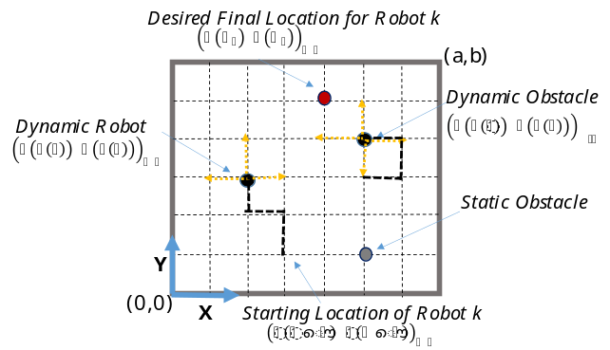
Fig. 1 Robots and obstacles marching in confined work space with stationary obstacles.

In the simulation examples that follow, the workspace is defined by a rectangular area whose size is (a, b) as shown in Figure 1. n is the number of swarming robots that are comingling with m number of stationary obstacles and with h number of obstacle in motion. All robots and obstacles in motion or “dynamic obstacles” follow SRW properties. The location of static obstacle does not change with time. Let $s\left(t\right)$ define the step count at time or discreet event t. The location of an object in the Cartesian coordinates can then be defined by the value of their components for a given step count $\left(x(s(t)),y(s(t))\right)$. For example, robot k and dynamic obstacle w march simultaneously under SRW algorithm. The walk stops when all robots in a subset reach their desired locations. Let’s say that the subset has one robot at zero step with initial position $\left(x(s(0)),y(s(0))\right)$, then it requires $s(t_{f})$ steps to reach the final location $\left(x(s(t_{f})),y(s(t_{f}))\right)$. During one walk journey, a robot could collide with a workspace boundary, an obstacle, or another robot.
Multiple walks will be simulated to average the number of steps it takes a robot to reach final destination starting from the same initial condition. In one walk, a success is defined as the average number of steps taken by the robot to reach its final position. However, not all walks could lead to a reasonable success. Therefore, a cut- off step of 10⁶ is applied to limit the maximum number of steps within one walk.
It is assumed that the robot has a defense mechanism such as a simple obstacle avoidance bumper switch that instructs the robot to try to move away by repeating the step again hoping it doesn’t land on a boundary or another object. Such overlap is counted as a step and it will weight on the robot’s success to find its desired location. On the other hand, obstacles are assumed to have least intelligence; therefore, they don’t change the coarse of motion when overlaps occur. An example of that could be a worker wondering in workspace and not paying attention to surrounding.
In practice, AGVs or in general, most programmable mobile robots are equipped with basic obstacle avoidance sensors such as low range ultrasonic sensors or spring-loaded switches. The mobile robot could know its final position by means of magnetic, color, inductive, or capacitive sensors mounted on the floor. The examples discussed in the simulation section assume that all navigation sensors are turned off except for the obstacle detection sensor and final state sensor.
In this paper, simulations of AGVs are studied for several environments defined in the following subsections.

2.1 Random Walk Roaming amidst Static Obstacles
The static obstacles are defined as non-moving objects which are randomly and deterministically structured within the workspace. The obstacles(s) are placed in such a way as to mimic various kinds of ‘obstacle regions’ in real time workspace. To perform a Random Walk amidst an array of static obstacles, an algorithm has been proposed which will be explained in Algorithm 1 in Figure 2.

2.2 Random Walk Roaming amidst Static Obstacles
The dynamic obstacle(s) are defined as moving objects under constant change in motion. The obstacle(s) can move either on a preprogrammed path or on a random walk that abides by any real-world human robot workspace which contains different interactions such as robot-robot and human-robot interactions. Algorithm 2 in Figure 3 describes the boundary conditions of dynamic obstacles similar to Algorithm 1. The Dynamic Obstacles are simulated into a Markov Chain obstacle and Random Walk obstacle. The Markov Chain obstacle design is based on the Markov Property which states that “Future is independent of the past given the present” [50].

Mathematically this statement can be expressed as

$P_{r}\left(S_{t+1 }|s_{t}\right)=P_{r}\left(S_{t+1 }|s_{1},….,s_{t}\right)$ (1)

Where in the above equation, $s_{t}$ or $S\left(t\right)$ denotes the current state and $S\left(t+1\right)$ or $s_{t+1}$ denotes the next state. The transition state of the Markov Chain obstacle is entirely independent of the past states. An obstacle such as (ow) in the workspace (a,b) in Figure 1 is based on Markov Chain model. In this obstacle design, the obstacle changes its positions on n fixed number of states with the probabilities from a fixed transition matrix. The Markov Chain in this study is assumed to be known absorbing. On the other hand, the Random Walk Obstacle design assumes a free-ranging AGV roaming between random obstacles. In this study, the robot such as (Rk) and obstacle(s) such as (Ow) both are moving on a Random Walk model. The obstacles are independent entities moving around the workspace (a,b) generating random initial positions with no destinations. The random walk concept is related to the Hamiltonian cycle. A Hamiltonian cycle is a path along a set of points that passes through every point exactly once before returning to the original start point. In the context of an AGV, a Hamiltonian cycle would allow the vehicle to pass through every point on a grid that defines its working zone. Generating a Hamiltonian cycle ensures that the robot reaches the end point, but at the cost of moving efficiently. While this method will not be used directly, the results of the random walk can be compared to the Hamiltonian cycle of the operating space.

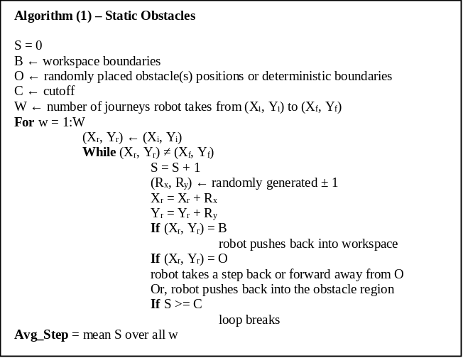
Fig. 2. Random walk of a robot within confined environment with static obstacles.

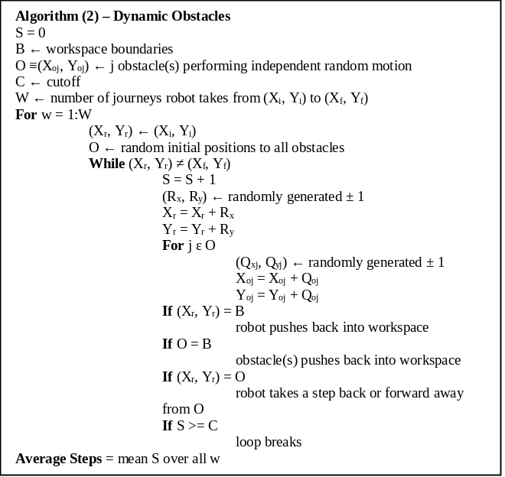
Fig. 3. Random walk of a robot within confined environment with dynamic obstacles.

2.3 Probability of Presence
The “Probability of Presence” of a robot for a specified obstacle region are also simulated to present long-term chances of a robot to be in a certain position. To pursue a long-term probability of presence, the robot is performing infinite SRW with no destination within the obstacle region [51]. The theorem stipulates that the long-term stationary probability matrix P of random walk is computed from a matrix degree of freedom D
$P=\left(\frac{1}{∑D_{ij}}\right)$ (2)
Where$D_{ij}$ is the number of directions the robot can move when at the position (i,j) and $D_{ij}$= 0 for $(i,j)$ at obstacle’s position [52]. It is important to note that here the P is basically an invariant or stationary distribution vector written in form of a matrix since we have a 2D workspace grid.

2.4 Proposed Obstacle Designs
The proposed approach is to ensure safety through probabilistic “Obstacle Design” approach in a workspace and are composed of mainly six types of structured static obstacle designs, Diagonal Design, Passage Design, L-shaped Design, Zig Zag Design and Dynamic Obstacles Design. The dynamic obstacle contains two types (i) Markov Chain Obstacle (ii) Obstacles performing Simple Random Walk. The main emphasis behind making different obstacle designs is to cover the geometry of real-world workspaces and study their tradeoff. In this paper, our null hypothesis is that there is no effect of obstacles on the success of an AGV. This study presents an alternative hypothesis which concludes that effect of various obstacle designs has a significant effect on the success of a freely moving AGV.
Both Algorithms (1) and (2) simulate the step movements of AGV randomly within workspace. The AGV pushes back when it hits a static or dynamic obstacle (such as another AGV) or workspace boundary, and recalculate its walk again. These steps are still counted in the measuring the efficiency of the AGV. Algorithm (1) deals with structured static obstacles which are configured through various design approaches. Meanwhile, Algorithm (2) is deployed for randomly moving dynamic obstacles.

- Simulation: Randomly Walking AGV within Structured Static Obstacles and in Confined Workspace

3.1 Diagonal Obstacle Design
The first obstacle design examines the relationship between a free ranging AGV and any m number of obstacles arranged diagonally. Let the linear accumulative distance, $D$, index be defined by,
$D=\sum_{j=1}^{m}{\sqrt{{(x_{j}-x_{i})}^{2}+{(y_{j}-y_{i})}^{2}}+\sqrt{{(x_{j}-x_{f})}^{2}+{(y_{j}-y_{f})}^{2}}}$ (3)
where $\left(x_{j},y_{j}\right)$ is the location of the ij^{th} obstacle. The simulation case study examines 22 obstacles arranged diagonally between initial position at $\left(x_{i},y_{i}\right)$ at (1,1) unit, and final desired location $\left(x_{f},y_{f}\right)$ at (25,25) unit. The Average Step (AS) corresponding to, D, is simulated for every $m∈\left\{1,2,…22\right\}$.The robot locomotion is set to take place within a confined workspace area of (50$×$50) unit square, as shown in Figure 4. Algorithm (1) is deployed to compute the average number of successful steps it takes the robot to travel from the initial point to the final point. According to the ‘Law of Large numbers’ theorem [53], it is sufficient to use 300 random “walk” in order to compute the average number of successful steps.

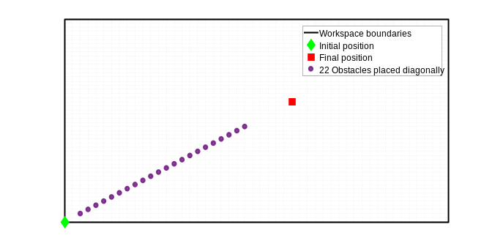
Fig. 4. Diagonal design with m number of obstacles are alighned diagonally between initial and final locations.

The relationship between the diagonal obstacles and the average successful steps for every m diagonal obstacles are computed, and plotted in Figure 5. The results show that the more linear obstacles are added between the start and final positions, the less steps will require AGV to find the desired location.

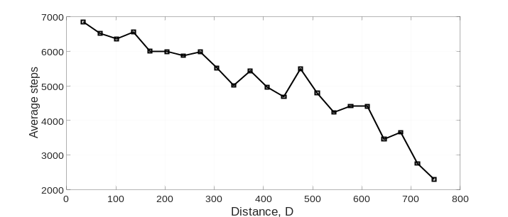
Fig. 5. The effect of installing diagonal obstacles on the success of a ranging AGV to finds its destination.

The probability of occurrence, i.e. the long-term probability in equation (2), is simulated for workspace area of size (20$×$20) unit square with 8 obstacles located between initial point (1,1) unit, and final point (10,10) unit. The probability of occurrence, can help predict the robot path and warn the facility workers about which area to avoid during work. It can be easily concluded from the results in Figure 6 that the probability of occurrence of robot colliding with nearby obstacle increases. In addition, the chance to find the AGV elsewhere in the workspace is uniformly minimum. As a results, an AGV exhibiting a random walk in a confined area, can find its destination faster by creating a physical or virtual diagonal obstacle within proximity of desired final location. In general, one advantage of installing the obstacle is due to the high probability of finding a robot near by the boundary.
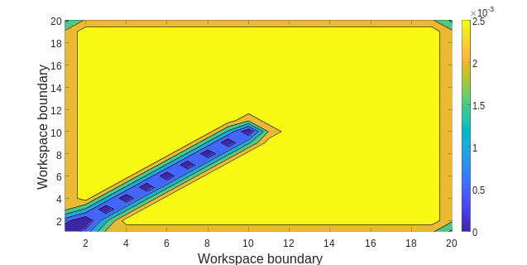
Fig. 6. Probability of occurrence for the diagonal obstacle design.

3.2 L-Shape Obstacle Design
The second case study deals with an obstacle design configured in L-shape with fixed width, W, as suggested in Figure 7. The length of the L-shape corresponds to the maximum linear distance traveled between two points within the workspace. The initial and final desired position of a free ranging AGV are assumed at (1,1) and $\left(a-1,b-1\right)$, respectively. The AGV stays within the L-shape area. Algorithm (1) is executed to determine the average number of successful steps for various width.

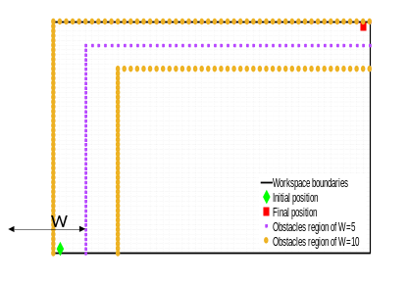
Fig. 7. Example of ‘L- shaped’ obstacle containining the initial and desired locations.

Multiple simulations are carried out for widths ranging from $W=\left[1,20\right]$ and at step size, $∆W$, of 1 unit. Consider three set of workspaces sizes (50$×$50), (75$×$75) and (100$×$100) unit square. The average success vs. width of L-shape is computed for workspace size, and all curves are plotted in Figure 8.a. Let the efficiency be defined by the average success normalized to the area size of the workspace. The average steps/enclosed L-shaped obstacle area is plotted in Figure 8.b.
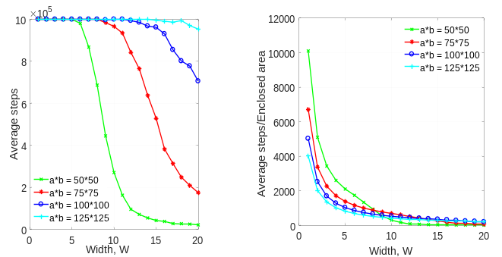
Fig. 8. L-shape obstacle design.: (a) Success simulated for several widths and workspaces sizes. (b) Effeciency of successful search.

Let a cutoff threshold of 10⁵ define the maximum number of steps before the AGV stops searching. Figure 8.a shows a rapid decay relationship, where it takes an AGV less steps to succeed in smaller workspace. The normalized plot in Figure 8.b implies that the exponential decay relationship becomes independent of the workspace size when the width size is large. However, the overall efficiency of search is better for the large workspace size within W$∈$[1 ~7] unit.

3.3 Passage Obstacle Design
Passage obstacle design refers to the smallest possible rectangular area that confines the movement of AG, as suggested in Figure 9. It is assumed that the starting and final positions are always located within the passage area, and distance between these points defines the passage length. In this case study, the intent is to determine how the width of the passage, W, relates to the success of the AGV to find final position. Let the starting and final position be at (1,1) unit, and (a-1, b-1) unit, respectively. Algorithm (1) is deployed to study this relationship for various workspaces sizes, including (50$×$50), (75$×$75), (100$×$100), and (125$×$125) unit square. The simulation is also carried out for width $W=\left[1,20\right]$unit, and at step size, $∆W$, of 1 unit. It can be observed from the results shown in Figure 10.a that the size of the workspace has little significance to the average success. The average success drops significanly for widths ranging from 1 to 5 unit. This sharp exponential decay could explain why all workspaces have almost identical efficiency, as observed in Figure 10.b.

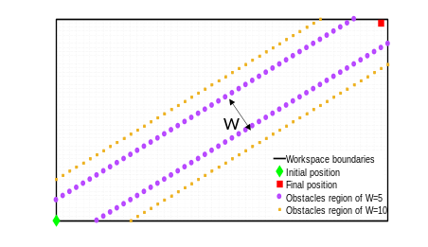
Fig. 9. Passage Design is created encompassing the initial and desired location of AGV.

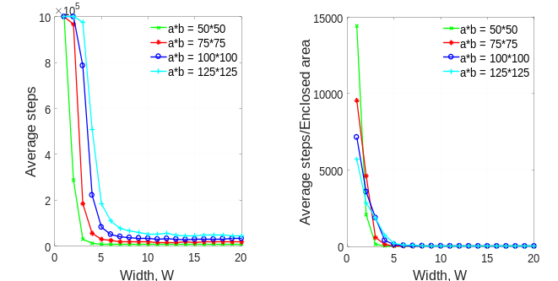
Fig .10. Passage obstacle design: (a) Success simulated for several widths and workspaces sizes. (b) Effeciency of successful search.

A more in depth simulation is performed to examine if the curves in Figure 10.a reach steady state. In order to make the analysis more robust, a higher walk values of 9600 is chosen, as it is highly likely to converge to the true value. Across different workspace sizes, it is observed that the average steps concave up after attaining its lowest possible value. It is evident from Figure 11 that the lowest value corresponds to an optimum width at which the average number of steps is minimum. It is, however, important to note that the increase in the optimum width is very small with respect to the increase in workspace sizes. It is also observed that the optimal width shifts up as workspace size increases.
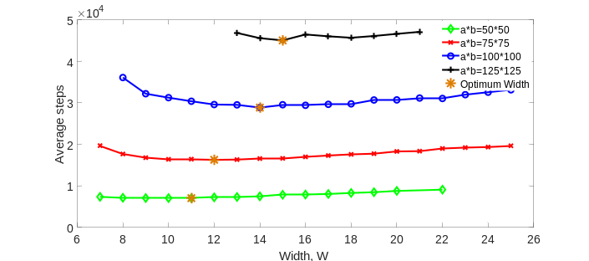
Fig. 11. Optimum widths for passage design computed at different workspace sizes.

3.4 Defected Passage Obstacle Design
Consider p number of consecutive obstacles being removed from the passage design. Let the defects be present in the “lower side” or “upper side” of the passage as shown in Figure 12. These two configurations are asymmetric along the diagonal line that connects the initial to final position. However, the large area that is open to the passage is equivalent in both case, and therefore, simulations will be carried out separately for each case.

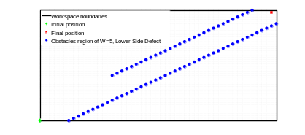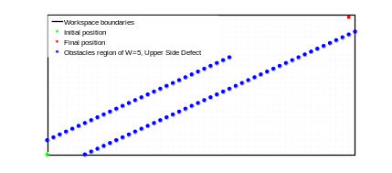
Fig. 12. Example of defect on one diagonal side of the passage: (a) Lower side defect (b) Upper side defect.

The simulations are carried out for “upper side” and “lower side” defected passage within the workspace of $(50×50$) unit square, with the goal to plot the average success against the number of obstacles removed. It should be pointed out that the order of the obstacle removed in the “lower side” case is chosen to begin from the lower corner of the workspace, i.e. removal begins closer to the initial position. The “upper side” case, however, begins from the upper corner of the workspace, i.e. removal begins from the final position. The maximum number of obstacles in each side is 28 units. It is clearly evident from simulation results in Figure 13 that in the case of defects in the “lower side”, the average success improves (or linearly decreasing) as the defects (or the number of sequentially removed obstacles) increase. Whereas an exactly opposite effect is observed for the defect in the “upper side”. The slopes obtained from the linear regression for defects [1 27] are equal in magnitude, but opposite as observed in Figure 13. This implies that when k=1, the average success is identical whether the obstacle is removed from upper side or lower side. However, the average success is farthest apart when only one obstacle is left close to the “upper side” or “lower side”. Interestingly, placing only one obstacle near to the final position would significantly improve the success of the AGV to find its final position. However, at p=28, the average steps between lower and upper sides drops drastically, and becomes identical; simply because the entire obstacles in the diagonal side is removed.

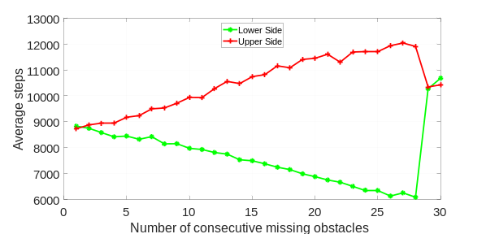
Fig. 13. AGV success in the realm of defective obstacle design.

3.5 Zig-zag Obstacle Design

Zig-zig obstacle, such as example in Figure 14, could be utilized across the workspace to mimic certain complexities of an industrial workspace. The average success of an AGV performing SRW is studied against widths by using Algorithm (1). The width, W, defined in Figure 14, is varied between $\left[1,30\right]$ unit, with increment, $∆W,$of 1 unit. Various workspaces sizes were tested including (50$×$50), (75$×$75), (100$×$100), and (125$×$125) unit square.

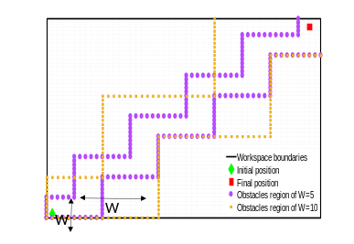
Fig. 14. Example of zig-zag obstacle design.

The simulation results shown in Figure 15.a depicts a fluctuating decay of the average success as the width increase. Also, the average success curves, corresponding to each workplace size, are significantly spread apart from each other. These effect could be related to irregularity of the obstacle design, especially because the interior search area is sensitive to the width. On the other hand, the normalized plot in Figure 15.b shows that the efficiency of search in the zig-zag design is approximately uniform when the workspace size is scaled.
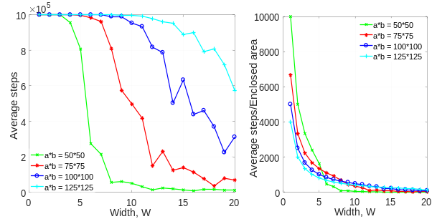
Fig. 15. Zig-zag obstacle design: (a) The average success is simulated for several widths and workspaces sizes. (b) Effeciency of successful search.

3.6 Comparison Between Obstacle Designs
A simulation study is conducted to evaluate how effective the obstacle designs are, in terms of their ability to guide an AGV from initial position (1,1) into a final desired position located at $(a-1, b-1)$. Consider the test conducted on a workspace size of (50$×$50) unit square. The average success is simulated for passage, L-shaped and zig-zag designs, and for various width. The results shown in Figure 16 shows passage that the design performed better than other types for all simulated widths. The L-shape obstacle design was the least effective, however, the decay profile is smooth and it could be approximated by Cosine Annealing function.

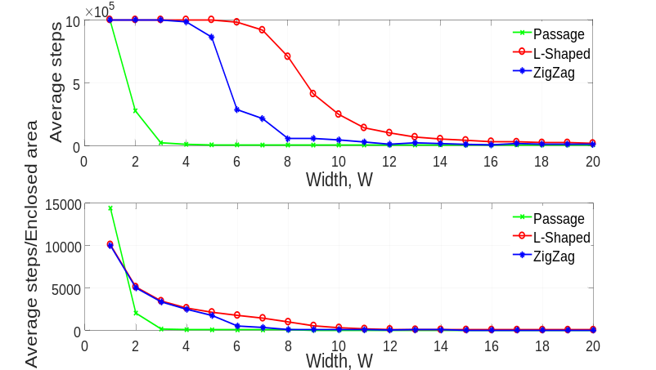
Fig. 16. Comparison between passage, L-shaped and zig-zag design.

- Simulation: Randomly Walking AGV within Random Static Obstacles and in Confined Workspace

A case study is put forward to examine the relation between a free ranging AGV, and m number of random obstacles placed inside a workspace. Let the degree of obstacle aggregation be defined by scattered distance
$D_{s}=\sum_{j=1}^{m}{{\left(x_{j}-\overline{x}\right)}^{2}+{\left(y_{j}-\overline{y}\right)}^{2} }$ (4)
where $(\overline{x},\overline{y})$ is the mean value of the scattered obstacles. Simulations are carried out to calculate the average success for m number of various subsets of randomly placed obstacles. Each m subset of obstacle was also iterated, q, number of times.
A simulation example is conducted for an AGV roaming within a confined workspace area of (50$×$50). The AGV is assumed to be initially placed at (1,1) unit, with target destination located at (25,25) unit. Consider that m subsets belong to individual values in set {1,4, 9,16, 25, 36}. The number of iterations tested per subset is q=50. The average success is plotted against the scattered distance and linear accumulative distance (Equation 3) for every iteration, with results shown in Figure 17.
Let the dispersion of randomly placed obstacles, 𝛅, be defined by the range of $D_{s}$ for q iterations of a subset m. Also, let the variation in the average success, 𝝽, be defined by the range of the average successes obtained for q iterations of a subset m. The following observation can be depicted from Figure 17.a: (1) Although the average success computed for each iteration seems random, the mean-value calculated for all the average success iterations increases as m increases, i.e. has a negative impact, and (2) 𝛅 and 𝝽 widen as m increases. The linear cumulative indicator, D, used in the simulation shown in Figure 17.b, references the obstacles relative to the initial and final positions, instead of the mean-value. The difference between D and D_{s} indicators is regarded to the dispersion of data points. The D value of each m obstacles correspond to distinct aggregation as compared to D_{s}.

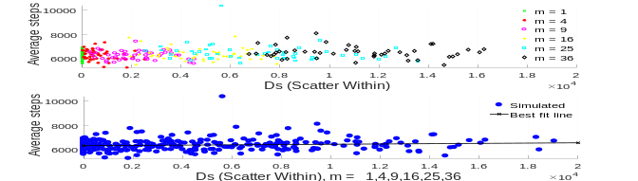
(a)
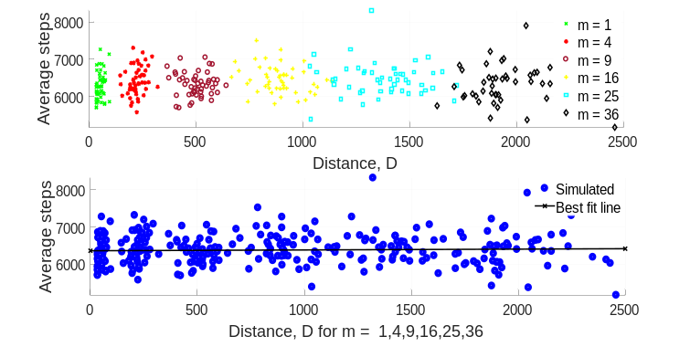
(b)
Fig. 17. The effect of randomly placed static obstacles on the success of a free ranging AGV to find its destination .(a) compared with scattered distance. (b) compared with linear accumulative distance.

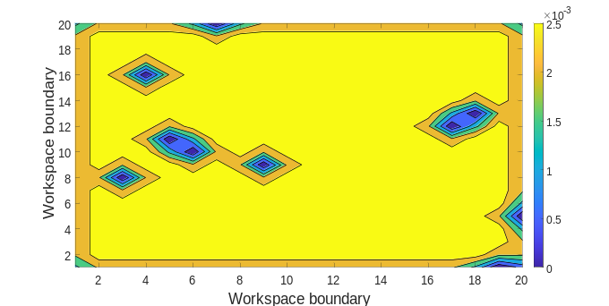
Fig. 18. Probability of occurance for randomly placed static obstacles.

An example of long-term probability is simulated for an AGV performing random walk in a workspace (20$×$20) unit square, amidst 10 randomly generated static obstacles. Figure 18 shows long term likelihood of the AGV to be present in the light region, “yellow-color”, whereas the dark regions, “blue-color”, corresponds to avoided region.
- Simulation: Multiple Randomly Walking AGVs in Confined Workspace

This study mimics a real-world collaborative workspace where human-robot or robot-robot interactions co-exist in a confined workspace with randomly placed static obstacles. Mobile robots or AGVs, and human motion are assumed to undergo independent SRW.
The first simulation case study is based on AGV performing SRW motion from the initial point to the final point in the presence of another independent AGV which is in 5-state Markov Chain motion. The Markov Chain implies that the AGV can only jump from one state to another one of 5-states located in the workspace. Let the workspace size be assigned to (50$×$50) unit square, with the initial and final desired position for one AGV be located at point $(1,1)$unit, and $(49, 49)$ unit, respectively. Algorithm (2) is implemented to compute the average number of successful steps and the average collision probability by using 300 random walks per test.

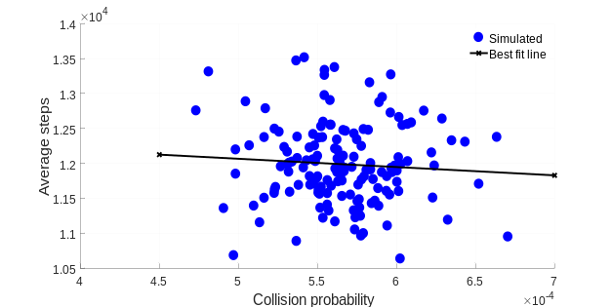
Fig. 19. Simulation of collision probability of an AGV and a ‘5 state Markov Chain’ AGV, in workspace free of obstacles.

The simulation calculates the average success against the collision probability for 150 random tests, with results shown in the scatter plot in Figure 19. The linear regression fit has a slight negative slope; indicating that an increase in the probability of the collision between the two AGVs has resulted in a decrease in the average success of the free ranging AGV. The mean values of the scatter plot data are approximately, ~$(1.2×{10}^{4}, 5.6×{10}^{-4})$, which is uniquely characterizes the average number of successful steps and probability of collision for the given boundary conditions.
The second case study considers (m+1) independent AGVs in dynamic motion, where all are assumed to undergo simple random walk, i.e. they can travel from any point to another point in a step wise manner. One of these AGVs is tasked to navigate from same the previous initial to the final desired positions, while others are in continuous random motion. The obstacle avoidance is enforced between any combination of AGVs, while all are kept inside workspace. Conversely, this case study is equivalent to a robot swarming among a crowd of randomly moving humans.

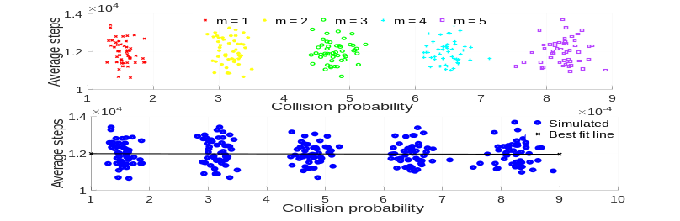
Fig. 20. Collision Probability of an AGV performing SRW with ‘m’ number of SRW AGVs.

Simulations are carried out for several number of AGVs described in group set m= {1, 2, 3, 4, 5}, where each group is simulated 50 iterations. The scattered data shown in Figure 20 indicates that the mean values of the average steps evaluated for each group are approximately equal. I.e., the number of roaming AGVs, m, has little impact on the average success. However, the increase of number of AGVs installation results in increase in the probability of collision.
The effect of the diagonal distance measured between the initial and final positions, R, is examined within the context of this case study. Let the workspace be modified into (100,100). The average success is simulated for same set of groups and plot against R. This relationship is linear for all m, as shown in Figure 21.
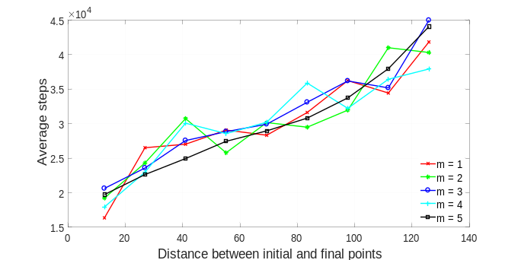
Fig. 21. The effect of distance between initial and final points on the success of a free ranging AGV to finds its destination.

In addition, the linear plots confirm that in an industrial workspace, increasing random dynamic obstacles has no impact on the average number of steps required for an AGV to find its destination.

- Conclusions
This paper examined how random walk of mobile robots is related to its success to finish a task within a confined workspace, and in presence of static and dynamic objects. The goal is to help engineers with the design of shared a workspace area for future advanced manufacturing facilities, where humans and robots co-exist. The distance measured between an initial and a final position relate to the success of the robot to reach its final position when a number of obstacles are placed randomly in a confined workspace. Specifically, randomly placed obstacles have a negative effect on the success of the AGV to find its way from an initial to a final position. With an increasing number of randomly placed obstacles, the average number of steps taken by the AGV to reach its final position increases. Methods based on the fixed design pattern of obstacles are studied with the goal to improve success of the robot to travel randomly between two points by using L-shape, passage, and Zig-Zag. For example, increasing the width of an ‘L’ shaped obstacle region has a negative impact on the success of the AGV. It can be concluded that with increasing size of obstacle region, the AGV takes greater number of steps to reach its final position. Increasing the width of a ‘Passage’ obstacle region has a negative impact on the success of the AGV. In other words, the AGV takes a greater number of steps to reach its final position. In this study, it can also be concluded that after a certain increase in width of the obstacle region, there is no effect on the success of the robot. Increasing the width of a ‘Zig- Zag’ obstacle region has a negative effect on the success of an AGV. The robot takes greater number of steps to reach its final position as the width of the region increases. In general, it was found that the success of the robot to reach its final position increases if J^{th} obstacle is near to the robot’s final position. If an AGV encounters J^{th} obstacle near its final position it will reach its final point in less time.
On the other hand, the success of the robot in the workspace where AGVs are undergoing Markov chain and random walk was studied. The success of an AGV has a positive impact if ‘m’ number of AGVs in Markov chain states are placed within the workspace. It can be concluded that the collision probability increases with a decrease in the average number of steps. The success of the AGV has no effect if ‘m’ number of AGVs performing random walk coexist in the same workspace.

In summary, ‘Passage Design’ is the most efficient way to guide AGV to its final position. In the case of dynamic obstacles, if the obstacles are in Markov chain, the lost AGV will reach its final position in a minimum average number of steps.

Future Work

The 2D Brownian motion of a single particle in a fluid or air is similar to a simple 2D random walk considered in this research, with the exception that each step in each direction is not just either -1 or +1, but any random number between -1 and +1. As a result, the Brownian motion looks much more irregular than the random walk because of the possibility of a particle to move in two-directions with more variable steps and not just integer steps. Complex interaction can be modeled by Brownian motion to track the behavior of a particle, where the following extensions are added to the work presented in this research. First, three-dimensional motion is considered; second, a large finite number of static or dynamic obstacles (particles of fluid) are added; third, obstacles undergo random and independent motion; and fourth, the scale of the workspace is large such that the obstacle size appears small.
Future work will extend the implementation to study the interaction of UAVs by using extended Brownian motion.

Funding

The corresponding author disclosed receipt of the following financial support for the research, authorship, and/or publication of this article: The research is conducted under support from Ohio Department of Higher Education (ODHE) and Regionally Aligned Priorities in Delivering Skills Program (RAPIDS 4.0) grant “Automated Guided Vehicles for Smart-logistics and Safe Material Handling in Advanced Manufacturing and Warehouse Industries.

References

[1] SICKUSAblog, “Additional Solutions for Collision Avoidance with Indoor AGVs,” SICKUSAblog, Jul-2019.
[2] “No Title.” [Online]. Available: https://www.osha.gov/recordkeeping/.
[3] OSHA, “Robot Accident Search Results.”
[4] A. P. Vancea and I. Orha, “A survey in the design and control of automated guided vehicle systems,” Carpathian J. Electron. Comput. Eng., vol. 12, no. 2, pp. 41–49, 2020.
[5] T. L.-A. (Tuan) and J. R. van der M. (Robert) M.B.M. de Koster (René), “Testing and classifying vehicle dispatching rules in three real-world settings,” J. Oper. Manag., vol. Volume 22, no. Issue 4 SPEC. ISS, pp. 369–386, 2004.
[6] E. Cardarelli, L. Sabattini, V. Digani, C. Secchi, and C. Fantuzzi, “Interacting with a multi AGV system,” Proc. - 2015 IEEE 11th Int. Conf. Intell. Comput. Commun. Process. ICCP 2015, no. March 2016, pp. 263–267, 2015.
[7] and T. N. (Germany) A. Prusak, J. Bernshausen, H. Roth, J. Warburg, C. Hille, H.-H. Gtting, “Applications of Automated Guided Vehicle (AGV) and Industry Robots with PMD-Camera,” Robot. Appl. Telemat. - 2007, 2007.
[8] M. T. Changliu Liu, “Designing the Robot Behavior for Safe Human–Robot Interactions,” in Trends in Control and Decision-Making for Human–Robot Collaboration Systems, 2017, pp. 241–270.
[9] L. Sabattini et al., “Technological roadmap to boost the introduction of AGVs in industrial applications,” Proc. - 2013 IEEE 9th Int. Conf. Intell. Comput. Commun. Process. ICCP 2013, no. September, pp. 203–208, 2013.
[10] B. S. P. Reddy & C. S. P. Rao, “A hybrid multi-objective GA for simultaneous scheduling of machines and AGVs in FMS,” Int. J. Adv. Manuf. Technol., vol. 31, pp. 602–613, 2006.
[11] M. V. S. Kumar, R. Janardhana, and C. S. P. Rao, “Simultaneous scheduling of machines and vehicles in an FMS environment with alternative routing,” Int. J. Adv. Manuf. Technol., vol. 53, no. 1–4, pp. 339–351, 2011.
[12] J. Jerald, P. Asokan, G. Prabaharan, and R. Saravanan, “Scheduling optimisation of flexible manufacturing systems using particle swarm optimisation algorithm,” Int. J. Adv. Manuf. Technol., vol. 25, no. 9–10, pp. 964–971, 2005.
[13] N. N. Krishnamurthy, “Developing Conflict-Free Routes for Automated Guided Vehicles Author ( s ): Nirup N . Krishnamurthy , Rajan Batta and Mark H . Karwan Published by : INFORMS Stable URL : https://www.jstor.org/stable/171602 All use subject to https://about.jstor.org/terms ,” vol. 41, no. 6, pp. 1077–1090, 2018.
[14] G. A. koff David W. Zeitler, Matthew L. Werner, “DYNAMIC OBJECT AVOIDANCE WITH AUTOMATED GUIDED VEHICLE,” 2005.
[15] R. M. T. David C. Emanuel, Robert S. Kunzig, “Method and Apparatus for Collision Avoidance,” 2013.
[16] S. Tae-Eun Park, “AGV CONTROL SYSTEM AND METHOD,” 2007.
[17] K. (JP) Jun Kondo, “TRAVEL CONTROL DEVICE FOR UNMANNED CONVEYANCE VEHICLE,” 2013.
[18] Sun-Gi Hong,Seokwon Bang,Dong Ryeol Park, “pparatus and method for estimating a position and an orientation of a mobile robot,” 2010.
[19] P. A. Lasota, T. Fong, and J. A. Shah, “A Survey of Methods for Safe Human-Robot Interaction,” Found. Trends Robot., vol. 5, no. 3, pp. 261–349, 2017.
[20] G. Michalos, S. Makris, P. Tsarouchi, T. Guasch, D. Kontovrakis, and G. Chryssolouris, “Design considerations for safe human-robot collaborative workplaces,” Procedia CIRP, vol. 37, pp. 248–253, 2015.
[21] R. Inam et al., “Risk Assessment for Human-Robot Collaboration in an automated warehouse scenario,” IEEE Int. Conf. Emerg. Technol. Fact. Autom. ETFA, vol. 2018-Septe, no. September, pp. 743–751, 2018.
[22] E. Magrini, F. Ferraguti, A. J. Ronga, F. Pini, A. De Luca, and F. Leali, “Human-robot coexistence and interaction in open industrial cells,” Robot. Comput. Integr. Manuf., vol. 61, no. July 2019, p. 101846, 2020.
[23] I. Draganjac, D. Miklic, Z. Kovacic, G. Vasiljevic, and S. Bogdan, “Decentralized Control of Multi-AGV Systems in Autonomous Warehousing Applications,” IEEE Trans. Autom. Sci. Eng., vol. 13, no. 4, pp. 1433–1447, 2016.
[24] R. S. Richard Kendall Miller, Automated Guided Vehicles and Automated Manufacturing. Society of Manufacturing EngineersP.O. Box 930 One SME Drive Dearborn, MIUnited States, 1987.
[25] C. R. Niklas Möller, Sven Ove Hansson, Jan-Erik Holmberg, Handbook of Safety Principles. Wiley, 2018.
[26] T. Helmer, Development of a Methodology for the Evaluation of Active Safety using the Example of Preventive Pedestrian Protection. Springer, Cham, 2015.
[27] MMH Staff, “AGVs enhance automotive powertrain production,” Modern Material Handling, Oct-2018.
[28] AGV TECHNOLOGY, “Understanding AGV Safety Systems,” AGV NETWORK, Jun-2020.
[29] R. Bostelman, “AGMs and Forklifts Gaining Sight for Safety,” Mater. Handl. Logist., vol. 68, no. 1, pp. 34–37, 2013.
[30] C. F. Christian Frese, Angelika Fetzner, “Multi-Sensor Obstacle Tracking for Safe Human-Robot Interaction.”
[31] J. H. Chen and K. T. Song, “Collision-Free Motion Planning for Human-Robot Collaborative Safety under Cartesian Constraint,” Proc. - IEEE Int. Conf. Robot. Autom., pp. 4348–4354, 2018.
[32] P. Wenger and P. Chedmail, “Ability of a robot to travel through its free work space in an environment with obstacles,” Int. J. Rob. Res., vol. 10, no. 3, pp. 214–227, 1991.
[33] N. Vahrenkamp et al., “Workspace analysis for planning human-robot interaction tasks,” IEEE-RAS Int. Conf. Humanoid Robot., pp. 1298–1303, 2016.
[34] F. Rezazadegan, J. Geng, M. Ghirardi, G. Menga, and G. Camuncoli, “Politecnico di Torino Porto Institutional Repository Risked-based Design for the Physical Human-Robot Interaction ( pHRI ): an Overview,” vol. 43, pp. 1249–1254, 2015.
[35] E. Kim, R. Kirschner, Y. Yamada, and S. Okamoto, “Estimating probability of human hand intrusion for speed and separation monitoring using interference theory,” Robot. Comput. Integr. Manuf., vol. 61, Feb. 2020.
[36] Alain Lambert ; Dominique Gruyer ; Guillaume Saint Pierre, “A fast Monte Carlo algorithm for collision probability estimation,” 2008.
[37] J. Van Den Berg, P. Abbee, and K. Goldberg, “LQG-MP: Optimized path planning for robots with motion uncertainty and imperfect state information,” in International Journal of Robotics Research, 2011, vol. 30, no. 7, pp. 895–913.
[38] S. Patil, J. Van Den Berg, and R. Alterovitz, “Estimating Probability of Collision for Safe Motion Planning under Gaussian Motion and Sensing Uncertainty.”
[39] Institute of Electrical and Electronics Engineers., “ICRA 2012 : 2012 IEEE International Conference on Robotics and Automation : St. Paul, Minnesota, USA, May 14-18, 2012.,” 2012.
[40] J. H. Liang and C. H. Lee, “Efficient collision-free path-planning of multiple mobile robots system using efficient artificial bee colony algorithm,” Adv. Eng. Softw., vol. 79, pp. 47–56, 2015.
[41] N. Pedrocchi, F. Vicentini, M. Malosio, and L. M. Tosatti, “Safe human-robot cooperation in an industrial environment,” Int. J. Adv. Robot. Syst., vol. 10, Jan. 2013.
[42] D. Claes and K. Tuyls, “Multi robot collision avoidance in a shared workspace,” Auton. Robots, vol. 42, no. 8, pp. 1749–1770, Dec. 2018.
[43] C. Park, J. S. Park, and D. Manocha, “Fast and Bounded Probabilistic Collision Detection for High-DOF Robots in Dynamic Environments.”
[44] J. H. Cho, D. S. Pae, M. T. Lim, and T. K. Kang, “A Real-Time Obstacle Avoidance Method for Autonomous Vehicles Using an Obstacle-Dependent Gaussian Potential Field,” J. Adv. Transp., vol. 2018, 2018.
[45] S. Carpin and G. Pillonetto, “Motion planning using adaptive random walks,” IEEE Trans. Robot., vol. 21, no. 1, pp. 129–136, 2005.
[46] L. Palmieri, A. Rudenko, and K. O. Arras, “A fast random walk approach to find diverse paths for robot navigation,” IEEE Robot. Autom. Lett., vol. 2, no. 1, pp. 269–276, Jan. 2017.
[47] B. Pang, Y. Song, C. Zhang, H. Wang, and R. Yang, “A Swarm Robotic Exploration Strategy Based on an Improved Random Walk Method,” J. Robot., vol. 2019, 2019.
[48] W. Chen, “Motion Planning with Monte Carlo Random Walks.”
[49] M. Biskup, Random walks. 1827.
[50] A. Singh, “Reinforcement Learning : Markov-Decision Process (Part 1),” 2019. [Online]. Available: file:///C:/Users/indra/Downloads/Reinforcement Learning _ Markov-Decision Process (Part 1).pdf.
[51] E. Behrends, Introduction to Markov chains, vol. 228. Springer, 2000.
[52] Ryan O’Donnell, Great Ideas in Theoretical Computer Science: Random Walks and Markov Chains (Spring 2016. USA: Youtube, 2017, pp. 53:13, 54:59.
[53] N. Etemadi, “An elementary proof of the strong law of large numbers,” vol. 55, pp. 119–122, 1981.

