CONTACT

Aditya Singh
 3/115, Sector-J, Jankipuram, Lucknow
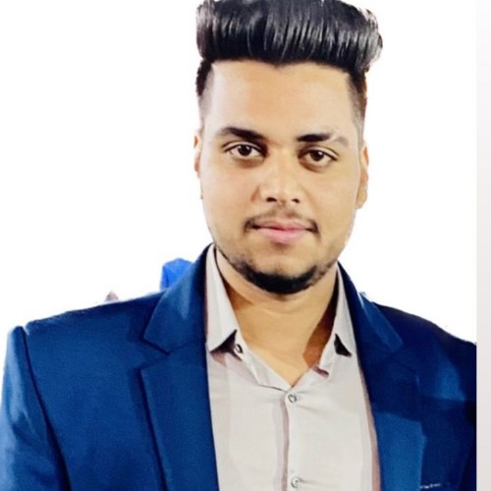
 7007544584
 adisingh0823@gmail.com

OBJECTIVE

To secure an entry-level marketing position with an organization that provides a positive learning environment. Ideate and implement novel strategies for the company's marketing department and simultaneously grow my skills as a marketing professional and contribute to the overall success of a company.

EDUCATION

2022

2021

2018

2016

SKILLS

Masters of Business Administration (pursuing)
Bachelor of Commerce Intermediate Highschool

- Good Communication •Marketing •Leadership

PROJECT S

A study on Customer Satisfaction and study of promotional activities with regard to Reliance Trends

- Reliance Trend
(July 2023 - August 2023)

- PNB Metlife, Gurgaon
(August 2023 - September 2023)

EXPERIENCE

- Credflow As a Business Development Executive
(January,2024 till Apirl,2024)

O level from NEILT CCC from NEILT

E

- Hindi
- English

INTEREST

- Reading
- Writing

