Program: Linear and Binary Search
LINEAR
#include <stdio.h>
void linearSearch(int values[], int target, int length);
int main(){
int arr[5],length, target;
printf("Enter The Number of Values: ");
scanf("%d", &length);
printf("Enter The %d Values: \n", length);
for (int i = 0; i < length; i++){
scanf("%d", &arr[i]);
}
printf("Enter The Value to be Searched: ");
scanf("%d", &target);
linearSearch(arr, target, length);
}
void linearSearch(int values[], int target, int length){
for (int i = 0; i < length; i++){
if (values[i] == target){
printf("Element Found at index %d ", i);
return;
}
}
printf("Elememt not Found");
}
OUTPUT:
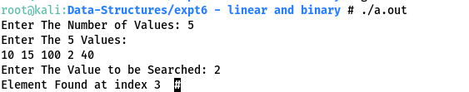

BINARY
#include <stdio.h>
void binarySearch(int values[], int target, int length);
int main()
{
int arr[5];
int length, target;
printf("Enter The Number of Values: ");
scanf("%d", &length);

printf("Enter The %d Values: \n", length);
for (int i = 0; i < length; i++)
{
scanf("%d", &arr[i]);
}

printf("Enter The Value to be Searched: ");
scanf("%d", &target);

binarySearch(arr, target, length);
return 0;
}

void binarySearch(int values[], int target, int length)
{
int low, high, mid;
low = 0;
high = length - 1;
mid = (low + high) / 2;

while (high >= low)
{
if (values[mid] < target)
{
low = mid + 1;
}
else if (target == values[mid])
{
printf("Element Found at index %d ", mid);
return;
}
else
{
high = mid - 1;
}
mid = (high + low) / 2;
}
if (low > high)
{
printf("Elememt not Found");
}
}
OUTPUT:
