Program:
Insertion Sort
#include <stdio.h>
void insertionSort(int arr[], int length){
for (int i = 1; i < length - 1; i++){
int temp = arr[i];
while (arr[i - 1] > temp){
arr[i] = arr[i - 1];
i--;
}
arr[i] = temp;
}
printf("The Sorted Values are: ");
for (int i = 0; i < length; i++){
printf("%d\t", arr[i]);
}
}
int main()
{
int arr[20],length;
printf("Enter The Number of Values: ");
scanf("%d", &length);
printf("Enter The %d Values: \n", length);
for (int i = 0; i < length; i++){
scanf("%d", &arr[i]);
}
insertionSort(arr, length);
return 0;
}

OUTPUT:
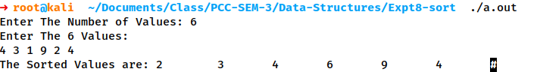

HeapSort
#include <stdio.h>
void heapSort(int arr[], int length){
int temp, c, root;
for (int i = 1; i < length; i++){
c = i;
do{
root = (c - 1) / 2;
if (arr[root] < arr[c]){
temp = arr[root];
arr[root] = arr[c];
arr[c] = temp;
}
c = root;
} while (c != 0);
}
printf("The MAX Values are: ");
for (int i = 0; i < length; i++){
printf("%d\t", arr[i]);
}
printf("\n");
for (int j = length - 1; j >= 0; j--){
temp = arr[0];
arr[0] = arr[j];
arr[j] = temp;
root = 0;
do{
c = 2 * root + 1;
if ((arr[c] < arr[c + 1]) && c < j - 1)
c++;
if (arr[root] < arr[c] && c < j){
temp = arr[root];
arr[root] = arr[c];
arr[c] = temp;
}
root = c;
} while (c < j);
}
printf("The Sorted Values are: ");
for (int i = 0; i < length; i++){
printf("%d\t", arr[i]);
}
}
int main()
{
int arr[20],length;
printf("Enter The Number of Values: ");
scanf("%d", &length);
printf("Enter The %d Values: \n", length);
for (int i = 0; i < length; i++){
scanf("%d", &arr[i]);
}
heapSort(arr, length);
return 0;
}

OUTPUT:
