Experiment 2 29th March 2022

**Binary Search**

Aim: To write a program to implement binary search using Divide and Conquer.

Theory:

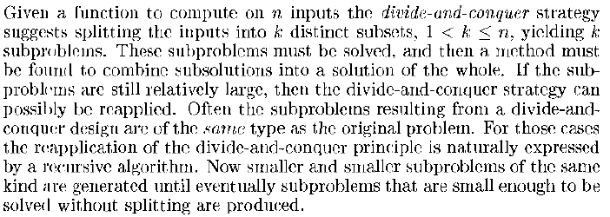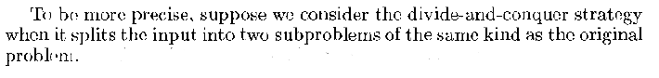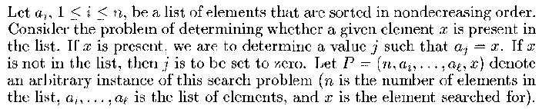

Task:

Write programs for the following algorithms:

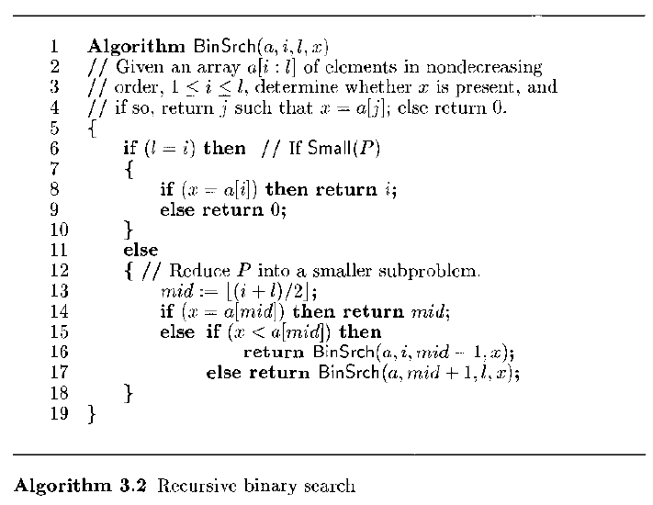

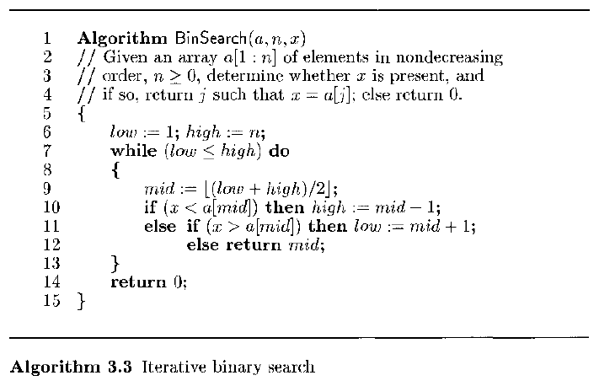

Test your programs.

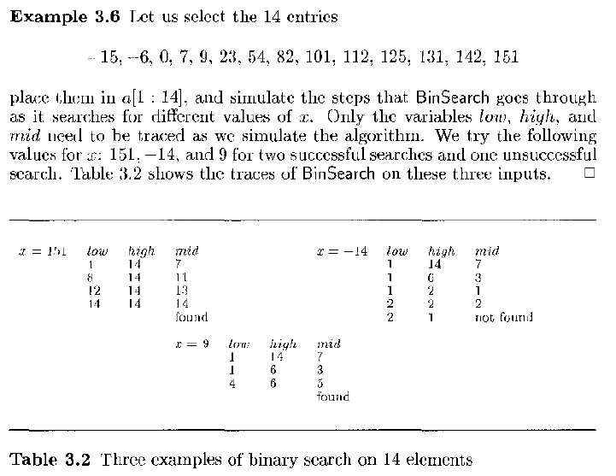

Programs and Output:

Conclusion: