Experiment 3 4th April 2022

**Merge Sort**

Aim: To write a program to implement merge sort using Divide and Conquer.

Theory:

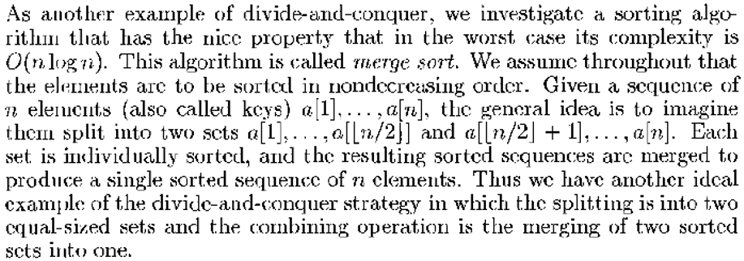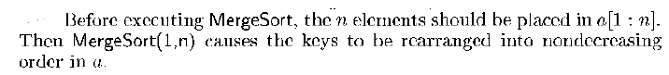

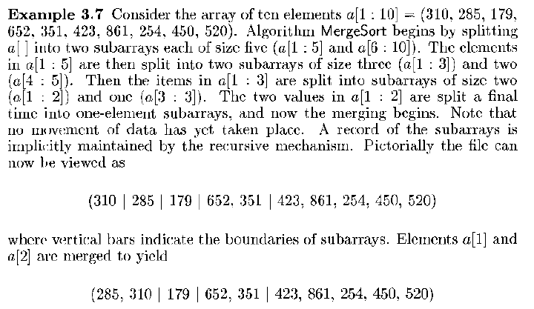

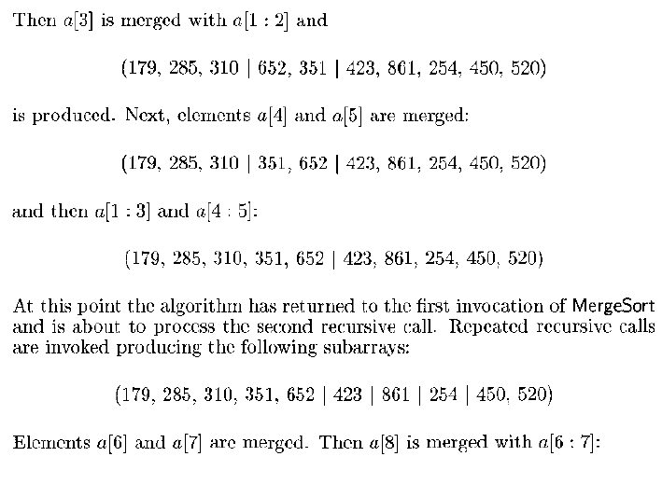

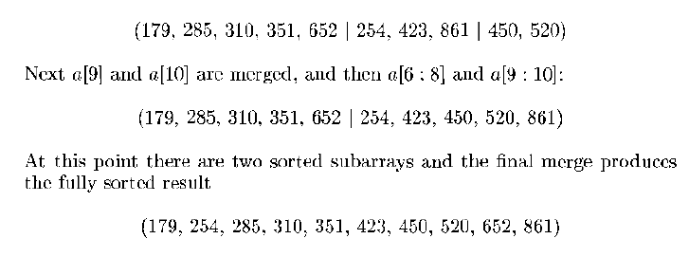

Task:

Write a program for the following algorithms:

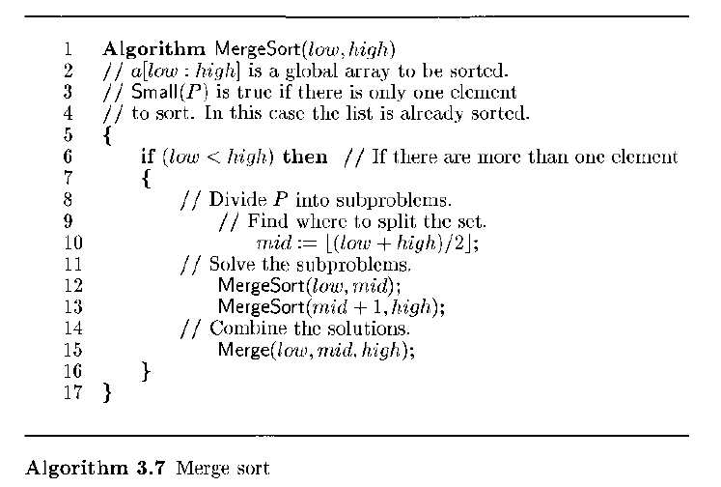

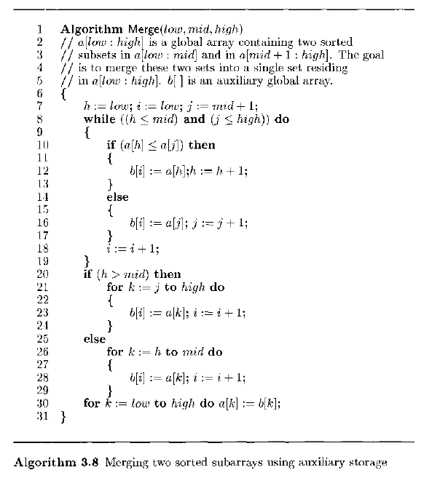

Given the set of numbers S = {16, 3, 7, 10, 25, 1} draw the tree of calls for MergeSort and Merge as in the following example.

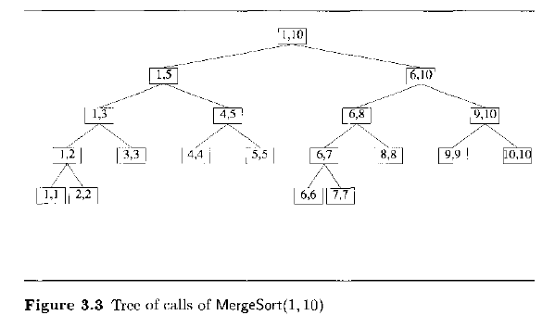

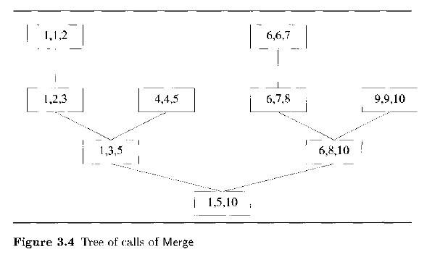

Program and Output:

Conclusion: