**Spotify academic research**

### **> Mood classification papers and datasets:**

1. <https://www.semanticscholar.org/paper/Mood-Classification-Using-Listening-Data-Korzeniowski-Nieto/c9419a94663a5f322b1872515fb1b26cc94e3ce7>
2. [https://www.semanticscholar.org/paper/MoodyLyrics%3A-A-Sentiment-Annotated-Lyrics-Dataset-Çano-Morisio/3e8049c3188bdeb402f335ebb70a5e521ba2ba0f](https://www.semanticscholar.org/paper/MoodyLyrics%3A-A-Sentiment-Annotated-Lyrics-Dataset-%C3%87ano-Morisio/3e8049c3188bdeb402f335ebb70a5e521ba2ba0f)
3. [https://www.semanticscholar.org/paper/Music-Mood-Dataset-Creation-Based-on-Last.fm-Tags-Çano-Morisio/8b881c598771482337b0b552384961b1b13b3d34](https://www.semanticscholar.org/paper/Music-Mood-Dataset-Creation-Based-on-Last.fm-Tags-%C3%87ano-Morisio/8b881c598771482337b0b552384961b1b13b3d34)
4. <https://www.semanticscholar.org/paper/LJ2M-dataset%3A-Toward-better-understanding-of-music-Liu-Liu/67f6f8e28f78916fb3bebe60d2da36a2c50fee0d> - Example of relation between user mood and music emotion

**Predicting demographics from listening behaviour:**

1. <https://www.semanticscholar.org/paper/Predicting-user-demographics-from-music-listening-Krismayer-Schedl/5ab8a10bfd197d2de2ec0446d9d615b1a962620f>

> <https://arxiv.org/pdf/2010.16030.pdf> - Multimodal metric learning for tag based music retrieval

><https://towardsdatascience.com/predicting-my-mood-using-my-spotify-data-2e898add122a> - Gives an overall outline of project briefly*

><https://medium.com/swlh/music-mood-ring-using-introductory-data-science-techniques-and-spotify-to-predict-my-mood-95c9d0fcbe81>

Youtube video: <https://www.youtube.com/watch?v=eK0M_6LXtKo>

**Some similar projects:**

1. <https://nitratine.net/blog/post/finding-emotion-in-music-with-python/>
2. <https://neokt.github.io/projects/audio-music-mood-classification/>
3. **Musicovery**- <https://wonderoftech.com/musicovery/> & <http://b2b.musicovery.com>
4. <http://habumusic.com>
5. <https://datax.berkeley.edu/projects/determining-user-mood-based-on-music-streaming-patterns/>

>**Creating the dataset:** <http://ceur-ws.org/Vol-2723/short26.pdf>

# **>Deployment of Web App + ML Model + APIs — Tutorial** <https://towardsdatascience.com/simple-deployment-of-web-app-ml-model-apis-tutorial-2ece8e66d98c>

# **Doubts:**

> How to represent after predicting moods ? how to visualise our model

**Some Existing interfaces:**

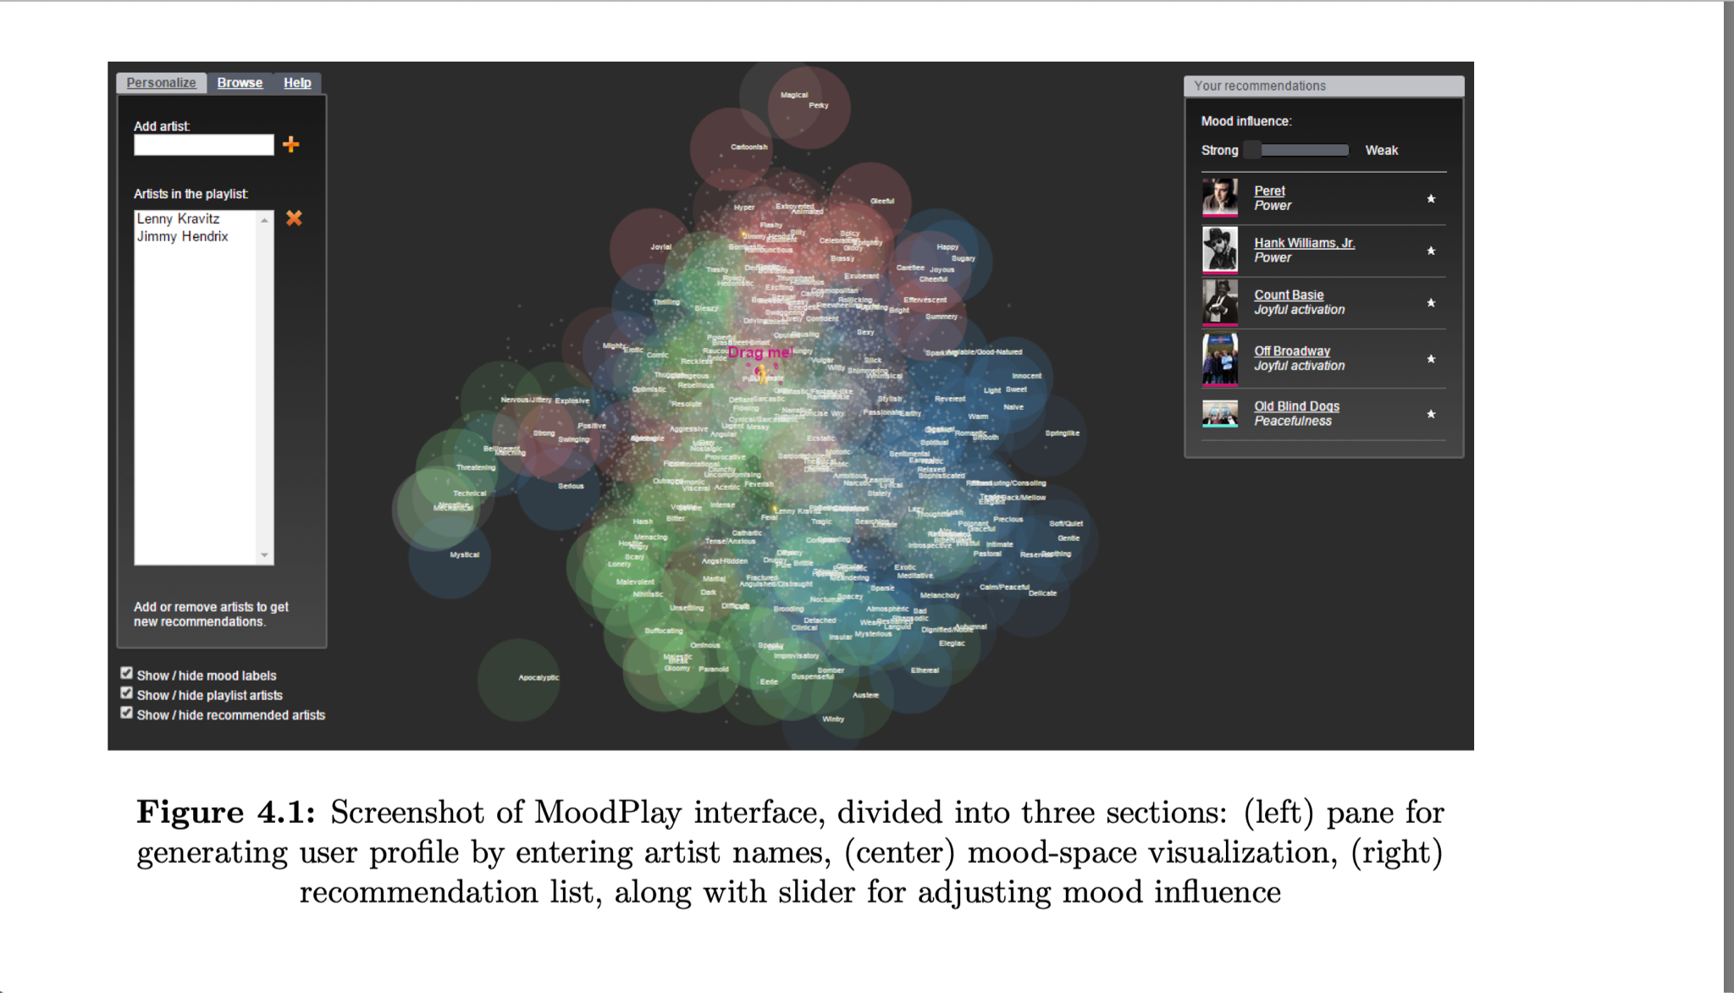

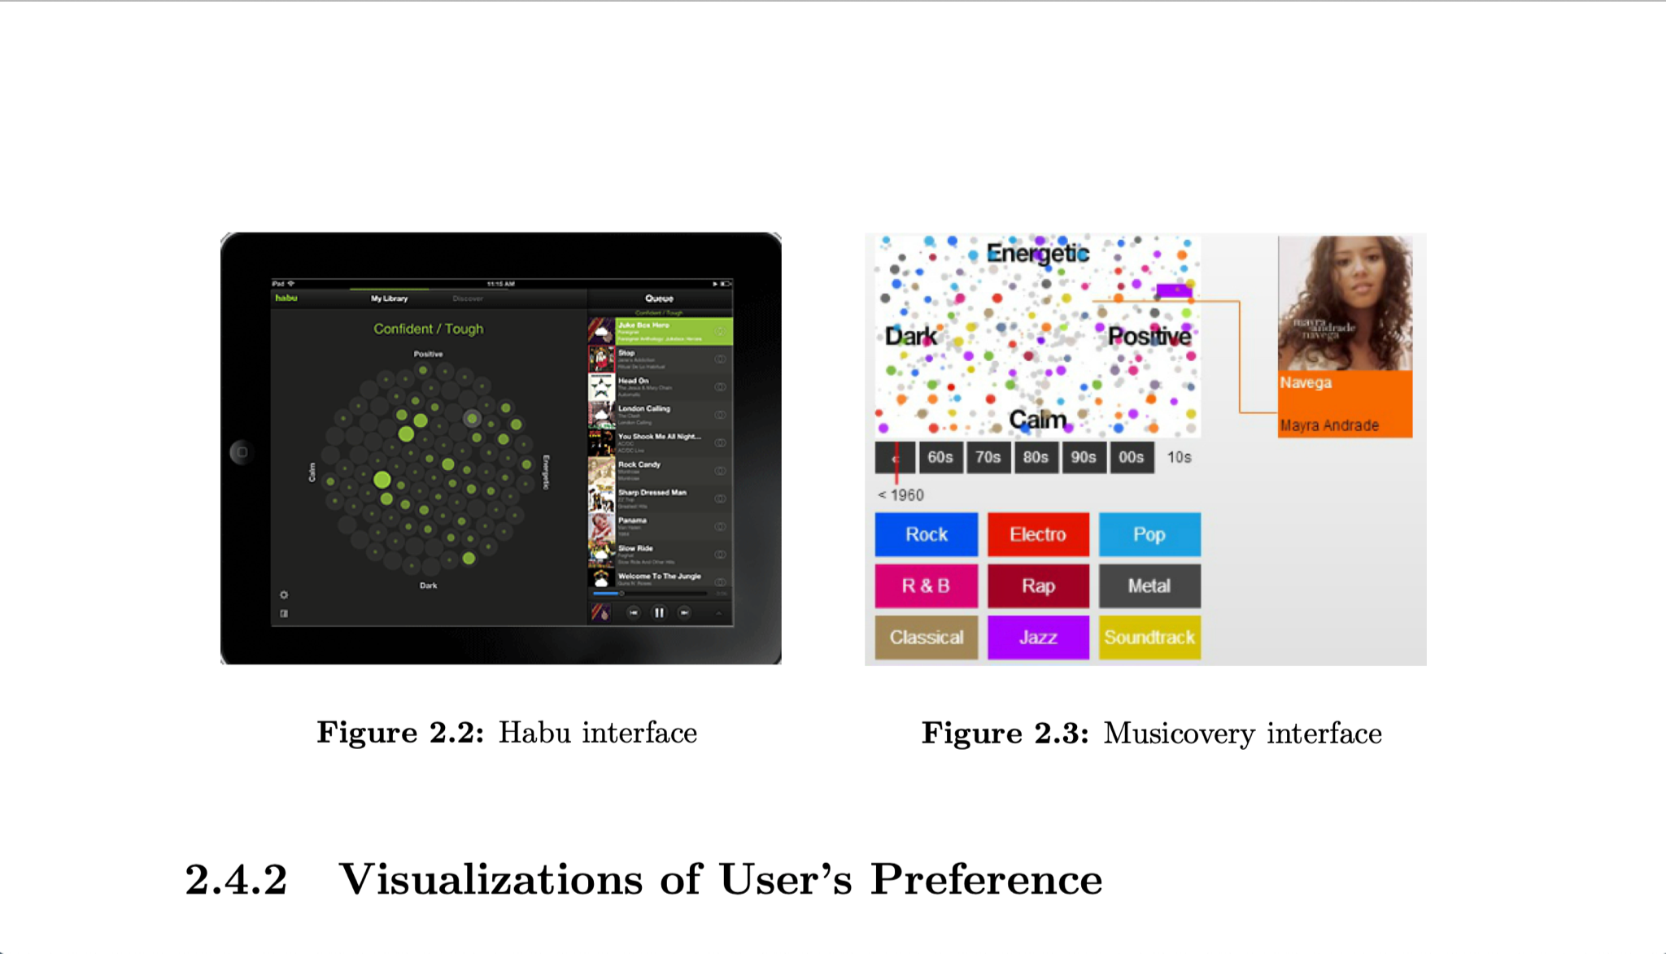

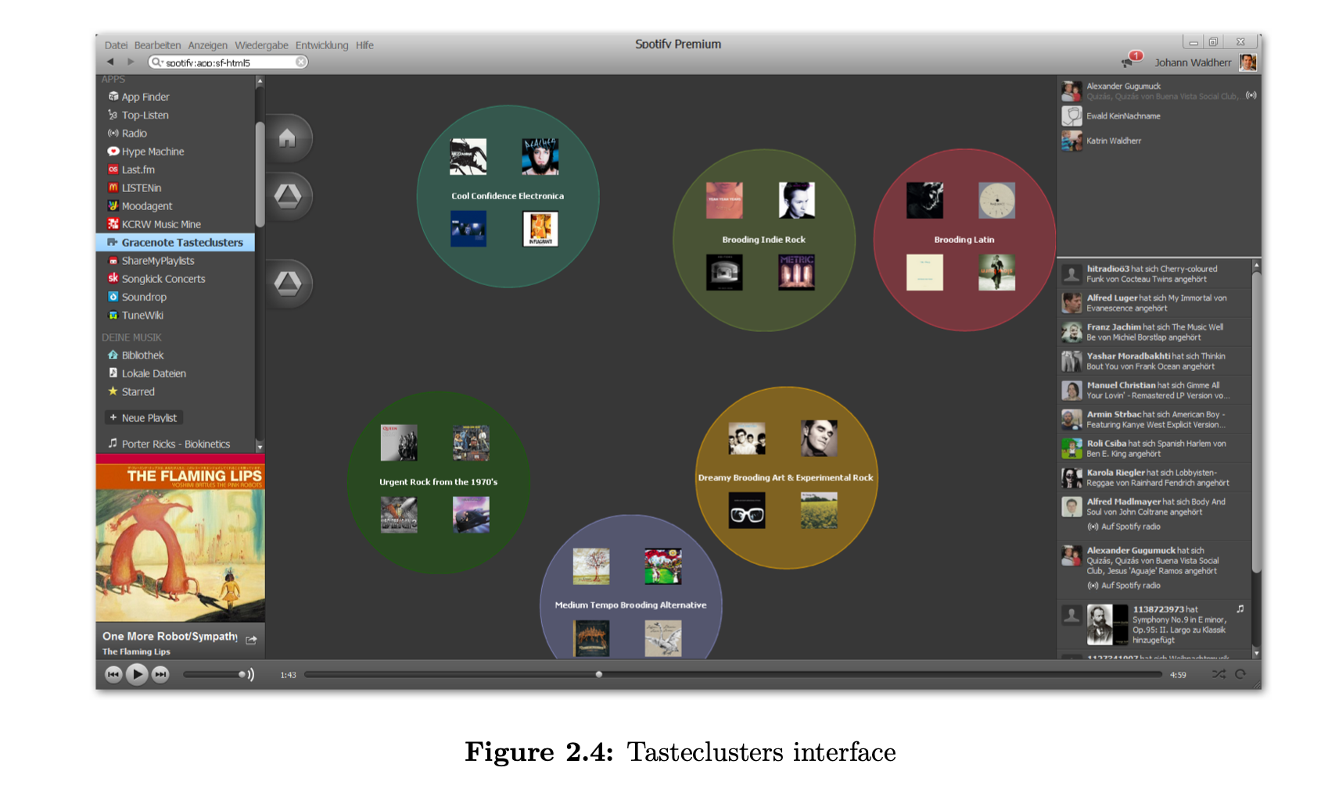

# 

**Project structure:**

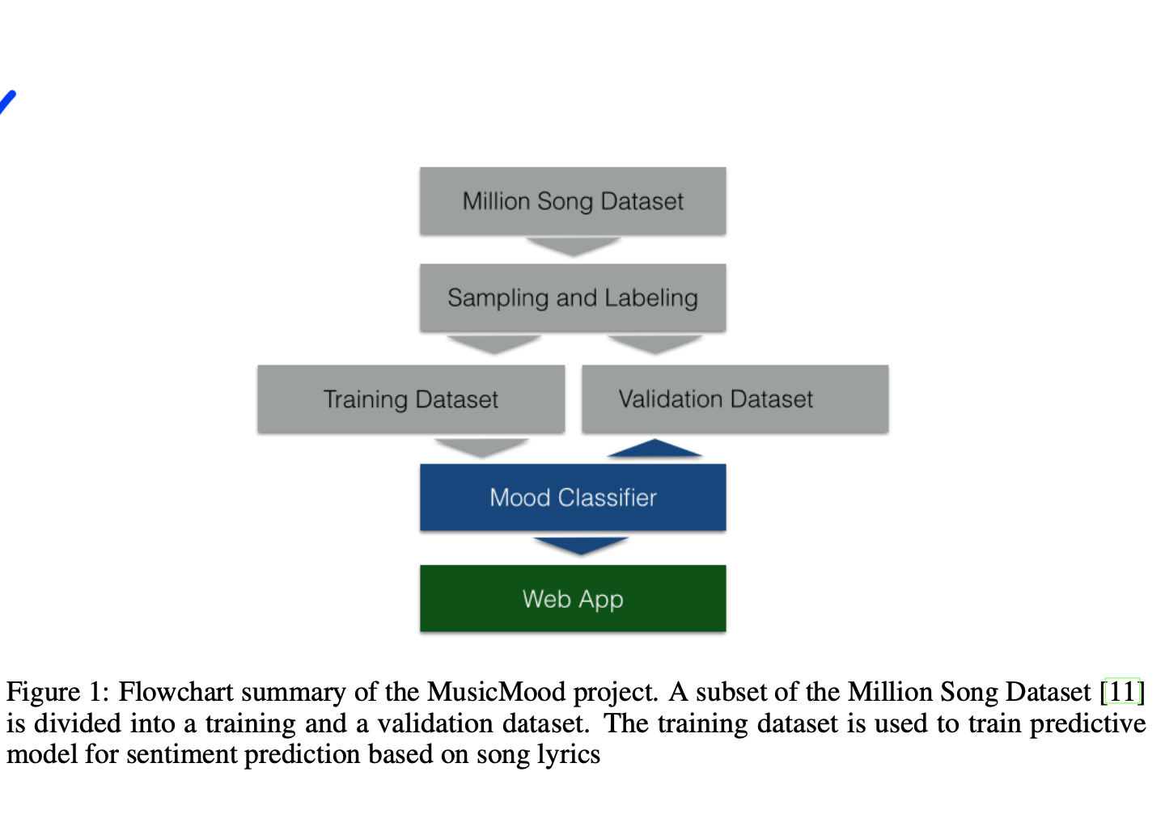

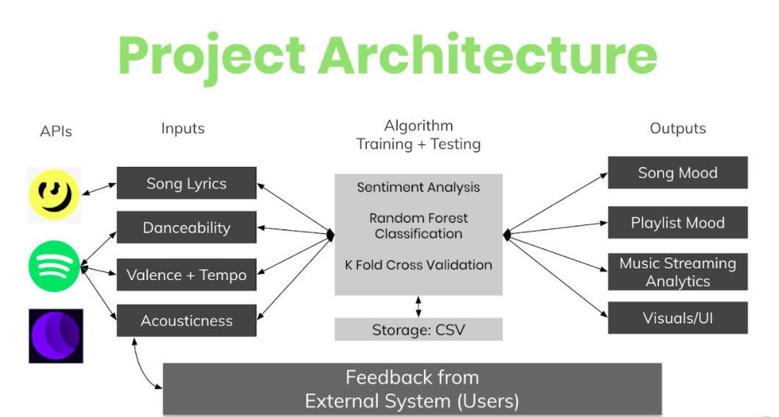

<https://developer.spotify.com/documentation/web-api/reference/#endpoint-get-users-top-artists-and-tracks>

Mental health using facebook