Intelligent Academic ERP & Timetable Generator
System Overview, Algorithms, and Implementation Details
Student Research Report
April 1, 2026

Abstract
This report documents the design and implementation of the Intelligent Academic ERP and Timetable Generator. The system provides both a CLI and web interface to manage academic master data, generate conflict-free timetables, and deliver decision-support dashboards. Two scheduling strategies are implemented: a greedy heuristic and a graph-coloring-inspired heuristic. Additional modules handle faculty availability, budget constraints, room reservations, cancellations, reporting, and audit logging. This document details system architecture, data model, scheduling logic, and operational features to support evaluation and future extension.
Keywords
Timetable scheduling, ERP, graph coloring, greedy heuristic, conflict detection, resource allocation
1. Introduction
Academic timetable generation is a constrained optimization problem involving rooms, faculty, sections, and time slots. Manual scheduling is error-prone and time-consuming; conflicts and resource underutilization are common. This project addresses the problem by integrating scheduling algorithms with an ERP-style management layer, providing both command-line and web-based workflows.
2. System Architecture
The system is composed of a CLI module and a Spring Boot web module that share a single MySQL database. The CLI supports CRUD operations, algorithm comparison, and CSV export. The web UI mirrors these features and adds dashboards, reports, bulk import/export, and room availability workflows.
3. Data Model
Core entities include Department, Faculty, Subject, Section, Classroom, TimeSlot, and Timetable. Supporting entities manage availability, room reservations, cancellations, users, password reset tokens, and audit logs.
4. Scheduling Problem Formulation
Inputs: departments, subjects (weekly hours), sections (strength), faculty (max hours, cost), rooms (capacity, cost), and time slots.
Constraints: no double-booking of faculty/rooms/sections in a slot, room capacity >= section strength, faculty availability, and budget limits.
Objective: produce a feasible timetable with minimal conflicts and reasonable utilization.
5. Algorithms
Greedy Heuristic: iterates sections and subjects, assigning the first feasible (slot, room, faculty) that meets constraints.
Graph-Coloring Heuristic: sorts subjects by weekly hours, rotates through slots, and selects least-loaded faculty to balance allocation.
Conflict Detection: counts and prevents overlapping use of faculty, rooms, or sections at the same slot.
6. ERP Features
Master data CRUD: departments, faculty, subjects, rooms, time slots, and sections.
Role-based access: ADMIN and FACULTY with login, password reset, and preferences.
Room workflows: availability search, recurring reservations, maintenance blocks.
Timetable operations: generate, preview, detect conflicts, export CSV, cancellation and rebooking.
Reports: conflict report, faculty overload report, room utilization report, exportable CSVs.
Audit logs for sensitive actions.
7. Decision Support Metrics
Dashboard KPIs include conflict counts, faculty overload percentage, room utilization, and budget usage.
Risk analysis flags faculty overload or underutilization and room underutilization.
8. Evaluation Considerations
Runtime and conflicts are reported for each algorithm; the system supports direct comparison for a semester/department.
Budget and capacity constraints are enforced during generation to avoid infeasible allocations.
9. Limitations
Graph coloring is heuristic rather than optimal coloring, so solutions may be suboptimal.
Genetic Algorithm code exists as a prototype but is not integrated into production flows.
Scalability depends on slot and room counts; complex constraints may require more advanced optimization techniques.
10. Future Work
Integrate the genetic algorithm or other metaheuristics (e.g., simulated annealing).
Introduce soft constraints (preferred times, compact schedules).
Add multi-department cross-constraints and shared resources.
Diagrams
Figure 1: Database ER Model
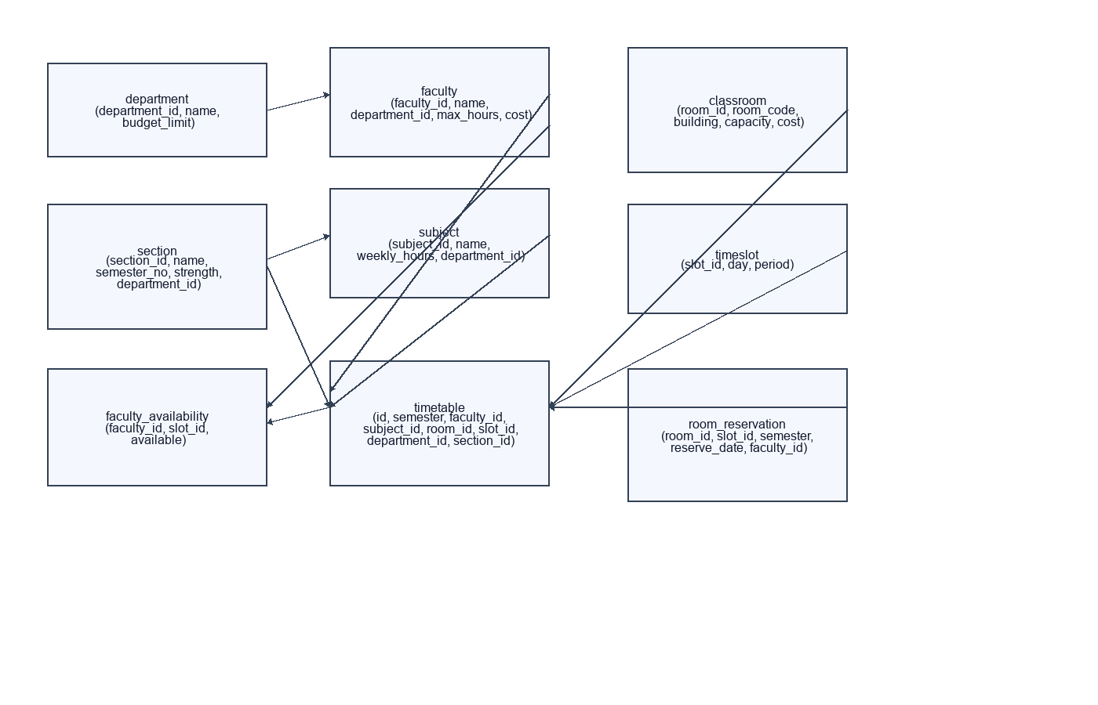
Figure 2: System Architecture
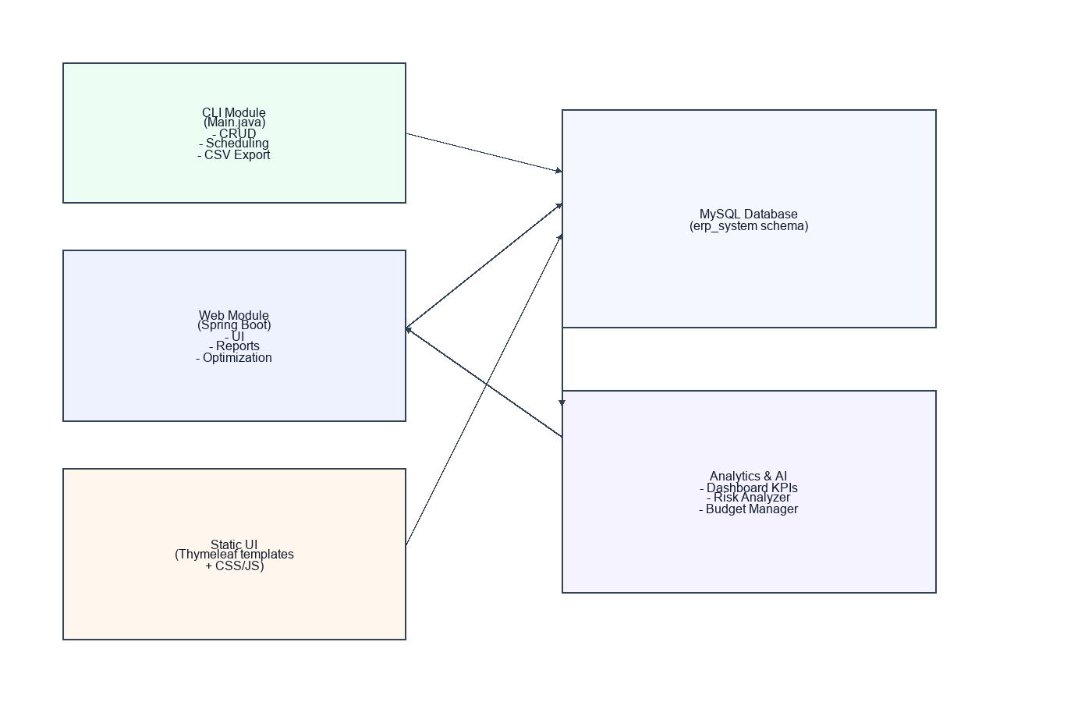
Figure 3: Scheduling Flow
