1. Download the Community Edition of the SonarQube from the below link. (Install Java 17 from Software center)

<https://www.sonarsource.com/products/sonarqube/downloads/?gads_campaign=SQ-Hroi-PMax&gads_ad_group=Global&gads_keyword=&gclid=EAIaIQobChMIkM2IkrjS_wIVtDbUAR3U0QSjEAAYASAAEgKo4fD_BwE>

1. Extract the zip to any folder.
2. Download the Sonar Scanner window -64 from the below url

<https://docs.sonarqube.org/latest/analyzing-source-code/scanners/sonarscanner/>

1. Ask Help Desk team to set the environment variable for Sonar Scanner till bin.

Here is the incident detail for the same.

<https://actprod.service-now.com/now/nav/ui/classic/params/target/incident.do%3Fsys_id%3Da53b5e1497aba910d92f7da71153afae%26sysparm_stack%3Dincident_list.do%3Fsysparm_query%3Dactive%3Dtrue>

1. Now start the StartSonar.bat file from SonarQube extracted folder from command prompt.
2. Start the SonarQube locally <http://localhost:9000/>.

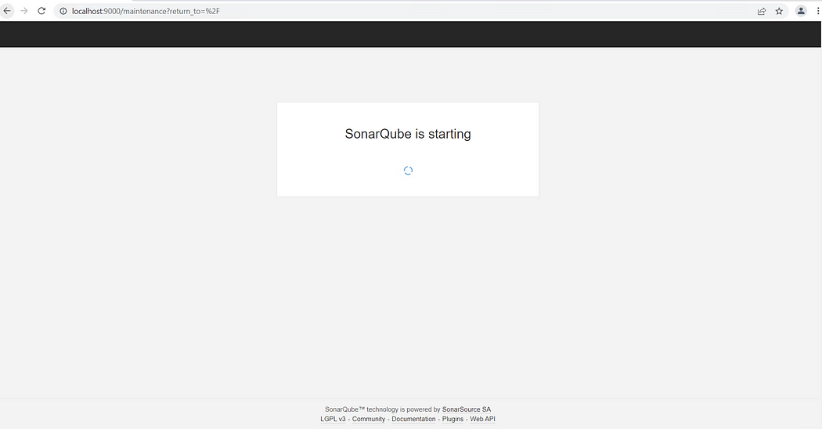

The default username and password are “admin”.

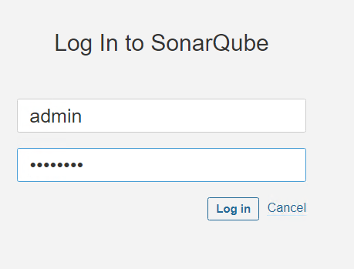

1. change the default password after log in.

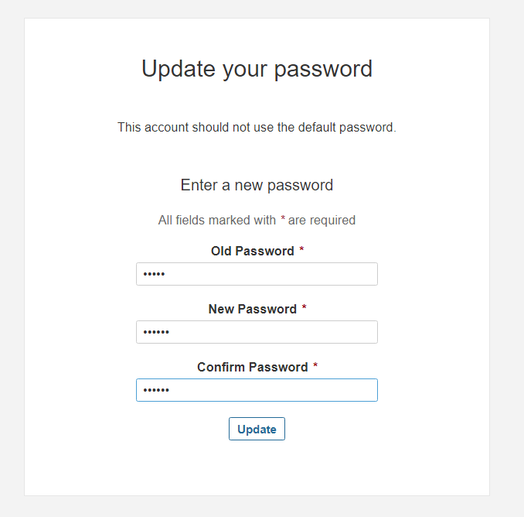

1. When SonarQube is up and running click on the Create Project button. A screenshot of a computer

   Description automatically generated with medium confidence

For the very first time you might see the screen below. Select **manually**.

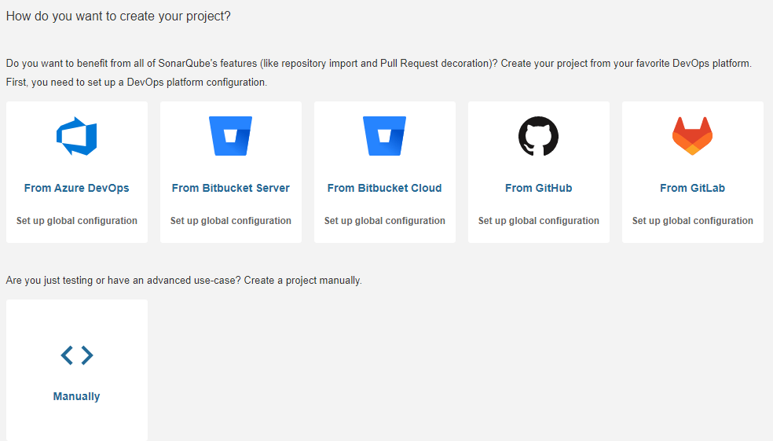

1. Select Locally from the screen below.

1. Generate the token and continue.

1. Select the appropriate technology and OS and run the sonar scanner command in terminal by copying from the screen in project folder.

1. Once the scanning is completed, SonarQube will automatically show the dashboard screen.
2. In case if using Scala or different technology, pls change the language as per the screenshot.

