An Internship Report
Of
Siemens Data Science Master
Submitted
To
School of Computer Science and Engineering
IILM University, Greater Noida, U.P.
In partial fulfilment of the requirement of degree of
B.Tech (CSE)

By
Roll Number of Student: 2410031316
Name of Student: PRAJJWAL SINGH
Batch: 2026-27

CANDIDATE'S DECLARATION
I, PRAJJWAL SINGH, do hereby declare that the internship report titled "Siemens Data Science Master" has been completed by me to fulfil the requirement for the award of the degree of Bachelor of Technology in Computer Science and Engineering. All the references have been quoted and I have not taken as such any material from any other source. I affirm that this report is my own and has not been submitted to any other institute for any degree/diploma requirement, and further I shall be solely responsible for any kind of copyright violation in this regard.
Signature:-
Student Name: PRAJJWAL SINGH
Roll No.: 2410031316

ACKNOWLEDGEMENT
I am using this opportunity to express my gratitude to everyone who supported me throughout the Internship Program. I am thankful for their aspiring guidance, invaluably constructive criticism and friendly advice during this work. I am sincerely grateful to them for sharing their truthful and illuminating views on a number of issues related to this work.
I would like to thank the AICTE – EduSkills Virtual Internship Program team and EduSkills Academy, supported by Siemens, for providing me the opportunity and the structured platform to learn and gain hands-on exposure in the domain of Siemens Data Science Master. I am also thankful to my institute, IILM University, Greater Noida, and the faculty of the School of Computer Science and Engineering for their continuous support and encouragement.
I express my gratitude to my parents for their blessings.
Signature:
Student Name: PRAJJWAL SINGH
Roll No.: 2410031316

TABLE OF CONTENTS
1. Candidate's Declaration i
2. Acknowledgement ii
3. Internship Completion Certificate -
4. Project Description 1
4.1 Introduction 1
4.2 Organization Profile 2
4.3 Problem Statement 3
4.4 Project Objectives 3
4.5 Scope of the Project 4
4.6 Technologies and Tools Used 4
4.7 System Architecture / Learning Approach 5
4.8 Methodology 6
4.9 Expected Outcomes 7
4.10 Certificates of Completion and Communication Proof 8
5. Bibliography/References 9

3. INTERNSHIP COMPLETION CERTIFICATE
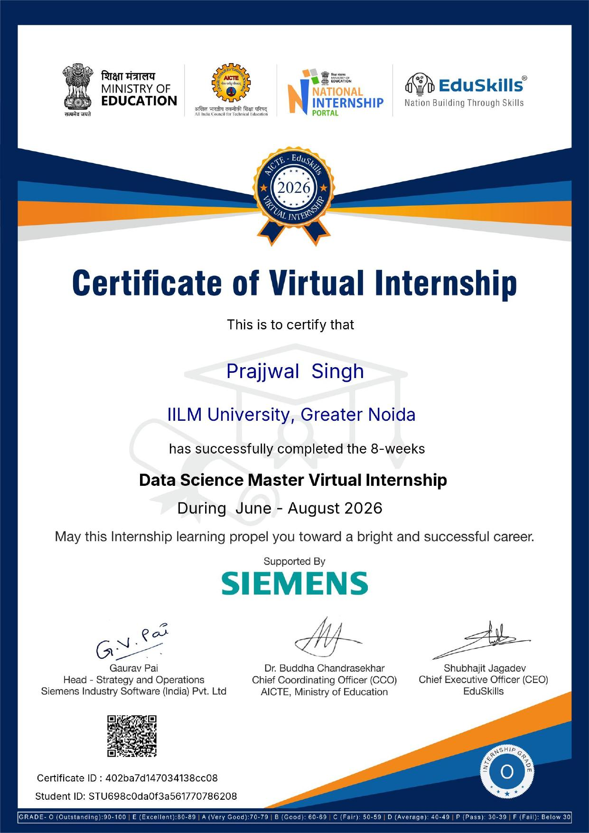

Internship Offer Letter
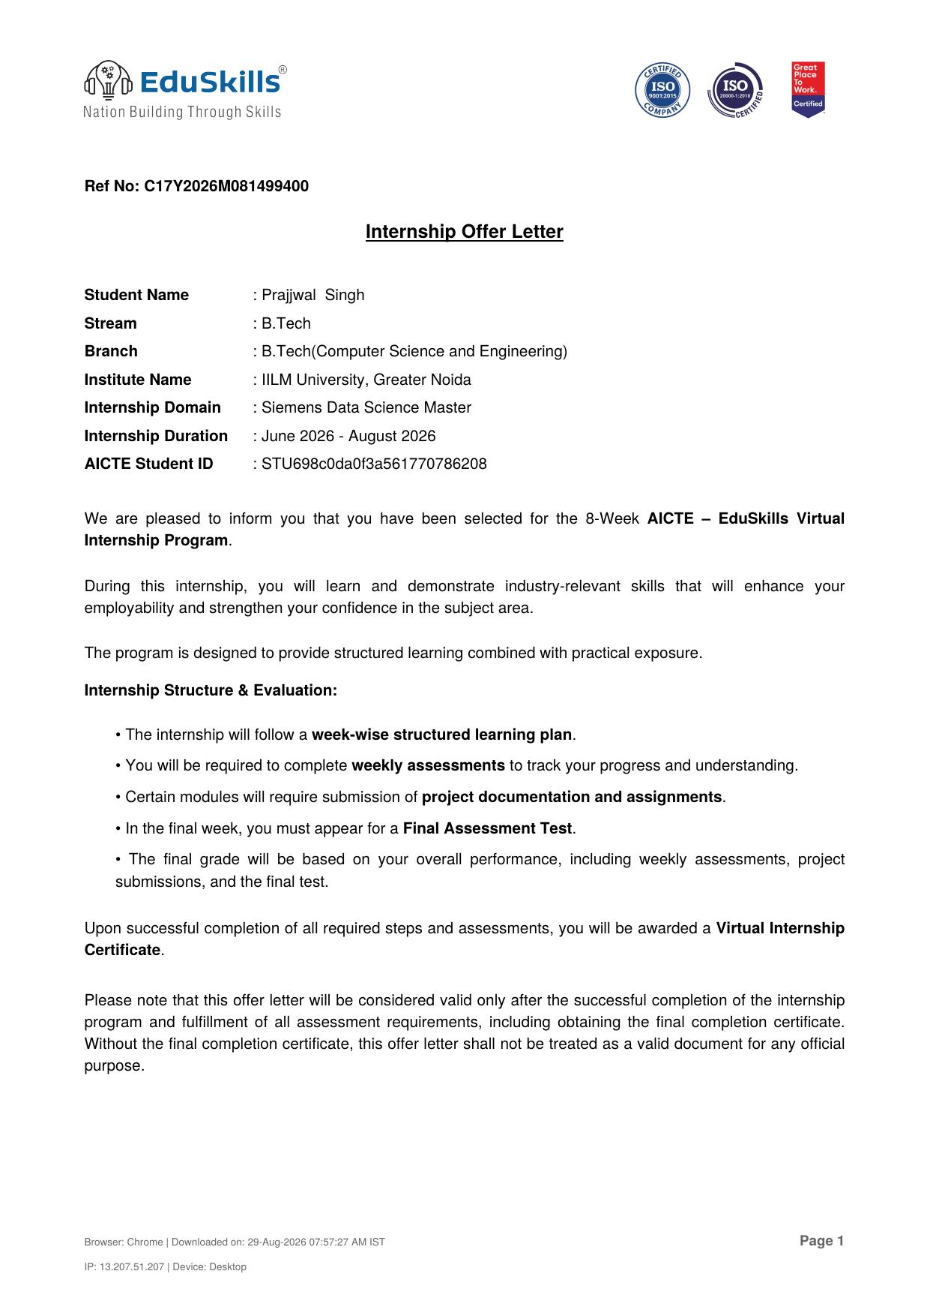

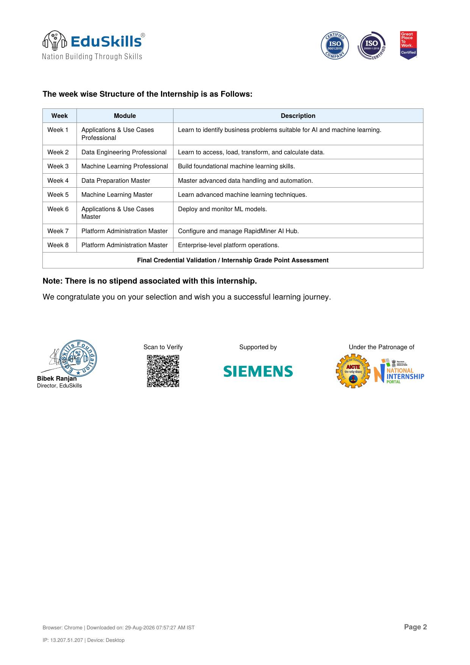

4. PROJECT DESCRIPTION

4.1 Introduction
This report presents a detailed account of the 8-week Virtual Internship undertaken under the AICTE – EduSkills Virtual Internship Program, in the domain of "Siemens Data Science Master", supported by Siemens Industry Software (India) Pvt. Ltd. The internship was carried out from June 2026 to August 2026 as part of the requirement of the Bachelor of Technology (Computer Science and Engineering) programme at IILM University, Greater Noida. The primary aim of this internship was to build a strong, practical foundation in data science — covering the identification of business problems suitable for AI/ML, data engineering, machine learning, data preparation and automation, model deployment and monitoring, and the administration of an enterprise-grade data science platform (RapidMiner AI Hub).
The internship followed a structured, week-wise curriculum that combined conceptual learning with hands-on assignments, weekly assessments, and project documentation. On successful completion of all the requirements, a Virtual Internship Certificate with an Outstanding (O) grade was awarded by EduSkills, supported by Siemens.

4.2 Organization Profile
EduSkills Academy is an ISO 9001:2015 and ISO 20000-1:2018 certified organization working under the theme "Nation Building Through Skills". EduSkills partners with the All India Council for Technical Education (AICTE) to run the AICTE – EduSkills Virtual Internship Program under the patronage of the AICTE National Internship Portal, Ministry of Education. This internship domain, Siemens Data Science Master, was supported by Siemens Industry Software (India) Pvt. Ltd., a global technology leader that provides industrial software and digitalization solutions, in collaboration with EduSkills to help engineering students build industry-relevant data science skills.

4.3 Problem Statement
While many engineering students are introduced to the theoretical concepts of data science and machine learning during their academic coursework, few get structured, hands-on exposure to the complete data science workflow used in the industry — from framing a business problem, to engineering and preparing data, building and refining machine learning models, and finally deploying, monitoring, and administering these solutions on a professional platform. The problem addressed by this internship was to bridge this gap by providing a progressive, professional-to-master level curriculum covering the end-to-end data science lifecycle using industry-standard tools.

4.4 Project Objectives
- To learn how to identify business problems that are suitable for AI and machine learning solutions.
- To gain hands-on skills in accessing, loading, transforming, and calculating data (data engineering).
- To build foundational and advanced machine learning skills.
- To master advanced data handling, cleaning, and automation techniques.
- To learn how to deploy and monitor machine learning models in real-world use cases.
- To configure and manage the RapidMiner AI Hub platform.
- To gain exposure to enterprise-level data science platform administration.

4.5 Scope of the Project
The scope of this internship spans the complete data science pipeline — starting with identifying suitable business use cases, moving through data engineering and preparation, building and mastering machine learning models, and concluding with the deployment, monitoring, and platform-level administration of data science solutions using RapidMiner AI Hub. The internship was carried out in a virtual, simulation/lab-based learning environment provided by EduSkills Academy and Siemens, and did not involve deployment on any live organizational production system.

4.6 Technologies and Tools Used
- Data Science Platform: RapidMiner AI Hub
- Core Areas: Data Engineering, Data Preparation, Machine Learning, Automation
- Programming & Analysis Foundations: Python, statistics, and data handling concepts
- Application Areas: Business use-case identification, model deployment and monitoring
- Platform Administration: Enterprise-level configuration and operations of RapidMiner AI Hub

4.7 System Architecture / Learning Approach
The internship curriculum was structured around a layered data science workflow, summarized below:
- Business Understanding Layer: Identifying business problems suitable for AI and machine learning.
- Data Engineering Layer: Accessing, loading, transforming, and calculating raw data.
- Modelling Layer: Building foundational and then advanced machine learning models.
- Data Preparation & Automation Layer: Advanced data handling, cleaning, and automated workflows.
- Deployment & Monitoring Layer: Deploying trained models and monitoring their performance.
- Platform Administration Layer: Configuring and managing RapidMiner AI Hub at an enterprise level.

4.8 Methodology
The internship followed a structured, week-wise methodology combining conceptual learning, hands-on labs, and weekly assessments, as summarized in the table below.
Week | Module | Description
Week 1 | Applications & Use Cases Professional | Learn to identify business problems suitable for AI and machine learning.
Week 2 | Data Engineering Professional | Learn to access, load, transform, and calculate data.
Week 3 | Machine Learning Professional | Build foundational machine learning skills.
Week 4 | Data Preparation Master | Master advanced data handling and automation.
Week 5 | Machine Learning Master | Learn advanced machine learning techniques.
Week 6 | Applications & Use Cases Master | Deploy and monitor ML models.
Week 7 | Platform Administration Master | Configure and manage RapidMiner AI Hub.
Week 8 | Platform Administration Master | Enterprise-level platform operations.
Each week concluded with a weekly assessment to evaluate conceptual understanding, and selected modules required submission of project documentation and assignments. In the final week, a Final Credential Validation / Internship Grade Point Assessment was conducted, and the overall grade was based on performance across all weekly assessments. There was no stipend associated with this internship.

4.9 Expected Outcomes
- Ability to identify business problems suitable for AI and machine learning solutions.
- Practical understanding of data engineering — accessing, loading, transforming, and calculating data.
- Hands-on foundational and advanced machine learning skills.
- Capability to perform advanced data preparation and automation.
- Skill to deploy and monitor machine learning models.
- Working knowledge of configuring and administering RapidMiner AI Hub at an enterprise level.
- An Outstanding (O) grade Virtual Internship Certificate in Siemens Data Science Master, awarded by EduSkills and supported by Siemens.

4.10 Certificates of Completion and Communication Proof
The Internship Offer Letter and the Internship Completion Certificate issued by EduSkills, supported by Siemens, confirming successful completion of the 8-week AICTE – EduSkills Virtual Internship Program in Siemens Data Science Master with an Outstanding (O) grade, are attached in Chapter 3 of this report. The email confirmation of successful completion received from EduSkills Foundation is attached below as further proof of completion.
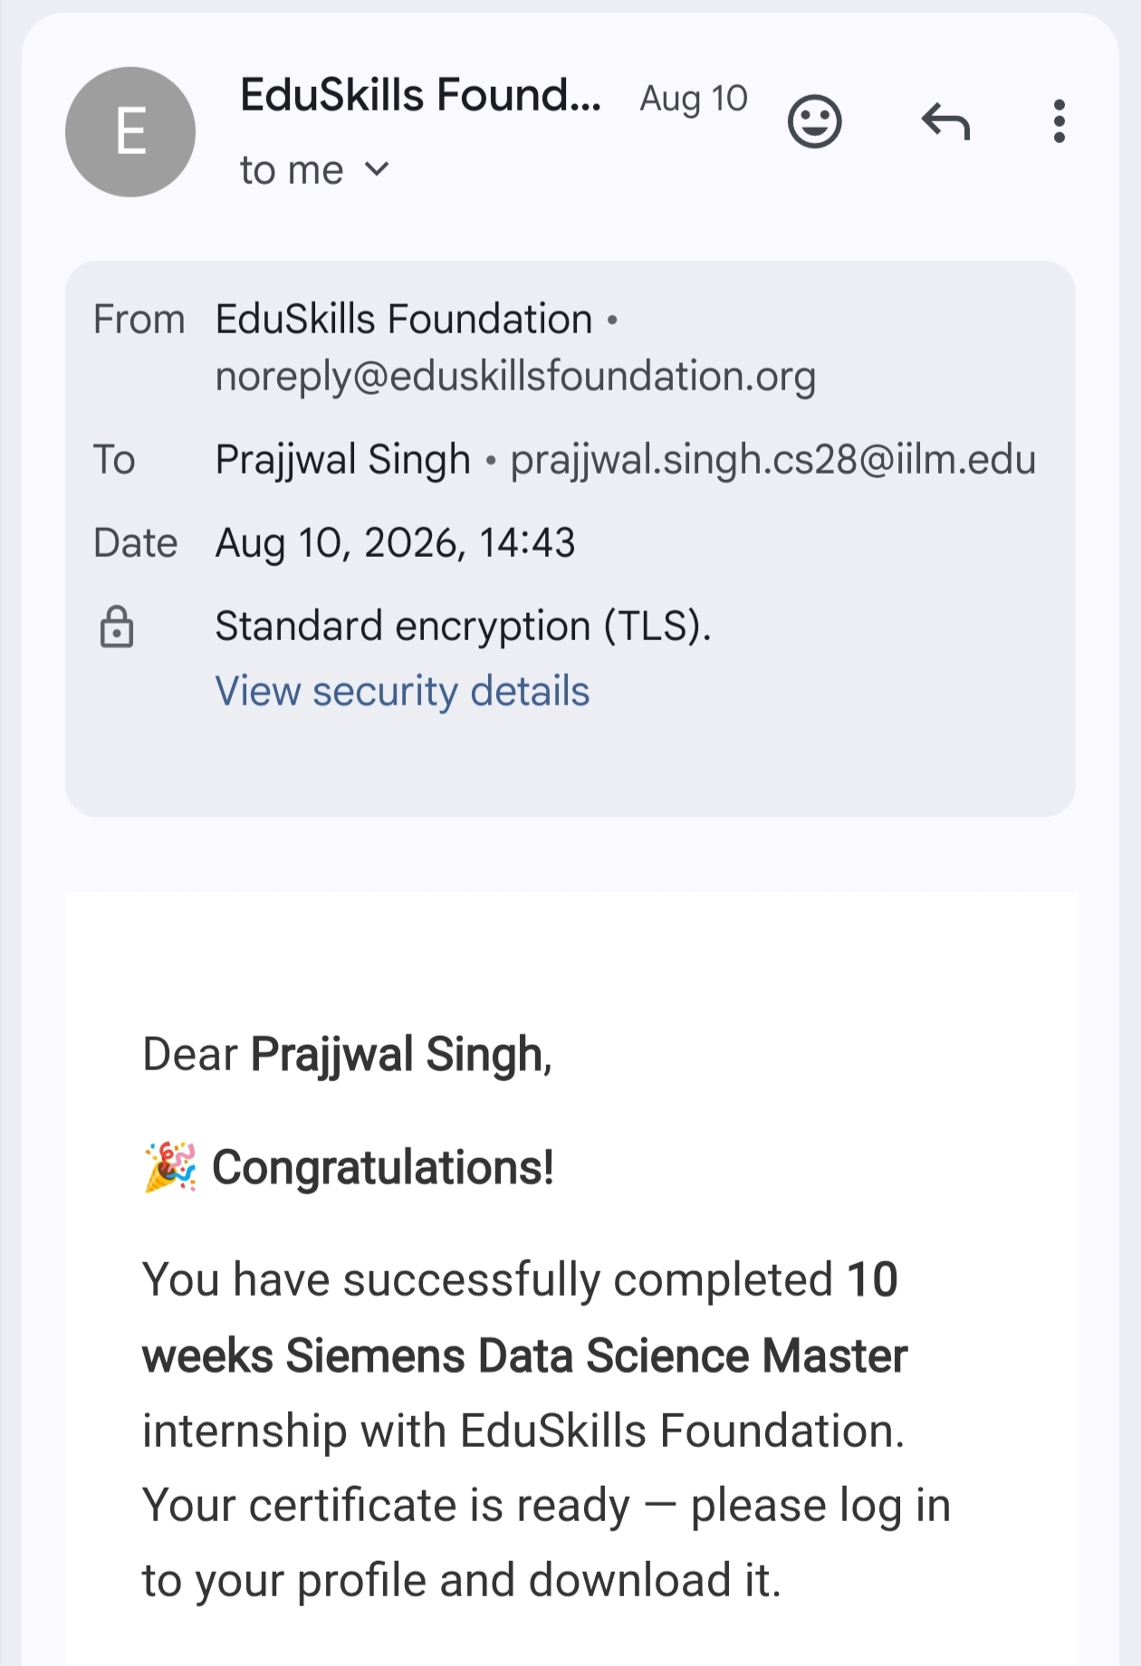

5. BIBLIOGRAPHY/REFERENCES
1. EduSkills Academy, "AICTE – EduSkills Virtual Internship Program – Siemens Data Science Master," Internship Offer Letter, Ref No. C17Y2026M081499400, 2026.
2. EduSkills, "Certificate of Virtual Internship – Data Science Master," Certificate ID: 402ba7d147034138cc08, Student ID: STU698c0da0f3a561770786208, Issued 2026.
3. EduSkills Foundation, Internship Completion Confirmation E-mail, dated August 10, 2026.
4. AICTE National Internship Portal, Ministry of Education, Government of India.
5. RapidMiner AI Hub Documentation, https://docs.rapidminer.com/

