I Wanna Be The Guy

“I Wanna Be The Guy” is a traditional 2D game. The player is “the kid”, and he can press “A” and ”D” to move kid left or right. Player can jump using white space. The mouse can shoot the bullet. The kid should go through the door to win. There are a lot of dangerous or hidden characters will cause kid died, such as spikes. The game is too difficult, so it allows player to attempt infinite times.

Class Diagram:

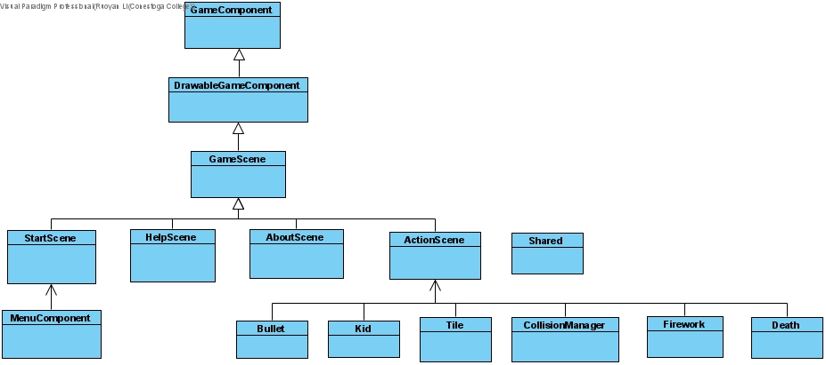

Reference:

<https://en.wikipedia.org/wiki/I_Wanna_Be_the_Guy>

<https://www.aigei.com/view/41575.html#items>

<https://www.aigei.com/music/class/energy>

https://www.aigei.com/