WORKSHOP GUIDE | HERMES AGENT

Build your own
AI Agent
  - Install Hermes Agent, connect Telegram, and schedule a secure daily email briefing.
Presented by Kang Zhou • Updated 29 August 2026
WORKSHOP | What you will leave with  A working Hermes Agent on Windows (via WSL2) or Linux.  A private Telegram control channel with explicit user pairing.  Read-only Gmail access through Himalaya and a tested scheduled briefing.

CONTENTS
1 | Prepare WSL2 or Linux | Build a stable host environment
2 | Install Hermes Agent | Configure a model and verify the install
3 | Connect Telegram | Pair a private mobile control channel
4 | Give Hermes mailbox access | Add Gmail through Himalaya safely
5 | Schedule a daily briefing | Create, test, and inspect a cron job
6 | Finish and extend | Acceptance checklist and next challenges
A | Optional Docker deployment | Container path for advanced operators

1 Prepare WSL2 or Linux
The workshop uses a Linux shell. Windows learners use WSL2; Linux learners can start at the prerequisites step.
NOTE | Choose the simplest supported path  Windows: use WSL2 for a Linux-native terminal and filesystem. Native Windows also works, but the commands in this guide are written for WSL2/Linux.  Linux: skip the WSL steps. Run the Linux commands directly in your terminal.

1 | Install WSL2 from an elevated Windows terminal  Open PowerShell or Windows Terminal as Administrator. Install the default Ubuntu LTS distribution, then reboot if Windows asks.

ADMIN POWERSHELL
wsl --install
# After the reboot, confirm the distro is using WSL2:
wsl --list --verbose

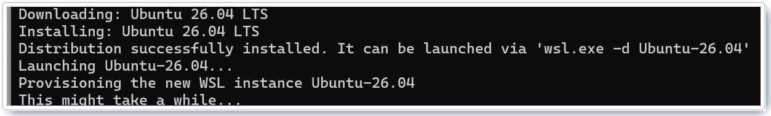
Figure 1. Sanitized example of a successful WSL installation. Your Ubuntu version may differ.
TIP | Your Linux account is separate  Ubuntu asks for a new Linux username and password. The password does not display while you type; that is normal. It is not your Windows password unless you deliberately make them the same.

Enable systemd in WSL2 (recommended)
Systemd lets Hermes install its gateway as a background service. Run this inside Ubuntu, then shut WSL down from PowerShell.
UBUNTU / WSL2
sudo tee /etc/wsl.conf >/dev/null <<'EOF'
[boot]
systemd=true
EOF

POWERSHELL, THEN UBUNTU
wsl --shutdown
# Reopen Ubuntu, then verify PID 1:
ps -p 1 -o comm=
# Expected: systemd

Install the small prerequisite set
2 | Install Git, curl, and xz-utils  The Hermes installer handles Python, Node.js, ripgrep, ffmpeg, and the virtual environment. Do not pre-install a second Python stack for this workshop.

UBUNTU OR DEBIAN LINUX
sudo apt update
sudo apt install -y git curl xz-utils

WATCH | Keep Linux projects on the Linux filesystem  Use paths such as ~/projects, not /mnt/c/Users/…. Linux tools are much faster and permissions are more reliable inside the WSL2 ext4 filesystem.

☐ `wsl --list --verbose` shows VERSION 2 (Windows only).
☐ `ps -p 1 -o comm=` prints systemd.
☐ `git --version` and `curl --version` both succeed.

2 Install Hermes Agent
Use the supported installer, connect a model provider, and validate the environment before adding external access.
OUTCOME | Why Docker is no longer required  Current Hermes releases install directly on Linux, macOS, WSL2, native Windows, and Termux. The direct path is simpler for a first workshop. Docker remains an optional deployment choice in Appendix A.

1 | Run the official installer  This is the current CLI-only installation path for Linux and WSL2. Review scripts before running them in production environments.

UBUNTU OR LINUX
curl -fsSL https://hermes-agent.nousresearch.com/install.sh | bash
source ~/.bashrc

2 | Verify the command and environment  The version check confirms the launcher. Hermes Doctor checks dependencies, configuration, security advisories, and optional integrations.

VERIFY
hermes --version
hermes doctor

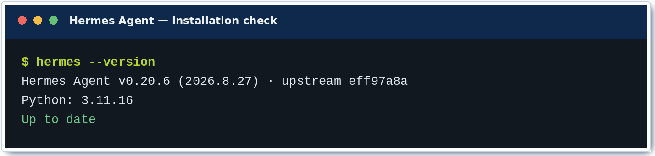
Figure 2. Version output captured from the workshop build on 29 August 2026.
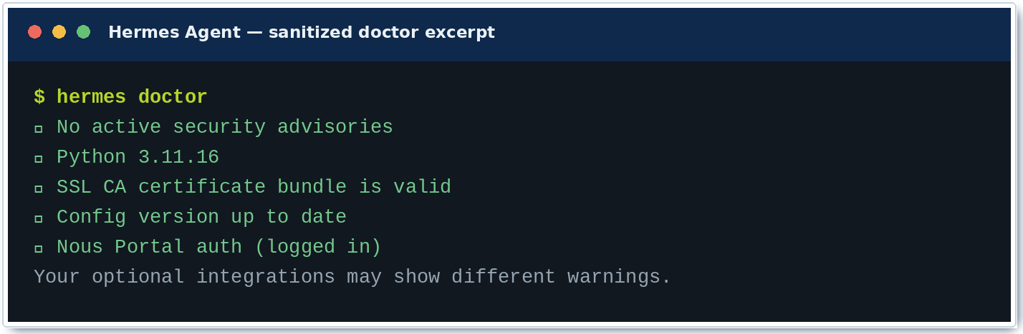
Figure 3. Sanitized Doctor excerpt. Optional tools can legitimately show warnings.

Connect a model provider
3 | Use Nous Portal for the lowest-friction setup  One OAuth login can configure the inference model plus managed web search, image, speech, and browser tools. A Portal subscription is required.

RECOMMENDED
hermes setup --portal

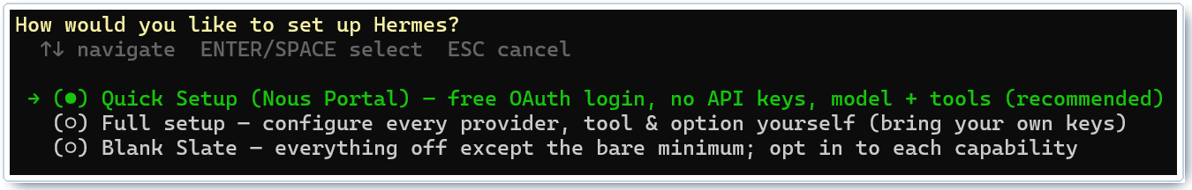
Figure 4. The full setup wizard also offers Portal, manual provider setup, or a blank slate.
Route | Use it when… | Command
Nous Portal | You want one OAuth login for models and managed tools. | hermes setup --portal
Another provider | You already have OpenAI, OpenRouter, Anthropic, or a custom endpoint. | hermes model
Tool backends | You want to choose web, browser, image, or TTS backends separately. | hermes tools

SECURITY | OAuth and API keys are credentials  Do not screenshot or paste login codes, refresh tokens, API keys, QR codes, or pairing links into a public document. The examples in this guide deliberately stop before credential-bearing screens.

Choose the terminal trust boundary
For the workshop, Local is the least complex backend. It also means Hermes commands run as your Linux user and can access that user’s files. Docker, SSH, and cloud sandboxes are available when you need stronger isolation or remote execution.
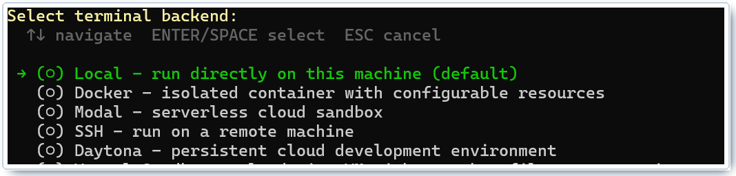
Figure 5. Terminal backend selection. Local is simple; Docker reduces blast radius.

Start the first conversation
WATCH | Before you test: Local is convenient, not isolated  Only connect people you trust. A messaging bot with a local terminal backend can act with your account’s file and command permissions. Isolation becomes the next design decision after the workshop succeeds.

INTERACTIVE CHAT
hermes

• “Summarize the files in my current directory without changing anything.”
• “Explain which tools are enabled and when you would ask before acting.”
• “Create a checklist for connecting Telegram, but do not change configuration yet.”
☐ `hermes --version` succeeds.
☐ `hermes doctor` has no blocking issue for your intended tools.
☐ A short chat returns a response from the selected model.

3 Connect Telegram
Add a private mobile control channel, pair only your own account, and keep the gateway running in the background.
SECURITY | Treat the bot like a remote shell  Never publish the bot token, onboarding QR code, pairing link, or pairing code.  Keep unknown users denied. Use the allowlist or DM pairing flow instead of “allow everyone.”

1 | Open the messaging setup wizard  Select Telegram. Hermes can guide you through automatic onboarding or a manual @BotFather token flow.

CONFIGURE MESSAGING
hermes gateway setup

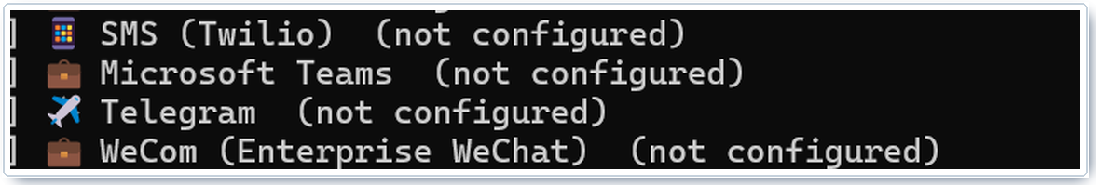
Figure 6. Telegram appears in the platform selector alongside other supported channels.
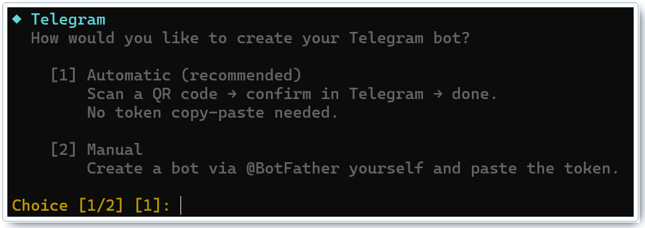
Figure 7. Telegram bot creation choices. Credential-bearing screens are intentionally omitted.
2 | Create the bot and pair your account  Follow the wizard. If you use @BotFather, paste the token only into your private terminal.  Message the new bot. Unknown users receive a one-time pairing code.  Approve only the code displayed in your own chat.

PAIR TELEGRAM — FAKE CODE EXAMPLE; REPLACE EXAMPLE1
hermes pairing list
hermes pairing approve telegram EXAMPLE1
hermes pairing list

3 | Install and start the gateway service  With systemd enabled, install the user service, start it now, and enable it for future logins.

BACKGROUND GATEWAY
hermes gateway install --start-now --start-on-login
hermes gateway status

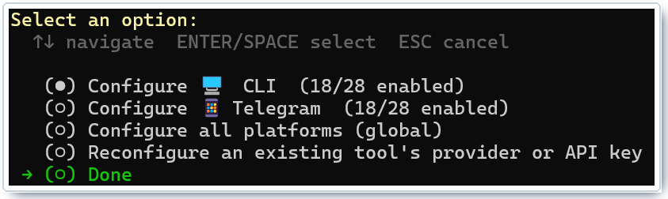
Figure 8. Tools can be configured separately for the CLI, Telegram, or all platforms.
WATCH | WSL itself can still stop  A user service keeps Hermes alive while WSL is running. If the WSL VM stops when you close every terminal, use the optional Windows login task below or leave the gateway in the foreground during the workshop.

OPTIONAL WINDOWS TASK SCHEDULER ACTION
Program: C:\Windows\System32\wsl.exe
Arguments: -d Ubuntu --exec /bin/sh -c "sleep infinity"
Trigger: At log on

Test from your phone
• Send: “What tools can you use in this chat?”
• Send a photo and ask for a short description if vision is enabled.
• Run `/whoami` to inspect your access tier, then `/status` to inspect the session.
• Run `/sethome` if this Telegram chat should receive platform-default cron deliveries.
☐ `hermes gateway status` reports the service as running.
☐ `hermes pairing list` shows only the intended account(s).
☐ The bot replies in the paired Telegram chat.

4 Give Hermes mailbox access
Configure Gmail through Himalaya with an app password, then validate read access before scheduling anything.
SECURITY | Start read-only by policy  The account protocol can technically send, move, and delete mail. This workshop prompt forbids those actions. Sending and deletion should require separate, explicit user approval and testing.

1 | Install the Himalaya email CLI  The bundled mailbox-search workflow uses Himalaya to list and read messages.

INSTALL HIMALAYA
curl -sSL https://raw.githubusercontent.com/pimalaya/himalaya/master/install.sh \
| PREFIX="$HOME/.local" sh
himalaya --version

NOTE | Command syntax in this guide  The examples were checked against Himalaya v2.1.0. This release uses --mailbox for folder selection and --json for structured output.

2 | Create a Gmail app password  Enable two-step verification on the Google account.  Open Google Account → Security → App passwords.  Create an app password for this agent. Do not use your normal Gmail password.

3 | Store the app password without shell-history exposure  Paste it into a silent prompt, write it to a mode-600 file, then remove it from the environment.

SECURE CREDENTIAL FILE
mkdir -p ~/.config/himalaya
install -m 600 /dev/null ~/.config/himalaya/gmail-password
read -rsp 'Paste Gmail app password: ' GMAIL_APP_PASSWORD; echo
printf '%s' "$GMAIL_APP_PASSWORD" > ~/.config/himalaya/gmail-password
unset GMAIL_APP_PASSWORD

4 | Create the Himalaya configuration  Replace the uppercase placeholders. Keep the password out of TOML; the command reads it from the protected file at runtime.

FILE: ~/.CONFIG/HIMALAYA/CONFIG.TOML
[accounts.personal]
email = "YOUR_ADDRESS@gmail.com"
display-name = "YOUR_NAME"
default = true
imap.server = "imaps://imap.gmail.com:993"
imap.sasl.plain.username = "YOUR_ADDRESS@gmail.com"
imap.sasl.plain.password.command = "cat /home/YOUR_LINUX_USER/.config/himalaya/gmail-password"
smtp.server = "smtps://smtp.gmail.com:465"
smtp.sasl.plain.username = "YOUR_ADDRESS@gmail.com"
smtp.sasl.plain.password.command = "cat /home/YOUR_LINUX_USER/.config/himalaya/gmail-password"
mailbox.alias.inbox = "INBOX"
mailbox.alias.sent = "[Gmail]/Sent Mail"
mailbox.alias.drafts = "[Gmail]/Drafts"
mailbox.alias.trash = "[Gmail]/Trash"
mailbox.alias.archive = "[Gmail]/All Mail"

WATCH | The Sent alias prevents duplicates  SMTP delivery can succeed even when saving a copy to the wrong Sent folder fails. Mapping [Gmail]/Sent Mail avoids treating that partial failure as a reason to resend.

Validate the account before giving it to an agent
READ-ONLY CHECKS
himalaya account list
himalaya --account personal account check
himalaya --account personal --json envelope list --mailbox INBOX --page-size 5

TIP | If Gmail rejects the login  Confirm IMAP is available for the account, re-copy the app password without spaces, verify the username is the full email address, and check the password file path and permissions.

☐ `himalaya account check` validates both IMAP and SMTP.
☐ The five-message listing returns subjects and senders without exposing the app password.
☐ No password or token appears directly in `config.toml`.

5 Schedule a daily email briefing
Create the job from Telegram or the CLI, make the prompt self-contained, and perform a manual run before trusting the schedule.
OUTCOME | What the automation should do  At 7:00 each morning, list recent inbox messages, identify what matters, and send a concise briefing to Telegram—without sending, moving, deleting, or marking email.

1 | Create the job in natural language (easiest)  Send the following message to your paired Telegram bot. Creating it from the destination chat lets Hermes preserve the correct delivery target.

SEND THIS TO HERMES IN TELEGRAM
Every day at 7:00 AM local time, use the mailbox-search skill and the
"personal" Himalaya account to review messages received since the previous run.
Send a concise briefing back to this Telegram chat with:
- the three most important items first;
- sender, subject, received time, and why each item matters;
- a separate action-needed list;
- a count of routine or low-priority messages.
Do not send, reply, move, delete, archive, or change flags on any email.
If mailbox access fails, report the error and do not guess.

NOTE | Self-contained prompts matter  Cron runs in a fresh session. Include the mailbox account name, time window, output format, delivery destination, and prohibited actions in the job itself.

CLI equivalent
For a deterministic workshop setup, create the same job from the terminal. The gateway must already know the Telegram home channel (use /sethome in the bot chat).
CREATE THE RECURRING JOB (BASH)
PROMPT='Use the mailbox-search skill with Himalaya account personal.
Review email received since the previous run.
Return the three most important messages first, then action-needed items
and a count of routine messages. Include sender, subject, received time,
and why it matters. Never send, reply, move, delete, archive, or change
flags. If access fails, report the error and do not guess.'
hermes cron create "0 7 * * *" "$PROMPT" \
--name "Daily email briefing" \
--deliver telegram \
--skill mailbox-search

WATCH | Pin unattended inference deliberately  Recurring jobs inherit cron.model or the global model unless you pin one. Hermes guards against silent model drift, but a global model change can pause an unpinned job. For long-term use, edit the job with an explicit --provider and --model chosen by the operator.

OPTIONAL MODEL PIN
hermes cron edit <job-id> --provider <provider> --model <model-slug>

2 | Inspect, trigger, and review the first run  Manual runs are asynchronous: queue the job, then inspect durable execution history and the Telegram result.

TEST BEFORE RELYING ON THE SCHEDULE
hermes cron list
hermes cron run <job-id>
hermes cron runs <job-id> --limit 5
hermes cron status

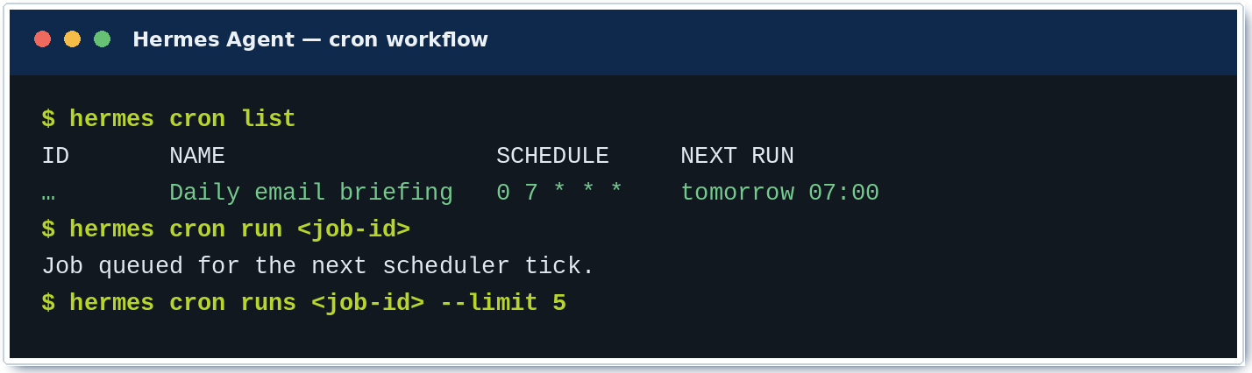
Figure 9. Expected cron workflow. IDs and timestamps will differ.
TIP | Schedules use the host clock  Run `date` on the Hermes host and confirm the timezone before relying on 07:00. This matters after moving a profile to a server or VPS.

Acceptance test for the briefing
☐ The manual run completes successfully in `hermes cron runs`.
☐ The Telegram message arrives in the intended chat—not another channel.
☐ Every listed message came from real mailbox output; missing data is labelled.
☐ The briefing performed no send, move, delete, archive, or flag action.
☐ The next run time and host timezone are correct.

6 Finish and extend
Confirm the whole chain, then add capability one boundary at a time.
WORKSHOP | Definition of done  The workshop is complete only after a manually triggered cron run reads real mail and delivers a safe briefing to the paired Telegram chat.

☐ WSL2/Linux is stable, and systemd is available where required.
☐ `hermes --version` and `hermes doctor` pass for the features you use.
☐ The Telegram gateway is running and only intended users are paired.
☐ Himalaya can list the inbox; the credential is stored outside TOML with mode 600.
☐ The daily briefing job exists, has been manually tested, and delivers to the right chat.
☐ The automation boundary is documented: read/summarize only; no mailbox mutation.

Next challenges
Challenge | Safe first version | What to avoid
Weekly research digest | Search trusted sources, deduplicate links, cite every claim. | Posting or emailing automatically on the first iteration.
System health brief | Read disk, memory, service state, and alert only on thresholds. | Self-healing commands without a rollback and approval path.
Calendar preparation | Summarize the next day and list preparation tasks. | Creating or moving meetings without confirmation.
Project agent | Set a work directory and let Hermes read project context files. | Running against a production repository with broad write access.

TIP | Second-order design rule  After the happy path works, the next bottlenecks are identity, isolation, observability, and recovery. Add logging and a clear approval boundary before adding more write access.

Troubleshooting quick reference
Symptom | Likely cause | Check / fix
`hermes` not found | Shell PATH not reloaded. | Run `source ~/.bashrc`; check `~/.local/bin`.
Bot stays silent | Gateway stopped or account not paired. | `hermes gateway status`; `hermes pairing list`.
Cron never fires | Gateway/scheduler not running or wrong timezone. | `hermes cron status`; run `date`; inspect `cron runs`.
Gmail auth fails | Normal password used, bad path, or app password copied incorrectly. | Recreate the app password; check mode 600 and absolute path.
WSL stops overnight | The VM exits after all WSL processes stop. | Create the Windows login task with `sleep infinity`.
Doctor shows optional warnings | Unused integrations are not configured. | Fix only warnings required for this workshop path.

Current documentation
Install: https://hermes-agent.nousresearch.com/docs/getting-started/installation
Windows / WSL2: https://hermes-agent.nousresearch.com/docs/user-guide/windows-wsl-quickstart
Messaging gateway: https://hermes-agent.nousresearch.com/docs/user-guide/messaging
Scheduled tasks: https://hermes-agent.nousresearch.com/docs/user-guide/features/cron
Nous Portal: https://hermes-agent.nousresearch.com/docs/integrations/nous-portal

A Optional Docker deployment
Use this path when you specifically want a containerized Hermes runtime. It is not required for the workshop.
NOTE | Two different Docker uses  Running Hermes inside a container is different from installing Hermes on the host and selecting Docker as its terminal backend. The commands below run the whole agent in Docker.

1 | Run first-time setup in a temporary container  The host directory ~/.hermes becomes the persistent data directory inside the container.

FIRST-TIME CONTAINER SETUP
mkdir -p ~/.hermes
docker run -it --rm \
-v ~/.hermes:/opt/data \
nousresearch/hermes-agent setup

2 | Start the persistent gateway container  The image is stateless; configuration, credentials, sessions, skills, memory, and cron jobs remain in the mounted host directory.

BACKGROUND GATEWAY CONTAINER
docker run -d \
--name hermes \
--restart unless-stopped \
--shm-size=1g \
-v ~/.hermes:/opt/data \
nousresearch/hermes-agent gateway run

SECURITY | Container boundaries still need design  Mount only the data and project directories the agent genuinely needs.  Do not run two gateway containers against the same data directory.  Do not publish the API or dashboard to the internet without authentication, a strong key, and network controls.

OPERATIONS
docker logs --tail 50 hermes
docker stats hermes
docker restart hermes
docker stop hermes

Full Docker guide: https://hermes-agent.nousresearch.com/docs/user-guide/docker
WORKSHOP GUIDE • VERSION 1.0 • 29 AUGUST 2026
Commands validated against Hermes Agent v0.20.6 and Himalaya v2.1.0.

