Assignment 1

GUO Huining, 25054068G

I. INTRODUCTION
Vehicle Routing Problem (VRP) is an extension of Travelling Salesman Problem, which is a complex problem that has wide applications in real-world logistics, transportation and other field. A group of vehicles are allowed to start from one or more depotes. During the process, the vehicles should satisfy some constraint like vehicle capacity or delivery time. VRP is aimed at designing an optimal route for vehicles to service customers who scatters in different places and achieve specific goals. In partical application, minimizing total distance, delivery time, and the number of vehicles used are always set as goals to make logistics companies more efficient.
Evolutionary algorithm (EA) is an umbrella term used to describe population-based stochastic direct search algorithms. EA mimic natural evolution processes such as natural selection, reproduction, mutation, and recombination to finding approximate optimal solutions for complex problems. Through continous iteration, potential solutions to the problem are continously evolved, with each generation produce better solutions until a predetermined termination condition is reached. Prominent representatives of such algorithms are genetic algorithms, evolution strategies, evolutionary programming, and genetic programming.
Genetic algorithms (GA) primarily use discrete approach to encode chromesomes (binary, permutation, and tree). Their evolutionary process is primarily complemented by crossover and mutation. GA excel at solving combinatorial optimization problems and have become a popular approach to vehicle-based resource allocation (VRP) problems. This report will apply GA to five specific VRP problem, present experimental results, and analyze the impact of algorithm parameters on the results.

II. Methodology

A. CLASSICAL VRP
The objective of this task is to plan an optimal delivery route for a vehicle with a capacity of 200. The vehicle must start from Warehouse 0, serve 100 customers, and finally return to Warehouse 0. The problem is a Capacity Vehicle Routing Problem (CVRP), and its optimization objective is to minimize the total distance traveled.
This program consists of three main modules: data processing, genetic algorithm, and visualization. The data processing module is responsible for reading and preprocessing the dataset and calculating the distance matrix between nodes. The genetic algorithm module performs iterative operations such as population initialization, fitness evaluation, selection, crossover, mutation, and population update, ultimately generating the optimal path solution. The visualization module analyzes the optimal path results, displays the vehicle path map and the algorithm evolution curve, and visualizes the optimization results.
- Data Processing
First, we read the information for 100 customers from the VRP.csv file. The data_process.py file defines a specific data processing class for reading the contents of the CSV file and saving the customer and depot data separately.
To optimize travel distance, the distance between customers and depots must be calculated frequently. To avoid duplicate calculations, an n dimensional distance matrix is created during data processing through the function cul_dist_matrix, where n is the total number of customers and depots. In this matrix, indices 0 to 99 correspond to customers, and indices 100 to 104 correspond to depots. Each element stores the Euclidean distance between the corresponding two points.
- Genectic Algorithm
After initializing the population and evaluating its initial fitness, the algorithm begins an iterative evolutionary cycle. In each generation, the algorithm performs crossover, mutation, and fitness evaluation on the population according to the configured probability parameters. The algorithm continuously tracks the evolution of the optimal solution across generations. If no significant improvement is observed over several generations, the algorithm is considered to have converged. After decoding, the final optimal individual result represents the shortest road route that satisfies vehicle load constraints and warehouse access requirements. The pseudocode is as follows.
GeneticAlgorithm_VRP:
1. Initialize population P randomly
2. Evaluate fitness for all individuals
3. For generation = 1 to MAX_GENERATIONS:
a. Select parents using tournament selection
b. Apply crossover and mutation to generate offspring
c. Evaluate offspring fitness
d. Update population with new offspring
4. Return the best individual found

- Chromesome Encoding and Initialization
The initial population is generated randomly, where each individual represents a feasible delivery route. In this task, every customer should be assigned to one of the four depots. Therefore, the chromosome encoding of the algorithm needs to combine the customer sequence and its depot allocation information. The first part of the chromosome represents a random permutation without repetitons of all customers. The second part corresponds to the depot assignment for each customer in the first part, indicating which depot serves that customer. The structure of individual is shown in the figure below.

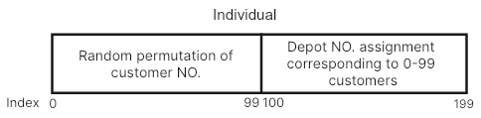

- Fitness Evaluation
The total travel distance of each solution is calculated as its fitness value, which measures how good the solution is. The core of total distance calculation is querying and accumulating the distance matrix. At each step of the path simulation, the algorithm reads the corresponding distance value from the distance matrix based on the vehicle’s current and next positions and accumulates them to gradually calculate the total distance.
In the fitness function, first split the customer access order contained in the individual and the corresponding depot order. The vehicle starts from depot 0 and visits customers in the order defined by the chromosome. During the route, the load of vehicle is continuously monitored. If the current load exceeds the capacity limit of vehicle, or if the current customer is assigned to a different depot than the previous one, the vehicle will first return to the depot assigned to the current customer for resupply before continuing delivery. This approach of handling that the vehicle always satisfies the capacity constraint without the need for additional penalty functions, making the fitness evaluation more intuitive and efficient.
Finally, the vehicle returns to the depot 0, and the total accumulated distance throughout the process is used as the fitness value of the chromosome. The pseudocode is as follows.
CuculateFitness(Individual):
1. total_distance ← 0, current_load ← 0
2. current_position ← depot_0
3. For each customer in visiting_order:
assigned_depot ← depot_assignments[customer]
demand ← customer_demand[customer]
If load exceeds capacity or depot changes:
total_distance += distance(current_position, assigned_depot)
current_load ← 0
current_position ← assigned_depot
total_distance += distance(current_position, customer)
current_position ← customer
current_load += demand
4. total_distance += distance(current_position, depot_0)
5. Return total_distance

- Selection Operator
This task utilizes the built-in tournament selection operator from the DEAP library to perform selection operations. A few individuals are randomly chosen from the population to compete, and the one with the higher fitness value is selected for reproduction. This selection strategy is more suitable for this problem compared to other selection methods, effectively preventing the algorithm from getting trapped in local optimal.
- Variation Operator
In this task, the chromosome encoding structure is divided into two parts, so the crossover and mutation operators cannot be directly applied. Custom operators are required to handle the customer visiting order and depot assignment separately, then combine them into a complete chromosome.
A hybrid strategy is adopted: For the customer visiting order part, which is essentially a permutation encoding problem requiring each customer to be visited exactly once, the Ordered Crossover operator from the DEAP library is employed. For the depot assignment part, the Uniform Crossover method is applied. It independently swaps the depot index of each customer between two parents with a specific probability. Since depot indices are predefined valid integers, this operation efficiently explores new assignment combinations without generating invalid solutions.
Similarly, mutation operations are also customized. For the customer visiting order, two customers are randomly swapped to generate a new route structure. For the depot assignment, a random customer’s depot number is changed to another valid one.
- Population Update
Elitism mechanism is applied to ensure that the best individual of each generation is always preserved. In the specific implementation, the best individual from the parent population is retained by replacing the worst-performing individual in the offspring population. This prevents the loss of the current optimal solution during the evolutionary process and helps maintain steady improvement across generations.

STOCHASTIC DEMAND PROBLEM
In real-world vehicle routing problems, customer demand often contains a degree of uncertainty, and optimizing routes based solely on deterministic values is not realistic. In this task, each customer’s demand is treated as a random variable that follows a normal distribution. The ‘DEMAND’ value provided in the dataset is considered the mean of the distribution, and during each run, the actual demand is randomly sampled from $\text{N}\text{(DEMAND, 0.2×DEMAND)}$, then truncated to a positive integer.
- Data Processing
The task reads customer and depot information from the VRP.csv file and construct distance matrix by data processing class.
- Genectic Algorithm
- Chromesome Encoding and Initialization
Consistent with Task 1, the first part of the chromosome represents a random permutation of customer visiting order, while the second part corresponds to the depot assignment information for each customer.
- Fitness Evaluation
For the fitness evaluation in Task 2, the algorithm simulates the vehicle delivery process according to the customer visiting order encoded in the chromosome. The calculation of the total travel distance follows the same logic as in Task 1 and will not be repeated here.
However, since customer demand in this task is uncertain, each evaluation must generate a set of actual demands based on the mean demand when considering vehicle capacity constraints. Specifically, the np.random.normal function is used to sample a random demand for each customer, following a normal distribution centered on the customer’s mean demand with a standard deviation of $\text{N}\text{(DEMAND, 0.2×DEMAND)}$.
- Selection Operator
Following the approach of Task 1 and uses a tournament selection mechanism.
- Variation Operator
Following the approach of Task 1. Using Ordered Crossover and random exchange to generate mutations in the customer access sequence part of the chromosome, utilize Uniform Crossover for its depot assignment part, and randomly change the depot allocation of a customer.

LARGE-SCALE OPTIMIZATION PROBLEM
- Data Processing
According to the task requirements, the Y-coordinates of the original 100 customers are increased by 150 to form a set of 200 customers for Task 3. After generating the Task 3 customer dataset, a distance matrix between the customers and depots is created. Both operations are encapsulated in the data processing class.
- K-Means
The clustering process is performed using the K-Means algorithm from the Scikit-learn library. It takes customer coordinate data as input, partitions the customers into a predetermined number of clusters (set to 5 in this task), and establishes a mapping between the generated cluster labels and customer indices, which is stored in a dictionary structure.
- Genectic Algorithm
- Chromesome Encoding and Initialization
The initial population is generated randomly, where each individual represents a feasible delivery route. In this task, both intra-cluster local customer sequence and global inter-cluster order should be considered. Therefore, the first half of the chromosome represents the visit sequence of customers within each cluster, while the second half represents the visit sequence of clusters.
During individual initialization, first generates a random permutation of customers within each cluster to form the intra-cluster paths. Then, the visit order of the clusters is randomly arranged. Concatenating these two parts produces the complete chromosome. The structure of individual is shown in the figure below.

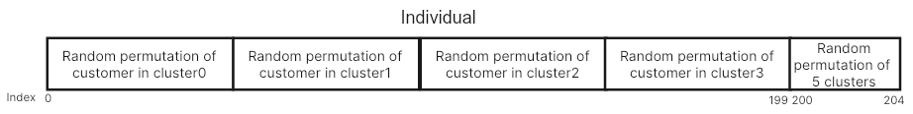

- Fitness Evaluation
The objective of Task 3 remains minimizing the total travel distance after servicing all customers. At the same time, under the constraint of vehicle capacity, vehicles must complete all visits within one cluster before moving to the next.
In the fitness function, first split the customer sequence and the cluster visitation order. The vehicle starts from depot 0 following the cluster visitation order, sequentially filters out all customers belonging to the current cluster from the customer sequence. It then services the customers within the current cluster while continuously monitoring the vehicle load. The logic for this check is consistent with that used in Task 1.
- Selection Operator
Basically follows the approach of Task 1 and uses a tournament selection mechanism.
- Variation Operator
Following the approach of Task 1. Using Ordered Crossover and random exchange in the intra-cluster customer access sequence part of the chromosome, utilize Uniform Crossover for its depot assignment part, and randomly change the depot allocation of a customer.
In the mutation phase, it performs mutations on the intra-cluster customer visiting sequence and the inter-cluster visiting order seperately. For the customer sequence, two customers within the same cluster are randomly swapped. For the cluster sequence, the visit order of two clusters is randomly swapped.

MULTI-OBJECTIVE OPTIMIZATION PROBLEM
This task incorporates a dual-objective fitness evaluation instead of a single objective. Additionally, a branch control is implemented at the program entry, allowing users to switch between the weighted method and the Pareto method via input, facilitating comparison of the two multi-objective optimization. approaches. The goal is to minimize total distance and maximize total efficiency.
For the weighted appraoch, the weighted single objective function is defined as: $f = w×f1−(1−w)×f2$. $f1$ is the sum of Euclidean distances between consecutive points in the route and $f2$ is the total efficiency. The efficiency for each customer i is computed as $EFFICIENCYi− di$. Here, di is the cumulative travel distance from the depot to customer i. In this task, di is regarded as the cumulative distance from the depot to customer i last time, rather than the cumulative distance of the entire route.
The essence of using weighted solutions is still single-objective optimization, which transforms the goal of maximizing f1 and minimizing f2 into minimizing the weighted function f. So it is direct and clear to use the calculated weighted function value as the optimization target.
The Pareto method is implemented using the NSGA-II algorithm.
- Mode Switching
An external input parameter is used to control the structure of the genetic algorithm’s objective function. If the parameter is set to ‘weighted’, the optimization uses the weighted solution. If set to ‘nsgaii’, the Pareto solution is enabled.
- Genectic Algorithm
- Chromesome Encoding and Initialization
Similar to Task 1, each chromosome represents the visit sequence of customers served by the vehicles.
In the initialization phase, for the weighted appraoch, weights = (-1.0, 0) is used to define the objective $f$to be minimized. For the Pareto appraoch, weights = (-1.0, 1.0) is used to define the objective f1 to be minimized and f2 to be maximized.
- Fitness Evaluation
For the weighted appraoch, the calculation of total distance $f1$ is similar to Task 1. For di, the cumulative distance traveled from the depot to customer i along the route, each time a vehicle returns to the depot and starts a new trip, the local distance is reset. After calculating the total distance and total efficiency, a weighting function is applied to combine them, and the resulting weighted value is used as the fitness of individual.
In the Pareto method, after calculating the total distance and total efficiency, $f1$ and f2 will be returned directly as the fitness of the two optimization targets for further pocessing.
- Selection Operator
For the weighted method, the problem is still single-objective, so tournament selection is used.
For the Pareto method, NSGA-II is applied. After the dual-objective fitness of all individuals is calculated, DEAP function selNSGA2() is used for selection. This function performs non-dominated sorting, assigning individuals to Pareto layers. Within each layer, it automatically computes the crowding distance to measure how spread out the individuals are in the objective space. Based on non-dominated rank and crowding distance, individuals are selected to form the next generation. After all generations, DEAP function sortNondominated() is used to extract the first layer as the final Pareto front.
- Variation Operator
Following the approach of Task 1. Using Ordered Crossover and random exchange to generate mutations in the customer access sequence part of the chromosome, utilize Uniform Crossover for its depot assignment part, and randomly change the depot allocation of a customer.

PICKUP AND DELIVERY PROBLEM
In this task, all demands, whether positive or negative, are treated as actions that increase the load of vehicle. Intuitively, this means that whether the vehicle delivers goods from the depot to customers or picks up goods from customers to bring back, the load on the vehicle always increases. The load is cleared only when the vehicle returns to the depot.
- Data Processing
The data processing module reads customer data from the VRP.csv file. Then, about 30% of the customers are randomly marked as pickup customers, whose demand values are set to negative numbers. The remaining customers keep positive demand values. Updated data is set as the customer data for Task 5.
- Genectic Algorithm
- Chromesome Encoding and Initialization
In Task 5, since only one depot is used, each individual directly represents the order in which the vehicle visits customers. During initialization, the initial population is generated by randomly shuffling all customer numbers.
- Fitness Evaluation
The vehicle starts from the depot and visits customers in the order defined by the chromosome. Before visiting each customer, the algorithm checks whether the current load plus the customer’s demand exceeds the vehicle’s capacity. If it does, the vehicle returns to the depot to unload or reload before continuing. After each visit, the load is updated as cur_load + cust_demand. Note that this logic ignores the sign of the demand; the same rule applies to both positive and negative values. Finally, after all customers are served, the vehicle returns to the depot. The total travel distance is used as the fitness value to evaluate each individual. The pseudocode is as follows.
CuculateFitness(Individual):
1. total_distance ← 0, current_load ← 0
2. current_position ← depot_0
3. For each customer in visiting_order:
demand ← customer_demand[customer] #demand can be negative
If ABS(current_load + demand) > max_capacity:
# return to depot
total_distance += distance(current_position, depot)
current_load ← 0
current_position ← depot
# continue to service current customer
total_distance += distance(current_position, customer)
current_position ← customer
current_load += demand
4. total_distance += distance(current_position, depot_0)
5. Return total_distance
- Selection Operator
Follows the approach of Task 1 and uses tournament selection mechanism.
- Variation Operator
Directly utilizes the cxOrdered and mutShuffleIndexes function from the DEAP library for crossover and mutation operations.

III. Experimental results

A. CLASSICAL VRP
Parameters involved
Parameters Name | Parameters Meaning
POPULATION_SIZE | Population size
MAX_GENERATIONS | Maximum evolutionary generation
CROSSOVER_PROB | Crossover rates
1. Basic Experimental
Main Parameter ssetting
POPULATION_SIZE = 200 | CROSSOVER_PROB = 0.8 | MUTATION_PROB = 0.15 | MAX_GENERATIONS = 200
Statistical Results(Independently Run 10 times)
Final optimal path distance (km) |  |  | Percent improvement relative to the initial solution
Optimal | Worst | Mean | Optimal | Worst | Mean
3146.7 | 3699.38 | 3431.67 | 58.7% | 53.6% | 55.3%
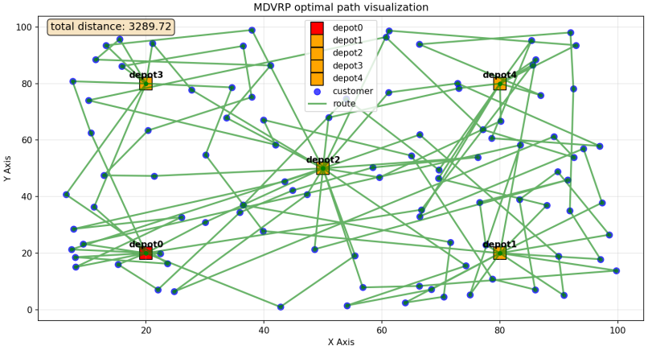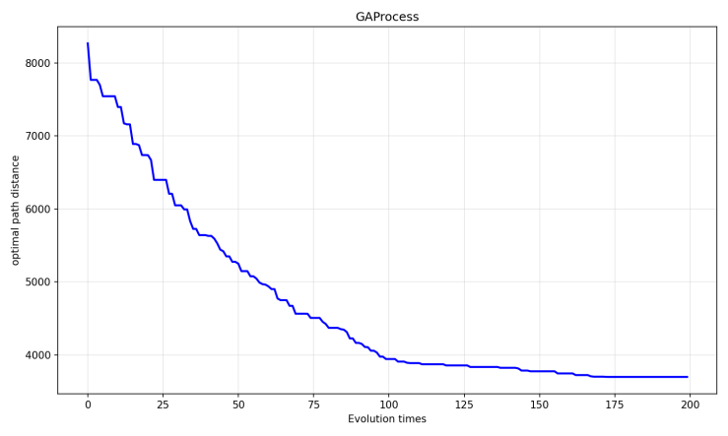
The above figures show the convergence process and the final path planning solution in one run.
Across the ten runs, the difference between the optimal and worst values was small, and the improvement of the final solution relative to the initial solution was relatively stable, demonstrating the algorithm's stability. The convergence curves shown show rapid convergence in the first 100 iterations, followed by small improvements. The curves remain smooth throughout, with no significant fluctuations.
2. Sensitivity Studies on Parameters
(1) Population Size
Based on the Basic Experiment, keeping other parameters the same, changing the population size to 100 and 300, and running them independently 10 times respectively, the statistical results are as follows.
Population Size = 100
Final optimal path distance (km) |  |  | Percent improvement relative to the initial solution
Optimal | Worst | Mean | Optimal | Worst | Mean
3630.88 | 4027.05 | 3793.23 | 55.1% | 44.5% | 49.7%
Population Size = 300
Final optimal path distance (km) |  |  | Percent improvement relative to the initial solution
Optimal | Worst | Mean | Optimal | Worst | Mean
2561.6 | 3458.07 | 2934.79 | 71.1% | 59.3% | 64.7%
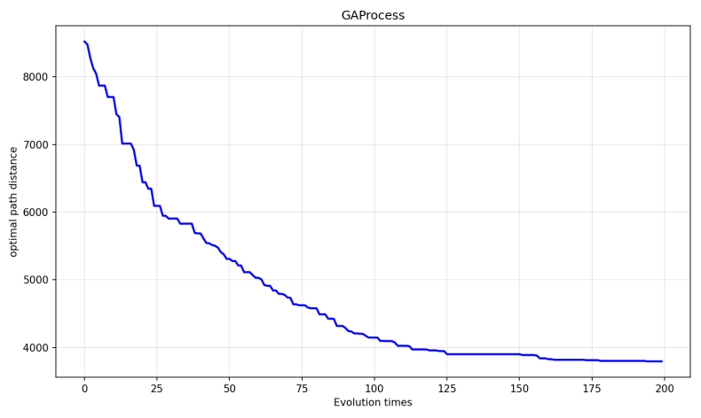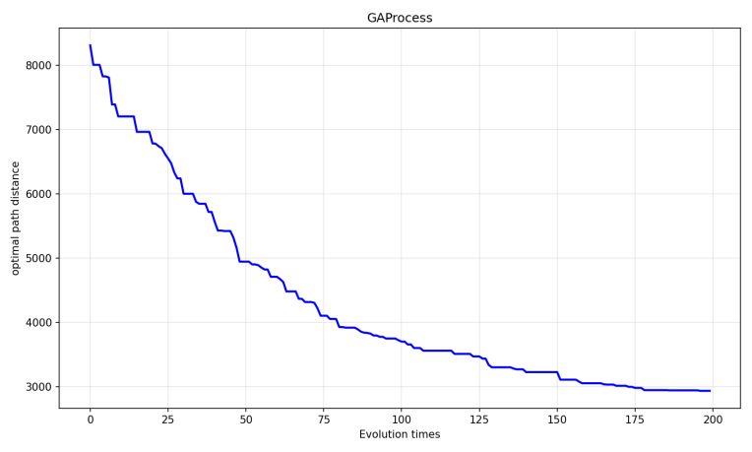
Left: Population Size = 100, Right:Population Size =300
The above figures show the convergence process in one run.
Using the same 200-generation evolution model and holding all other parameters constant, the average solution for a 300-population is 2934.79, representing an average improvement of 64.7%. This result is significantly higher than for populations of 100 and 200. This indicates that larger populations improve global search ability and produce more stable, high-quality results. Looking at the convergence curve, we see that for 100 populations, the algorithm converges rapidly in the first 25 generations and then gradually stabilizes around the 100th generation. For 300 populations, convergence in the first 25 generations is slightly slower than for 100 populations, but the difference is not significant. Convergence continues slowly from generations 100 to 200. This suggests that while initial convergence is fast, populations with small populations tend to fall into local optima early due to a lack of diversity. Larger populations with greater diversity and search ability are more likely to find globally optimal solutions.
- Crossover Rates
Based on the Basic Experiment, keeping other parameters the same, changing the Crossover Rates to 0.6 and 0.95, and running them independently 10 times respectively, the statistical results are as follows.
Crossover Rates = 0.6
Final optimal path distance (km) |  |  | Percent improvement relative to the initial solution
Optimal | Worst | Mean | Optimal | Worst | Mean
3900.37 | 4626.78 | 4223.21 | 52.5% | 43.3% | 48.1%
Crossover Rates = 0.95
Final optimal path distance (km) |  |  | Percent improvement relative to the initial solution
Optimal | Worst | Mean | Optimal | Worst | Mean
2925.24 | 3900.36 | 3466.91 | 62.9% | 49.4% | 56.7%
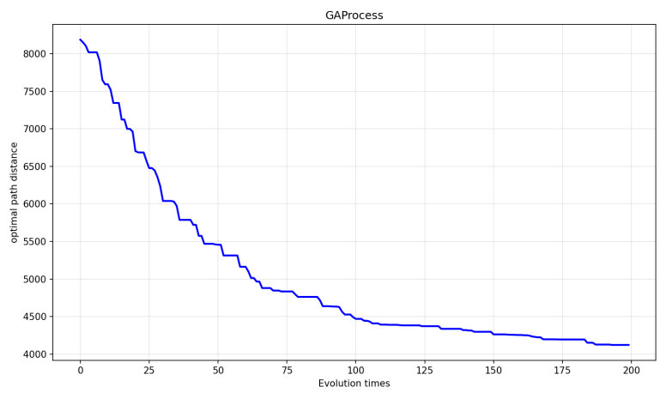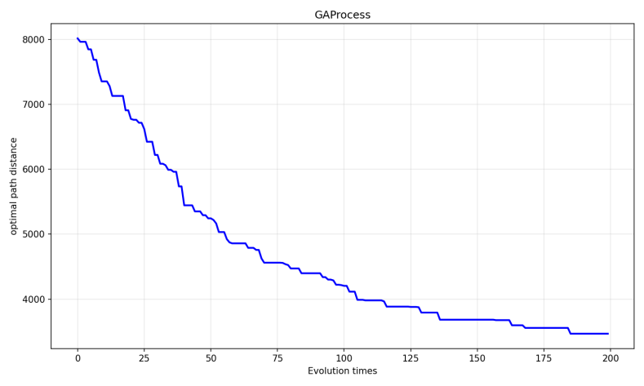
Left: Crossover Rates = 0.6, Right:Crossover Rates = 0.95
The above figures show the convergence process in one run. under two different crossover rates.
Over the same 200-generation evolution process, the average solution and average improvement with a crossover probability of 0.95 were significantly better than those with 0.5 and 0.8. The worst solution was comparable to the best solution with a crossover probability of 0.5. This demonstrates that a high crossover probability improves performance on this problem and plays an important role in the algorithm's rapid discovery and exploration.
Observing the convergence curves, we see that the solution with a crossover probability of 0.5 converges to approximately 5500 around the 50th generation, while the solution with a crossover probability of 0.95 converges to approximately 5100, beginning to form a gap between the two. Between generations 50 and 200, the solution with a crossover probability of 0.95 continues to explore. This demonstrates that a high crossover probability is essential for obtaining a globally optimal solution and is a key element of genetic algorithms.
- Mutation Rates
Based on the Basic Experiment, keeping other parameters the same, changing the Mutation Rates to 0.5 and 0.01, and running them independently 10 times respectively, the statistical results are as follows.
Mutation Rates = 0.5
Final optimal path distance (km) |  |  | Percent improvement relative to the initial solution
Optimal | Worst | Mean | Optimal | Worst | Mean
2975.78 | 4012.25 | 3125.38 | 62.5% | 54.7% | 58.6%
Mutation Rates = 0.01
Final optimal path distance (km) |  |  | Percent improvement relative to the initial solution
Optimal | Worst | Mean | Optimal | Worst | Mean
2971.21 | 3770.4 | 3089.21 | 61.7% | 53.6% | 57.3%
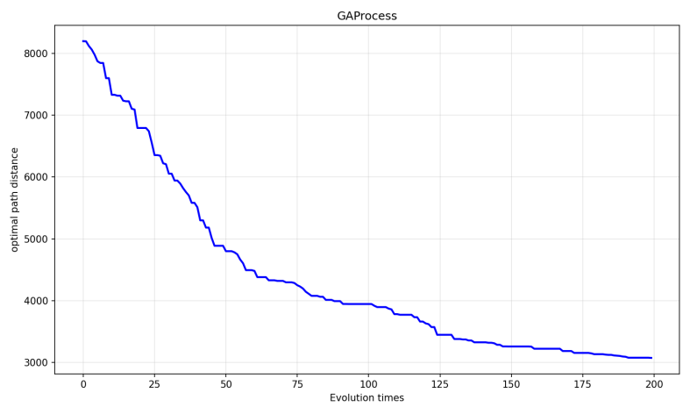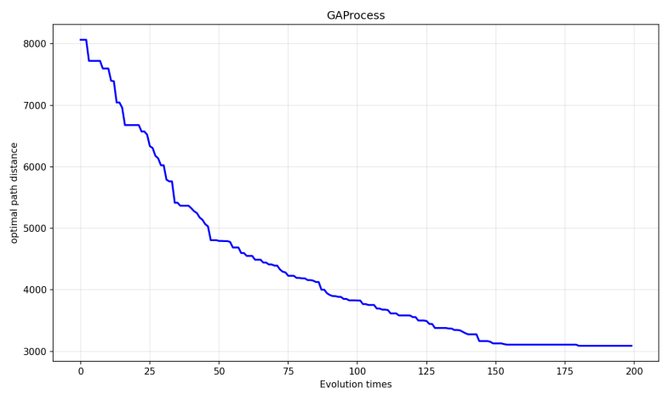
Left: Mutation Rates = 0.5, Right: Mutation Rates = 0.01
The above figures show the convergence process in one run under two different mutation rates.
Over the same 200-generation evolution process, the average solution and average improvement with a mutation rates of 0.5 and 0.01 not much difference. However, when the mutation rate is 0.5, the gap between the optimal and worst solutions is large. Furthermore, in the two convergence graphs, the left graph still shows a convergence trend after 200 generations, while the right graph has flattened out. This suggests that a higher mutation probability leads to greater randomness in the algorithm, resulting in greater solution fluctuations. However, this also increases exploratory power, making it more advantageous for exploring the global optimal solution.

STOCHASTIC DEMAND PROBLEM
Parameters involved are same as taskA. Therefore, only the experimental results are shown.
Statistical Results (Independently Run 10 times)
Final optimal path distance (km) |  |  | Percent improvement relative to the initial solution
Optimal | Worst | Mean | Optimal | Worst | Mean
3155.07 | 3763.12 | 3453.81 | 61.5% | 57.4% | 60.3%

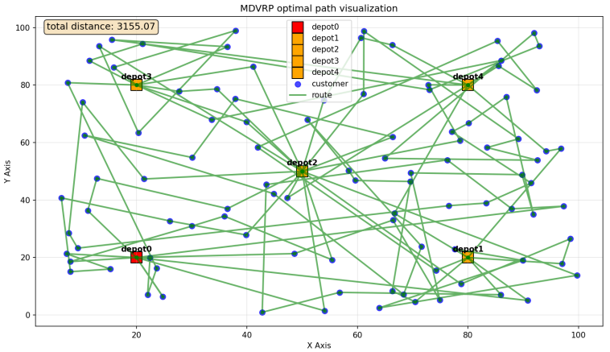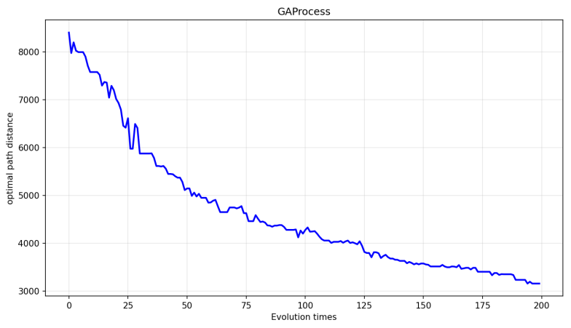
The above figures show the convergence process and the final path planning solution in one run.
When measured by the average and optimal path distances, the performance difference between A and B is very small, but B's improvement rate is significantly higher than A's. This suggests that with the same algorithm parameters, the introduction of random requirements has little impact on the quality of the final solution and the algorithm can effectively handle requirement uncertainty. Although the quality of the initial solution may be relatively low, the genetic algorithm plays a more important role in optimization. The overall convergence curves of the two problems are similar, but the introduction of random requirements introduces search uncertainty, resulting in greater fluctuations in the convergence curves.
- LARGE-SCALE OPTIMIZATION PROBLEM
Main Parameter Setting
POPULATION_SIZE = 200 | CROSSOVER_PROB = 0.8 | MUTATION_PROB = 0.15 | K=5
Statistical Results (Independently Run 10 times)
Final optimal path distance (km) |  |  | Percent improvement relative to the initial solution
Optimal | Worst | Mean | Optimal | Worst | Mean
6471.35 | 6692.32 | 6582.82 | 28.2% | 27% | 27.8%
The following figure shows the convergence process and the final path planning solution in one run.
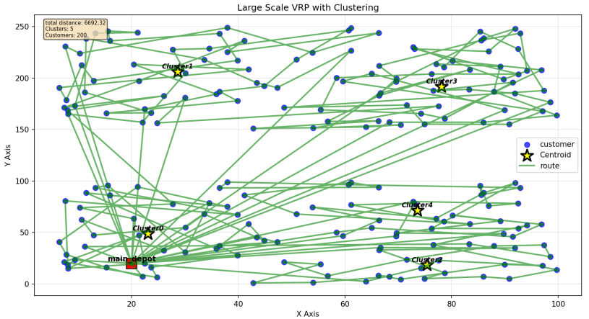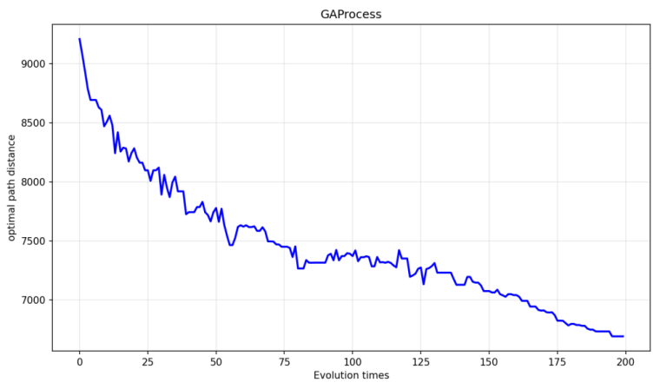

MULTI-OBJECTIVE OPTIMIZATION PROBLEM
Main Parameter Setting
POPULATION_SIZE = 200 | CROSSOVER_PROB = 0.8 | MUTATION_PROB = 0.15 | K=5
- Weighted Solutions
- w = 0.2 (100 generations)
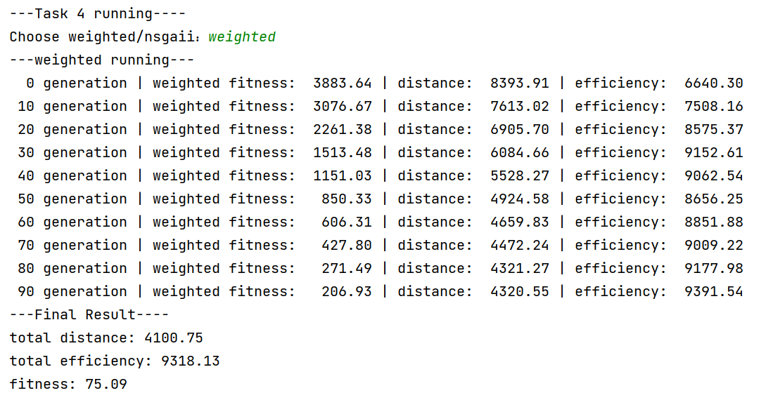
- w = 0.5 (100 generations)
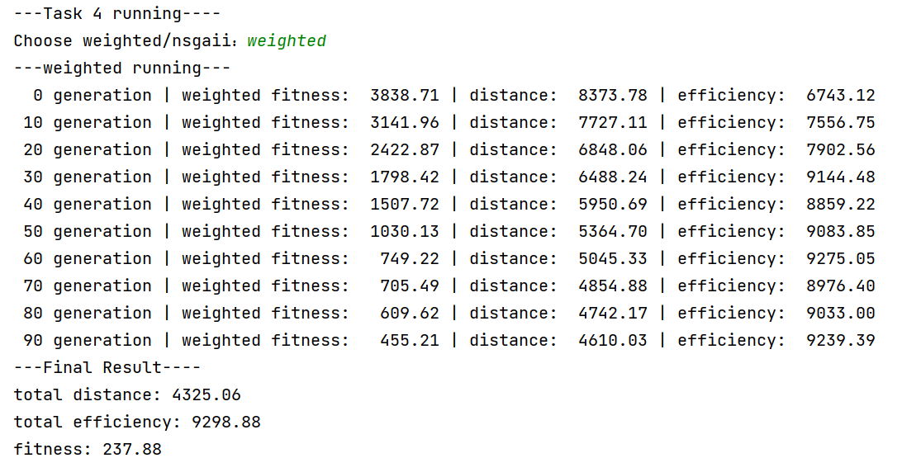
- w = 0.7 (100 generations)
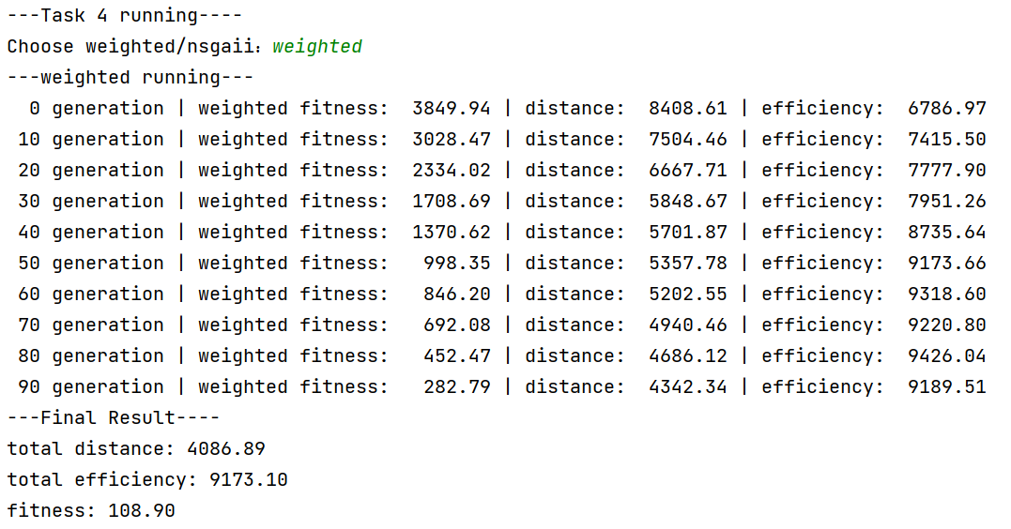
- w=1.0
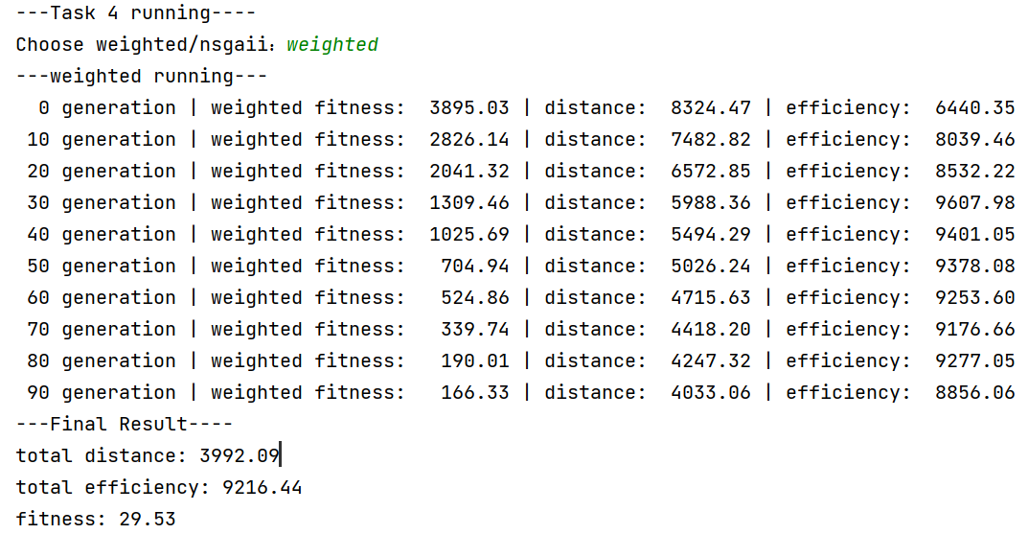
It is expected that the situation will be greatly affected by w. When w is close to 0, it tends to maximize efficiency and ignore distance, which may not be ideal in optimizing the total distance. When w is close to 1, it tends to minimize distance and ignore efficiency, which may result in a lower efficiency. However, in the results, the change of w has no obvious effect on the results. It is speculated that this may be due to the high correlation between the total distance f1 and di in the total efficiency f2.
- Pareto Solutiones

E. PICKUP AND DELIVERY PROBLEM
Parameters involved are same as taskA. Therefore, only the experimental results are shown. The following table show the running statistical results. The following two figures show the final route planning solutionthe and convergence process in one run.
Statistical Results (Independently Run 10 times)
Final optimal path distance (km) |  |  | Percent improvement relative to the initial solution
Optimal | Worst | Mean | Optimal | Worst | Mean
2586.69 | 2766.33 | 2661.95 | 46.1% | 41.7% | 44.2%
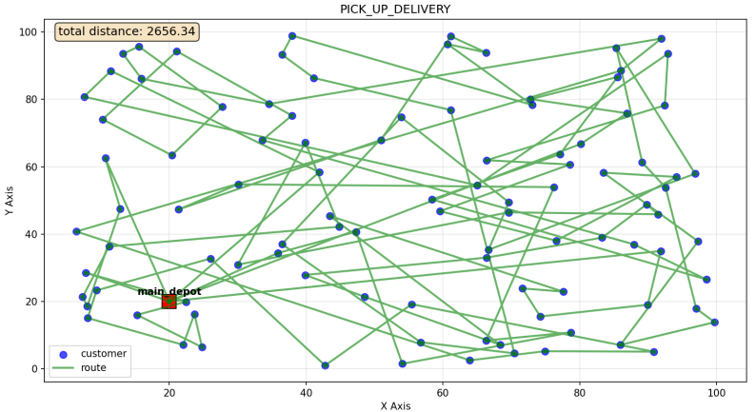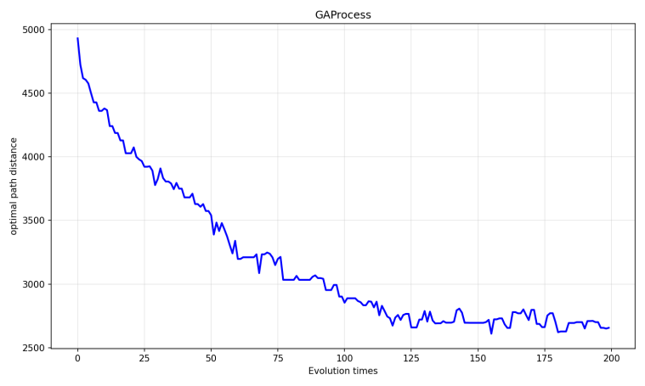

IV. Conclusion
Note: You should summarize what you have learned and your findings.

