Use Case Diagram

Electronics Store Inventory Management System (ESIMS)
Version 1.0 | Derived from the SRS and Test Plan Document

1. Purpose
This diagram models the actors and use cases of ESIMS as specified in the Software Requirements Specification (functional requirements FR-1 through FR-8) and validated by the Test Plan Document (role-based access, stock update, and notification scenarios).

2. Diagram
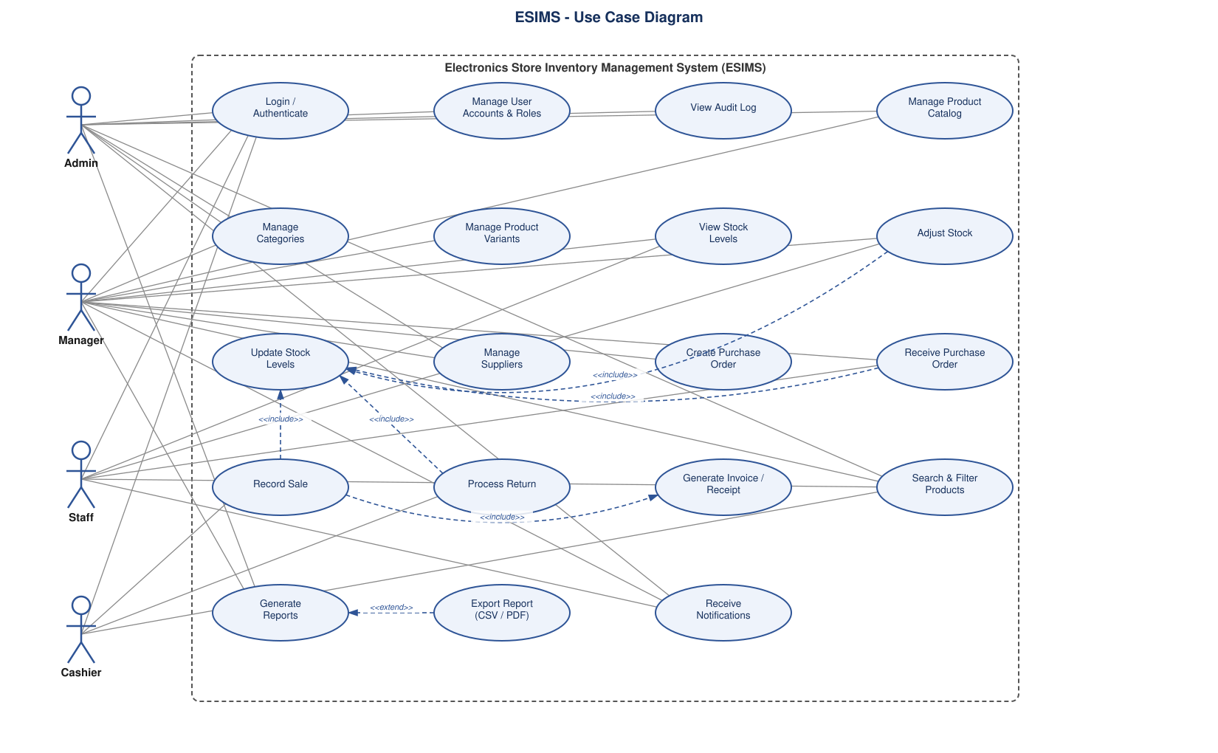
Dashed arrows denote <<include>> and <<extend>> relationships between use cases; solid lines denote actor associations. The dashed boundary represents the ESIMS system.

3. Actors
Actor | Description / Primary Use Cases
Admin | Full system access: user/role management, audit log, product catalog, suppliers, reports.
Manager | Manages products, categories, variants, stock, suppliers, purchase orders, reports.
Staff | Views stock, adjusts stock, receives purchase orders.
Cashier | Records sales, processes returns, searches products.

4. Use Cases
Use Case | Notes
Login / Authenticate | Required before any protected action; enforces role-based access (FR-5.2).
Manage User Accounts & Roles | Admin only; create/edit users, assign roles (FR-5.1).
View Audit Log | Admin only; read-only activity/audit trail (FR-5.3).
Manage Product Catalog | Add/edit/delete/view products (FR-1.1).
Manage Categories | Hierarchical categories/subcategories (FR-1.2).
Manage Product Variants | Track variants such as color, storage size (FR-1.3).
View Stock Levels | Per product, per warehouse/store location (FR-2.1).
Adjust Stock | Manual adjustment with mandatory reason; includes Update Stock Levels (FR-2.4).
Update Stock Levels | Included use case; shared stock-update logic triggered by sales, returns, receipts, adjustments (FR-2.2).
Manage Suppliers | Supplier records and pricing history (FR-3.1, FR-3.4).
Create Purchase Order | Create and manage purchase orders (FR-3.2).
Receive Purchase Order | Partial/full receipt against a PO; includes Update Stock Levels (FR-3.3).
Record Sale | Records a sale; includes Update Stock Levels and Generate Invoice/Receipt (FR-4.1).
Process Return | Validates and restocks returns; includes Update Stock Levels (FR-4.2).
Generate Invoice / Receipt | Included use case triggered by Record Sale (FR-4.3).
Search & Filter Products | By name, SKU, category, brand, stock level, price (FR-7.1, FR-7.2).
Generate Reports | Stock valuation, sales trend, low-stock, supplier performance (FR-6.1-6.4).
Export Report (CSV / PDF) | Extends Generate Reports (FR-6.5).
Receive Notifications | Low-stock/out-of-stock alerts and order status updates (FR-8.1, FR-8.2).

