Software Architecture and Design Specification
Project: Electronics Store Inventory Management System (ESIMS)
Version: 1.0
Authors: ESIMS project team
Date: 13-11-2026
Status: Final (development freeze, November 2026)

Revision History
Version | Date | Author | Change Summary
1.0 | 13-11-2026 | ESIMS project team | First SAD. Consolidates docs/architecture.md, docs/schema.md, the component diagram and the security, deployment and monitoring notes into the SAD template; adds sequence diagrams, API design and the STRIDE analysis.

Approvals
Role | Name | Signature/Date
Course Coordinator
Project Team Lead

1. Introduction

1.1 Purpose
This document specifies the architecture and design of the Electronics Store Inventory Management System (ESIMS). It explains how the system is divided into components, why that structure was chosen, and how the main flows, interfaces and security controls work, so that developers and reviewers can trace each requirement of the SRS to a design element.

1.2 Scope
Covers the whole ESIMS application: the React web client, the FastAPI backend with its eight modules, the PostgreSQL database, and the production runtime (web server, backup and uptime monitor). Hosting infrastructure beyond the Docker Compose stack is out of scope.

1.3 Audience
Developers, QA engineers, security auditors, instructors and assessment evaluators, and the operations team that deploys and maintains the system.

1.4 Definitions
ESIMS, SPA (single-page application), API, RBAC, ORM, CSRF, TLS, STRIDE, ADR (architecture decision record), SKU, PO (purchase order), GST. The full glossary is in section 5.1.

2. Document Overview

2.1 How to use this document
Section 3 gives the architecture: goals, the component diagram, the pattern chosen and its rationale, the technology stack, risks, traceability to the SRS and the security architecture. Section 4 gives the design: sequence diagrams for three flows, the API of four components, error handling and monitoring, and the user interface. Section 5 holds the glossary, references and tools.

2.2 Related Documents
- Software Requirements Specification (SRS) v1.1: Documents/SRS_Electronics_Store_Inventory_Management_System.docx
- Software Test Plan (STP) v1.1: Documents/Test_Plan_Document.docx, with backend/tests/TRACEABILITY.md
- Security Requirements Document, Use Case Diagram and Use Case Flow Document: Documents/
- Developer notes kept next to the code: docs/architecture.md, docs/schema.md, docs/deployment.md, docs/monitoring.md, docs/backup-recovery.md, docs/retention.md

3. Architecture

3.1 Goals & Constraints
Goals: keep stock and money data correct under concurrent use (no overselling, sale and stock deduction atomic); keep modules independent so a change in one does not ripple into the others; secure by default (every route needs a signed-in user and a permission); handle 10,000+ SKUs with searches under 2 seconds; 99.5% availability in store hours; run on any Docker host.
Constraints: desktop web only; one currency and one GST rate; records kept at least 8 years; no card data; configuration by environment variables only; modules may depend only on modules below them (SRS 2.5, NFR-11).

3.2 Stakeholders & Concerns
Stakeholder | Concerns
Store owner / Admin | Control of accounts and locations, an audit trail, backups and recovery, security
Manager | Correct stock and prices, reports, purchase orders, approving late returns
Staff and Cashier | Fast screens, clear errors, seeing only their own location, minimal training
Developers | Modularity, testability, clear rules on what may call what
Operations | Simple deployment, health checks, alerting, backups, upgrades with migrations
Auditors / tax authority | Immutable audit log, retained and unalterable invoices, traceable batches and serial numbers
Instructors / evaluators | Traceability from requirements to design and tests

3.3 Component (UML) Diagram
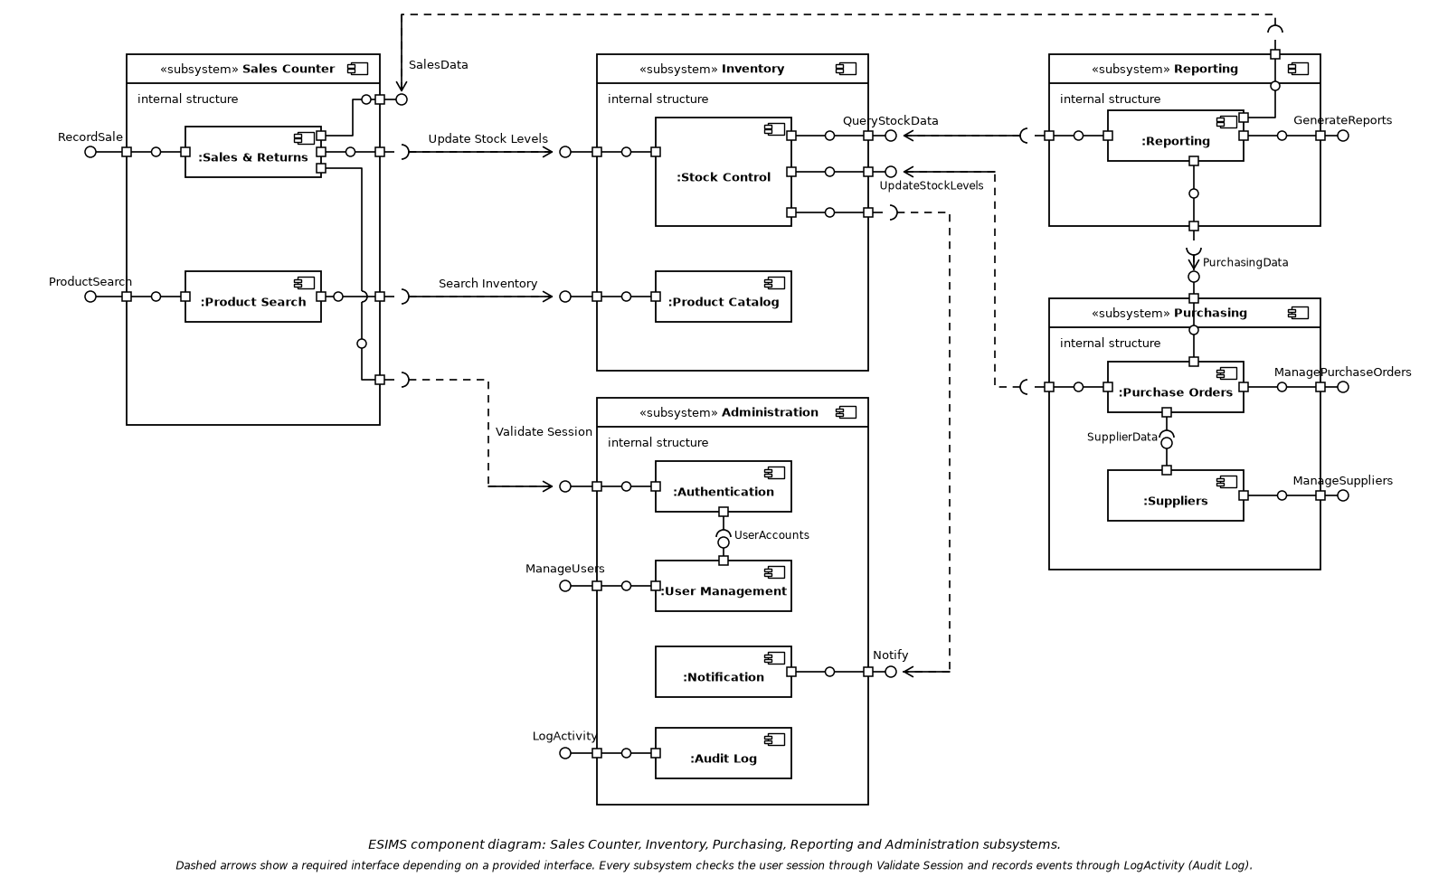
Figure 1: ESIMS component diagram (Documents/esims_component_diagram.png). Dashed arrows show a required interface depending on a provided interface; every subsystem validates the session through the Administration subsystem and logs through Audit Log.
The diagram's five subsystems map to the backend modules like this: Sales Counter = sales and the search part of product; Inventory = stock and the product catalog; Purchasing = purchasing; Reporting = reporting; Administration = auth (authentication and user management), notifications and audit.

3.4 Component Descriptions
Module (backend/app/modules) | Responsibility | Tables owned
product | Catalog, hierarchical categories and attributes, variants, product images, search and filter (FR-1.x, FR-7.x) | categories, category_attributes, products, product_variants, product_images
stock | Per-location stock, movements, adjustments, transfers, batches and serials, locations, alert evaluation (FR-2.x) | locations, stock_levels, item_costs, batches, batch_stock, batch_receipts, serial_numbers, stock_movements, stock_transfers
purchasing | Suppliers, supplier catalog and price history, purchase orders and receiving (FR-3.x) | suppliers, supplier_products, purchase_orders, purchase_order_lines, po_receipts, po_receipt_lines, po_receipt_serials, supplier_price_history
sales | Sales, returns with the 30-day rule and Manager override, invoices and credit notes, PDF documents, batch recall (FR-4.x) | sales, sale_lines, sale_line_serials, sale_line_batches, payments, returns, return_lines, return_line_serials, return_line_batches, invoices
reporting | Valuation, sales trend, reorder and supplier performance reports with CSV and PDF export (FR-6.x) | none; it reads through other modules' services
auth | Login, lockout, server-side sessions, users, roles and permissions, password reset, manager override (FR-5.1, FR-5.2) | roles, users, user_sessions, password_reset_tokens
notifications | In-app low-stock and purchase order notifications, alert lifecycle (FR-8.x) | notifications, stock_alerts
audit | Immutable audit log and its Admin viewer (FR-5.3) | audit_log

Each module has the same shape: __init__.py re-exports the public service interface (a Python Protocol in service.py), router.py holds its HTTP routes, mounted under /api/<module> by app/main.py, and _internal/ holds models, repositories and implementation, which are private. Public calls between modules include stock.update_stock, stock.stock_positions, product.product_stock_item, auth.require, auth.verify_override, audit_service.record and notifications.reevaluate_stock_alert.
Dependency order (a module may import only modules to its right):
reporting > sales | purchasing > stock > product > notifications > auth > audit
A lower module that must react to a higher one (stock raising a low-stock alert) goes through notifications. Other components outside the backend modules:
Component | Role
Frontend (frontend/src) | React SPA; src/modules mirrors the backend modules; src/shell holds the header, sidebar and shared components; Vite dev server proxies /api to the backend
web (Caddy, production) | Serves the built SPA, proxies /api to the backend, terminates HTTPS and redirects HTTP
migrate | Runs alembic upgrade head on every start, then exits
backup | Daily database and product-image backup with checksum verification and retention
monitor | Polls /api/health every 30 s and sends DOWN and Recovered alerts
db | PostgreSQL 16 with data in the db-data volume

3.5 Chosen Architecture Pattern and Rationale
ESIMS is a modular monolith: one deployable backend and one database, divided into modules with a strict one-way dependency order. A sale, its stock deduction, its invoice and its audit entry must succeed or fail together (NFR-15); in one process with one database that is an ordinary transaction. Microservices were rejected: they would turn that transaction into a distributed one, multiply deployment work for a small team, and give no benefit at the scale of a store chain. A plain layered monolith without module rules was rejected because it would not satisfy NFR-11, so the boundaries are enforced by tests (import-linter contracts in backend/pyproject.toml, run by tests/test_architecture.py).
ADR | Decision | Reason
ADR-1 | Modular monolith with one-way module layers | Atomic multi-module transactions (NFR-15), independent modules (NFR-11), one deployment (NFR-13)
ADR-2 | Server-side sessions in a cookie, not self-contained tokens | Deactivation and logout must end a session at once (SEC-AUTH-5, SEC-SES-3); only a SHA-256 of the token is stored
ADR-3 | Business rules enforced in PostgreSQL as well as in code (CHECK constraints, unique indexes, triggers) | Stock never below zero, immutable audit log and invoices, retention floor: they hold even if application code is wrong (NFR-8, NFR-14, NFR-16)
ADR-4 | Notifications is a lower module; stock calls it | Lets stock raise alerts without importing upward, keeping the dependency order acyclic
ADR-5 | Invoices and credit notes store a versioned JSONB snapshot | A later catalog or price edit can never rewrite an issued document
ADR-6 | Everything runs in Docker; configuration only by environment variables | Same steps on any cloud or on-premises host (NFR-13); no secrets in source (SEC-DAT-6)

3.6 Technology Stack & Data Stores
Layer | Technology
Backend | Python 3.12, FastAPI 0.115, SQLAlchemy 2.0 (ORM), Alembic (migrations), Pydantic settings, psycopg 3, argon2-cffi (password hashing), fpdf2 (PDF), uvicorn
Frontend | React 18, TypeScript 5.7, Vite 6, React Router 6
Database | PostgreSQL 16
Web server | Caddy (production): static files, reverse proxy, automatic HTTPS
Runtime | Docker and Docker Compose (docker-compose.yml for development, docker-compose.prod.yml for production)
Quality | pytest, Vitest and Testing Library, ruff, ESLint and Prettier, import-linter; GitHub Actions CI runs lint, tests and builds on every pull request
Email | SMTP (Mailpit catches mail in development)

Data store | Content
PostgreSQL (db-data volume) | All application data: catalog, stock, purchasing, sales, users, sessions, notifications, audit log
product-images volume | Product image files, served only through authenticated API routes
Backup location (BACKUP_PATH) | Daily db.dump, images.tar.gz and SHA256SUMS; kept 30 days daily, then monthly for at least 96 months
retention-archive volume | Operator archive of expired sale bundles (scripts.retention)
uptime-data volume | checks.jsonl, one line per health poll

3.7 Risks & Mitigations
Risk | Mitigation
Overselling or lost updates when several counters sell the same item | Row-locked stock updates in one transaction, items processed in a fixed order to avoid deadlocks, CHECK (quantity >= 0); verified by the concurrent-sales load test
Data loss | Daily backups to storage separate from the app server, checksums verified before any restore, a documented restore drill, monthly backups kept for at least 96 months
Audit log or issued invoices tampered with | Database triggers reject UPDATE, DELETE and TRUNCATE; no application route edits them
Module boundaries erode over time | import-linter contracts fail the build and the test suite
Uptime monitor runs on the server it watches | Point an external checker at /api/health, or run the monitor container on another host (docs/monitoring.md)
Large PDF exports are slow (about 13 s for 50,000 valuation rows) | CSV export takes about 2 s; PDF renderer draws single-line rows directly
Users cannot receive password emails (no SMTP) | Operators set passwords with scripts.set_password
Browser coverage limited to Chromium so far | Manual Firefox and Edge checklist in docs/usability/report.md

3.8 Traceability to Requirements
Requirement | Design element
FR-1.1 to FR-1.3 Catalog, categories, variants | product module; recursive category tree under an advisory lock; unique SKU trigger
FR-2.1 to FR-2.5 Stock | stock module; stock_levels with CHECK; stock_movements; batches and serials; notifications.reevaluate_stock_alert
FR-3.1 to FR-3.4 Purchasing | purchasing module; PO lifecycle (A-7); immutable supplier_price_history
FR-4.1 to FR-4.3 Sales, returns, invoices | sales module; sequence diagrams 2 and 3; invoice snapshot; PDF renderer
FR-5.1, FR-5.2 RBAC and authentication | auth module; Permission matrix; require(); sequence diagram 1
FR-5.3 Audit log | audit module; audit_service.record in the same transaction; reject_modification trigger
FR-6.1 to FR-6.5 Reports | reporting module reads through service interfaces; shared rows feed JSON, CSV and PDF
FR-7.1, FR-7.2 Search and filter | GET /api/product with q, filters and sort; batched stock read through the StockCheck protocol
FR-8.1, FR-8.2 Notifications | notifications module; bell and /notifications page; 60 s unread-count polling
NFR-1 to NFR-3 Performance and scale | SQL-side filtering, indexes, batched stock reads; load test at 10,003 SKUs
NFR-4, NFR-5 Reliability | /api/health, monitor service and alerts; backup service and restore drill
NFR-6 to NFR-8 Security | Section 3.9; Argon2 hashes, server-side sessions, deny-by-default RBAC, append-only audit
NFR-11 Modularity | Module layout and import-linter contracts (section 3.4)
NFR-13 Portability | Docker Compose production stack (docs/deployment.md)
NFR-14 to NFR-16 Integrity and retention | Row locks and CHECK constraints; single transaction per request; migration 0013 retention triggers

3.9 Security Architecture
Threat modelling (STRIDE). ESIMS has no public interface other than the login page and the health check, and is used by authenticated store staff. The main threats and the controls that answer them:
Threat | Control
Spoofing | Argon2 salted password hashes; one generic login error that does not reveal whether the user exists; lockout after 5 failed logins for 15 minutes; random session tokens stored only as SHA-256; cookie is HttpOnly and SameSite=Strict (Secure in production)
Tampering | CSRF header checked on every unsafe request; parameterized SQL and escaped search terms; server-side validation of all input; database triggers on audit log, invoices and retained records; image uploads checked by content, renamed and size-limited
Repudiation | Every data change, login, failed login and permission denial is written to the audit log with user, time, module, action and before/after values, in the same transaction as the change
Information disclosure | HTTPS in production; Cache-Control: no-store on API responses; passwords and tokens never logged or returned; location scoping for Staff and Cashier; generic error messages; secrets only in environment variables
Denial of service | Login lockout limits brute force; health monitoring and alerts; row-level locks only for the short span of a transaction. General request rate limiting is not implemented (SEC-OPS-3 is out of scope)
Elevation of privilege | Deny by default: create_app refuses to start if a route lacks require(...) or signed_in; permissions read from the database on every request; Admin cannot demote themselves or the last active Admin; late returns need a Manager signing in

Role permission matrix (reference for SEC-AZ-1 and SEC-AZ-2; the code is ROLE_PERMISSIONS in auth/_internal/permissions.py). Staff and Cashier act only on their assigned location (SRS A-9).
Function | Admin | Manager | Staff | Cashier
Manage user accounts and roles | Yes | No | No | No
View audit log | Yes | No | No | No
Manage products, categories, variants | Yes | Yes | No | No
View stock levels | Yes | Yes | Yes | No
Adjust stock | Yes | Yes | Yes | No
Transfer stock between locations | Yes | Yes | Yes | No
Manage suppliers | Yes | Yes | No | No
Create purchase order | Yes | Yes | No | No
Receive purchase order | Yes | Yes | Yes | No
Record sale / process return | Yes | Yes | No | Yes
Approve return older than 30 days | Yes | Yes | No | No
Search and filter products | Yes | Yes | Yes | Yes
Generate and export reports | Yes | Yes | No | No
Receive notifications | Yes | Yes | Yes | No

4. Design

4.1 Design Overview
Every API call passes through the same stages:
- Middleware: no_store sets Cache-Control; log_requests writes METHOD /path -> status in N ms (5xx at ERROR level).
- CSRF check: unsafe methods need the CSRF header to match the CSRF cookie, except the public auth routes.
- Authentication and authorization: current_user validates the session cookie (idle timeout, absolute lifetime, account status); require(Permission.X) checks the role's permission and writes an unauthorized_access_attempt audit entry on denial; authorize_location applies the location rule.
- Router: validates the request with Pydantic models and calls the module's service functions; it owns the transaction and commits once at the end, or rolls back on any error.
- Service and _internal: business rules, repositories and models. Cross-module calls go through public service interfaces only.
- Database: constraints and triggers back the rules the code enforces.
The frontend mirrors this: each feature module under src/modules has its pages and API calls; the shell builds the menu from the server-sent permissions of the signed-in user and wraps every route in RequirePermission, so hiding a menu item is cosmetic and the API enforces the same rule with a 403.

4.2 UML Sequence Diagrams
Three flows specific to ESIMS: signing in with lockout, recording a sale, and processing a return older than 30 days.

4.2.1 Login with lockout and session creation
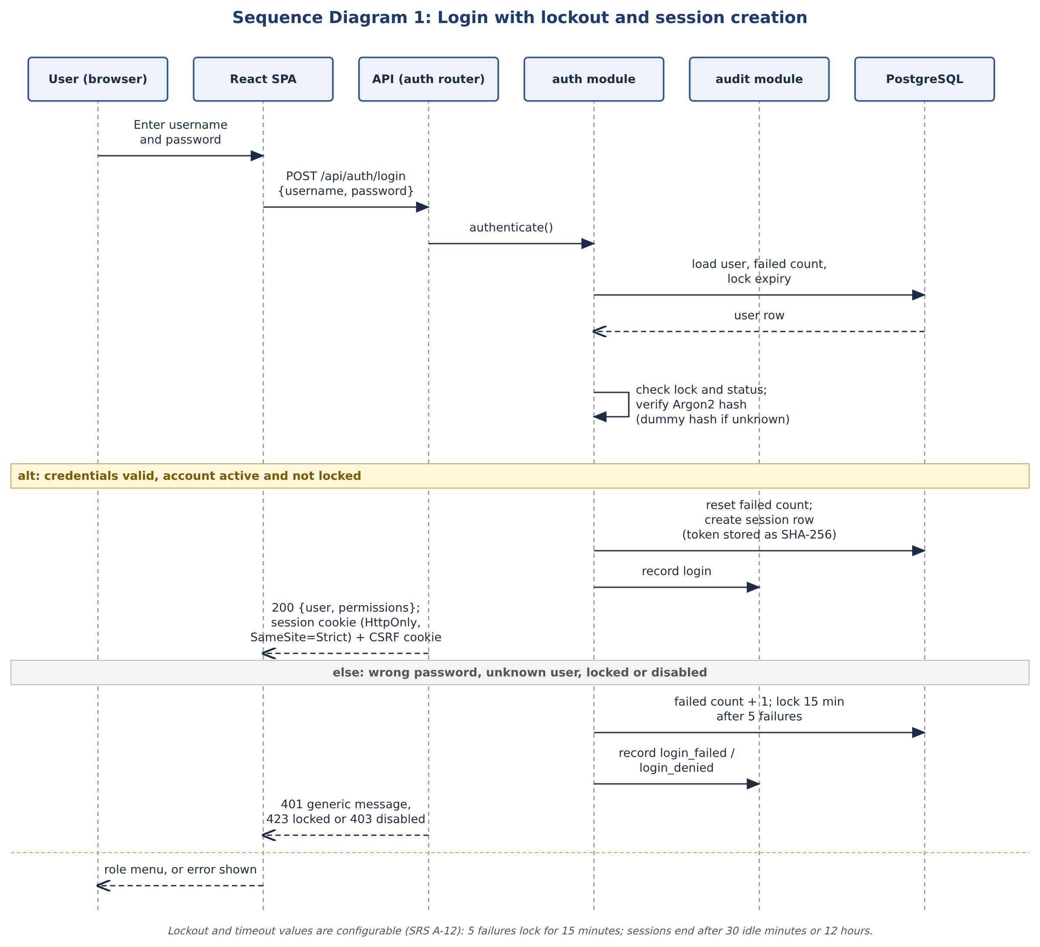
Figure 2: Sequence diagram 1, login (FR-5.2, SEC-AUTH-3, SEC-AUTH-4).

4.2.2 Record a sale
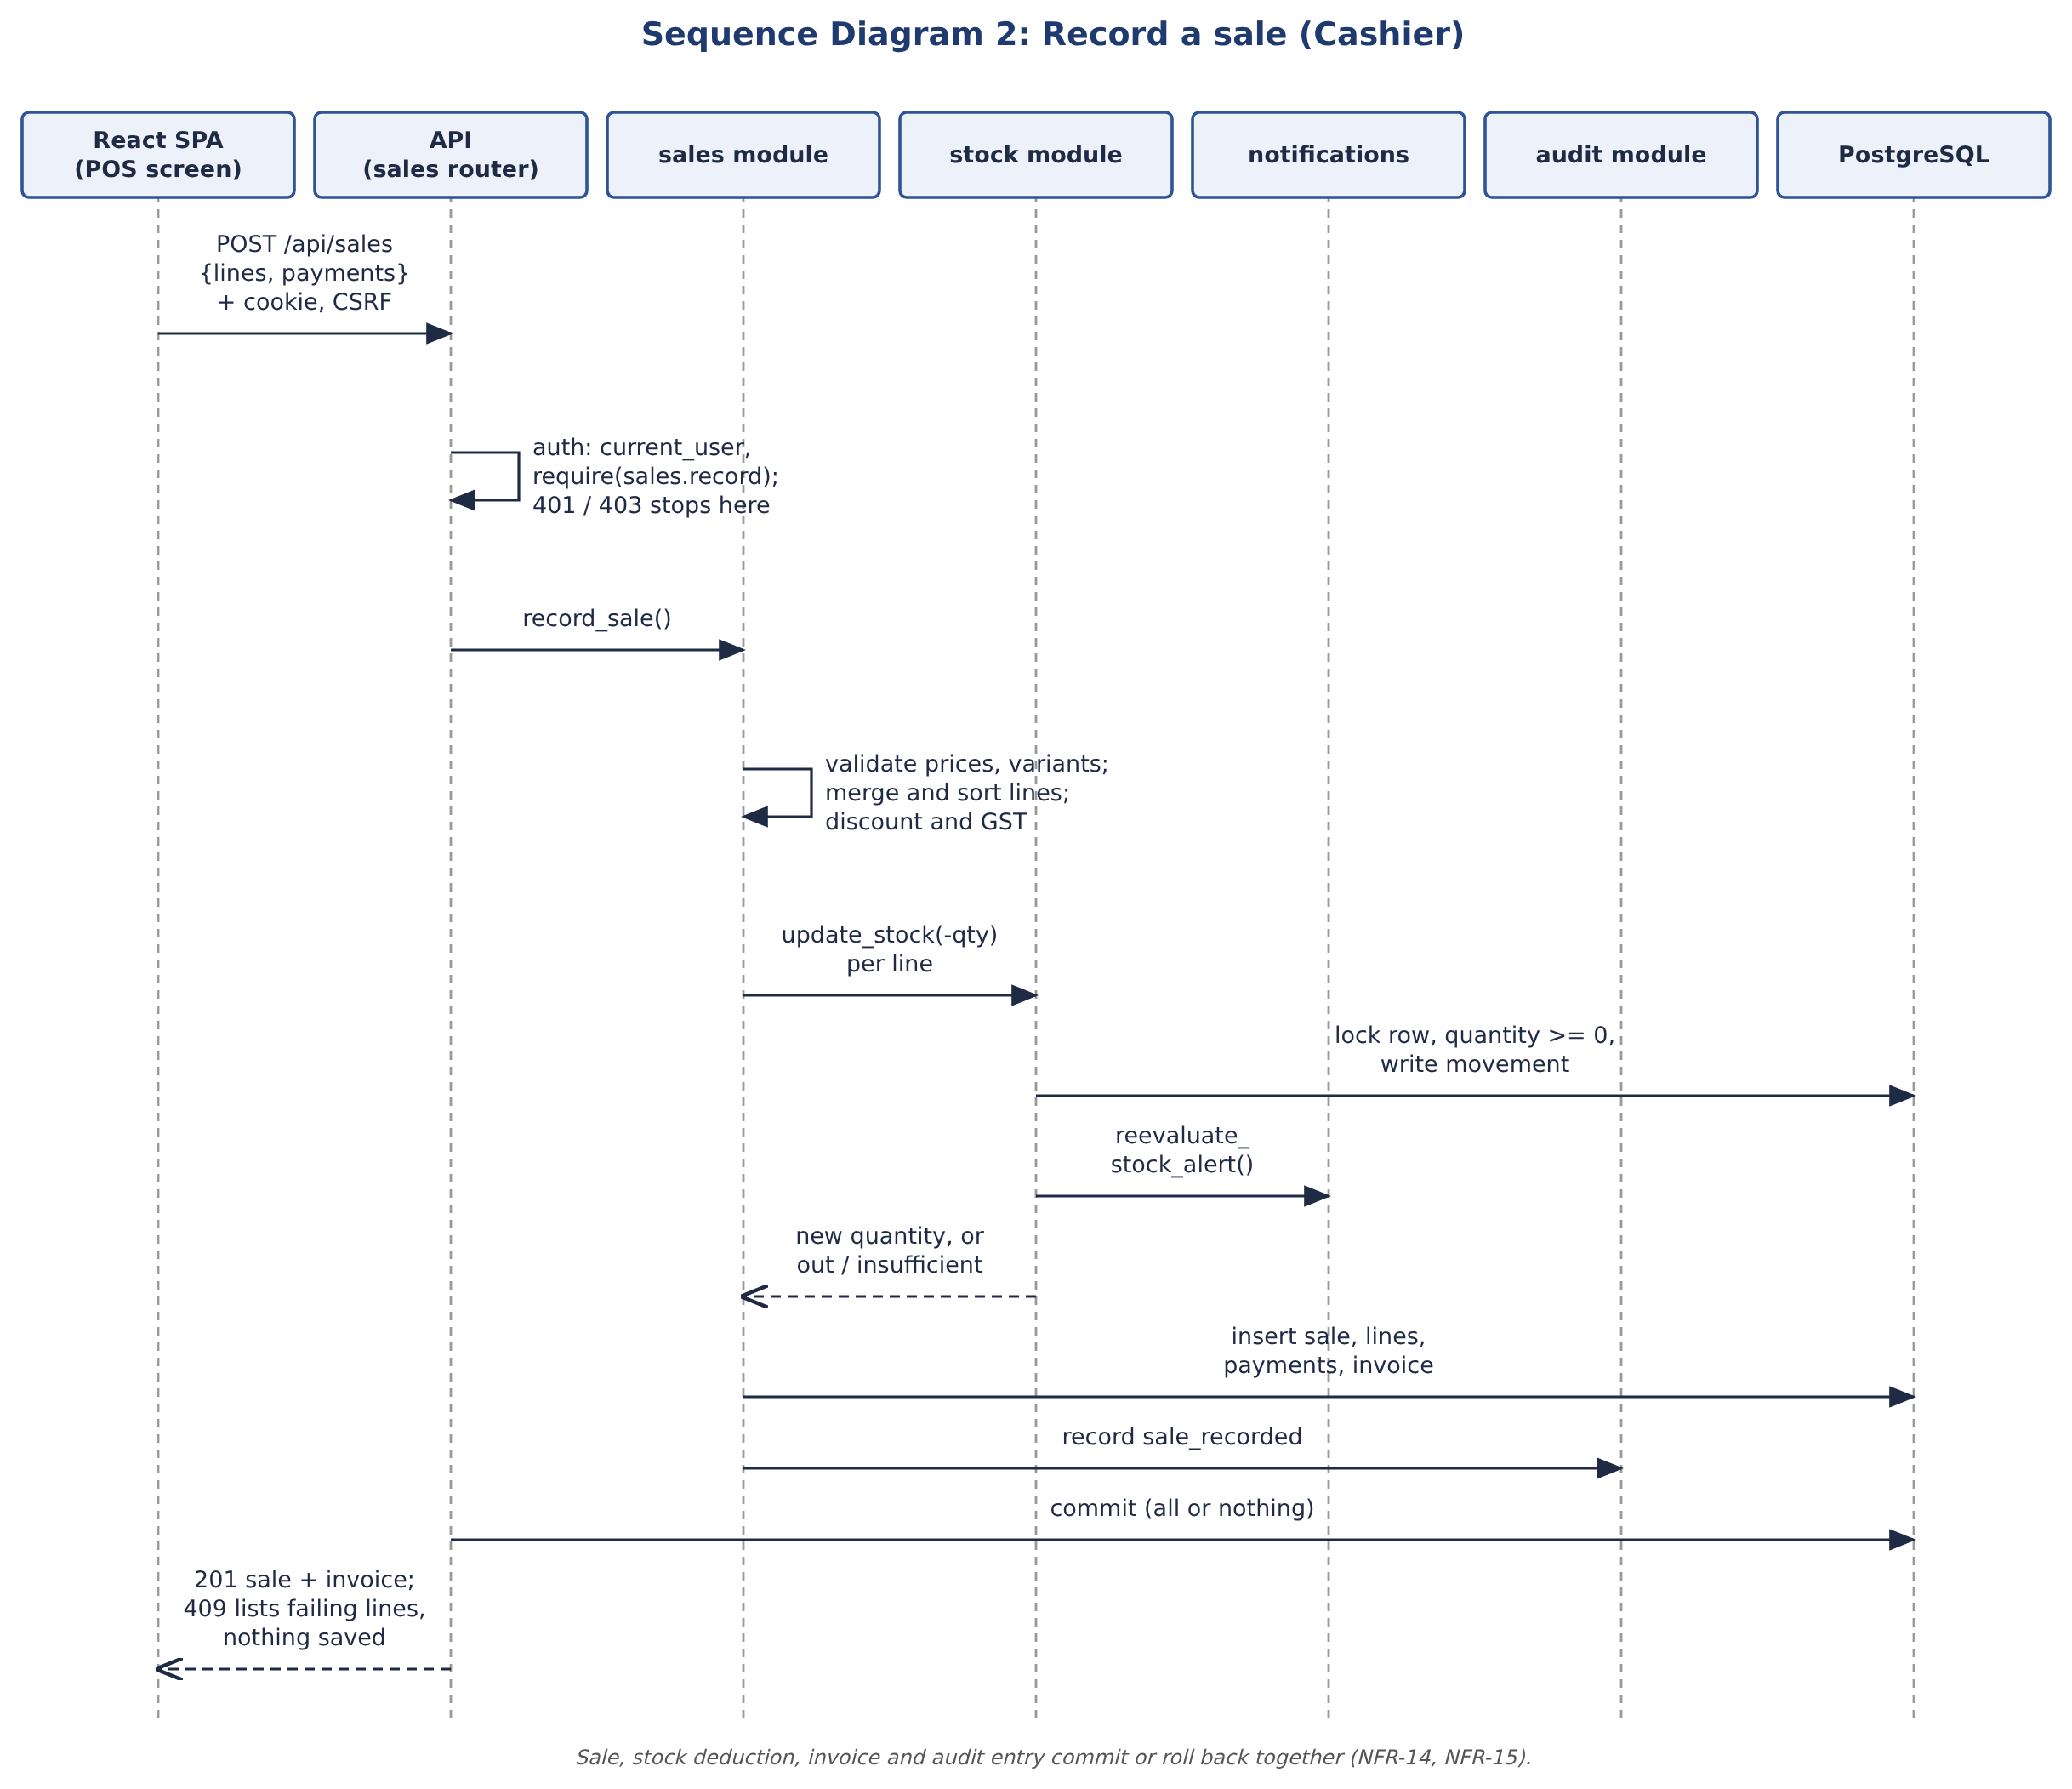
Figure 3: Sequence diagram 2, record a sale (FR-4.1, FR-2.2, NFR-14, NFR-15).

4.2.3 Process a late return with Manager override
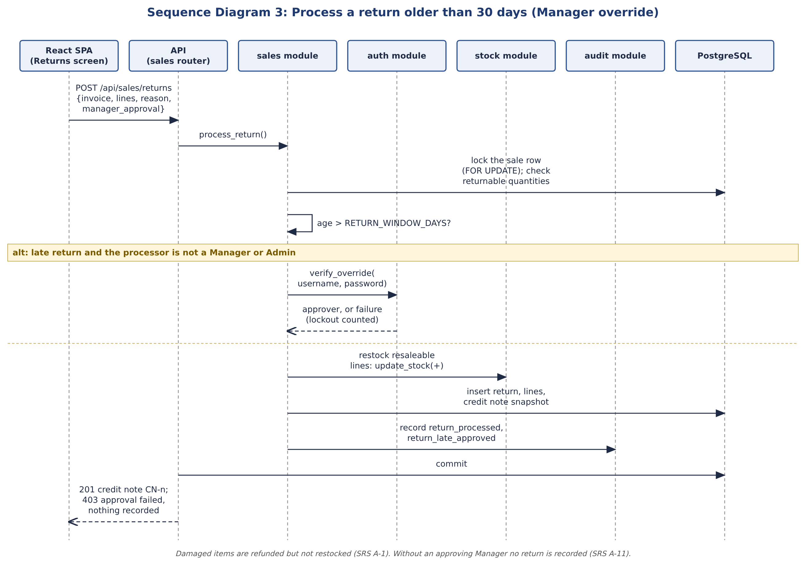
Figure 4: Sequence diagram 3, late return (FR-4.2, SRS A-1 and A-11).

4.3 API Design
All routes are under /api, exchange JSON, and need the session cookie; unsafe methods also need the CSRF header. The interactive OpenAPI description is served at /docs. The interfaces of four components are given below.

4.3.1 auth
Endpoint | Request | Response | Errors
POST /api/auth/login  Public | {username, password} | 200 {id, username, full_name, role, location_id, permissions[]}; sets the session and CSRF cookies | 401 Invalid username or password (also for unknown users)  403 account disabled  423 account locked
POST /api/auth/logout  Public, safe when signed out | none | 204; session ended on the server and cookie cleared | none
GET /api/auth/me  Any signed-in user | none | 200 current user with permissions | 401 not signed in or session expired
POST /api/auth/users  users.manage (Admin) | {full_name, username, email, role, location_id} | 201 user; a single-use setup link is emailed, never the password | 403 not permitted  409 / 422 duplicate or invalid fields

4.3.2 sales
Endpoint | Request | Response | Errors
POST /api/sales  sales.record (Cashier, Manager, Admin) | {location_id?, lines: [{product_id, variant_id?, quantity, discount, discount_type, serial_numbers[]}], payments: [{method, amount, reference?}], customer_name?, idempotency_key?} | 201 {id, sold_at, subtotal, discount_total, tax_total, total, lines[], payments[], invoice{invoice_number, invoice_label, content}} | 401 / 403 not signed in or not permitted  404 location not found  409 insufficient stock (all failing lines listed)  422 invalid input
POST /api/sales/returns  sales.record | {invoice_number, lines: [{sale_line_id, quantity, condition: resaleable | damaged, serial_number_ids?}], reason, manager_approval?: {username, password}} | 201 credit note {CN number, lines[], refund amounts} | 404 invoice not found  403 Manager approval required or failed  422 quantity above returnable or invalid input
GET /api/sales/by-invoice/{invoice_number} | none | 200 sale with returnable quantities per line | 404 invoice not found
GET /api/sales/invoices/{invoice_number}/pdf | none | 200 PDF of the stored invoice snapshot (audited) | 404 invoice not found

4.3.3 stock
Endpoint | Request | Response | Errors
POST /api/stock/adjustments  stock.adjust (Staff, Manager, Admin) | {product_id, variant_id?, location_id, quantity_change, reason, reason_code: damage | loss | correction} | 201 {product_id, variant_id, location_id, quantity_change, previous_quantity, quantity} | 403 other location (Staff)  404 product or location not found  409 would result in negative stock  422 reason missing or change is zero
POST /api/stock/transfers  stock.transfer | {product_id, variant_id?, from_location_id, to_location_id, quantity} | 201 transfer record; source decreased and destination increased in one transaction | 403 / 404 / 409 / 422 as above
GET /api/stock/levels  stock.view | none | 200 stock rows per item and location (Staff: own location) | 403 not permitted

4.3.4 product (search and filter)
Endpoint | Request (query) | Response | Errors
GET /api/product  products.view (all roles) | page, page_size (1 to 100), q (up to 100 chars), category_id, min_price, max_price, stock_status (in_stock | low_stock | out_of_stock), sort (relevance | name | price | stock), order (asc | desc) | 200 {items[{name, sku, category path, price, active variants, live stock}], page, page_size, total}; never cached | 401 / 403  422 search term too long or bad parameter

4.4 Error Handling, Logging & Monitoring
- Errors: validation problems return 422 with a list of {field, message}; business-rule conflicts return 409 or 403 with a plain message (for example Manager approval failed.); login failures use one generic message; unhandled errors return a generic 500 and log the stack trace on the server only.
- Logging: one line per request (method, path, status, duration); 5xx at ERROR. Passwords, tokens and card data are never logged. Business events go to the audit log instead (section 3.9).
- Monitoring: GET /api/health runs SELECT 1 and returns 200 or 503; the monitor service polls it every 30 s and alerts by email or chat webhook after 2 consecutive failures, and again on recovery. Uptime is reported over store hours (python -m scripts.uptime report). Backup failures and overdue backups use the same channels.

4.5 UX Design
- Desktop layout: header with brand, notification bell (unread count, latest 10, polling every 60 s) and user menu; sidebar with only the screens the role may use; shared DataTable, FormField, ConfirmDialog and AccessDenied components.
- Point of sale: scanner-style Enter adds the SKU, Escape clears, Alt+S focuses search, Alt+Enter completes the sale, errors are announced through a live region.
- Accessibility: labelled form fields, skip link, semantic headings, named navigation, disabled submit buttons while a request runs.
- Role guides for Cashier, Staff, Manager and Admin are in docs/guides. The usability review so far is an expert review (docs/usability); sessions with real users are still to be run.

4.6 Open Issues & Next Steps
- Run user sessions with cashiers and staff, and the Firefox and Edge checklist, then record the findings.
- Per-category tax and multiple currencies are not supported; reports and the return window use UTC dates.
- Batch and serial adjustments can only remove stock, and the system chooses the units.
- A few modules (sales, stock, purchasing, reporting) keep implementation in service.py, purchase_orders.py or documents.py instead of _internal/; moving it is a refactor for later.
- Run the restore drill yearly on production backups and confirm GST and retention rules before go-live.
- Security requirements the Security Requirements Document marks out of scope (password policy, request rate limiting, security headers) remain candidates for later.

5. Appendices

5.1 Glossary
Term | Meaning
ADR | Architecture decision record
API | Application Programming Interface
CSRF | Cross-Site Request Forgery: a request sent by another site using the user's cookies
ESIMS | Electronics Store Inventory Management System
GST | Goods and Services Tax
ORM | Object-relational mapper (SQLAlchemy)
PO | Purchase order
RBAC | Role-based access control
SKU | Stock keeping unit
SPA | Single-page application (the React client)
STRIDE | Spoofing, Tampering, Repudiation, Information disclosure, Denial of service, Elevation of privilege
TLS | Transport Layer Security (HTTPS)

5.2 References
- IEEE 42010, Architecture description (the structure the SAD template follows).
- ESIMS SRS v1.1, STP v1.1, Security Requirements Document v1.0, Use Case Flow Document v1.0.
- docs/architecture.md, docs/schema.md, docs/deployment.md, docs/monitoring.md, docs/backup-recovery.md, docs/retention.md in the repository.

5.3 Tools
Docker and Docker Compose, GitHub and GitHub Actions, Alembic, import-linter, ruff, pytest, Vitest, Mailpit. Diagrams: the component diagram is Documents/esims_component_diagram.png; the use case and sequence diagrams were drawn as SVG and rendered to PNG.

