Loanliness
Reimplementing and improving loan default prediction
Report on the reimplementation of Liang, Jin and Wang, “Loanliness: Predicting Loan Repayment Ability by Using Machine Learning Methods”
01 OVERVIEW
The paper trains five classifiers (logistic regression, random forest, Naive Bayes, a multi-layer perceptron and LightGBM) on the Kaggle Home Credit Default Risk data to predict whether a client will default. It reports accuracy, per-class precision, recall and F1, ROC curves, and random-forest feature importance. This project reproduces that pipeline in three notebooks: loan_pipeline.ipynb (joins and preprocessing), loan_models.ipynb (the paper’s models, tables and figures) and loan_improved.ipynb (a stronger model that goes beyond the paper). A shared module, loan_utils.py, supplies the splits and metric code so every notebook is scored identically.
02 REIMPLEMENTATION
Data and protocol. The application table is joined with aggregates (mean, min, max, sum, category shares) of the bureau, previous-application, POS-cash, installment and credit-card tables. After dropping columns with over 30% missing values, mean imputation, one-hot encoding and min-max scaling, 700 features remain. As in the paper, models are trained on a class-balanced down-sampled train set (39,720 rows) and scored on a balanced test set (9,930 rows). We also report scores on the natural-ratio test set (61,503 rows, 8.1% defaults). The paper’s exclusion of the EXT_SOURCE credit scores is kept. The paper gives no hyperparameters, so we chose standard values; the random forest was then tuned by 3-fold grid search on ROC-AUC.
Model (balanced test) | Accuracy | Precision 0/1 | Recall 0/1 | F1 0/1 | AUC | Paper acc.
Logistic Regression | 0.674 | 0.68/0.67 | 0.67/0.68 | 0.67/0.68 | 0.735 | 0.693
Random Forest | 0.669 | 0.67/0.67 | 0.68/0.66 | 0.67/0.67 | 0.726 | 0.635
Naive Bayes | 0.591 | 0.57/0.63 | 0.75/0.44 | 0.65/0.52 | 0.630 | 0.521
Multi-layer Perceptron | 0.670 | 0.70/0.65 | 0.59/0.74 | 0.64/0.69 | 0.727 | 0.692
LightGBM | 0.688 | 0.69/0.69 | 0.68/0.69 | 0.69/0.69 | 0.753 | 0.575
Table 1. Reimplementation of the paper’s Table III (last column: accuracy reported in the paper).
Results. Logistic regression and the MLP land within two points of the paper’s accuracy, Naive Bayes is weakest in both, and the top two random-forest features (DAYS_EMPLOYED, DAYS_BIRTH) match the paper’s Figure 3. The paper’s random forest and LightGBM rows are not reproduced: it reports positive-class precision of 1.00 with recall of 0.27 and 0.15, the signature of models that predict almost no defaults. Trained on the balanced set, ours are balanced across both classes (precision and recall 0.66 to 0.69), and LightGBM is the best model (AUC 0.753) rather than the second worst. Tuning the forest helped only slightly (AUC 0.726 to 0.732), with tree depth mattering most. On the natural-ratio test, recall and AUC hold but precision on defaults falls to 0.13 to 0.16, and accuracy misleadingly ranks Naive Bayes first (0.725) despite its lowest AUC.
03 IMPROVEMENT BEYOND THE PAPER
Since LightGBM was the strongest model, loan_improved.ipynb builds a single tuned LightGBM on the same train and test rows (matched by SK_ID_CURR), so scores are directly comparable. It makes four changes:
- All training rows. No down-sampling (246,008 rows); imbalance is handled with scale_pos_weight, and the decision threshold is picked from out-of-fold predictions (maximum TPR minus FPR).
- Raw features. No column dropping or imputation. LightGBM takes the NaNs and 16 categorical columns directly, and six ratio features are added (e.g. annuity/credit, credit/goods price).
- EXT_SOURCE_1..3 restored. These external credit scores are excluded by the paper, so results are given with and without them.
- Tuning. Random search over 20 configurations with early stopping, then a final fit at learning rate 0.02 averaged over 3 folds. Small trees (15 to 23 leaves), large leaves and a 0.2 column fraction worked best.
Configuration (balanced test) | Features | Accuracy | AUC | OOF AUC
Paper-protocol LightGBM (down-sampled) | 700 | 0.688 | 0.753 | –
Paper features, all rows, untuned | 700 | 0.694 | 0.760 | 0.755
New features, no EXT_SOURCE, tuned | 834 | 0.700 | 0.768 | 0.763
New features + EXT_SOURCE, untuned | 837 | 0.713 | 0.788 | 0.782
New features + EXT_SOURCE, tuned | 837 | 0.715 | 0.790 | 0.786
Table 2. Ablation of the improved model. OOF AUC is out-of-fold AUC on the train set.
Results. The final model reaches 0.790 AUC and 0.715 accuracy on the balanced test (0.792 AUC at the natural ratio), a gain of +0.037 AUC and +0.027 accuracy over the paper-protocol LightGBM. Using all rows adds about 0.007 AUC; raw NaNs, ratios and tuning add 0.008 more; the three EXT_SOURCE columns add 0.022, more than everything else combined, and carry 24% of total gain. The six ratios take 6.6% of gain, mainly annuity/credit and credit/goods price. Without EXT_SOURCE the model still respects the paper’s feature restriction and scores 0.768 AUC. Out-of-fold AUCs give the same ordering, so the ranking does not depend on the test set.
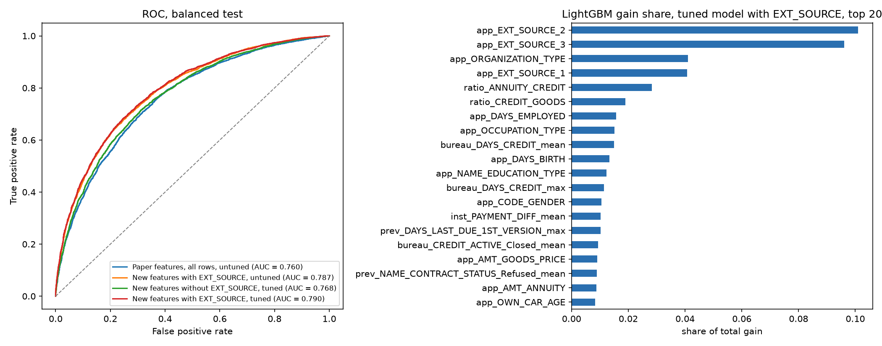
Figure 1. ROC curves of the four improved configurations (left) and top-20 gain share of the final model (right).
04 LIMITATIONS
Exact numbers differ from the paper because it gives no hyperparameters. Results use one seed and three folds, so differences of 0.002 to 0.003 show direction only. The random-search validation AUC is slightly optimistic because early stopping uses the same rows; out-of-fold and test scores are unaffected. The no-EXT_SOURCE model reuses the configuration found with them, and models that use EXT_SOURCE are not comparable with the paper’s Table III.

