**THỰC HÀNH BUỔI 5**

**Lab 7: Streamlit**

Code python:

import streamlit as st

st.text("Hello Word")

st.button("Hit me")

st.checkbox("Check me out")

st.radio("Radio", [1,2,3])

st.selectbox("Select", [1,2,3])

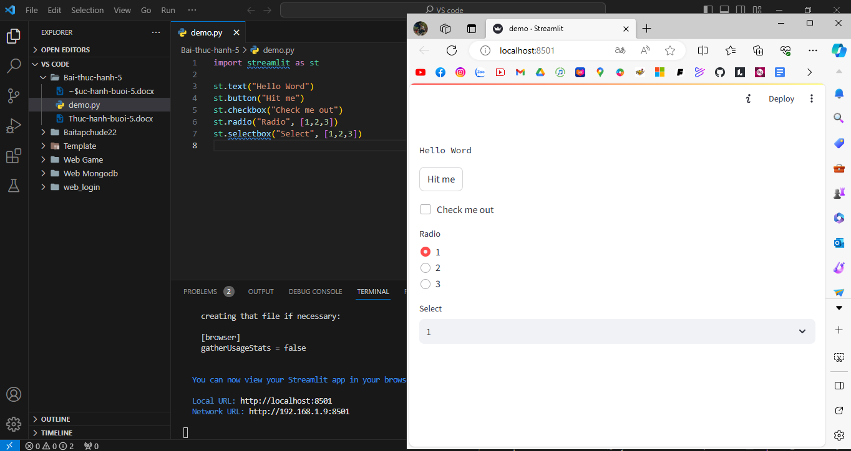

**Streamlit run app.py**

Code python:

import streamlit as st

import altair as alt

import pandas as pd

import numpy as np

def visualize_data(df, x_axis, y_axis):

    chart = alt.Chart(df).mark_circle().encode(

        x=x_axis,

        y=y_axis,

        tooltip=[x_axis, y_axis]

    ).interactive()

    st.altair_chart(chart, use_container_width=True)

def load_data():

    uploaded_file = st.file_uploader("Upload a CSV file", type=["csv"])

    if uploaded_file is not None:

        df = pd.read_csv(uploaded_file)

    else:

        file_path = "metrics.csv"

        df = pd.read_csv(file_path)

    return df

def main():

    df = load_data()

    page = st.sidebar.selectbox("Choose a page", ["Homepage", "Exploration"])

    if page == "Homepage":

        st.header("This is your data explorer.")

        st.write("Please select a page on the left.")

        st.write(df)

    elif page == "Exploration":

        st.title("Data Exploration")

        x_axis = st.selectbox("Choose a variable for the x-axis", df.columns, index=3)

        y_axis = st.selectbox("Choose a variable for the y-axis", df.columns, index=4)

        visualize_data(df, x_axis, y_axis)

if __name__ == "__main__":

    main()

