THUC HANH BUOI 1

Lab1

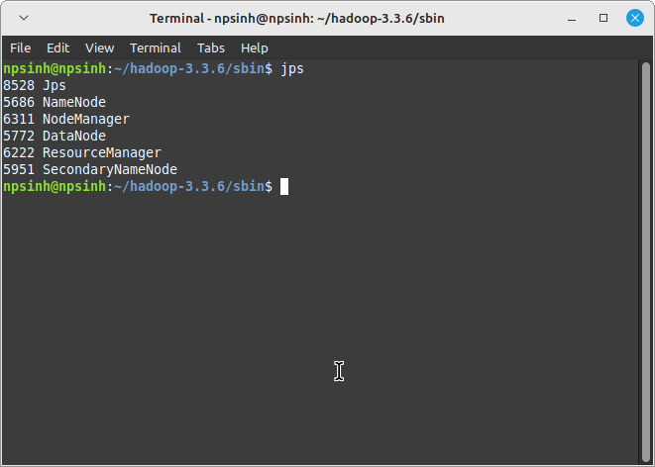
Localhost:9864
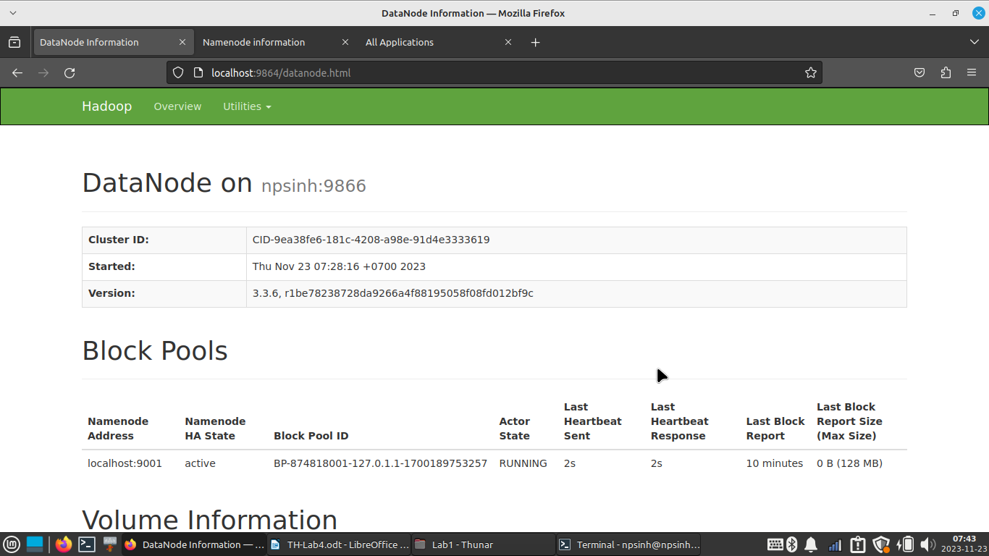
Localhost:9870
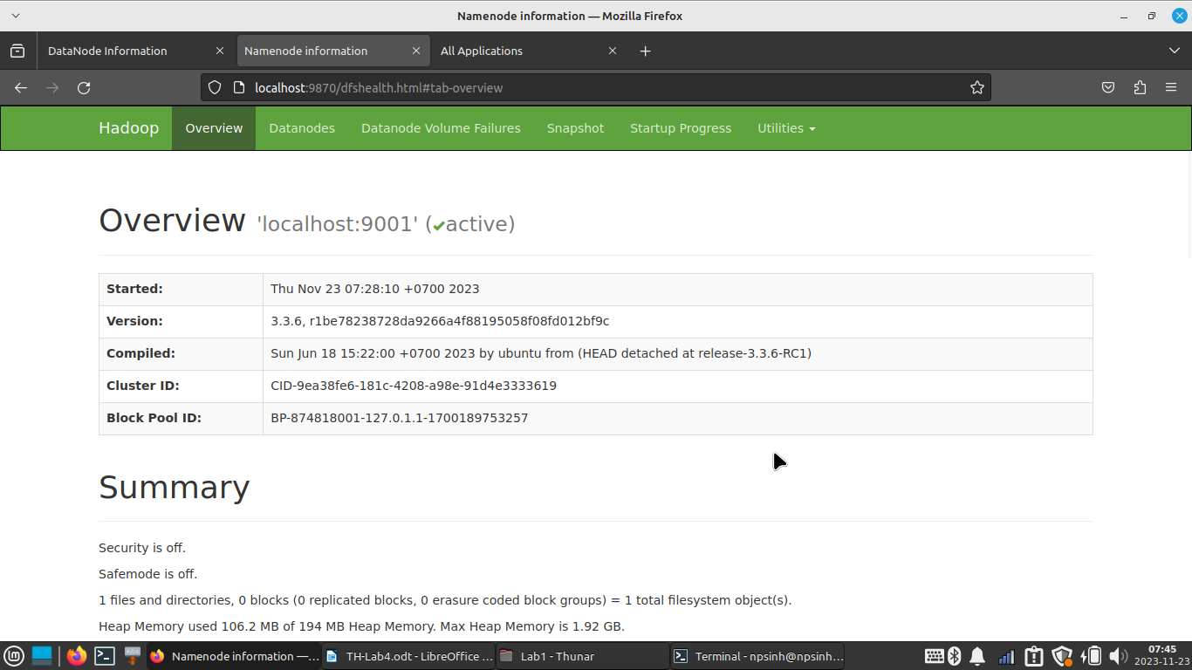
Localhost:8088
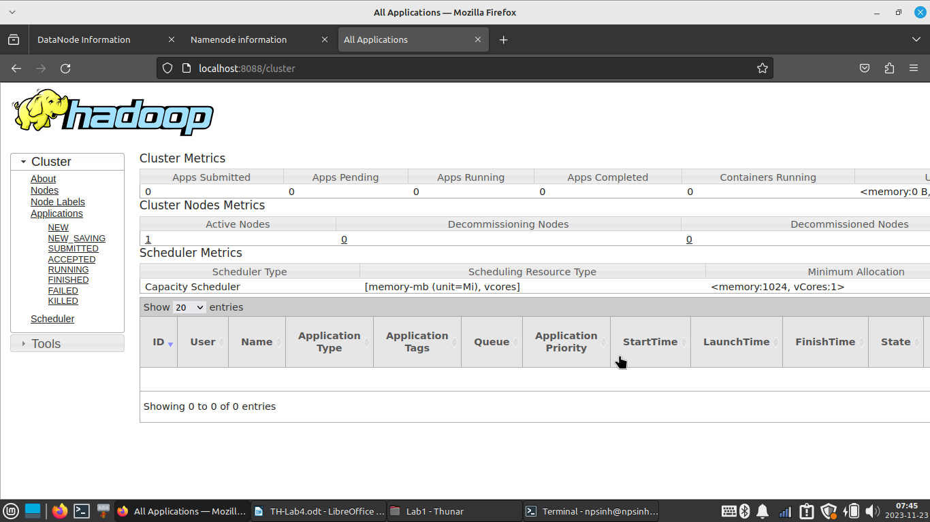
Lab4
Code python:

import nltk
nltk.download('stopwords')
nltk.download('punkt')

text = """decision trees are a very effective method of supervised learning. it aims is the partition of a dataset into groups as homogeneous as possible in terms of the variable to be predicted. it takes as input a set of classified data, and outpus a tree that resembles to an orientation diagram where each end node leaf is a decision a class and each non final node internal represents a test. each leaf represents the decision of belonging to a class of data verifying all tests path from the root to the leaf"""

from nltk.corpus import stopwords
stop_words = set(stopwords.words("english"))

from nltk.tokenize import word_tokenize,sent_tokenize
tokenize_words = word_tokenize(text)

tokenize_words_without_stop_words = []
for word in tokenize_words:
if word not in stop_words:
tokenize_words_without_stop_words.append(word)

print("Cac tu dung duoc xoa:\n",set(tokenize_words)-set(tokenize_words_without_stop_words))

print("Khong phai tu dung:\n",tokenize_words_without_stop_words)

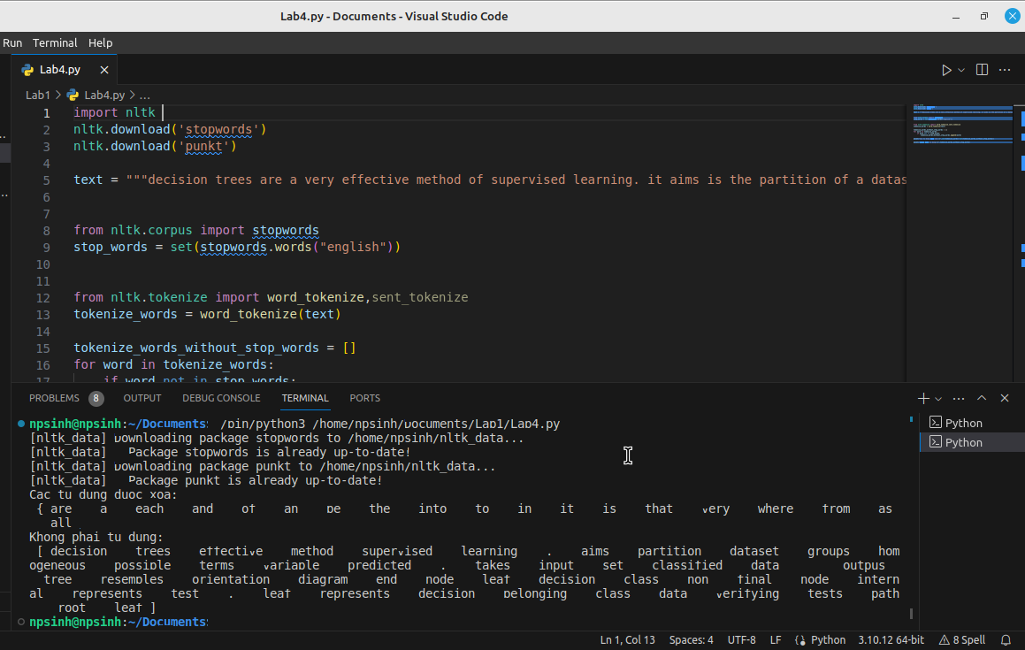

Lab5
Code python:

from pybloom_live import BloomFilter
import nltk

nltk.download('words')

file_path = "wordcount.txt"

with open(file_path, 'r') as file:
text = file.read()

words = nltk.word_tokenize(text)

bloom_filter = BloomFilter(capacity=100000, error_rate=0.001)

for word in words:
bloom_filter.add(word)

words_to_check = ["of", "example", "some", "words", "to", "check"]

for check in words_to_check:
if check in bloom_filter:
print(f"Từ '{check}' Có trong văn bản.")
else:
print(f"Từ '{check}' Không có trong văn bản.")

