THUC HANH BUOI 2
Lab6
Code python:

import hashlib

def flajolet_martin(data):
max_rightmost_zero_bit_position = -1

for element in data:
hash_value = hashlib.md5(element.encode()).hexdigest()
rightmost_zero_bit_position = len(hash_value) - len(hash_value.rstrip('0'))

if rightmost_zero_bit_position > max_rightmost_zero_bit_position:
max_rightmost_zero_bit_position = rightmost_zero_bit_position

estimated_number_of_distinct_elements = 2 ** max_rightmost_zero_bit_position

return estimated_number_of_distinct_elements

data = "ab23 Big data is a field that treats ways to analyze from or otherwise deal with data Current usage of the term big data tends to predictive analytics user behavior, analytics or advanced data analytics Data sets grow rapidly in part because they are increasingly Internet of things devices such as mobile devices. Xz33. Small Small Small Small Small Small Small Small Small Small Small Small Small Small Small Small"

elements = data.split()

estimated_count = flajolet_martin(elements)
small_count = elements.count("Small")

print("Số tên của các phần tử riêng biệt là:", estimated_count)
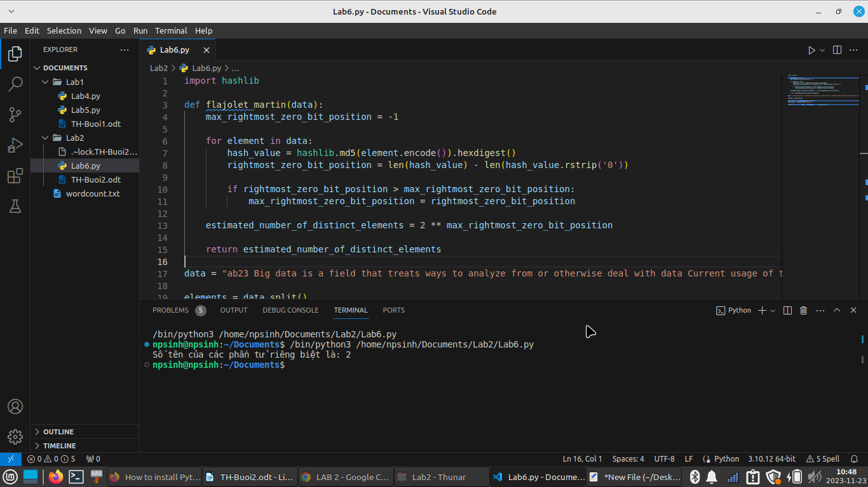
Lab7

- Cai dat pip: wget https://downloads.apache.org/pig/pig-0.17.0/pig-0.17.0.tar.gz

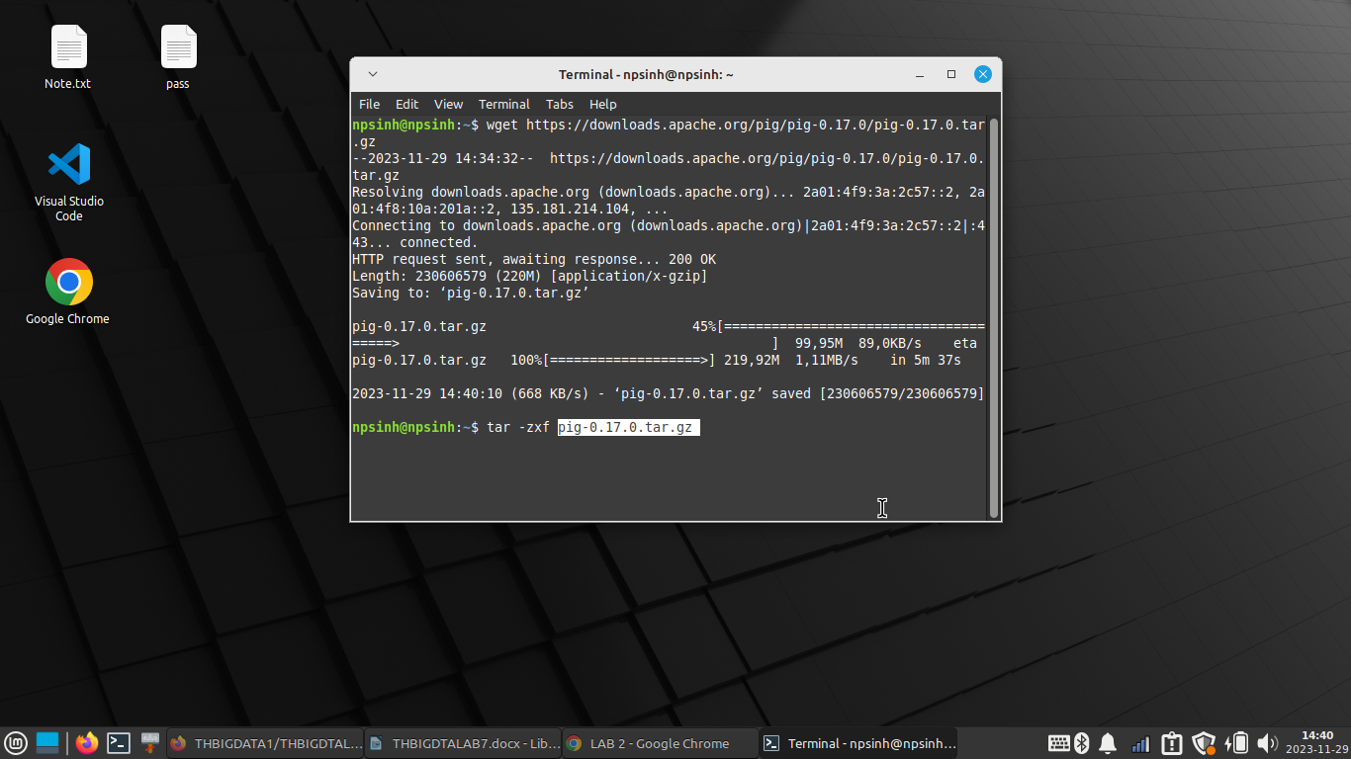
- Giai nen file pig vua downloads: tar -xzvf pig-0.17.0.tar.gz

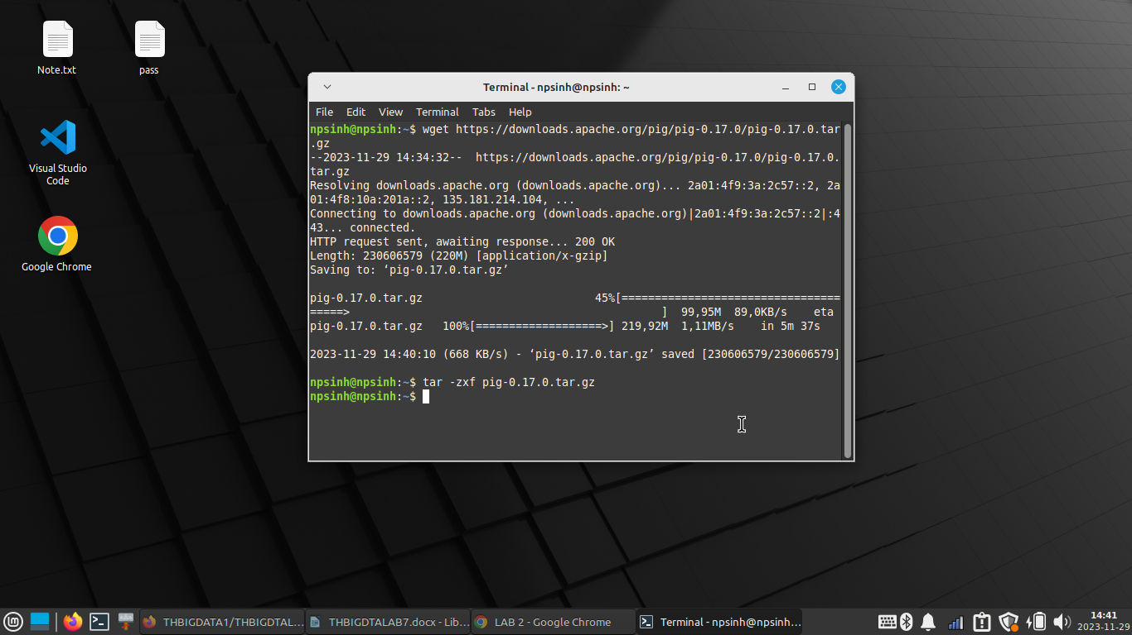

- Di chuyen file pig vua giai nen vao duong dan: /usr/local/pig

=> sudo mv pig-0.17.0 /usr/local/pig

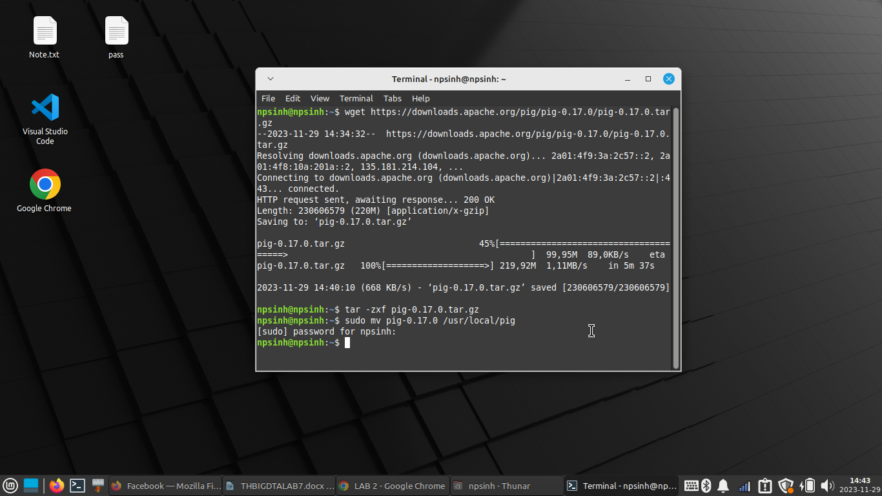

- export cac duong dan sau:
echo 'export PIG_HOME=/usr/local/pig' >> ~/.bashrc
echo 'export PATH=$PATH:$PIG_HOME/bin' >> ~/.bashrc
echo 'export JAVA_HOME=/usr/lib/jvm/java-8-openjdk-amd64' >> ~/.bashrc

source ~/.bashrc
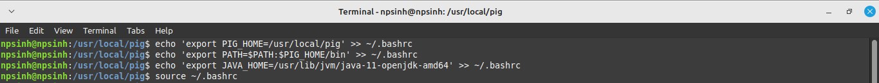
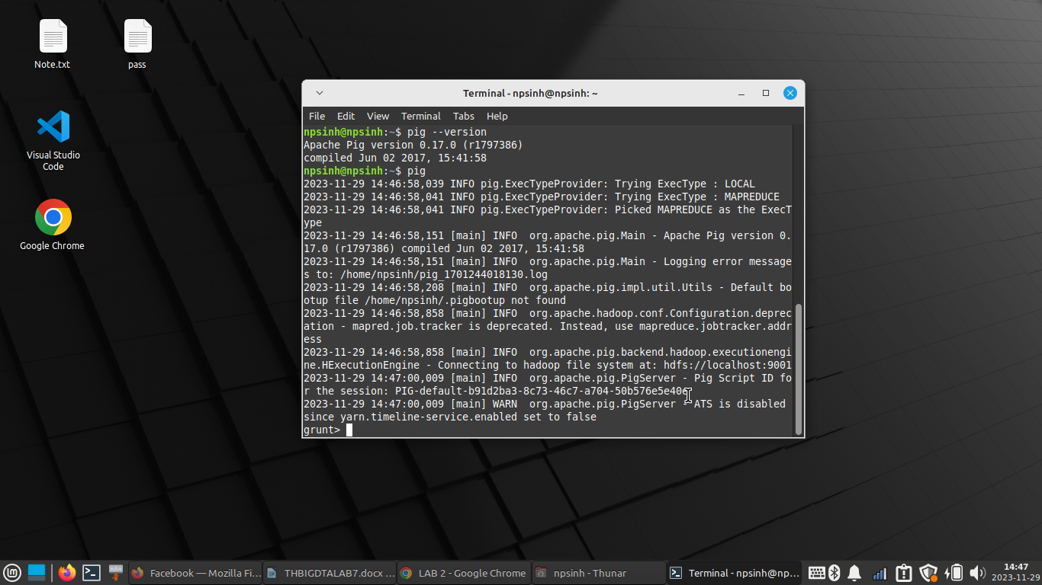
- Kiem tra Pig: pig -version

