Bloons TD 6
Autonomous Multi-Agent Game QA Framework
Technical Design, Agent Workflow and Code Walkthrough

Item | Value
Repository | Sinha28Shivam/Netflix_Agentic_Gameplay (NetflixGameTestHCL)
Game under test | Bloons TD 6 (Netflix edition) - package com.netflix.NGP.BloonsTDSix
Plugin id | bloons_td6 (default --game)
Mission | Reach Round 10 on Monkey Meadow, Easy, Standard
AI model | Anthropic Claude (VISION_MODEL / DECIDER_MODEL, default claude-opus-4-8)
Document date | 27 October 2026

Table of Contents
Right-click and choose 'Update Field' to build the table of contents.

1. Executive Summary
This document explains, end to end, how the NetflixGameTestHCL framework autonomously tests Bloons TD 6 on a real Android device. It covers the multi-agent architecture, the orchestrated workflow, every agent's responsibilities and algorithms, the Bloons-specific plugin, data artefacts, verdict rules, the reinforcement-learning subsystem, configuration, and known gaps found while reviewing the code.
The framework treats game QA as a pipeline of cooperating, single-purpose agents:
- Setup (once per new game) - the MapAgent walks the game's menus and records a screen graph; the PlannerAgent turns written requirements into a test plan with navigation paths.
- Test cycle (every run) - the ExecutorAgent drives the game (navigate to a Monkey Meadow match, place towers, run rounds) while the PerformanceAgent and ComplianceAgent run in parallel threads collecting evidence.
- Judgement - the ValidatorAgent turns the combined evidence into PASS / FAIL / PARTIAL / INCONCLUSIVE verdicts; on a gameplay failure the Recovery step self-heals and the cycle is retried.
- Reporting - the ReportAgent writes JSON and HTML scan reports.
Three design principles run through the whole codebase:
- Zero hardcoded coordinates - every button, tower icon and grass tile is found at runtime by OCR or by describing it in natural language to the Claude vision model (vlm_locate).
- Verify-after-act - no action is trusted on the model's word. Navigation is verified by a screen change, tower placement by the cash going down, round start by the round counter going up.
- Rules first, AI only when ambiguous - compliance uses deterministic rules (ComplianceOracle); only genuinely visual questions go to an AI judge, and low-confidence answers are queued for human review instead of being counted.
Note: Section 2 sets out exactly why the framework is called agentic. It covers the definition used, the eight agentic properties with code evidence for each, a comparison with scripted automation, a traced example, where AI is and is not used, and the limits of the claim.

2. Why This Framework Is Agentic - The Claim and the Evidence
"Agentic" is used loosely in industry, so this section states precisely what we claim, which code proves each part of the claim, how the system differs from a conventional test script, and where the claim stops. Every statement below is traceable to a file and function in the repository.

2.1 Definition used in this document
We call a system *agentic* when it pursues a goal (not a fixed script) by repeatedly perceiving its environment, deciding what to do based on what it perceived, acting on the environment, verifying the outcome, and adapting (retrying, recovering or re-planning) when the outcome is not what it expected - with memory of what it has learned and with work split across specialised, cooperating agents. A traditional automation script, by contrast, replays fixed coordinates and fixed steps and simply fails when the screen differs.
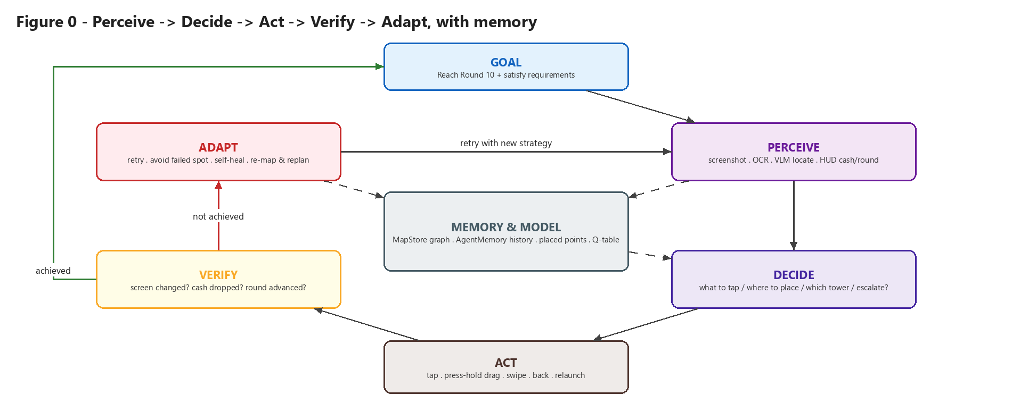
Figure 0 - The agentic loop as implemented for Bloons TD6.

2.2 The eight agentic properties and where the code implements them
Table 1 - Agentic properties mapped to code
# | Agentic property | How the framework does it for Bloons | Code evidence
1 | Goal-directed | Given only a mission ("Reach Round 10 on Monkey Meadow, Easy, Standard") and a list of requirements; the agents work out how to reach and test each one. Success is judged against the goal, not against steps executed. | config.MISSION, BloonsTD6.goal, is_goal_reached(), OracleAgent.verify(), RequirementSpec
2 | Perception of an unseen UI | Every frame is screenshotted and interpreted at runtime: OCR reads text, the Claude VLM locates elements from plain-English descriptions, the HUD parser reads cash and round. Nothing is located by stored coordinates. | qa_common.ocr_all, vlm_locate, vlm_locate_precise, read_hud, VisionAgent.observe, descriptions.py
3 | Autonomous decision-making | The system chooses its own next action from observed state: which tower to buy (rotation vs. cash), where to drop it (VLM picks open grass, avoiding failed spots), whether a popup must be cleared, whether a step was skipped by the game, which spec drives the cycle, and when to escalate from OCR to VLM to relaunch. | _deploy_if_affordable, place_one, clear_popups, navigate skip logic, driver selection in _run_cycle, self_heal, DecisionAgent.decide, RLDecisionAgent
4 | Acting on a real environment | Taps, press-hold drags, swipes, BACK, force-stop and relaunch on a physical Android device through ADB/Appium. | src/device/device.py, adb_utils.tap/drag/swipe/back/launch_game
5 | Verify-after-act (closed loop) | No action is trusted because the model said so. Navigation must change the screen signature; a placement must lower cash; a round start must raise the round counter; a sell must raise cash. Failure feeds the next attempt. | wait_for_change, screen_changed, place_one._placed, start_and_fast_forward, scenarios.py
6 | Self-correction and recovery | Diagnoses why an action failed and changes strategy: red range circle => bad tile, pick another; no redness => gesture failed, switch to tap-tap; VLM failed points are fed back so the model does not repeat them; stuck screens trigger an OCR -> VLM -> relaunch ladder; failed gameplay cycles are retried. | redness, vlm_locate(avoid=...), self_heal, RecoveryAgent, retry loop in run_cycle_and_report
7 | Memory, learning and re-planning | Builds and persists a model of the game (MapStore screen graph) that later runs reuse; skips setup for known games; detects MapGaps, extends the map and replans once (continuous learning loop); keeps short-term working memory of scenes and decisions; learns a navigation policy by Q-learning from its own map. | MapStore, _setup_done, _relearn_on_gaps, explore_gaps, AgentMemory, src/rl/*
8 | Multi-agent specialisation and coordination | Separate agents with single responsibilities (map, plan, execute, measure, inspect, judge, validate, recover, report) coordinated by an orchestrator; three agents run concurrently and their evidence is fused by a validator that has no device or model access. | orchestrator.py (_PerfWorker, _ComplianceWorker, ValidatorAgent), src/agents/**

2.3 Agentic vs. conventional scripted automation
Table 2 - Scripted vs. agentic
Concern | Conventional script (e.g. recorded taps) | This framework
Finding a button | Hardcoded x,y or a resource id | OCR text match, else VLM locates it from a description; coordinates computed per frame
UI changes / new device resolution | Breaks; script must be re-recorded | Re-located automatically; descriptions are resolution-independent
Unexpected popup (level up, reward, update) | Test fails or taps the wrong thing | Detected from screen text and dismissed (clear_popups), or escalated to VLM
Game skips a screen ("Continue saved game") | Desynchronises and fails | Notices the next step is already visible and continues (navigate, build_map)
Did the action work? | Assumed | Proven by an observable outcome (screen hash, cash, round)
Invalid tower spot | Not detectable | Red-overlay analysis + cash check, chooses a new spot
Adding a new requirement | Write new script code | Add a RequirementSpec; planner finds the route from the map
Adding a new game | New test project | New plugin (profile, specs, descriptions); engine unchanged
Pass/fail | Assertion on a fixed step | Validator fuses gameplay, performance and compliance evidence; uncertain AI judgements go to a human

2.4 Worked example - one Bloons decision traced through the loop
Placing the first tower shows every element of the loop in about ten seconds of real play:
Table 3 - Agentic trace of a tower placement (illustrative values)
Loop stage | What happens | Function
Goal | Have a tower on the map so rounds can be survived toward Round 10 | play()
Perceive | Screenshot; read HUD cash = 650; VLM locates the Dart Monkey icon (coarse, then cropped and refined) | read_hud, vlm_locate_precise
Decide | VLM asked for the most open grass away from the path, HUD and shop; previously failed points are excluded | vlm_locate(GRASS_DESC, avoid=...)
Act | Press-hold-drag from icon to grass | drag()
Verify | Re-read HUD: cash still 650 -> placement did NOT happen | _placed()
Diagnose | Redness at drop point = 0.31 (>= 0.12) -> the spot is on the path | redness()
Adapt | Add spot to avoid-list, re-locate icon, ask VLM for a different grass point, retry | place_one retry loop
Verify | Cash now 480 -> placed; point remembered so later towers avoid it | placed.append()
Escalate if needed | After 3 tries, or if the match was lost, abort placement rather than loop forever | solidly_in_match, _defeat_showing

2.5 Where the AI is used - and where it deliberately is not
Being agentic does not mean sending everything to a model. The framework uses AI only where judgement or open-ended perception is required, and uses deterministic code wherever a fact can be checked exactly. This keeps runs reproducible and auditable, and is a core part of the claim's credibility.
Table 4 - Division of labour between AI, code and humans
Task | Decided by | Why
Locate buttons, towers, grass, dialogs | Claude VLM (after cheap OCR attempt) | Open-ended visual perception of a stylised UI
Visual compliance (contrast, ad labelling, colour-only info) | Claude VerificationJudge, confidence-gated | Cannot be reduced to a rule
Optional plan expansion (USE_LLM=1) | LLM | Turns vague free-text requirements into concrete checks
Next action in the per-step loop | LLM DecisionAgent or learned RL policy | Open-ended exploration
Did the action succeed? | Deterministic (cash, round, pixel hash) | Must be objective - the model is never trusted to grade itself
IAP price, age gate, denylist, tap-target size | Deterministic ComplianceOracle | Exact rules, zero hallucination risk
Final PASS/FAIL verdict | Deterministic ValidatorAgent | No device and no model - pure evaluation of evidence
Low-confidence AI answers (< 0.75) | Human review queue | Uncertainty is surfaced, not hidden

2.6 Levels of autonomy in the codebase
The framework contains two control paths. Being explicit about them keeps the claim accurate:
Table 5 - Control paths
Path | Entry point | Autonomy level | Status
A. Orchestrated pipeline (production) | python main.py | Goal-directed, perception-driven, self-verifying and self-healing. The high-level task order (map -> plan -> navigate -> play -> validate) is designed by engineers; the agents decide *how* to carry out each step on whatever screen they actually see. | Default path
B. Per-step decision loop | VisionAgent -> DecisionAgent / RLDecisionAgent -> ExecutorAgent -> OracleAgent, with AgentMemory and RecoveryAgent; used by scripts/run_plan.py (TestRunner) and scripts/rl_navigate.py | Fully open-ended: the model or a learned policy chooses *every* next action from structured state, mission, objective and the last 8 decisions in memory. | Implemented, opt-in

In short: Path A is a bounded agentic workflow. The workflow structure is fixed, but every action inside it is perceived, decided, verified and corrected autonomously. Path B is a fully autonomous agent loop. Both share the same perception, action, memory and verification layers.

2.7 Boundaries of the claim
To keep the claim defensible, the following limits are acknowledged (details in section 15):
- The *in-match strategy* is heuristic (place three Darts, rotate the roster when affordable, fast-forward). The agent adapts how it executes that strategy, but does not yet learn which strategy wins. In-match RL is on the roadmap (GameplayReward exists; live training does not).
- The orchestrator's stage order is engineered, not model-planned; LLM planning is optional (USE_LLM).
- The learning loop re-maps and re-plans once per run by design (no unbounded self-modification).
- A human remains in the loop for low-confidence compliance judgements.
- Current scene-name mismatches cause Bloons requirements to be planned as MapGaps (section 15). This weakens requirement routing but not the perceive-act-verify behaviour of the executor.

2.8 How to demonstrate the claim
These checks give observable evidence of agentic behaviour in a live run:
- Run python main.py --game bloons_td6 and open outputs/logs/run_<ts>.log: every locate shows [ocr] or [vlm], every tap is followed by an OK (screen changed) or a retry, and placements log cash a->b.
- Use a different resolution or device: no code or coordinate changes are needed.
- Trigger a popup (reward, level up) mid-run: the log shows handled a popup (continuing toward: ...).
- Delete outputs/results/map_store.json: the next run detects a new game and re-maps automatically; a second run skips setup (SETUP: game already mapped & planned).
- Force a failure (e.g. leave the match): the orchestrator logs RECOVERY (self-heal) and the escalation phase used, then retries the cycle.
- Train the RL policy (python -m src.rl.train --game bloons_td6) and run scripts/rl_navigate.py: the device is navigated by a policy the system learned from its own map.
- Inspect outputs/logs/*.png: every decision has a timestamped screenshot as evidence.

3. Bloons TD 6 - Game Context for QA
Bloons TD 6 is a tower-defense game: balloons ("bloons") travel along a dirt path and the player places monkey towers on grass to pop them. Each popped bloon earns cash, which buys more towers and upgrades. A match is divided into rounds; the player loses lives when bloons reach the end of the path.

3.1 QA mission
The mission is defined in src/core/config.py (MISSION) and surfaced by the plugin (BloonsTD6.goal, mission_summary):
Table 6 - Mission configuration
Key | Value | Used by
game | Bloons TD 6 | reports, planner
map | Monkey Meadow | objective_for_scene(), seed path
difficulty | Easy | objective_for_scene(), seed path
mode | Standard | objective_for_scene(), seed path
target_round | 10 | is_goal_reached(), BloonsTD6.play()

3.2 Scene vocabulary
The plugin declares the scenes the vision model is allowed to report (_BLOONS_SCENES in src/games/bloons_td6/profile.py). VisionAgent builds its system prompt from this list.
Table 7 - Bloons scene vocabulary
Scene | Meaning | Objective (objective_for_scene)
loading | Splash / tip loading screen | Wait for load
main_menu | Home screen (PLAY, Heroes, Monkeys ...) | Open Play menu
map_selection | Map carousel | Select Monkey Meadow
difficulty_selection | Easy / Medium / Hard | Select Easy
game_mode | Standard / other modes | Select Standard
placement | In match, before the first round | Place starting tower
in_round | A round is running | Monitor round
between_rounds | Waiting for START | Start next round
victory / defeat | End-of-match screens | Verify victory / defeat screen
dialog | Blocking popup | Dismiss dialog
tower_detail | A tower's upgrade/target panel is open | Observe
system_update_modal | OS / store update overlay | Observe
unknown | Fallback | Observe

3.3 Golden navigation path
The seed file data/seeds/bloons_seed.json lists the labels a human would tap from launch to a live match:
{"labels": ["START", "PLAY", "Monkey Meadow", "EASY", "STAnDARD"]}

STAnDARD is spelled the way the OCR engine actually reads the game's font. The RL module normalises such noise (normalize_target) when it builds its MDP.
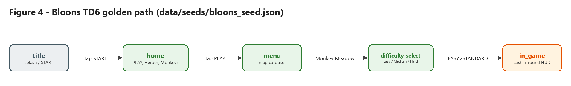
Figure 4 - The Bloons golden path, as recorded in the MapStore (5 logical screens).

4. System Architecture
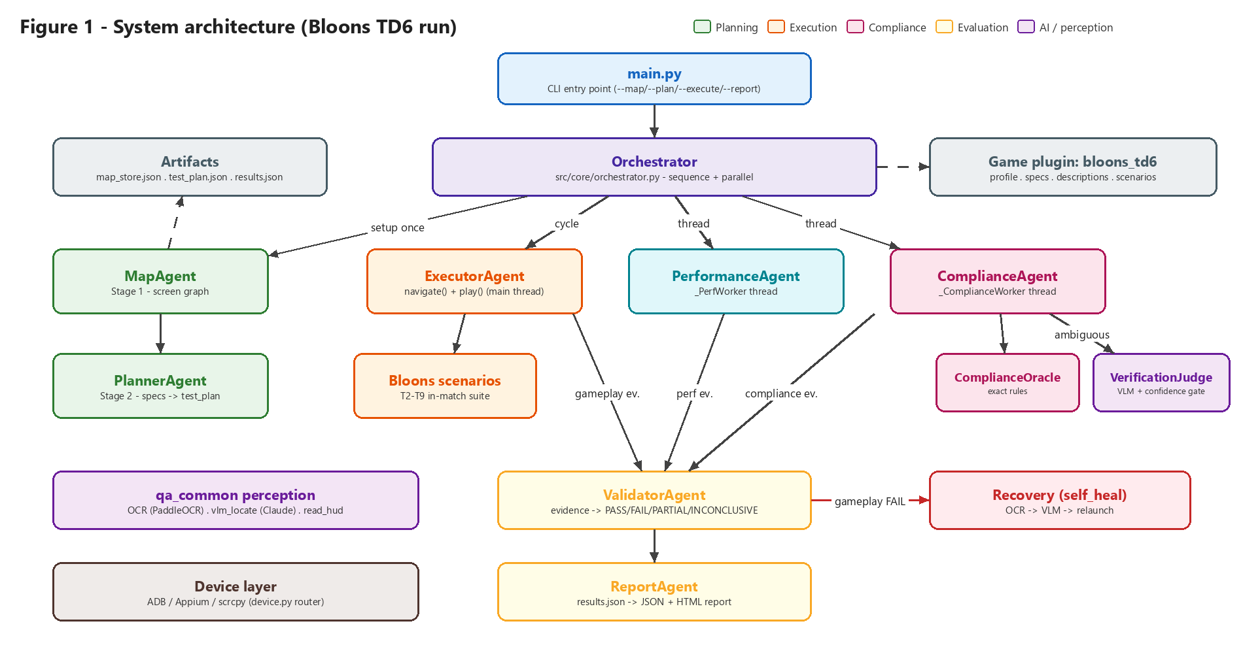
Figure 1 - Components involved in a Bloons TD6 run.

4.1 Layers
Table 8 - Architectural layers
Layer | Package / file | Responsibility
Entry point | main.py | Parses CLI flags, binds GAME_ID before imports, calls the orchestrator or a single stage.
Orchestration | src/core/orchestrator.py | Setup-once logic, parallel test cycle, retries, learning loop, report.
Agents | src/agents/** | Planning (Map, Planner), Execution (Executor, Performance, Recovery), Compliance, Evaluation (Validator, Report), Core (Vision, Decision, Oracle).
Engine | src/core/engine/ | VerificationJudge (AI half of compliance) and TestRunner (scoped plan runner).
Perception | src/core/qa_common.py | OCR, VLM locate, HUD reading, screen-change detection, popup handling, logging, result recording.
Game plugins | src/games/ | GameProfile base, registry, genre mix-ins, and the bloons_td6 plugin.
Models | src/models/ | MapStore graph, gameplay checks, objectives, shared descriptions.
Device | src/device/ | ADB / Appium router, perf sampling (dumpsys), fast scrcpy I/O.
RL | src/rl/ | Navigation MDP, tabular Q-learning, reward functions, RLDecisionAgent.

4.2 Resolve-once binding pattern
Two modules are bound once at import time from configuration, so the rest of the code never branches on them:
- src/device/device.py picks the device backend from EXECUTION_MODE (adb default, or appium) and re-exports tap, swipe, drag, screencap, launch_game, force_stop, etc.
- src/core/active_game.py resolves GAME = get_game(config.GAME_ID) from the plugin registry. For Bloons this is a BloonsTD6() instance. That is why main.py sets os.environ['GAME_ID'] before any agent import.

4.3 Repository map (Bloons-relevant files)
main.py CLI entry point
src/core/orchestrator.py setup + parallel cycle + recovery + learning loop
src/core/qa_common.py OCR / VLM / HUD / screen-change / popups / logging
src/core/config.py all tunables (env-overridable)
src/core/memory.py AgentMemory (per-step decision-loop memory)
src/core/active_game.py GAME = registry.get_game(GAME_ID)
src/core/engine/verification_judge.py AI compliance judge (confidence-gated)
src/core/engine/test_runner.py scoped TestCase runner (alternate path)
src/agents/planning/map_agent.py Stage 1 - MapAgent
src/agents/planning/planner_agent.py Stage 2 - PlannerAgent, RequirementSpec, TestCase
src/agents/execution/executor_agent.py Stage 3 - navigate(), play(), place_one()
src/agents/execution/performance_agent.py FPS / memory / CPU sampling
src/agents/execution/recovery_agent.py memory-driven RecoveryAgent (decision loop)
src/agents/compliance/compliance_agent.py routing: oracle -> judge -> human queue
src/agents/compliance/compliance_oracle.py deterministic compliance rules
src/agents/evaluation/validator_agent.py evidence -> verdicts
src/agents/evaluation/report_agent.py JSON + HTML report
src/agents/core/vision_agent.py VLM scene perception (JSON state)
src/agents/core/decision_agent.py LLM next-action policy (+ RL switch)
src/agents/core/oracle_agent.py mission verdict (victory/defeat/round)
src/games/bloons_td6/profile.py BloonsTD6(TowerDefenseMixin, GameProfile)
src/games/bloons_td6/specs.py 12 RequirementSpec
src/games/bloons_td6/descriptions.py natural-language VLM element prompts
src/games/bloons_td6/scenarios.py in-match test suite T2-T9
src/games/genres/tower_defense.py TD economy constants
src/models/map_store.py MapStore graph (nodes / edges / BFS)
src/rl/* MDP, Q-learning, reward, RL policy
data/seeds/bloons_seed.json golden path labels
data/maps/bloons_td6.json persisted MapStore graph
outputs/results/*.json map_store, test_plan, results
outputs/reports/ scan_report_<ts>.json / .html

5. Entry Point and Run Modes (main.py)
main.py is a thin wrapper. It prints a banner, parses arguments, sets GAME_ID, then either hands control to orchestrator.run() (default) or runs only the requested stages in order.
Table 9 - CLI modes
Command | What runs | Pre-condition / output
python main.py | Setup (only if new game) -> parallel cycle + recovery -> learning loop -> report | Exit 0 on success, 1 on failure
python main.py --force-setup | Same, but always re-runs MapAgent + PlannerAgent | Rebuilds map and plan
python main.py --execute-setup | Alias of --force-setup
python main.py --map | Stage 1 only: MapAgent().build_map() | Writes outputs/results/map_store.json
python main.py --plan | Stage 2 only: PlannerAgent().build_plan() | Needs map_store.json; writes test_plan.json
python main.py --execute | Stage 3 only: run_cycle_and_report(write_report=False) | Needs test_plan.json; writes results.json
python main.py --report | Stage 4 only: generate_report() | Needs results.json; writes reports
--game bloons_td6 | Selects the plugin (default bloons_td6 or $GAME_ID) | Must be registered

Granular flags can be combined, e.g. python main.py --map --plan runs Stage 1 then Stage 2 and stops at the first failing stage.

6. Orchestrated Multi-Agent Workflow
src/core/orchestrator.py is a custom orchestrator (not a generic agent framework): every stage and hand-off is explicit Python. It implements two phases - SETUP and TEST CYCLE.
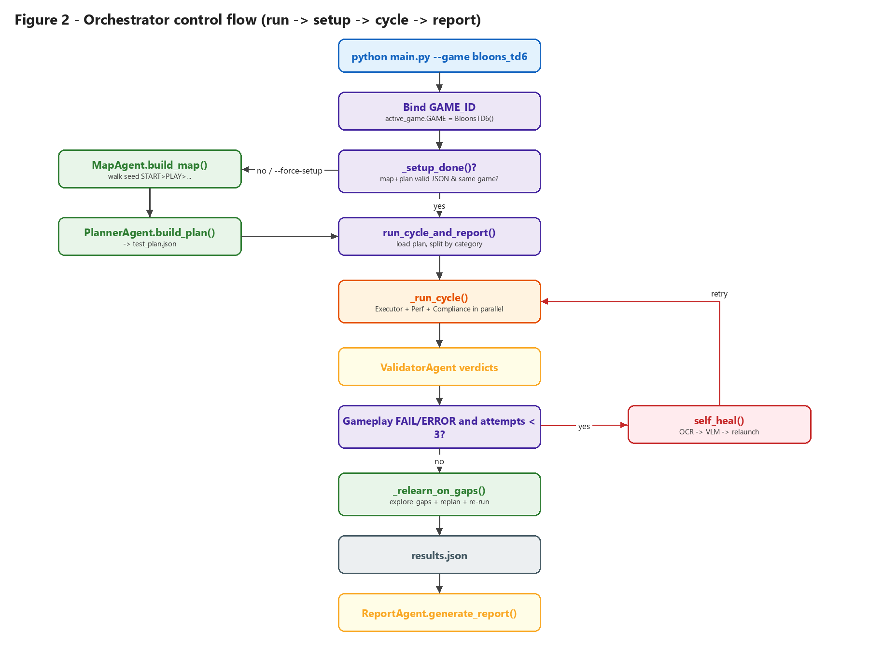
Figure 2 - Orchestrator control flow.

6.1 Phase 1 - Setup (once per new game)
setup(force) decides whether mapping and planning are needed by calling _setup_done(), which returns True only when all of the following hold:
- outputs/results/map_store.json and outputs/results/test_plan.json exist, are non-empty and parse as JSON (_valid_json_file) - a truncated file from an interrupted run counts as not done.
- The game_id/game recorded in both files matches the active game's id or display name. Switching from Minecraft to Bloons therefore forces a fresh setup automatically (logged as a *game switch*).
If setup is needed (or --force-setup), it runs MapAgent().build_map() then PlannerAgent().build_plan() and fails fast if either artefact is missing afterwards.

6.2 Phase 2 - Test cycle
run_cycle_and_report() performs these steps:
- Checks the Claude client is configured (client_ready()) and that test_plan.json is valid.
- Loads scenarios and splits them into gameplay_specs, comp_specs, perf_specs. Scenarios flagged needs_mapping are dropped unless they are compliance (compliance inspects whatever is on screen, so a map gap does not block it).
- Runs up to MAX_RECOVERY_ATTEMPTS (3) cycles. After each _run_cycle() it retries only when a gameplay verdict is FAIL or ERROR - performance and compliance verdicts are evidence-based and would not change on a blind retry. Between attempts it calls self_heal().
- Runs the continuous learning loop _relearn_on_gaps() (section 6.5).
- Writes outputs/results/results.json, logs a PASS/PARTIAL/FAIL/INCONCLUSIVE/ERROR summary and (in a full run) calls the ReportAgent.

6.3 Inside one cycle: _run_cycle()
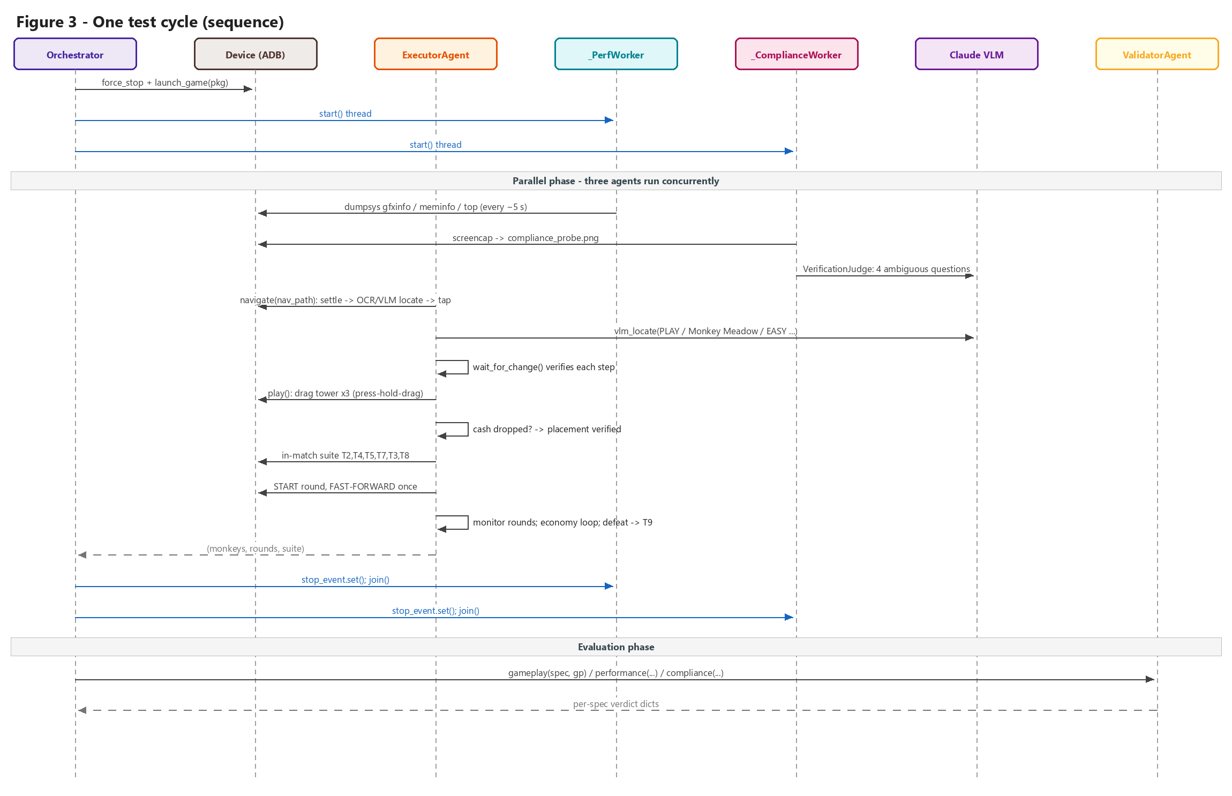
Figure 3 - Message sequence for a single Bloons test cycle.
Driver selection. One play() run satisfies all gameplay specs (enter match, cash change, round advance), so the orchestrator picks a single *driver* spec: the gameplay spec with the longest nav_path. If the driver has no nav_path, a failsafe loads it from the plugin's seed file (GAME.seed_file -> data/seeds/bloons_seed.json labels). The target round comes from driver.params.target_round (default 5; GMP-03 in specs.json sets 10).
Clean start. force_stop(GAME_PACKAGE) + launch_game(GAME_PACKAGE) + 3 s wait.
Parallel workers. Two daemon threads share a threading.Event stop flag; the interval is LOOP_SLEEP_SECONDS + 3 = 5 s.
Table 10 - Parallel worker threads
Worker | What it does every interval | Why it does not collide with the Executor
_PerfWorker | PerformanceAgent.sample('in_game') - FPS + jank from dumpsys gfxinfo framestats, PSS memory from dumpsys meminfo, CPU% from top | Reads adb dumpsys output only - no screenshots
_ComplianceWorker | Takes its own screenshot (compliance_probe.png), gets UI texts (uiautomator, fallback OCR), evaluates element_present checks, runs a fresh ComplianceAgent.inspect() and stores the latest evidence per spec under a lock | Separate image file from the Executor's current.png; fresh agent per pass so counts never inflate

Executor (main thread). navigate(driver['nav_path']) then, for turn-based games like Bloons, play(target_round) which returns (monkeys_placed, rounds_reached, suite_results). The orchestrator converts this to the gameplay evidence dict gp = {monkeys, rounds, target, reached_match, suite} where reached_match = solidly_in_match(). (Real-time runner games take a different branch that calls GAME.play() directly.) Any exception marks session_ok = False.
Join + validate. In a finally block the stop event is set and workers are joined (10 s / 15 s timeouts). Then the ValidatorAgent produces one verdict per spec, each stamped with start_time and end_time. A compliance spec that was never inspected gets INCONCLUSIVE.

6.4 Recovery: self_heal()
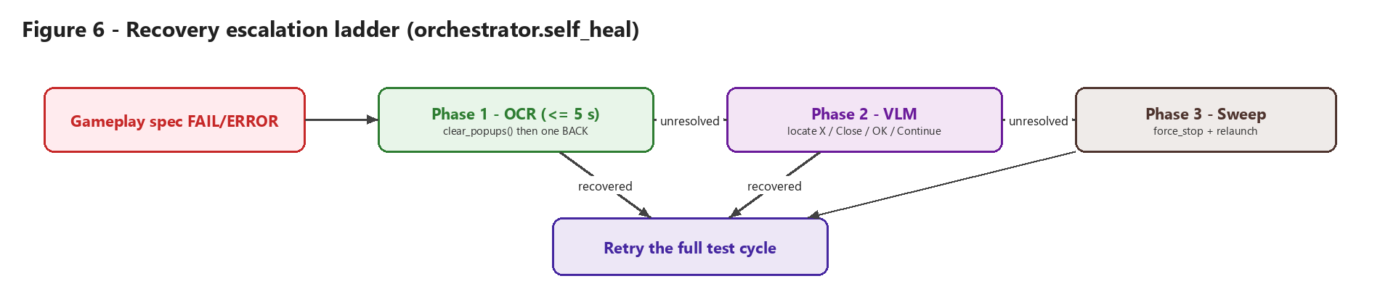
Figure 6 - Escalation ladder: cheap -> smart -> brute force.
Table 11 - self_heal phases
Phase | Mechanism | Budget / success test
1. OCR | clear_popups() (detects dialog-like token sets such as OK+CANCEL, 'claim reward', 'level up' and taps the affirmative button or screen centre), otherwise one Android BACK | ~5 s (HEAL_OCR_BUDGET_S); wait_for_change()
2. VLM | Ask Claude to locate 'a control that closes or dismisses a blocking dialog... X / Close / OK / Continue / No Thanks / Back' and tap it | Screen must change within 4 s
3. Sweep | force_stop + launch_game to a known clean state | Always ends the heal

6.5 Continuous learning loop: _relearn_on_gaps()
If any scenario in the plan was flagged needs_mapping, the orchestrator performs exactly one learning iteration (no re-map storms):
- MapAgent.explore_gaps() - targeted extension of the map (falls back to a full build_map() if it raises).
- PlannerAgent.build_plan() - replans against the extended map.
- Selects only scenarios whose id was a gap and is now routable, runs a mini _run_cycle() for them, and merges their fresh results into the original list (preserving order, appending new ids).

7. Agents in Detail
This section documents each agent: where it lives, its inputs and outputs, its algorithm and what it does specifically for Bloons TD6.
Table 12 - Agent catalogue
Agent | File | Phase | Model calls? | Role in one sentence
MapAgent | planning/map_agent.py | Setup | VLM (locate) | Walks the golden path and records the screen graph.
PlannerAgent | planning/planner_agent.py | Setup | Optional LLM | Converts requirements into routable scenarios.
ExecutorAgent | execution/executor_agent.py | Cycle (main) | VLM (locate) | Navigates into a match and plays it, verifying every action.
PerformanceAgent | execution/performance_agent.py | Cycle (thread) | No | Samples FPS, jank, memory, CPU, load times.
ComplianceAgent | compliance/compliance_agent.py | Cycle (thread) | Judge only | Routes compliance checks to rules, then AI, then humans.
ComplianceOracle | compliance/compliance_oracle.py | Cycle | No | Exact compliance rules over text and element data.
VerificationJudge | core/engine/verification_judge.py | Cycle | VLM | Answers 4 fixed visual questions with a confidence score.
ValidatorAgent | evaluation/validator_agent.py | After cycle | No | Turns evidence into verdicts.
Recovery (self_heal) | core/orchestrator.py | On failure | VLM (phase 2) | Unblocks the device before a retry.
RecoveryAgent | execution/recovery_agent.py | Decision loop | No | Memory-driven recovery for the per-step loop.
ReportAgent | evaluation/report_agent.py | End | No | Writes JSON + HTML scan reports.
VisionAgent | core/vision_agent.py | Decision loop / mapping | VLM | Describes the screen as structured JSON.
DecisionAgent | core/decision_agent.py | Decision loop | LLM | Chooses the next action from state + memory.
OracleAgent | core/oracle_agent.py | Decision loop | No | Mission verdict: victory, defeat, target round.
RLDecisionAgent | src/rl/rl_decision_agent.py | Decision loop (opt-in) | No (LLM fallback) | Q-table navigation policy.

7.1 MapAgent - Stage 1: Auto-Mapping
Purpose. Build a graph of the game's screens (nodes) and the taps that move between them (edges) so later stages can navigate anywhere without hardcoded scripts.
Inputs: seed labels (GAME.seed_file), live device. Outputs: outputs/results/map_store.json (flat schema for the executor/planner) and data/maps/bloons_td6.json (MapStore schema).
Algorithm - build_map():
- Load seed labels; force-stop and relaunch Bloons.
- For each seed step: _settle() (wait until the pixel hash is stable and no loading tokens are visible), clear any popup, save a screenshot, tag the scene (_tag_scene: in_game if solidly_in_match(), else difficulty_select, home, title or menu from OCR keywords), and record a node with id <scene>_<hash> plus the path taken to reach it.
- Locate the step's button with the OCR -> VLM -> OCR-fallback cascade (_locate). PLAY is special-cased to a VLM description of the big round green PLAY button (to avoid 'PLAY SOCIAL').
- Tap and verify with wait_for_change(); if unchanged, re-tap once and wait again; up to 3 attempts.
- Resume detection. If the step never becomes actionable, check whether any later seed step is visible (two consistent locates required). If so, the game skipped ahead (e.g. 'Continue saved game'), so the skipped labels are folded into the node path and mapping resumes there. If already in a match, the step is skipped. Otherwise a MapGap is recorded and the walk stops.
- After the loop, always record the final screen (even if OCR read nothing) - typically the live in_game node.
- Write the flat JSON and translate nodes/edges through MapStore.upsert_node/upsert_edge so the MapStore file is re-loadable.
explore_gaps(max_new_edges=15). For every known node, probe each actionable element not yet tried, observe the result and add a new node/edge with source='explore'. Used by the learning loop.
seed_from_walkthrough(). Alternate mode that replays recorded actions through an ExecutorAgent and a VisionAgent, recording each observed scene.

7.2 PlannerAgent - Stage 2: Test Planning
Purpose. Turn written requirements into a runnable plan where each scenario carries the navigation path to its target screen.
Requirement sources (first non-empty wins):
- GAME.build_requirements() - for Bloons, the 12 RequirementSpec objects in src/games/bloons_td6/specs.py. Each is converted to {id, requirement, category, target_scene, checks:[{type: check_fn, **check_args}]}.
- The plugin's specs_file JSON (for Bloons this is data/seeds/specs.json).
- The global SPECS_FILE.
Map source: data/maps/bloons_td6.json if present, else the flat map_store.json if it belongs to the same game.
Path resolution - _find_target_path():
- target_text: find a node whose OCR tokens contain the text and use its path; else find an edge whose label contains the text and use parent path + that label.
- target_scene: collect nodes whose scene/label equals the target and take the one with the longest path.
- No match -> empty path and needs_mapping = True (a MapGap).
Scenario output (outputs/results/test_plan.json):
{
"game": "Bloons TD 6", "game_id": "bloons_td6", "created_world": "",
"scenarios": [{
"id": "test_06_battle_speed_toggle",
"category": "gameplay",
"title": "Battle Speed Toggle",
"objective": "Drive the game to confirm: Battle Speed Toggle",
"nav_path": ["START", "PLAY", "Monkey Meadow", "EASY", "STANDARD"],
"target": {"scene": "in_round"},
"checks": [{"type": "assert_game_speed_multiplier_applied", "expected_multiplier": 3}],
"params": {}, "passes": 5, "needs_mapping": false
}]
}

With USE_LLM=1, _expand_with_llm() asks the model to rewrite vague requirements into a concrete objective and check list, constrained to the scenes and labels that exist in the map. The class also keeps the older plan() API that uses MapStore.path_to() (BFS) and writes data/plans/<game>_test_plan.json of TestCase objects.

7.3 ExecutorAgent - Stage 3: Navigate and Play
The executor module contains both a small ExecutorAgent class (dispatches DecisionAgent JSON actions: tap by label, wait, swipes, done) and the production functions navigate() and play() used by the orchestrator.

7.3.1 navigate(nav_path)
- For each step: _settle() (pixel-hash stability + loading wait up to 90 s), clear popups, screenshot.
- _parse_step() builds {name, ocr_label, desc} - preferring an element description from the plugin, else a generic "the '<name>' button or menu item".
- _locate() cascade: OCR exact/contains match on attempt 1 -> vlm_locate() -> OCR fallback.
- Tap, wait_for_change(timeout=10); re-tap once; up to 3 attempts.
- If a step fails but the next step is visible (two consistent locates) the step is treated as already passed; if it was the last step and solidly_in_match() is true, it is also satisfied. Otherwise navigation fails and returns False.

7.3.2 play(target_round) - the Bloons gameplay loop
- Settle and clear popups. If not solidly_in_match() (needs both round and cash readable on the HUD and not on a menu), look for an intermediate confirm/PLAY button (CONFIRM_PLAY_DESC, e.g. the difficulty rules card) and tap it. If still not in a match, return (0, 0, []) rather than hunting for tower icons that cannot exist.
- Place 3 Dart Monkeys with place_one() (Figure 5).
- If at least one tower was placed, run the in-match scenario suite (section 8.4) and capture its results by snapshotting qa_common._RESULTS before and after.
- start_and_fast_forward(): tap START (single play triangle), re-capture, then tap FAST-FORWARD (green double chevron) exactly once - it is a toggle and the game remembers the speed. Wait up to 40 s for the round counter to advance.
- Monitor loop with deadline max(360 s, rounds_to_go x 150 s): every 8 s screenshot, clear interstitials, check for defeat (OCR 'defeat'/'game over' -> run T9 Restart and stop), read round from HUD, engage FF if the first tap missed, tap START for the next round, and run the economy loop.
- Return (len(placed), last_round, suite_results).
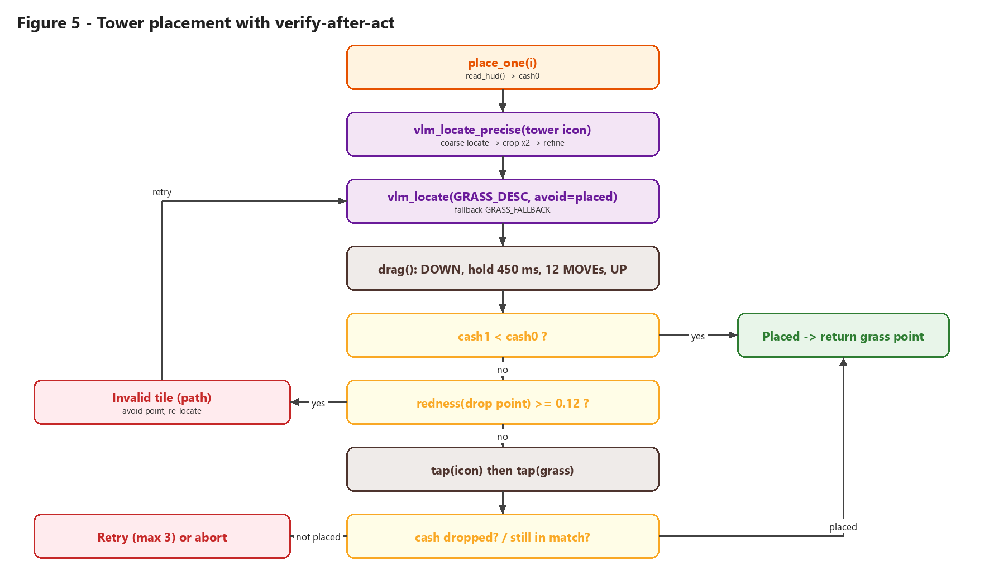
Figure 5 - place_one(): every buy is verified by the cash drop.

7.3.3 place_one() details
- Tower icon located with vlm_locate_precise(): a coarse locate, then an 820x560 crop around it upscaled 2x and re-located for pixel accuracy (small icons near the screen edge were otherwise ~250 px off).
- Grass located with GRASS_DESC (large open patch, ~120 px clearance from path, water, shop panel, HUD and existing towers), falling back to GRASS_FALLBACK. Already-placed points are passed as avoid so the VLM stays at least 150 px away.
- Primary gesture is a real press-and-hold drag through input motionevent (DOWN, hold 450 ms, 12 MOVE steps, UP, settle 1.2 s). Plain swipes are frequently ignored by Bloons.
- Ground truth is the HUD cash: placement counts only if cash_after < cash_before.
- Failure diagnosis: redness() of a 70 px box at the drop point >= 0.12 means the range circle turned red, i.e. an invalid tile (path); that point is avoided. Low redness means the gesture did not register, so a tap-select + tap-place fallback is tried.
- Aborts immediately if the match is lost or the battlefield is left.

7.3.4 Economy loop - _deploy_if_affordable()
Reinvests round income into more towers while len(placed) < MAX_MONKEYS (12) and cash >= DART_COST (170) + CASH_RESERVE (150). It rotates through the roster for variety and falls back to the Dart Monkey when the rotated tower is unaffordable or not found.
Table 13 - TOWER_ROSTER
Tower | Description key | Approx. cost
Dart Monkey | DART_DESC (brown monkey, ~$170, no padlock) | 170 (DART_COST)
Tack Shooter | TACK_DESC | 280
Bomb Shooter | BOMB_DESC | 350
Ice Monkey | ICE_DESC | 340

7.4 PerformanceAgent
Runs in _PerfWorker during play. Each sample(scene) records FPS, janky frames, memory MB, CPU % and a timestamp using src/device/perf_utils.py:
- FPS - parses dumpsys gfxinfo <pkg> framestats, sorts VSYNC timestamps, averages deltas, fps = 1e9 / avg_delta_ns; jank = deltas > 1.5 x 16.67 ms.
- Memory - TOTAL PSS from dumpsys meminfo <pkg> / 1024.
- CPU - the package line of top -n 1 -b.
summary() returns avg FPS, peak memory, load times and issues; status is FAIL if avg FPS < 30 (MIN_ACCEPTABLE_FPS), peak memory > 1024 MB, or any scene load > 8 s.

7.5 ComplianceAgent, ComplianceOracle and VerificationJudge
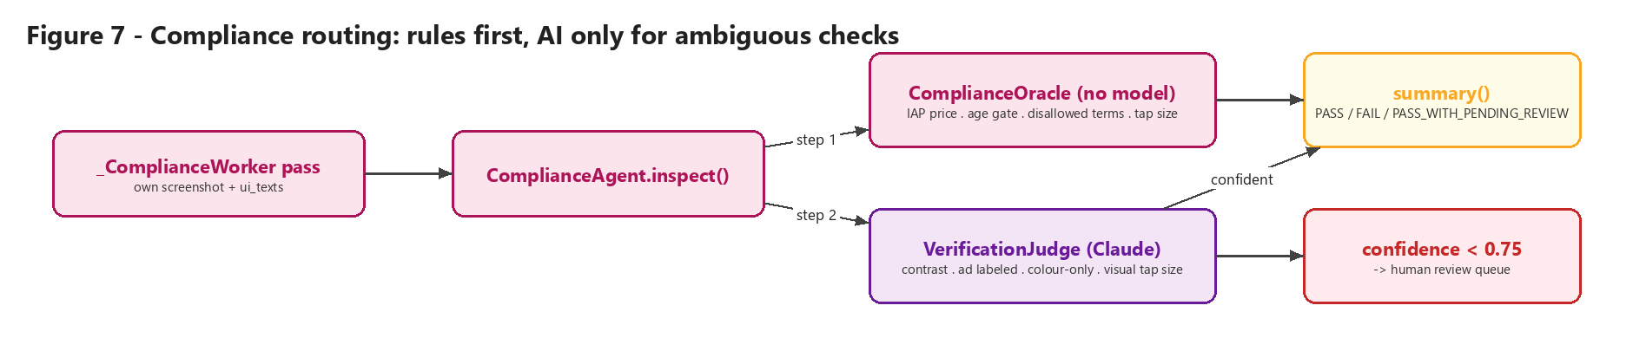
Figure 7 - Compliance routing.
Step 1 - ComplianceOracle (no model). Pure functions over UI text and element data:
Table 14 - Deterministic compliance rules
Check | Rule | Severity
compliance_01_iap_price_disclosure | On an IAP screen, some text matches [$EUR GBP JPY]\s?\d | high
compliance_02_age_gate_text | On an age gate, one of 'years old', 'date of birth', 'age rating' appears | high
compliance_03_splash_duration | Splash shown 1800-2200 ms (timestamps) | medium
compliance_04_disallowed_terms | No denylisted term on screen | high
compliance_05_tap_target_size | Every element with width/height is >= 48 px | medium

run_all_exact_checks() only runs rules that apply: IAP if the spec title mentions purchase/iap/price/buy; age gate if it mentions age/rating/splash; tap-target size always.
Step 2 - VerificationJudge (Claude). Only four registered questions are allowed (AMBIGUOUS_CHECK_REGISTRY); anything else raises an error so 'AI opinion' cannot silently grow:
- text_contrast_adequate - is body text readable against its background?
- ad_clearly_labeled - are ads distinguishable from gameplay?
- color_only_information - is essential info conveyed only by colour?
- tap_target_visual_size - do buttons look thumb-sized (used when no pixel boxes exist)?
The judge returns {verdict, confidence, reasoning}. If confidence < 0.75 the finding becomes needs_human_review and is queued, not counted. Parse failures are treated as confidence 0.
Step 3 - summary(). FAIL if any high-severity exact failure or confident judge failure; otherwise PASS; downgraded to PASS_WITH_PENDING_REVIEW if anything is queued for a human.

7.6 ValidatorAgent
Pure evaluation - no device and no model. Every verdict is {id, category, title, verdict, metrics, logs}.
Table 15 - Verdict rules
Category | Rule | Metrics
gameplay | FAIL if no live match reached (reached_match false and 0 monkeys and 0 rounds). Otherwise PASS ('reached live match and completed gameplay steps'). Suite-name matching (mc1-mc7) exists for Minecraft only; for Bloons the T-suite results are listed in logs only when the verdict is FAIL (see section 15). | monkeys_placed, rounds_reached, target
performance | no_crash check -> PASS iff the session completed. Otherwise INCONCLUSIVE if no FPS samples, FAIL if PerformanceAgent status is FAIL, else PASS. Issues copied to logs. | avg_fps, peak_memory_mb, samples
compliance | INCONCLUSIVE if never inspected. FAIL if any element_present text missing or summary FAIL. PARTIAL if a timing check exists (not measurable from one frame) or summary is PASS_WITH_PENDING_REVIEW. Otherwise PASS. | scene, exact_failed, pending_review

7.7 RecoveryAgent (decision-loop variant)
Separate from the orchestrator's self_heal(). Driven by AgentMemory: should_recover() is true when the same scene has been seen SAME_SCENE_RECOVERY_THRESHOLD (5) times in a row. recover() waits out loading screens, taps the first button of a reported blocking modal, taps 'OK' on dialogs, otherwise nudges the app with monkey -p <pkg> 1; after 3 failed attempts it force-stops and relaunches.

7.8 ReportAgent
Reads results.json plus test_plan.json and map_store.json. generate_json_report() writes outputs/reports/scan_report_<YYYYMMDD_HHMMSS>.json (game, model, totals per verdict, map coverage, per-result metrics/logs/duration). generate_report() also writes a self-contained, colour-coded HTML dashboard with summary cards and a results table. It can be regenerated any time with python main.py --report.

7.9 VisionAgent, DecisionAgent, OracleAgent and AgentMemory (per-step decision loop)
These agents form the open-ended *perceive -> decide -> act -> verify* loop ("Path A" in the RL design doc). The production orchestrator uses scripted navigate()/play() instead, so these are the extension point for LLM- or RL-driven exploration.
- VisionAgent.observe(screenshot, ui_texts) - never decides actions; returns JSON {scene, blocking_modal, resources{cash,lives,round}, actionable_elements[{label,kind,x,y,enabled}], confidence} with the scene enum built from the Bloons vocabulary. Unparseable output -> {scene: unknown, confidence: 0}.
- DecisionAgent.decide(state, memory) - never sees screenshots; receives mission, objective, state and the last 8 history entries, returns exactly one JSON action (tap/wait/swipe_*/done) with no coordinates. make_decision_policy() returns an RLDecisionAgent when USE_RL_POLICY is on and a Q-table exists.
- OracleAgent.verify(state) - PASS on victory or when GAME.is_goal_reached() (round >= 10), FAIL on defeat, otherwise RUNNING.
- ExecutorAgent.execute(decision, state) - maps the label in the decision to an element's x/y from the vision state and taps it.

7.9.1 AgentMemory (src/core/memory.py)
A dataclass holding the short-term working memory of the decision loop:
Table 16 - AgentMemory fields
Field | Default | Purpose
mission | "Reach Round 10 on Monkey Meadow" | Long-term goal passed to DecisionAgent
objective | "Launch Game" | Current sub-goal; set from GAME.objective_for_scene(scene) by src/models/objectives.py
scene / previous_scene | "unknown" | Current and last perceived scene
confidence | 0.0 | VisionAgent confidence for the current scene
history | [] | Last 50 {scene, decision} entries (FIFO); DecisionAgent sees the last 8
visited_scenes | [] | Unique scenes seen in order (coverage)
recovery_attempts | 0 | Incremented by RecoveryAgent; relaunch after 3
same_scene_count | 0 | Consecutive identical scenes - stuck detector (threshold 5) and RL stuck penalty
last_action | None | Most recent decision

update_scene(state) shifts scene -> previous_scene, stores the new scene/confidence, increments or resets same_scene_count, and appends unseen scenes to visited_scenes. log_decision(decision) sets last_action and appends to the bounded history.

8. The Bloons TD6 Game Plugin

8.1 Plugin system
Every game is a GameProfile subclass registered with @register (src/games/registry.py). GameProfile is genre-neutral (identity, mission, scene vocabulary, build_requirements(), optional hooks such as read_hud, is_defeat, on_main_menu, play, run_in_match_suite). Tower-defense concepts live in TowerDefenseMixin (genre='tower_defense', cheapest_unit_cost, cash_reserve, max_units).
@register
class BloonsTD6(TowerDefenseMixin, GameProfile):
game_id = "bloons_td6"
display_name = "Bloons TD 6"
package = config.GAME_PACKAGE # com.netflix.NGP.BloonsTDSix
mission_summary = "Reach Round 10 on Monkey Meadow"
goal = dict(config.MISSION)
scene_vocabulary = _BLOONS_SCENES
rl_goal_scene = config.RL_GOAL_SCENE # "in_game"

Table 17 - BloonsTD6 hooks
Hook | Bloons implementation
seed_file / specs_file | data/seeds/bloons_seed.json / data/seeds/specs.json (historical paths from config)
build_requirements() | BLOONS_REQUIREMENTS (12 specs)
element_descriptions() | dart, bomb, ice, tack, grass, grass_fallback, start_round, fast_forward, back, confirm_play
gameplay_check_registry() | GAMEPLAY_CHECK_REGISTRY from src/models/gameplay_checks.py
objective_for_scene() | Scene -> objective map (Table 2)
is_goal_reached(state) | resources.round >= 10
on_main_menu(png) | OCR blob contains Bloons menu words (heroes, legends, knowledge, play social, beginner ... continue saved game)
read_hud(png) | Inherited generic reader (section 9.3)
run_in_match_suite() | Delegates to scenarios.run_in_match_suite
play() | Wraps the executor's TD loop into a PlayResult

8.2 Requirements (specs.py)
Table 18 - Bloons RequirementSpec list
ID | Title | Cat. | Target screen | check_fn / args | AI judge
test_01 | Title Screen Navigation & Profile Handshake | GP | main_menu | assert_screen_reached_with_currency_visible {cash} | -
test_02 | Sidebar Carousel Navigation | GP | placement | assert_tower_panel_scroll_reveals_items {min 1} | Yes
test_03 | Drag-and-Drop Placement Validation | GP | placement | assert_tower_snapped_to_legal_tile {path, rock, occupied} | Yes
test_04 | Target Priority Adjustment | GP | tower_detail | assert_targeting_cycles_through_all_states {First, Last, Close, Strong} | -
test_05 | Upgrade Path Branching Logic | GP | tower_detail | assert_third_path_locks_after_threshold {3, tier 2} | -
test_06 | Battle Speed Toggle | GP | in_round | assert_game_speed_multiplier_applied {3} | -
test_07 | Cooldown Ability Synchronization | GP | in_round | assert_ability_cooldown_overlay_shown_after_use {hero} | -
test_08 | Micro-Management Re-Sell | GP | in_round | assert_cash_updates_after_sell_and_replace {same footprint} | -
test_09 | Defeat Modal Interaction | GP | defeat | assert_restart_reloads_map_with_full_health | -
test_10 | System Update Notification | GP | system_update_modal | assert_overlay_dismissed_and_run_resumes {10 s} | -
compliance_01 | IAP prompts show exact price | CMP | main_menu | assert_iap_modal_shows_price_text | -
performance_01 | In-round FPS above floor | PERF | in_round | assert_fps_above_threshold {30} | -

data/seeds/specs.json holds an alternative, simpler spec set (CMP-01 splash >= 2000 ms, CMP-02 Privacy link, PERF-01 fps >= 30, PERF-02 no crash in 10 min, GMP-01 enter Monkey Meadow, GMP-02 placing reduces cash, GMP-03 round advances, target_round 10). It is only used when build_requirements() returns nothing.

8.3 Natural-language element descriptions
src/games/bloons_td6/descriptions.py replaces coordinates with precise prompts. Each encodes what to pick and what to avoid, because those were the real mistakes observed:
Table 19 - VLM element prompts
Key | Essence of the description
DART_DESC | Cheapest UNLOCKED primary tower in the 2-column shop on the right; brown Dart Monkey ~$170; must have a price and no padlock; point on the artwork, not the price or panel margin.
BOMB / ICE / TACK | Cannon / frost monkey / spiked wooden tower; price shown, no padlock; point inside the icon tile.
GRASS_DESC | Large open green patch in the centre, ~120 px clear of path, water, shop panel, HUD and other monkeys.
GRASS_FALLBACK | Any clearly placeable grass not on path/water/panel/HUD/monkeys.
GREEN_DESC (START) | Rightmost bottom-right button with a SINGLE play triangle; ignore colour; not the double-chevron fast-forward; not found if a round is running.
FF_DESC | Green button with a DOUBLE chevron; explicitly not the yellow lightning-bolt and not the single-triangle START.
BACK_DESC | Curved / left arrow, usually top-left.
CONFIRM_PLAY_DESC | Green round PLAY on a difficulty rules card; return not-found if absent.

8.4 In-match scenario suite (scenarios.py)
Each scenario is defensive (missing precondition -> NOT_OBSERVED, exception -> FAIL), verify-after-act, and records via q.record(name, status, detail). Order matters: non-destructive tests first, sell/replace last.
Table 20 - In-match suite
Order | Scenario | Action | PASS criterion (observable outcome)
1 | T2 Sidebar Carousel | Swipe the shop list up 240 px, then restore | Screen signature changed (else NOT_OBSERVED)
2 | T4 Target Priority | Select placed tower, tap the '>' targeting arrow | OCR mode word changed (First/Last/Close/Strong)
3 | T5 Upgrade Branching | Tap an affordable upgrade; look for a padlock | Cash decreased (lock detection reported as info)
4 | T7 Hero Ability | If hero ability and a MOAB are both visible, tap ability | Screen changed (usually NOT_OBSERVED on Easy early rounds)
5 | T3 Drag-and-Drop Validity | Try to drop on the PATH, then on GRASS | Path drop: cash unchanged (rejected); grass drop: cash decreased
6 | T8 Sell & Replace | Sell placed tower, re-buy Dart in the same spot | Cash rose after sell and fell after replace
on defeat | T9 Defeat Modal | Tap Restart/Retry (VLM, then OCR) | HUD round readable again (map reloaded)

Note: T6 (speed toggle) is exercised by start_and_fast_forward() rather than the suite; T1 (title screen) and T10 (system update overlay) are covered by navigation and popup handling respectively.

9. Shared Perception and Action Layer (qa_common.py)

9.1 OCR
ocr_all(png) runs PaddleOCR and returns [{text, score, x, y}] (centre of each text box). Results are cached by (path, mtime) because the same frame is OCR'd many times per step and CPU OCR can take seconds. find_text() does an exact match first, then a guarded contains match (>= 4 chars). clean_tokens() filters and caps tokens for signatures and scene tagging.

9.2 VLM localisation
- vlm_locate(png, description, avoid) sends the PNG (base64) and description to Claude via the Anthropic Messages API with a strict system prompt (return only {found,x,y} centre pixel; prefer a best-effort guess over refusing because every result is verified). Up to 5 attempts; rejects invalid JSON, out-of-image points, points within 140 px of failures and points within 25 px of the border; previous failures are fed back as 'stay 150 px away'. Each call runs on a 4-worker thread pool with a 60 s hard timeout.
- vlm_locate_precise() adds the crop-and-zoom refine step for small targets.
- ask_llm() / _extract_json() are used by the optional LLM plan expansion.

9.3 HUD reading
read_hud() dispatches to GAME.read_hud() (generic for Bloons). Cash is the right-most bare 2-6 digit number inside the top-left HUD strip (x < 35 % width, y < 18 % height) - the wallet has a coin icon, not a '$', and shop prices must be excluded. Round is an N/M pattern with M >= 20 in the top strip. OCR's common 'O' for '0' confusion is fixed when adjacent to digits.

9.4 Screen-change detection
screen_signature() = (OCR token set, 64-bit average pixel hash). screen_changed() is true if >= 2 tokens differ or the hash Hamming distance >= 6. wait_for_change() polls (pixel-hash only) until a change holds steady for 2 reads. This dual signal catches navigation even when the cartoon font defeats OCR.

9.5 Match-state and popups
- in_match() - round readable and not on a menu; solidly_in_match() additionally needs cash.
- is_loading(tokens) - loading/tip keywords.
- clear_popups(goal) - only acts if _looks_like_dialog() (affirm+negative pair, 'claim reward', 'free gift', 'overwrite', 'are you sure', 'level up', 'new hero', 'unlocked'); taps OK/YES/CONFIRM/... via OCR or the screen centre for button-less interstitials; up to 4 rounds.
- redness(png, x, y) - fraction of strongly red pixels around a point (invalid-placement signal).
- log(), save_shot(), record(), results_summary() - timestamped run log in outputs/logs/run_<ts>.log with a screenshot per step.

10. Device Layer
Table 21 - Device primitives
Function | ADB implementation
screencap(path) | adb exec-out screencap -p -> PNG file
get_ui_texts() | uiautomator dump -> visible text list
launch_game(pkg) | am start -n pkg/activity if GAME_ACTIVITY set, else monkey -p pkg 1; waits 5 s
force_stop(pkg) | am force-stop pkg
tap(x, y) | input tap x y + 1.2 s
swipe(...) | input swipe x1 y1 x2 y2 ms
drag(...) | input motionevent DOWN/MOVE/UP with hold (API >= 26), else input swipe
back() | input keyevent 4

EXECUTION_MODE=appium swaps in src/device/appium_utils.py with an identical surface. fast_io.py (scrcpy) is used by the real-time Subway Surfers plugin, not by Bloons. The ADB path is resolved from ADB_PATH, PATH, or common SDK folders; DEVICE_SERIAL selects a device.

11. Data Artefacts
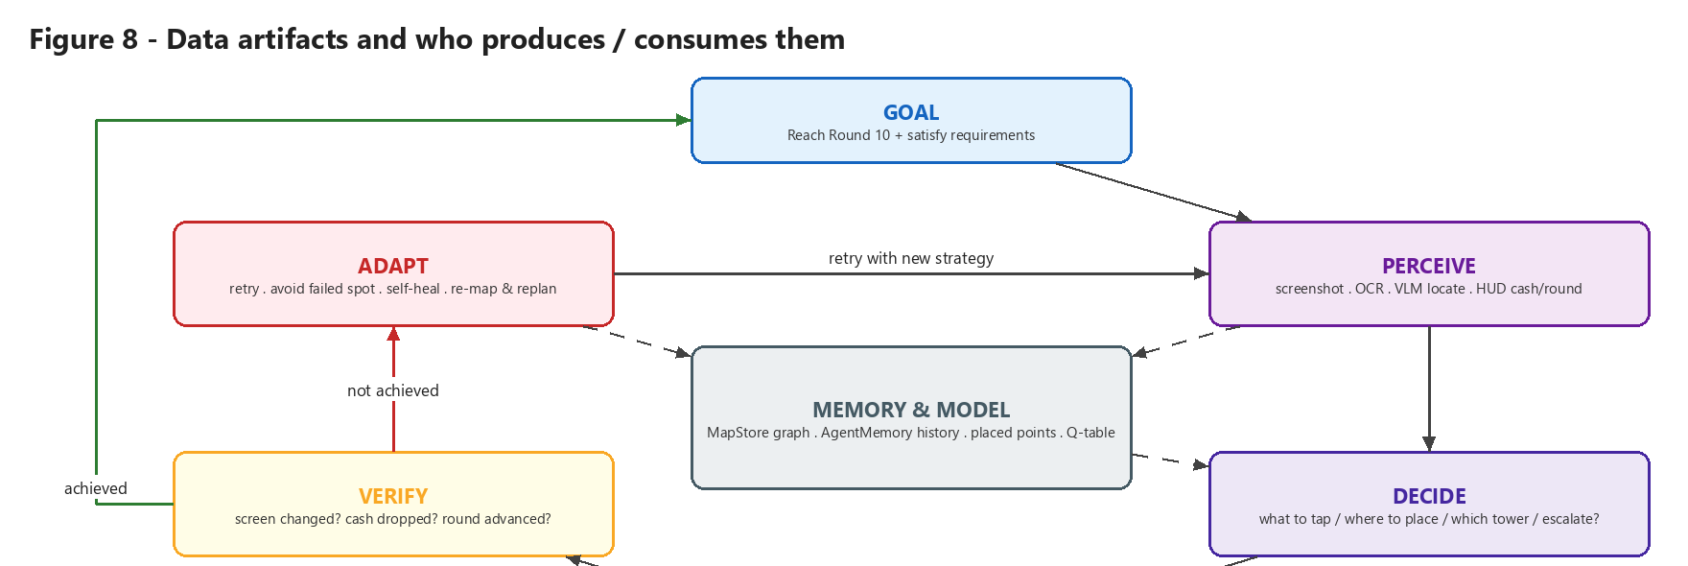
Figure 8 - Producers and consumers of each artefact.
Table 22 - Artefacts
File | Producer | Consumer | Content
data/seeds/bloons_seed.json | Human | MapAgent, orchestrator failsafe | Golden-path labels
outputs/results/map_store.json | MapAgent | Planner, setup check, ReportAgent | Flat graph: game, package, root, nodes{scene,tokens,path,elements}, edges{from,label,to}, gaps
data/maps/bloons_td6.json | MapAgent via MapStore | Planner, RL | ScreenNode / TransitionEdge (13 nodes, 12 edges, 5 labels)
outputs/results/test_plan.json | PlannerAgent | Orchestrator, ReportAgent | Scenarios with nav_path, target, checks, needs_mapping
outputs/results/results.json | Orchestrator | ReportAgent | Verdict list with metrics, logs, start/end time
outputs/reports/scan_report_*.json|.html | ReportAgent | Humans / CI | Summary + per-test table
outputs/logs/*.png, run_*.log | qa_common | Debugging | Screenshots per step and full run log
outputs/rl/bloons_td6_qtable.json | src/rl/train.py | RLDecisionAgent | 5x5 Q-table, gamma 0.95

Example result entry:
{
"id": "performance_01_in_round_fps_floor", "category": "performance",
"title": "In-round FPS stays above floor during a full wave",
"verdict": "PASS",
"metrics": {"avg_fps": 58.7, "peak_memory_mb": 612.4, "samples": 41},
"logs": [],
"start_time": "2026-10-27T15:02:11", "end_time": "2026-10-27T15:14:40"
}

11.1 MapStore API
- upsert_node(screen_id, label, ui_texts, actionable_elements, is_terminal, tags) - creates or updates (seen_count, last_seen, texts, tags).
- upsert_edge(from, action, to, source) - deduplicates by (from, to, action type, target) and increments seen_count.
- path_to(target, start='main_menu') - BFS shortest path over edges; None = MapGap.
- coverage_summary() - screens, edges, terminal screens, unexplored targets.
- Corrupt/empty files load as an empty map rather than crashing.

12. Reinforcement Learning Subsystem
Because the MapStore graph is effectively a tabular MDP, a navigation policy can be trained offline with no device and no API cost.
Table 23 - Navigation MDP
MDP element | Bloons instance
States | Logical screens (nodes collapsed by label): title, home, menu, difficulty_select, in_game
Actions | Normalised taps: START, PLAY, MONKEY MEADOW, EASY, STANDARD
Transitions | T(s'|s,a) proportional to edge seen_count (the graph is genuinely stochastic)
Reward | +1.0 on reaching in_game, -0.01 per step (NavigationReward)
Algorithm | Tabular Q-learning: alpha 0.5, gamma 0.95, epsilon 1.0 -> 0.02 (x0.995/episode), random tie-break; validated against value iteration
Result (per docs) | Mean 5.33 taps to in_game, 99.9 % success - equal to the value-iteration optimum

GameplayReward (roadmap) shapes in-match learning: +/-1 for victory/defeat (OracleAgent), +0.20 per round advanced, +0.05 per verified placement, +0.01 progress, -0.10 stuck past 5 same scenes, -0.10 for low FPS or memory over budget, -0.01 per step.
python -m src.rl.train --game bloons_td6 --episodes 5000 # train offline
python scripts/rl_navigate.py --game bloons_td6 # drive the device with the Q-table
set USE_RL_POLICY=1 # make DecisionAgent use RL (LLM fallback)

13. Configuration Reference
All values come from src/core/config.py and can be overridden with environment variables or a .env file (loaded by python-dotenv). Never commit a real LLM_API_KEY.
Table 24 - Configuration
Variable | Default | Effect
GAME_ID | bloons_td6 | Active plugin
GAME_PACKAGE / GAME_ACTIVITY | com.netflix.NGP.BloonsTDSix / '' | App to launch/stop
EXECUTION_MODE | adb | adb | appium
ADB_PATH / DEVICE_SERIAL | auto / '' | adb binary and target device
LLM_API_KEY | '' | Anthropic key (required for VLM)
LLM_BASE_URL | https://api.anthropic.com/v1 | Trailing /v1 is stripped automatically
VISION_MODEL / DECIDER_MODEL | claude-opus-4-8 | Model for locate / judge / decide
SEED_FILE / SPECS_FILE | data/seeds/bloons_seed.json / specs.json | Golden path / fallback specs
DART_COST / CASH_RESERVE / MAX_MONKEYS | 170 / 150 / 12 | Economy loop
PLAY_MINUTES | 10 | Play budget (informational)
SAME_SCENE_RECOVERY_THRESHOLD | 5 | Stuck detection
MAX_RECOVERY_ATTEMPTS | 3 | Cycle retries / RecoveryAgent relaunch
LOOP_SLEEP_SECONDS | 2 | Worker interval = this + 3
MIN_ACCEPTABLE_FPS / MAX_ACCEPTABLE_MEMORY_MB / MAX_ACCEPTABLE_LOAD_SECONDS | 30 / 1024 / 8.0 | Performance thresholds
MIN_TAP_TARGET_PX / MIN_TEXT_CONTRAST_RATIO | 48 / 4.5 | Accessibility thresholds
USE_RL_POLICY / RL_POLICY_FILE / RL_GOAL_SCENE | off / auto / in_game | RL switch
USE_LLM | unset | =1 enables LLM plan expansion
REPORT_DIR / MAPS_DIR / PLANS_DIR / LOG_DIR | outputs/reports, data/maps, data/plans, outputs/logs | Output folders

14. How to Run a Bloons TD6 Test
- Install Python 3.11+, Android platform-tools (adb) and connect a device/emulator with USB debugging and Bloons TD6 (Netflix) installed and signed in.
- python -m venv venv then venv\Scripts\activate and pip install -r requirements.txt.
- Create .env with LLM_API_KEY=..., GAME_ID=bloons_td6, EXECUTION_MODE=adb.
- Check the device: adb devices.
- First run (maps + plans + tests + report): python main.py --game bloons_td6.
- Subsequent runs skip setup automatically; force it with python main.py --force-setup.
- Open the newest outputs/reports/scan_report_*.html; inspect outputs/logs/ screenshots for evidence.
Useful utilities: python -m scripts.check_drag (gesture calibration), python -m scripts.bench_fast_io (capture FPS), python scripts/map_and_plan.py seed|plan --game bloons_td6, python scripts/run_plan.py --game bloons_td6.

14.1 Automated tests
python -m pytest tests/ -v runs offline tests that need no device:
Table 25 - Test suite
Test file | Covers
test_map_and_plan.py | Map graph generation, BFS routing, planner
test_compliance_split.py | Oracle rules, judge registry and confidence gating
test_runner_dispatch.py / test_runner_genre.py | TestRunner dispatch and genre handling
test_registry.py | Plugin registration and lookup
test_rl.py | MDP construction and Q-learning convergence
test_drag_contract.py / test_subway_perception.py | Gesture contract and fast-I/O perception
smoke_test.py / test_api.py | Environment and API smoke checks

15. Code Review Observations and Known Gaps
The following were found while tracing the Bloons path through the code. They do not stop a run but explain behaviour that may otherwise look surprising.
Known issue: Scene vocabulary mismatch. Bloons RequirementSpec.target_screen values (main_menu, placement, in_round, tower_detail ...) do not match the labels the MapAgent writes (title, home, menu, difficulty_select, in_game). Simulating _find_target_path() against the committed data/maps/bloons_td6.json returns no match for all 12 specs, so every scenario is planned with needs_mapping: true. The orchestrator then drops the gameplay and performance specs from the main cycle (compliance still runs), and the learning loop re-maps with the same tagging, so they stay unresolved. Fix: align the two vocabularies (e.g. map placement/in_round to in_game, main_menu to home) or use the scene names from specs.json (in_game).

Important: Fuzzy description matching in navigate(). _parse_step() matches a step name if it is a substring of an element-description key. The seed step START therefore matches start_round (the in-match START ROUND button) and PLAY matches confirm_play. The OCR-first attempt usually still finds the correct text, but VLM attempts search for the wrong element. Use exact key matches or a dedicated navigation-description map.

Important: Dead Bloons fallback. The special-case for PLAY in executor_agent._parse_step() checks game_id == 'bloons_td_6', but the id is bloons_td6, so it never fires. (MapAgent's own _parse_step does apply the correct PLAY description.)

Important: play() indirection. executor_agent.play() first calls GAME.play(target_round=...). BloonsTD6.play(self, ctx=None) does not accept target_round, so a TypeError is caught and logged ('GAME.play error') and the built-in TD loop runs. The outcome is correct, but if the signature were fixed the two functions would recurse into each other. Make one of them the single source of truth.

Important: Bloons suite results are not mapped to specs. ValidatorAgent.gameplay() only maps suite entries to specs for Minecraft names (mc1-mc7). For Bloons, every gameplay spec gets PASS once a live match is reached, even if a T-scenario failed; _apply_suite() (which would downgrade to PARTIAL) is defined but not called. Add a T2-T9 -> test_0N mapping and call _apply_suite().

Note: Load-time tracking unused. PerformanceAgent.mark_load_start/end are never called by the orchestrator, so the '> 8 s load' rule and splash-timing compliance cannot fire; timing checks are reported as PARTIAL.

Note: Two decision paths. AgentMemory, VisionAgent, DecisionAgent, OracleAgent, RecoveryAgent and TestRunner form a complete per-step loop that the default main.py path does not use. They are the extension point for LLM/RL-driven exploration.

16. Glossary
Table 26 - Glossary
Term | Meaning
VLM | Vision-Language Model - here Anthropic Claude, used to locate UI elements from a description and to judge visual compliance.
OCR | Optical Character Recognition (PaddleOCR) - reads on-screen text cheaply and deterministically.
MapStore | Persistent per-game graph of screens and transitions.
MapGap | A requirement whose target screen has no known route in the map.
Golden path | Seed list of labels from launch to a live match.
Verify-after-act | Accept an action only after an observable outcome (screen change, cash, round).
HUD | Heads-up display - the in-match lives / cash / round strip.
MOAB | Massive Ornary Air Blimp - a large Bloons enemy used by T7.
PASS_WITH_PENDING_REVIEW | Compliance status when nothing failed but low-confidence judge findings await a human.
INCONCLUSIVE | Evidence was not collected (e.g. no FPS samples, screen never inspected).
PARTIAL | Passed what could be measured but something remains pending.
Q-learning | Model-free RL algorithm that learns action values Q(s,a) from experience.

