1. What are the two values of the Boolean data type? How do you write them?

A) The two values of Boolean data type are true and false. In normal coding we write is as

boolean a = true;(in java)

a = true(in python)

2. What are the three different types of Boolean operators?

A) The three different types of Boolean operators are :-

1. and

2. or

3. not

3. Make a list of each Boolean operator's truth tables (i.e. every possible combination of Boolean values for the operator and what it evaluate ).

A)

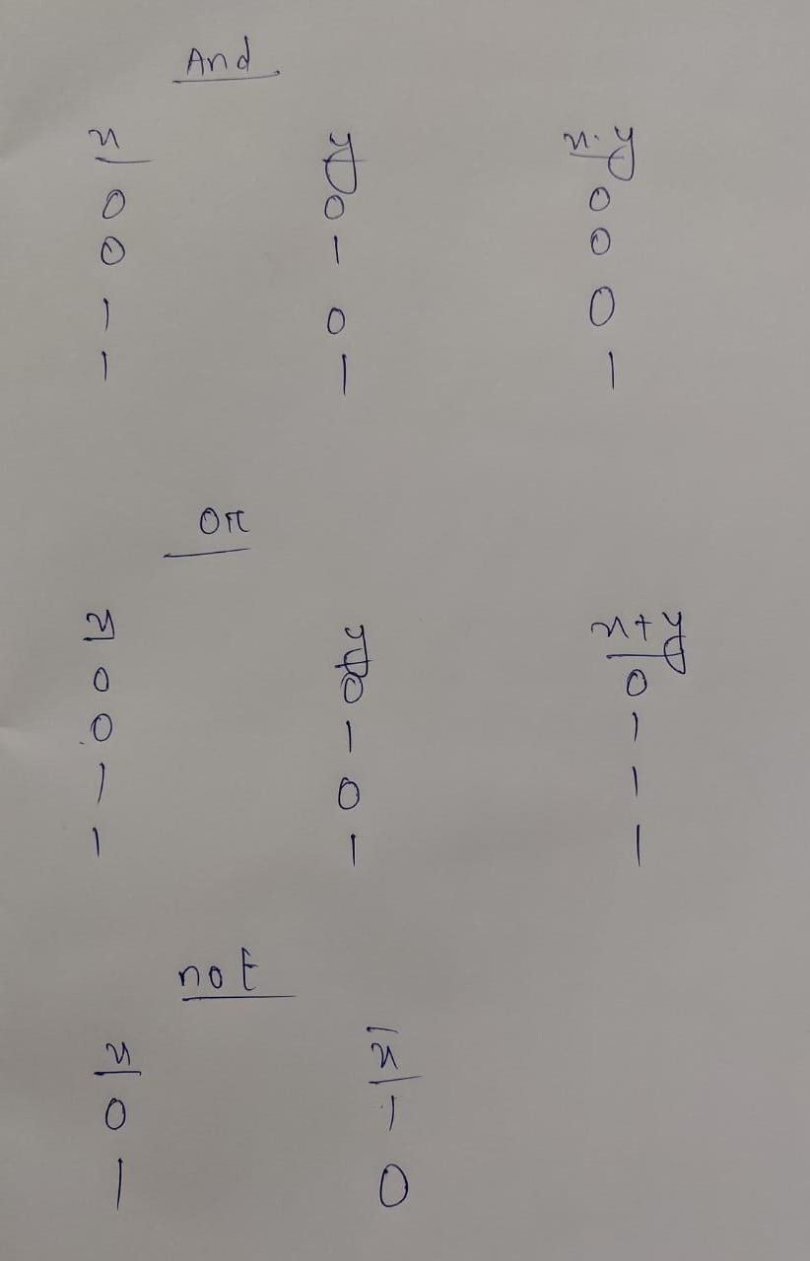4. What are the values of the following expressions?

(5 > 4) and (3 == 5)

:- false

not (5 > 4)

:- false

(5 > 4) or (3 == 5)

:- true

not ((5 > 4) or (3 == 5))

:- false

(True and True) and (True == False)

:- false

(not False) or (not True)

:- true

5. What are the six comparison operators?

A) The six comparison operators are equal to(==), not equal to(!=), greater than(>), greater than or equal to(>=), less than(<), less than or equal to(<=)

6. How do you tell the difference between the equal to and assignment operators?Describe a condition and when you would use one.

A) Equal to is to compare between two operands(any kind of value which is comparable with the other one) while the assignment operator is used to assign the values to the operands(variables)

Suppose i is an iterator in a loop and the objectives is to find the even numbers and no of even nos upto 10.

int c=0;

for(i=0;i<11;i++){

if(i%2==0)/\*here equal to operator is being used to check if the rhs is equals to lhs, and if the condition is true then it will go inside the if block \*/

c=c+1; //here we have used the assignment operator to the rhs value inside the lhs variable

7. Identify the three blocks in this code:

spam = 0

{if spam == 10:

print('eggs')}//1st block

{if spam > 5:

print('bacon')}//2nd block

{else:

print('ham')}//3rd block

print('spam')

print('spam')

I have used ‘{}’ symbols to identify the blocks

8. Write code that prints Hello if 1 is stored in spam, prints Howdy if 2 is stored in spam, and prints Greetings! if anything else is stored in spam.

A)

spam =int(input(“Enter the number :”)

if(spam==1):

print(“Hello”)

elif spam==2:

print(“Howdy”)

else:

print(“Greetings!”)

9.If your programme is stuck in an endless loop, what keys you’ll press?

A) Ctrl + C

10. How can you tell the difference between break and continue?

A) break statement stops the entire process of the loop and continue statement only stops the current iteration of the loop.

11. In a for loop, what is the difference between range(10), range(0, 10), and range(0, 10, 1)?

A) There is no difference among all the three types. All the three performs the same task.

12. Write a short program that prints the numbers 1 to 10 using a for loop. Then write an equivalent program that prints the numbers 1 to 10 using a while loop.

A) For loop :-

for i in range(11):

print(i)

While loop :-

I=0

while(I<11){

print(I)

I++

}

13. If you had a function named bacon() inside a module named spam, how would you call it after importing spam?

A)

Import spam as sp

def bacon():

pass #codes to be written inside the function

bacon()