Installing/starting Mongo
https://docs.mongodb.com/manual/tutorial/install-mongodb-on-windows/

Java Connecting to Mongo
http://www.codejava.net/java-se/jdbc/java-connecting-to-mongodb-database-examples

Added External Jar in IntelliJ

[File->ProjectStructure->Dependencies Add jar ]

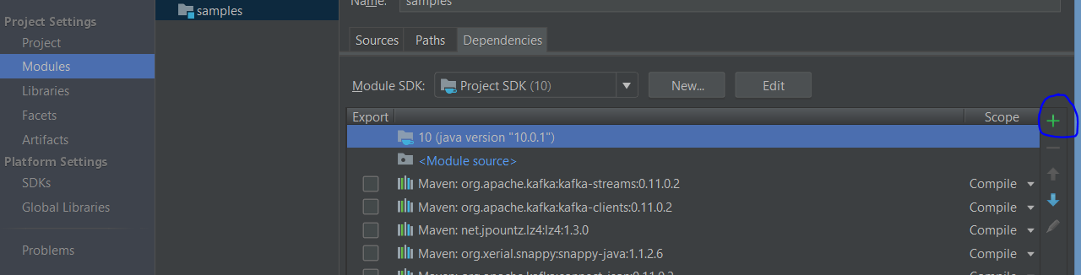

Install Robo 3T which is one of the GUI for Mongo

1)Create MongoDB database
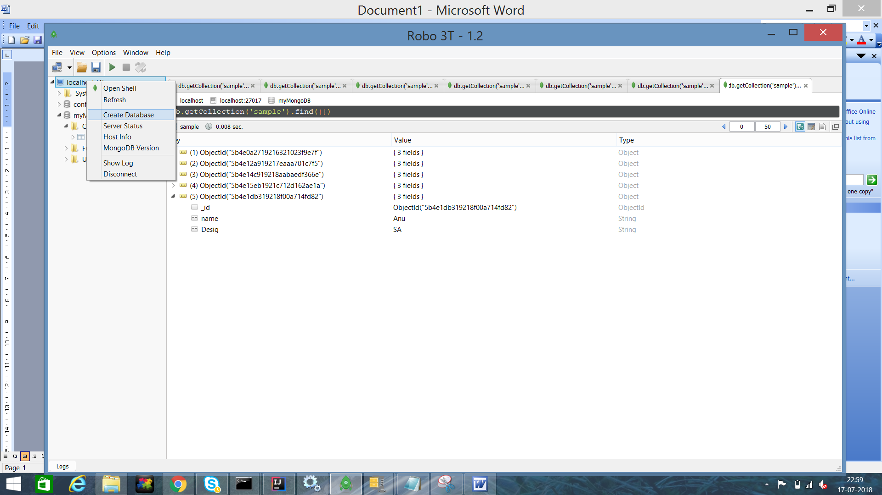

2)Create Collection

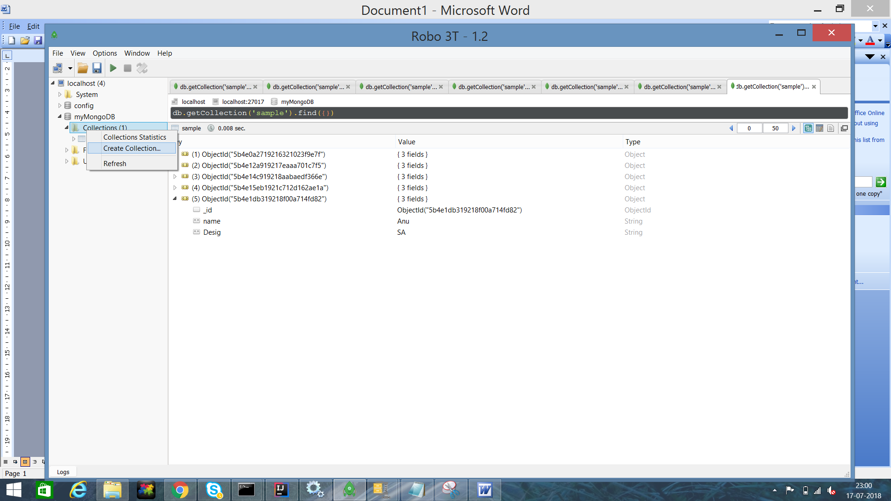

Display Records in MongoDB

