Readme / Documentation

Box Model (2D) on marine Carbon Disulfide (BM2D – CS2)

by Sinikka Lennartz

version: 1.0, December 2020

1. **General remarks**

The model is similar to the CS2-model as described in (Lennartz et al., 2019), but is applied here to a global grid of the surface ocean, similar to the approach in (Lennartz et al., 2017). It is a two-dimensional model of the surface ocean, simulating the photochemical production and degradation (unknown sink process) and air-sea exchange of carbon disulfide. Each box in the model grid is considered with variable depth depending on the mixed layer depth in each particular location, so that the light penetration for photoproduction can be calculated accordingly. The boxes do not exchange water horizontally (no transport considered!). Note that the model calculates CS2 in nanomoles per litres, so divide by 1000 to get to picomolar concentrations. If you use this model, please cite (Lennartz et al., 2020), if you find bugs, please let me know - sinikka.lennartz[at]uni-oldenburg.de

1. **Model overview**

The following flow chart illustrates the input data (left) needed for the respective processes (photoproduction, chemical sink, air-sea exchange) and the final prognostic/state-variable: CS2 concentration in the mixed layer (average, assuming a fully mixed mixed layer).

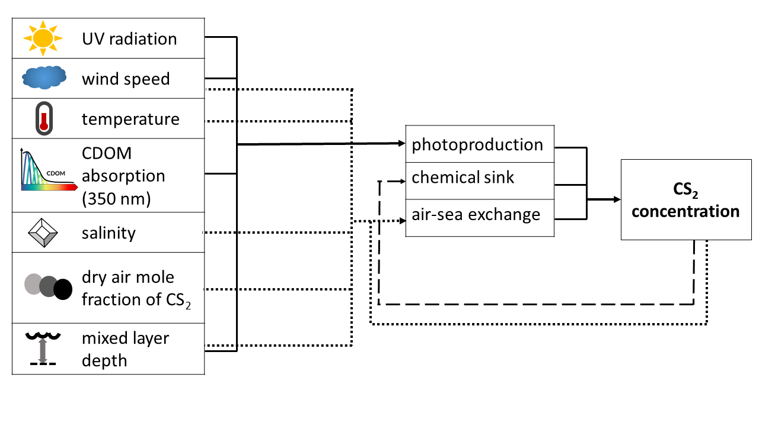

1. **Usage**

* Download the model code into your working folder: the code files should all be in the same directory, and the data should be in a subdirectory called “data”.
* Make sure the current folder and its subfolders are added to the Matlab path (or set the current directory to the directory with the model code)
* Add the forcing data to the subdirectory: either give the files the default names as they appear in the function “loadin.m”, or adjust the “loadin.m” file accordingly. The format of the data should be the following
  + Climatological data (cair – air mixing ratio, lat – latitude, lon - longitude, MLD – mixed layer depth, sal – salinity): dimensions lat x lon x month, all in main “data” folder
  + Monthly resolved data (ACDOM350): dimensions lat x lon x month
  + Monthly resolved data with diel cycle (data point every 2 hr - , press – pressure, sst – sea surface temperature, wind – wind speed, ssrd – short wave downwelling radiation): lat x lon x timeofday x month
  + Note that all input data need to have the same spatial format, and currently, the T42 grid (64x128) is hardcoded. Changes on this would need several changes in init2D_interp.m, calcphotoproduction.m and potentially some others.
* Set parameters: you can set the parameters for the scaling factor of the photoproduction rate constant (between 0 and 1), the air-sea exchange parameterization, the Henry constant and its temperature dependency. This can be done in the main file “BMCS2mainloop_alone.m” (the “alone” refers to the standalone version, there exists an inverse set-up as well which is not part of this release as it is not available in a global configuration – contact me if interested).
* Set initialisation year and month in “BMCS2mainloop_alone.m”: this needs to be done as “inityear=”, also “endyear=” to define the last year considered
* Set initial condition in “init2D_interp.m” (search in file for “Initial conditions”). Default is 8 pmol/L.
* Run the main script BMCS2mainloop_alone.m

1. **List of functions**

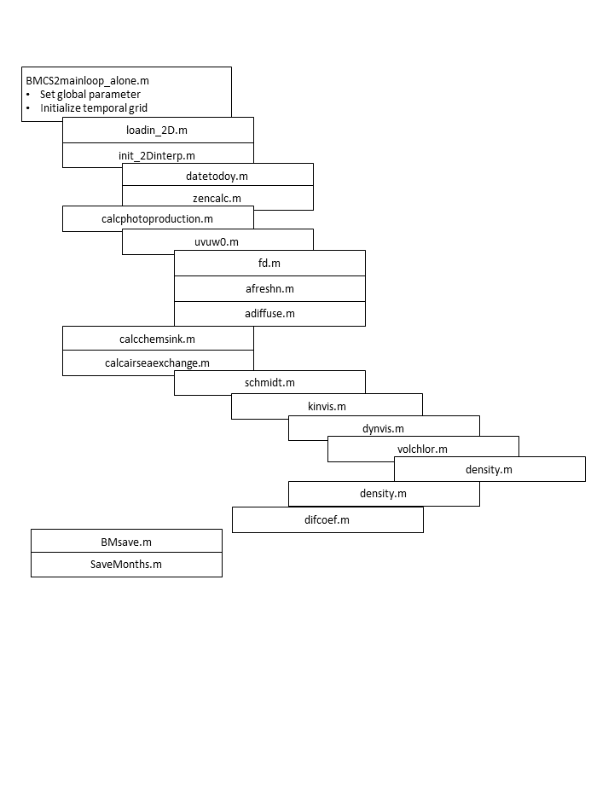

|  |  |
| --- | --- |
| BMCS2mainloop_alone.m | Main loop for box model, run this script which calls all other functions |
| Initialisation | |
| loadin_2D.m | loads the forcing data, i.e. air mixing ratio, latitude, longitude, mixed layer depth, salinity, acdom350, pressure, sea surface temperature, wind speed, shortwave radiation, substitutes filling values |
| init_2Dinterp.m | Interpolates to model grid (only temporally, not –yet- spatially!) |
| Main functions for processes | |
| calcphotoproduction.m | Calculates photochemical production of OCS in seawater, based on the light field (under the surface, attenuated at wavelength 350nm). The photoproduction rate constant is scaled with an empirical function using the absorption coefficient of CDOM at 350nm. This photoproduction rate is then converted with a factor to the photoproduction rate of CS2 (this is done in the mainloop) |
| calcchemsink.m | Calculates a first order chemical loss process – set reaction rate constant here |
| calcairseaexchange.m | Calculates air sea exchange based on equilibrium concentration, air mixing ratio and a parameterization for transfer velocity based on wind speed. Choice between three wind speed parameterizations, i.e. Wanninkhof 1992, Nightingale 2000 and Ho, 2006 |
| Helper-functions | |
| datetodoy.m | Calculates the actual date based on day of year |
| zencalc.m | Calculates the zenith based on latitude, longitude and day of year (Julian day) |
| uvuw0.m | Calculates UV radiation under the sea surface |
| fd.m | Calculates FD part of direct UV radiation |
| afreshn.m | calculates freshnel albedo for  directly incident light. |
| adiffuse.m | calculates albedo for diffuse incident light |
| schmidt.m | Calculates the Schmidt number to correct the gas transfer velocity parameterization |
| kinvis.m | Calculates kinematic viscosity |
| dynvis.m | Calculates dynamic viscosity |
| volchlor.m | Calculates the molar volume of OCS |
| density.m | Calculates seawater density |
| difcoef.m | Calculates the diffusion coefficient of OCS in seawater |
| BMsave.m | Saves the output in the current loop for each month |
| SaveMonths.m | Saves output for each year |

1. References

Lennartz, S. T., Marandino, C. A., von Hobe, M., Cortes, P., Quack, B., Simo, R., Booge, D., Pozzer, A., Steinhoff, T., Arevalo-Martinez, D. L., Kloss, C., Bracher, A., Röttgers, R., Atlas, E. and Krüger, K.: Direct oceanic emissions unlikely to account for the missing source of atmospheric carbonyl sulfide, Atmos. Chem. Phys., 17(1), 385–402, doi:10.5194/acp-17-385-2017, 2017.

Lennartz, S. T., von Hobe, M., Booge, D., Bittig, H. C., Fischer, T., Gonçalves-Araujo, R., Ksionzek, K. B., Koch, B. P., Bracher, A., Röttgers, R., Quack, B. and Marandino, C. A.: The influence of dissolved organic matter on the marine production of carbonyl sulfide (OCS) and carbon disulfide (CS2) in the Peruvian upwelling, Ocean Sci., 15(4), 1071–1090, doi:10.5194/os-15-1071-2019, 2019.

Lennartz, S. T., Gauss, M., von Hobe, M. and Marandino, C. A.: Monthly resolved modelled oceanic emissions of carbonyl sulfide and carbon disulfide for the period 2000–2019, Earth Syst. Sci. Data Discuss., doi:https://doi.org/10.5194/essd-2020-389, 2020.