Tyler Burleson

CSCI-3400-001

Chapter 1 Conceptual Application

P1. 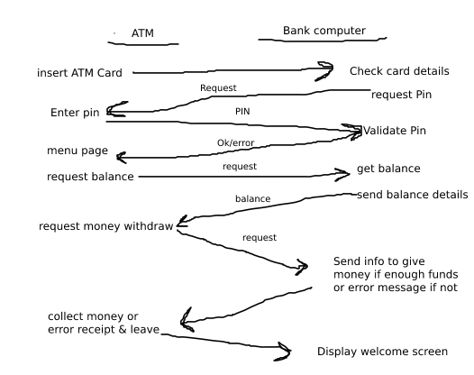

P2. **R=PN(L/R)**

P3. **A)Circuit-switched network/ There are going to be long sessions and circuit switching gives a fixed bandwidth**

**B) Yes, to ensure the link has enough bandwidth to complete the tasks**

P4. **A)16 B)8 C)Yes**

P5.**A)(**150/100km/hr=1.5hrs)propagation speed + (2*3mins = 6mins)time taken for the cars= **1hour 36 minutes**

**B)** (150/100km/hr=1.5hrs)propagation speed+ (4mins 48sec)time taken for the cars= **1 hour 34minutes 48 seconds**

P8.**A)**The number of users is equal to Transmission rate of the link used by the user over Transmission rate required by the user, 3000Kbs/150Kbps=**20 users B)**If the transmission rate is 10% that means the probability is 1/10=**0.1 C) 120Cn(1/10)n(9/10)120-n**

P14. **A)**The total delay comes from the queuing delay and the transmission delay. This means Total Delay=Queuing Delay + Transmission Delay=**L/R(1/1-I)   
B)**assume transmission is x, so the transmission delay is x=L/R, Traffic intensity I=La/R=xa, so the total delay is =**x/1-xa**