Tyler Burleson

Lab02

CSCI 3400

**HTTP**

1. My browser and server are running HTTP 1.1  
   
2. The browser will accept the following:  
   
3. My IP-10.0.0.41 U Mass-128.119.245.12  
   
4. The status code was 200  
   Graphical user interface, text, application

   Description automatically generated
5. It was last modified 02/08/2023  
   
6. 128 Bytes  
   
7. No header  
   Graphical user interface, text

   Description automatically generated
8. No  
   Graphical user interface, text, application

   Description automatically generated
9. Yes  
   Text

   Description automatically generated
10. Yes  
    
11. Status code: 304/ No since the data was stored in the browser cache  
    
12. 1 get, packet 22  
    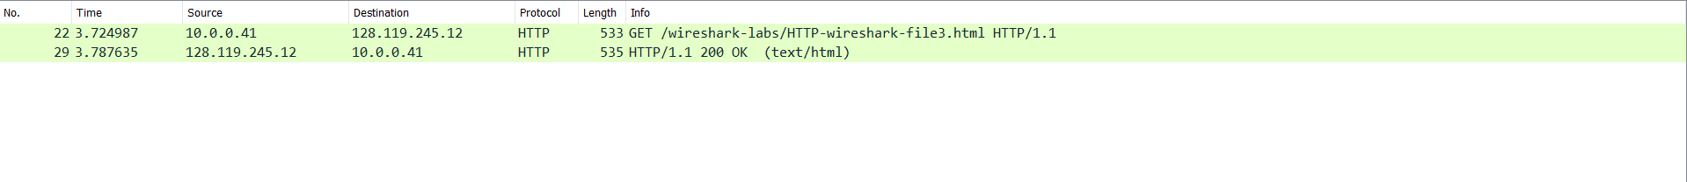
13. Packet 29  
    
14. 200  
    
15. 481  
    
16. 3 get requests  
    Table

    Description automatically generated with low confidence
17. Serially since each image has a different time stamp
18. Status code: 401  
    
19. Authorization and Cache control

**DNS**

1. 58.229.6.255  
   Text

   Description automatically generated
2. 128.232.132.8  
   Text

   Description automatically generated
3. Text

   Description automatically generated
4. TCP
5. Graphical user interface

   Description automatically generated with medium confidence
6. 196.168.1.1 they are the same
7. Type: A  
   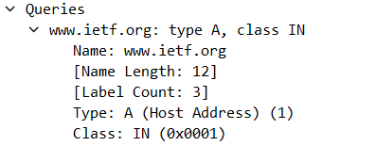
8. 6 answers provided, and it contains: The name, Type of query-A, Class-IN, TTL-1800, length of the data-4, and address-196.168.1.1
9. Yes
10. Yes
11. 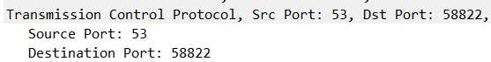
12. 196.168.1.1, yes
13. 1 and the type is A
14. 0
15. Text

    Description automatically generated
16. 196.168.1.1, yes
17. Type PTR
18. 168.192.in-addr.arpa, and no IP address is provided
19. Text

    Description automatically generated
20. The address is 18.0.72.3
21. Type A  
    Text

    Description automatically generated
22. No answers were given except the name servers
23. 