Tyler Burleson

CSCI 3400

Lab04

1. 
2. 
3. There are 20 bytes in the header. The total length is 84, so the payload is 84 – 20 = 64 bytes.
4. 
5. TTL and header checksum can always change
6. These stay constant: Version doesn’t change, Uses IPv4 for all packets  
   These can change: TTL, Header Checksum
7. The IP header increments with each new ping request
8. 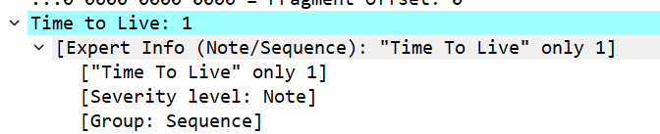
9. The ID field changed since it has a unique value, but the TTL remains the same.
10. Yes, it is fragmented across multiple datagrams.
11. Text

    Description automatically generated  
    1500 bytes
12. Text

    Description automatically generated
13. The identification, TTL, and header change
14. There were 3 packets from the original datagram.
15. Header, fragment offset, and checksum.