Tyler Burleson

CSCI 3400

Lab 6

**1-3:**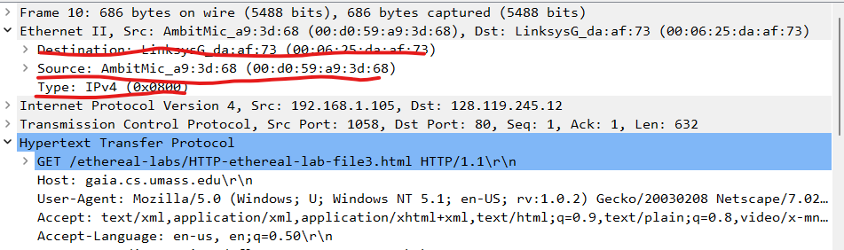

**4:** The difference between GET and OK is 197 bytes

**5:** The source address is the Linksys router not my laptop or the gaia.cs.umass

**6:** Destination is the AmbitMic = (00 : d0 : 59 : a9 : 3d : 68)

**7:** Both messages share the same hex frame of 0x800

**8:** The O in OK is 52 bytes from the start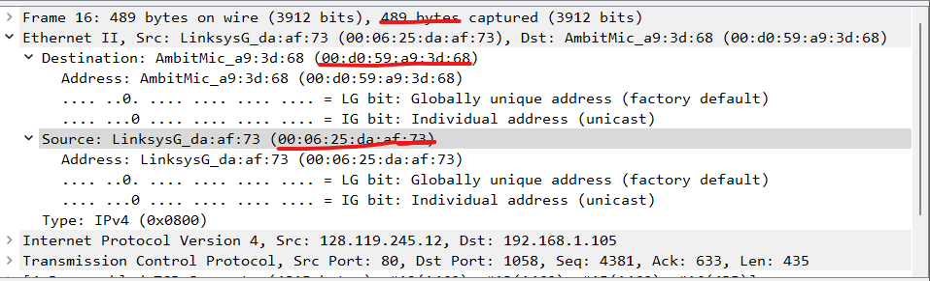

**10-12:** 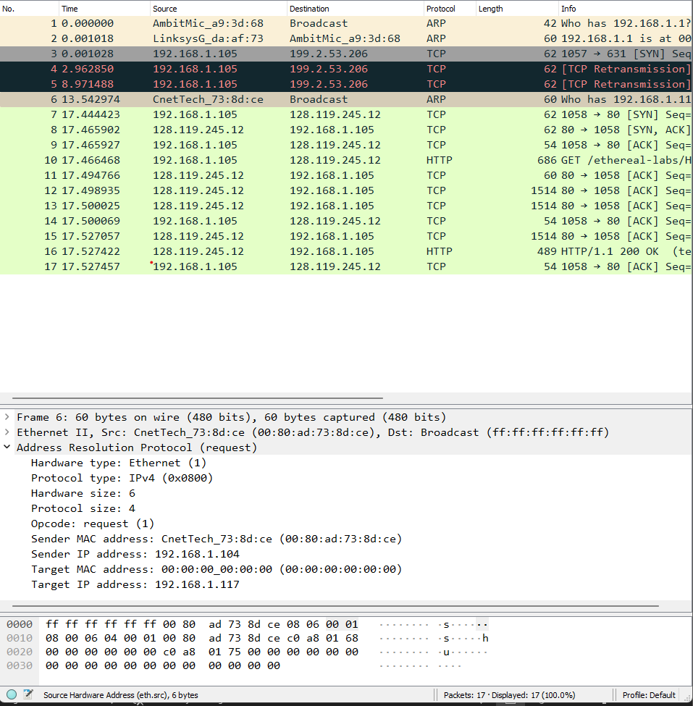

**13:** It begins at 20 bytes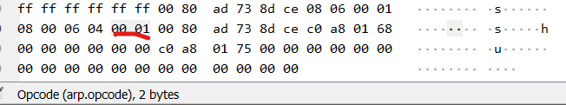

**14:** The hex value for the source is (00 : 80 : ad : 73 :8d : ce) and the target is (ff : ff : ff : ff : ff : ff)

**15:** The 1st and 2nd packets are sent to the computer running Wireshark. The ARP is sent to the computer running Wireshark through the ARP-requested ethernet address