Tyler Burleson

CSCI2200 -002

Homework 2

1. (T/F) We can use the ls command to display multiple directories at one time

**True**  
2. Which is the correct way to enter the following command?  
a. ls -a -l -t  
b. ls -al -t  
c. ls -alt  
d. a., b., and c. are all correct  
3. Which ls option appends an indicator character to the end of each listed  
name?

-F  
4. In a long file listing, information about each file/directory is displayed in  
several space-separated fields. Which field (number) lists the file/directory  
name?

9  
5. Which command do we use to display a brief description of a file’s contents?

file  
6. What is “[o]ne of the earliest and simplest” text representation systems?

ASCII Text  
7. Using less, what command will jump to the end of a file?

G  
8. How would you find the first occurrence of “foo” in a file while using less?

/foo  
9. How about the next occurrence?

n  
10.Which directory contains all of the system-wide configuration files for the  
system?

/etc  
11.Which directory contains the executable programs that are installed for  
system users?

/bin -> correct answer /usr  
12.Which directory stores data that often changes?

/var  
13.How can we create multiple references (possibly with different names) to a  
given file?

ln  
14.What is the definition of a wildcard?

A symbol that represents other characters  
15.Which wildcard matches a single character?

?  
16.Which character class matches any numeral?

# -> correct answer [[:digit:]]  
17.Why are cp, mv, and rm potentially dangerous?

When they are completed you can’t go back  
18.What are the two options that allow us to copy entire directories?

-a -r  
19.Look at the following screen shot:  
What command would I enter to copy (all of) dir1 into dir2?

cp -r dir1 dir2  
20.Look at the following screen shot:  
What command would you use to create a symbolic link named file-sym in  
dir1 that links to file1

ln -f /dir1/file-sym file1 -> ln -s file1 dir1/file-sym

Figure

Figure

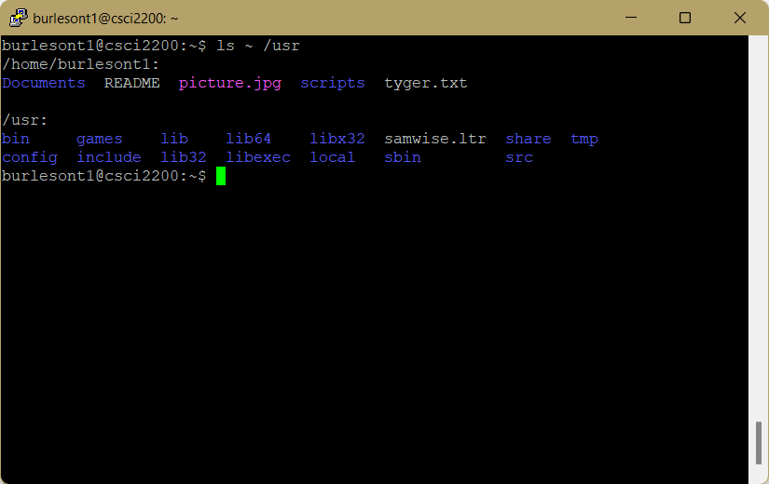

Figure

Figure

Figure

Figure

Figure

Figure

Figure

Figure

Figure

Figure

Figure

Figure

Figure

Figure

Figure

Figure

Figure

Figure

Figure

Figure

Figure

Figure

Figure

Figure

Figure

Figure

Figure

Figure

Figure

Figure

Figure