Tyler Burleson

CSCI2200-002

Homework 6

Figure

Figure

Figure

Figure

Figure

Figure

Figure

Figure

Figure

Figure

Figure

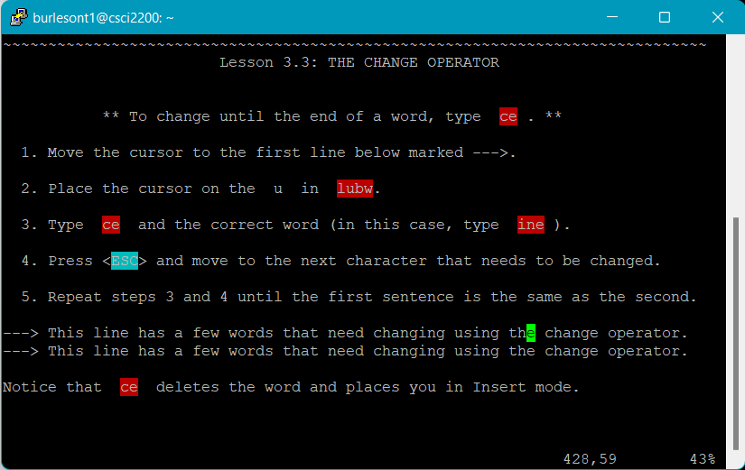

Figure

Figure

Figure

Figure

Figure

Figure

Figure

Figure

Figure

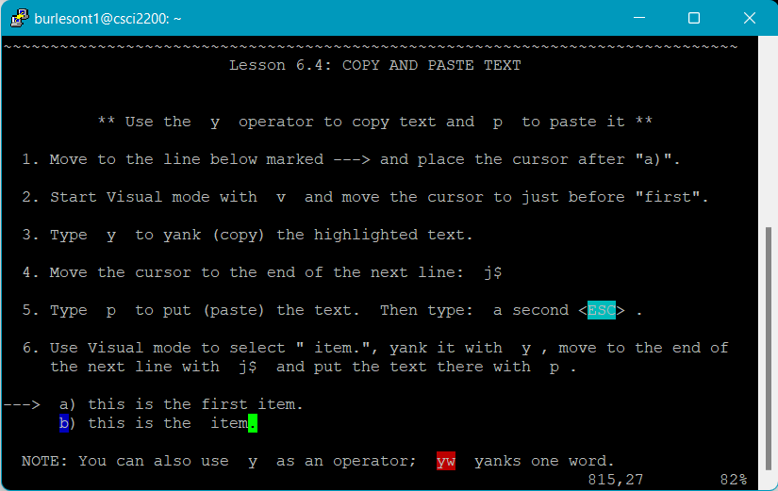

Figure

Figure

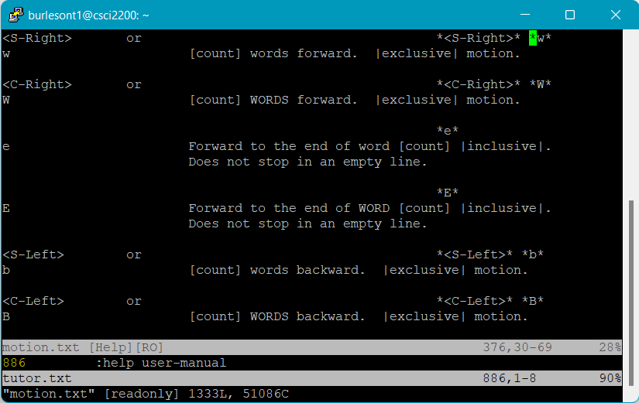

Figure

Figure