Tyler Burleson

Lab 01

CSCI 2200

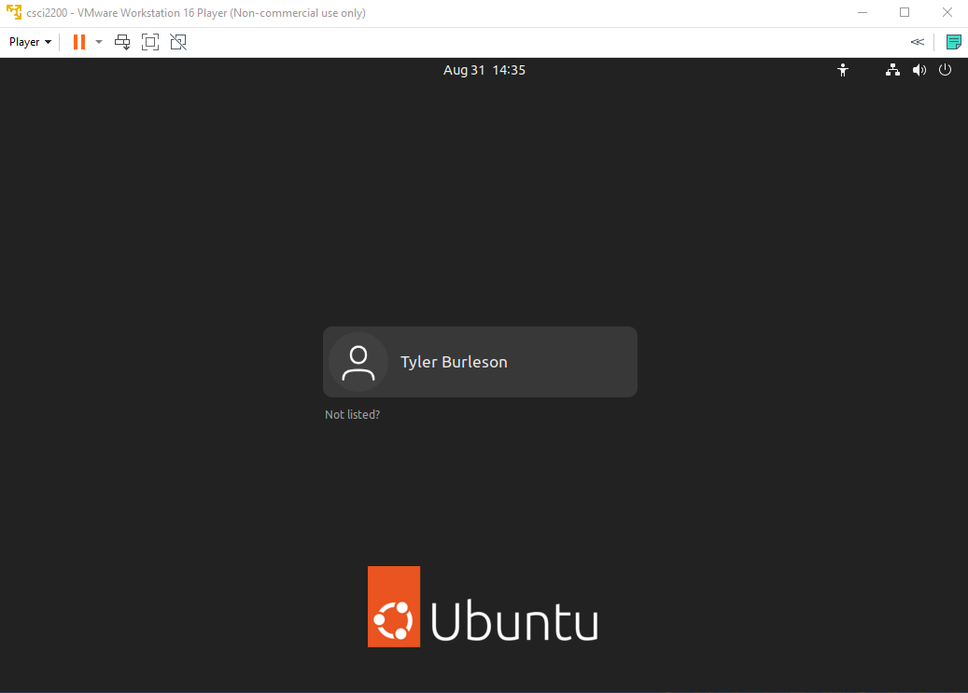

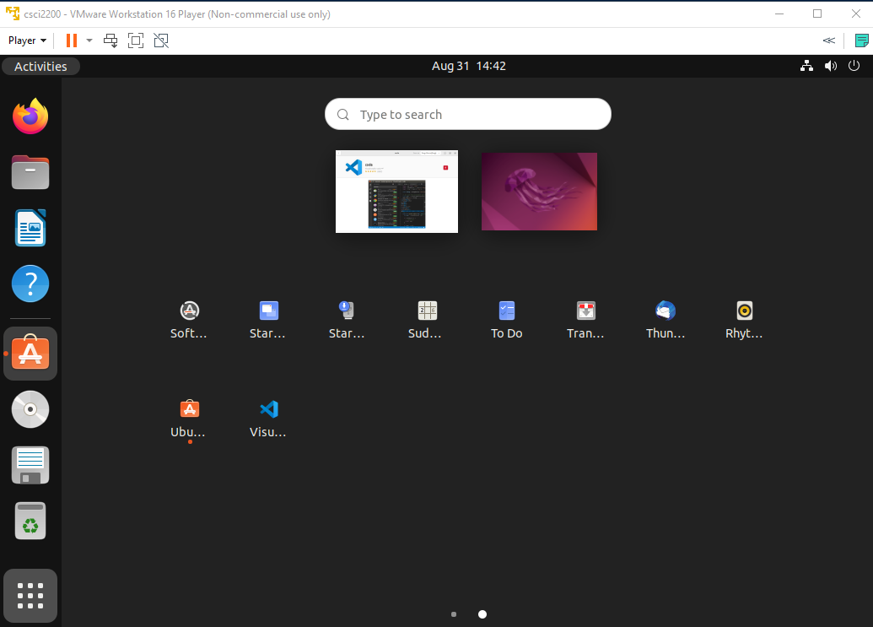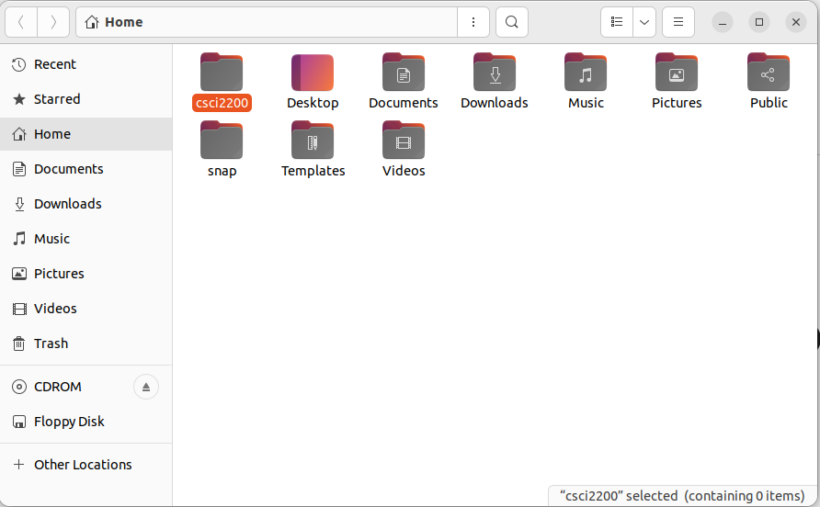

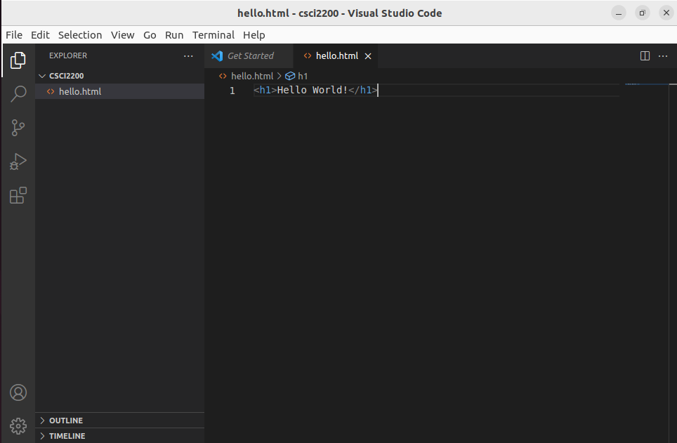

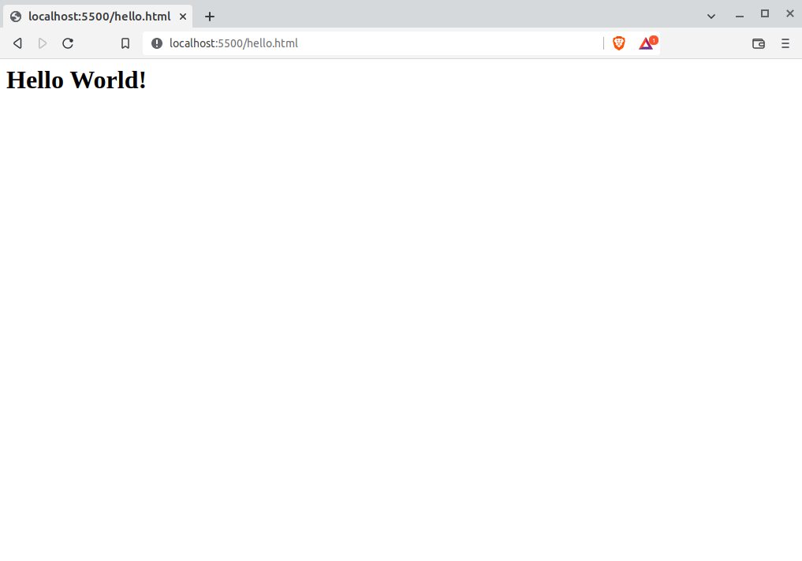

**Research Questions**

1. How is it that our virtual machine can connect to the Internet? Hint: With the VM running, click  
   File -> Manage -> Virtual Machine Settings. You may find the answer there

It has access to the NAT Adapter  
2. On that note, what does NAT mean?

Network Address Translation  
3. How can we go about re-launching our VM? (There are a couple of ways...)

Open Vmware and select csci220  
4. Look in the directory in which you installed your VM. What is the file name of the virtual disk?

csci2200  
5. What is a ‘hypervisor?’ Give an example of one

Program used to manage virtual machines: VMware, HyperV  
6. What does an operating system do? What are its responsibilities?

Acts as an interface between the user and the machine

Schedule resource usage among tasks

Facilitates input & output

Provides graceful error recovery  
7. Describe the relationship between a system’s hardware, its operating system, and its users

Acts as an interface between the user and the machine  
8. What are the four types of software?

Application,System,Programming,Driver  
9. What are the four basic operations we can perform on a file?

Copy,Move,Rename,Delete  
10. How did you like the Tetris app? I thought it was pretty cool

It was pretty neat