Tyler Burleson

CSCI2200-002

Lab 05

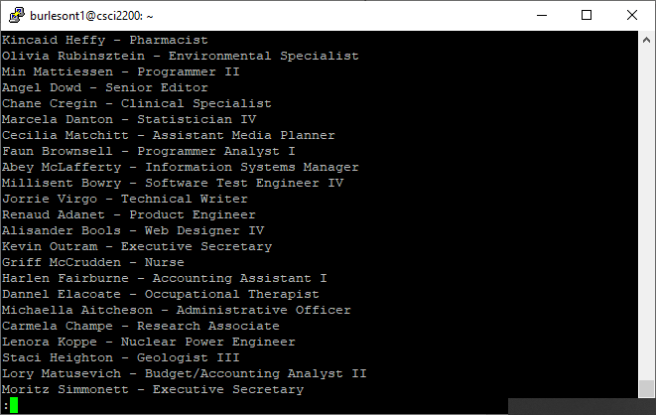

Figure

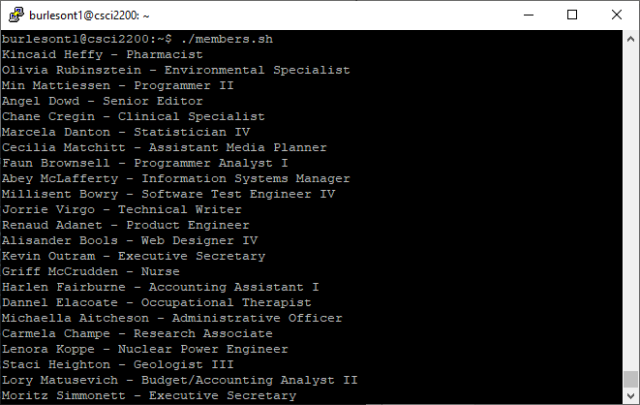

Figure

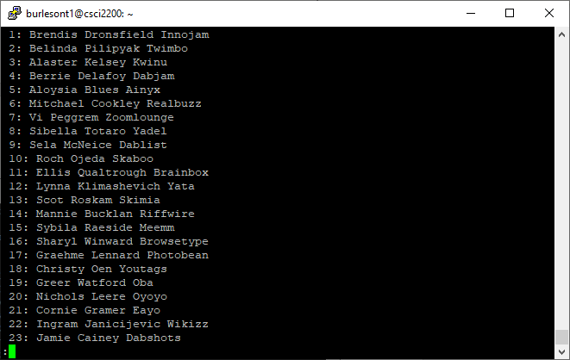

Figure

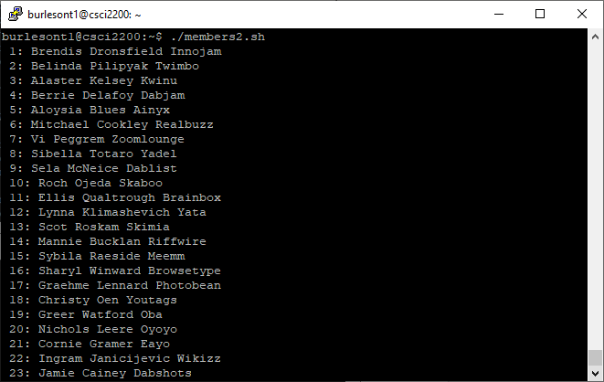

Figure

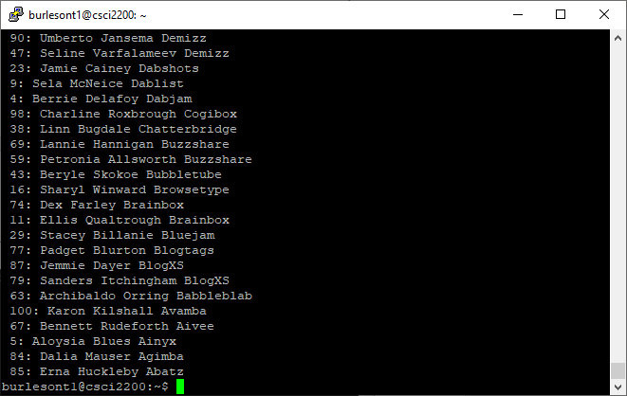

Figure

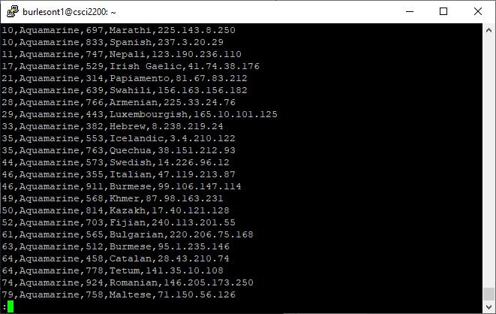

Figure

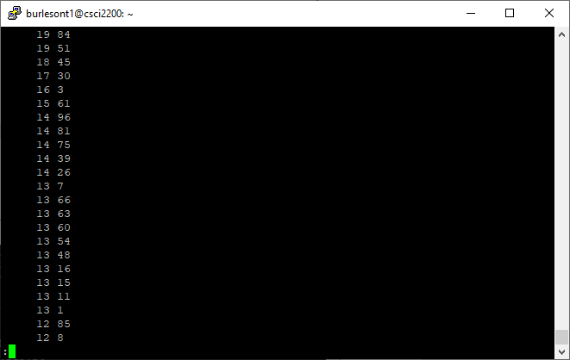

Figure

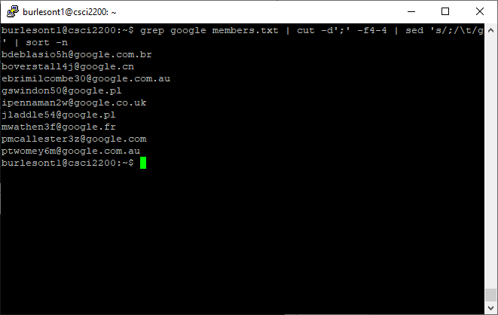

Figure

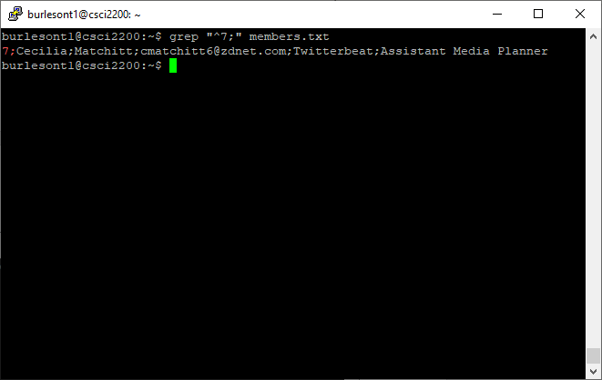

Figure

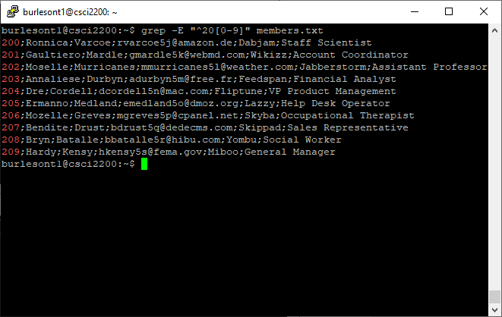

Figure

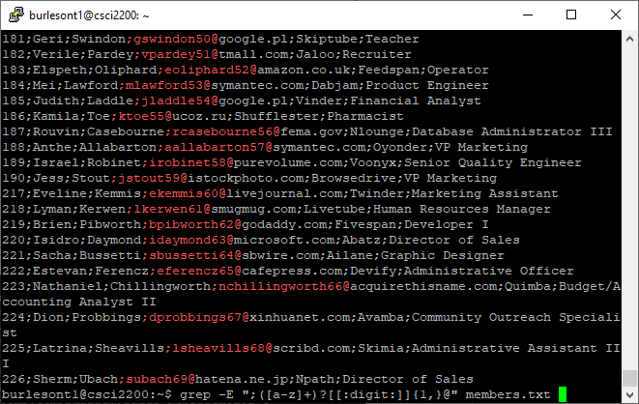

Figure

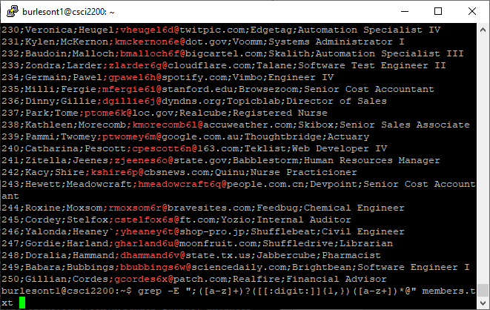

Figure

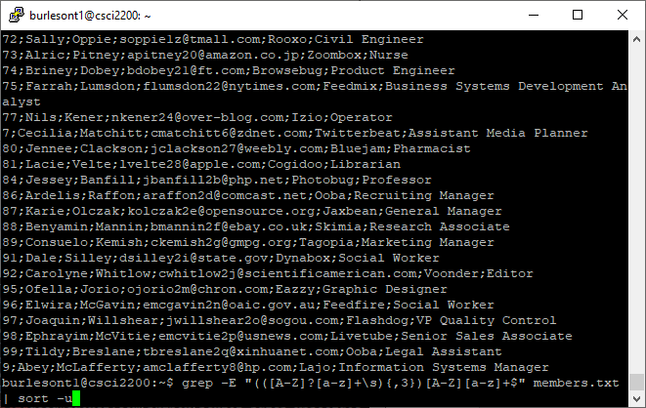

Figure

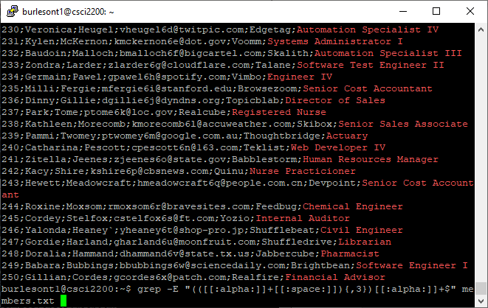

Figure

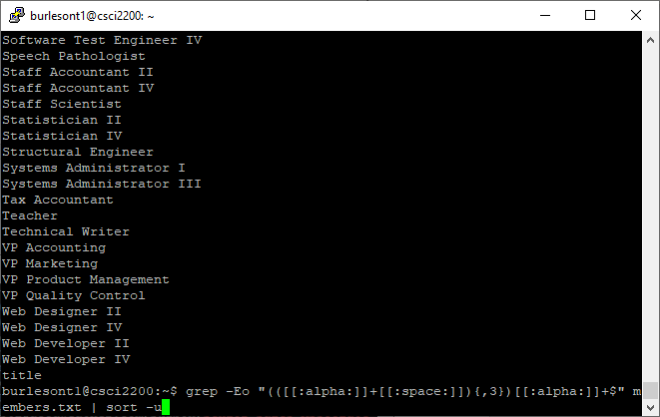

Figure

**Research Questions:**

members2.txt (id;first_name;last_name;email;company_name;job_title)  
1. What is the first name of [ebrock2g@tripod.com](mailto:ebrock2g@tripod.com)?

**Elana**  
2. What company does member #53 work for?

**Jaxnation**  
3. How many times does the name first name ‘Hayden’ appear in the file (one command, no  
pipes)?

**1 time**  
4. How many times does the ‘.com’ top level domain occur in the file?

**62**  
members.txt (id;first_name;last_name;email;company_name;job_title)  
5. How many members work for Tekfly?

**3**  
6. Of the job titles in the file, which two appear most often?

Introduction to Unix

**Occupational Therapist, Director of Sales**  
CSCI 2200  
7. Print the first 15 lines of members.txt (minus the first line) and replace the semicolons with ‘ - ‘  
(space,dash,space), except between the first and last names, which should just have one space

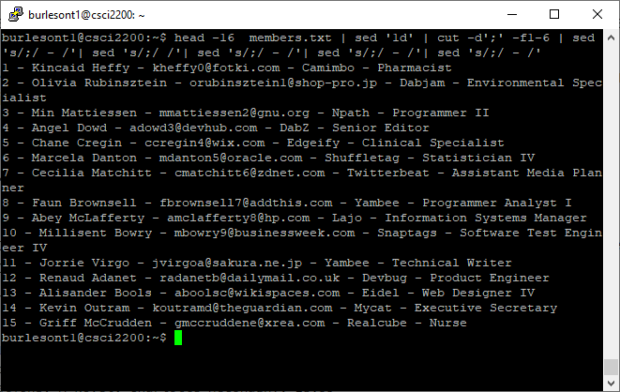

Figure

random_data.txt (random_number, color, random_number, ip_address)  
8. How many times does the number 42 appear in the first field of the file?

**37**  
9. Find all of the entries whose color value is ‘Purple.’ Sort them on the third (random number)

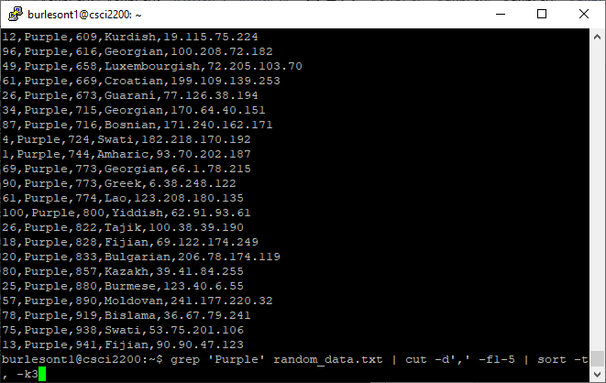

Figure

field. What are the values of the Language and IP address fields for the first result? 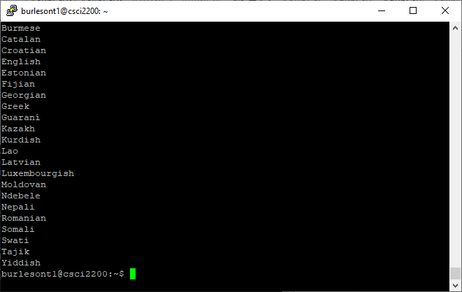

Figure

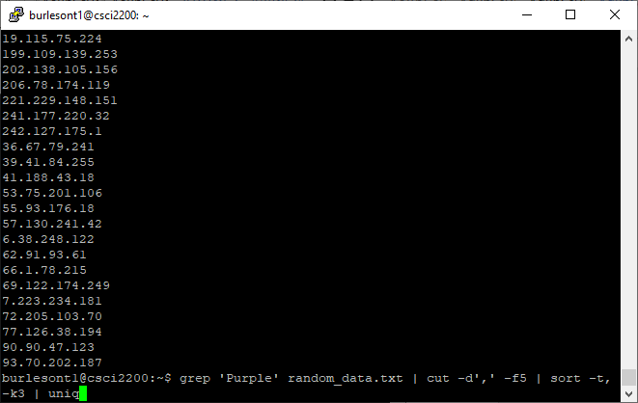

Figure

10. Turn #8 into a bash script. Save the script as rand.sh. Make it executable and run it. Grab a  
screen shot and paste it into your lab submission (I don’t need the commands you used here.  
Just the screen shot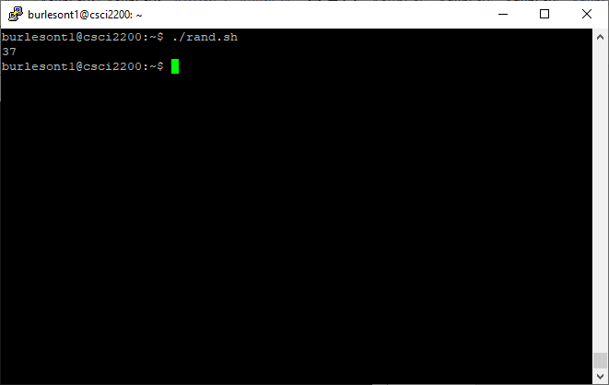

Figure