Tyler Burleson

CSCI2200-002

Project 1

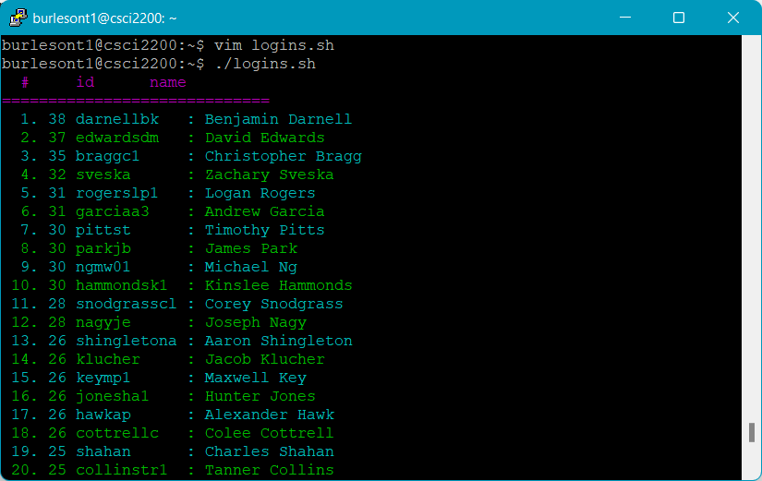

Figure