TITLE PAGE
Title. Threshold and time-window choices determine whether nirsevimab escape substitutions appear to have increased: an analysis of 38,925 public respiratory syncytial virus genomes
Running head. RSV F escape substitutions in public genomes (44 characters)
Authors. [To be completed by the authors.]
Affiliations. [To be completed by the authors.]
Corresponding author. [Name, postal address, email, telephone - to be completed.]
Keywords. respiratory syncytial virus; nirsevimab; resistance-associated substitution; genomic surveillance; fusion protein
Word counts. Abstract 193 words (limit 200). Text approximately 4,052 words (limit 4,000). References 14 (limit 50). Display items 8: Figures 1-5 and Tables 1-3 (limit 8).

ABSTRACT
Reported frequencies of nirsevimab resistance-associated substitutions in respiratory syncytial virus (RSV) differ between studies using different reference sequences, thresholds and time spans. We combined 25,384 GenBank records with 44,275 eligible GISAID EpiRSV records (69,659 in total), processed both uniformly, called fusion (F) protein variants against each subtype's own consensus, and classified them using published deep mutational scanning (DMS) scores. After de-duplication 38,925 records remained. Among records collected from 2017 onward, none of 10,598 predating 1 July 2023 carried a DMS-defined high-escape substitution against 35 of 26,064 collected on or after that date (0.134%, 95% CI 0.094-0.187; Fisher p = 1.3 x 10-5). That contrast is contingent on two analyst choices. Including records from before 2016 adds 13 historical carriers, twelve in one 2014-15 clade, and the difference is no longer significant (13/12,861 versus 35/26,064, p = 0.44). Lowering the Fab-escape cutoff from 2.036 to 1.0 reverses its direction. High-escape residues were reconstructed on 32 independent branches, 26 leading to a single sampled carrier. Of 689 F variants tested for temporal trend, 105 changed significantly (50 increasing, 55 decreasing) and none was high-escape. Archive-derived resistance frequencies require their threshold and window to be stated.
KEYWORDS: respiratory syncytial virus; nirsevimab; resistance-associated substitution; genomic surveillance; fusion protein

1 INTRODUCTION
RSV causes a large burden of lower respiratory tract infection in infants worldwide [9-11]. Long-acting monoclonal antibodies directed at the prefusion conformation of the F protein are now used for infant prophylaxis; nirsevimab binds antigenic site Ø, and clesrovimab, licensed more recently, binds a separate epitope. In the Phase 2b and MELODY randomised trials more than 99% of isolates retained susceptibility to nirsevimab, and binding-site substitutions reducing it were found in two participants [2].
Since prophylaxis became widespread, individual groups have reported F substitutions in circulating virus. A 2026 systematic review of site Ø substitutions pooled seven studies and 2,156 samples, reporting limited variability in RSV-A with K65R most common and higher frequencies in RSV-B, while distinguishing common polymorphisms that retain susceptibility from resistance-associated variants [1]. Primary reports include breakthrough RSV-B infections in France during 2024-25 [4], three children in Spain in 2025/26 carrying F:N201T with recombinant expression confirming reduced nirsevimab recognition [5], 68 isolates from Eastern Spain in 2023/24 [6], and a single adult case carrying F:K68Q [7]. These studies use different reference sequences, definitions and observation periods, so their reported frequencies are not directly comparable.
A deep mutational scan (DMS) of RSV F has since measured how nearly all F mutations affect cell entry and neutralisation by nirsevimab and clesrovimab, reporting that resistant strains have arisen sporadically but remain rare, and showing that bivalent IgG binding buffers escape so that Fab potency is the more sensitive readout [3]. We applied that functional classification to the combined public sequence archive. Our aim is not to estimate a resistance frequency, which archive data cannot support, but to measure how strongly such an estimate depends on two choices an analyst must make and rarely reports: where the functional threshold is set, and which collection years are included.

2 MATERIALS AND METHODS

2.1 Sequence assembly
GenBank contributed 25,384 sequence records for human orthopneumovirus (taxon 11250) of 13-16 kb. A GISAID EpiRSV export contributed 56,856 unique records, of which 44,275 passed filtering for human host, 13-16 kb length and a resolvable collection date; 4,267 lacked a metadata row and were excluded. GISAID holdings begin in 2020, so earlier coverage rests on GenBank alone. Retrieved 2 November 2026.
The combined 69,659 records were assigned to subtype with the Nextclade minimizer index (RSV-A 37,290, RSV-B 32,365; one record sorted to human metapneumovirus, three unassigned, all excluded) and aligned to the corresponding reference dataset [12], which supplied lineage assignments and reference-anchored F translations. Alignment-based extraction was used rather than deposited CDS annotation, present in only 60-65% of GenBank genome records. Records were retained with F coverage of at least 95% of the 574-residue frame, leaving 65,416. Table 1 gives the full accounting.
Stage | Records
GenBank sequence records retrieved (taxon 11250, 13-16 kb) | 25,384
GISAID EpiRSV records retrieved (unique) | 56,856
GISAID records passing host, length and date filters | 44,275
Combined input to subtype assignment | 69,659
Assigned RSV-A / RSV-B (1 human metapneumovirus, 3 unassigned excluded) | 37,290 / 32,365
F coverage >=95% and a resolvable collection date | 65,416
After de-duplication on identical F, country and collection date | 38,925
Primary analysis window, 2017 onward | 36,662

Table 1. Cohort assembly.

2.2 Collection dates and their precision
Deposited collection dates vary in precision. Of the 65,416 dated records, 63,033 carry a full date, 1,429 a year and month, and 954 a year only. Partial dates were expanded to the first day of the stated month or year and flagged; both the flag and the date exactly as deposited are in the manifest. A year-only date cannot be allocated across a mid-year boundary, so the primary comparison was repeated with those records excluded. In the de-duplicated analysis set 37,804 records carry a full date, 583 a month and 538 a year only; 190 of the year-only records fall in the primary window, of which 29 are dated 2023 and are assigned to the earlier period by this convention. None of the 538 year-only records is a carrier, and excluding them does not materially change the result (Section 3.4).

2.3 De-duplication across databases
Records identical in F sequence, country and collection date were collapsed to one. Cross-database redundancy was measured rather than assumed. Of 41,514 GISAID records passing QC, 16,973 (40.9%) fall in a group that also contains a GenBank record and so match a GenBank record on all three fields; a further 7,660 fall in groups of two or more GISAID records with no GenBank counterpart, which is within-database repetition. In total 9,344 GISAID records (22.5%) were not retained as the representative of their group. Matching on these three fields is consistent with the same specimen having been deposited twice but does not demonstrate it. Of the 38,925 resulting groups, 16,171 contain more than one record. The rule will collapse genuinely distinct infections sharing an F sequence, country and date, so full group membership is deposited and the primary comparison was repeated with no de-duplication at all (Section 3.4). Because the archive is a convenience sample, the resulting records are described throughout as de-duplicated archive records, not as a population denominator.

2.4 Variant calling and functional classification
Variants were called against each subtype's own consensus, computed from the analysis set, because the two subtype consensuses differ at 59 of 574 F residues. Observed residues were joined to the DMS tables [3] on site and mutant residue; the scan's numbering matched the RSV-A consensus at 98.4% of its 504 scored sites.
A residue was classified DMS-defined high-escape when its Fab-escape score was at least 2.036 with cell entry at or above -0.5 (12 nirsevimab and 6 clesrovimab mutations of 9,812 scored). The cutoff is anchored on F:N201T, for which reduced nirsevimab recognition has been demonstrated by recombinant expression [5]. This is a deliberately narrow, score-based category and is not equivalent to the set of all known resistance-associated variants: F:K68Q, reported in a severe adult case [7], scores 0.572 and falls outside it at every cutoff examined, while the DMS study itself reports subtype-dependent effects at position 201 and reduced IgG neutralisation for K68Q on an RSV-B background [3]. Because the category is defined by score rather than phenotype, and because no virus in this study was tested functionally, all classifications are described as predicted.
Twelve nirsevimab mutations fall at five F positions (68, 201, 208, 209, 210). Across the primary window 99.69% of records have all five positions callable and mean callability at those positions is 99.93%, so at least 95% overall F coverage is not materially diluting the denominator at the positions that matter.
The DMS was performed on an RSV-A background, so its transfer to RSV-B is an assumption stated per substitution. The two RSV-B substitutions contributing most carriers sit at sites where the RSV-B consensus matches the scan's wildtype (N208D: wildtype N, RSV-B consensus N; K68I: wildtype K, RSV-B consensus K), and the RSV-A carriers are scored on the scan's own background. Matching the wildtype residue does not establish that the score transfers unchanged across backgrounds, and no such claim is made.
Two naming conventions are used and should not be conflated. Carriage is reported relative to each subtype's consensus, so the RSV-B departure at site 209 is R209E. Acquisition branches are named by the ancestral state reconstructed at that branch, which may differ from the consensus; the same RSV-B event is K209E because the reconstructed ancestor carried lysine. Acquisitions are therefore reported as site and acquired residue (for example, 209 to E).

2.5 Statistics and phylogenetics
Proportions and their intervals are Clopper-Pearson throughout, including zero-count upper bounds. Periods were compared with Fisher's exact test at a fixed calendar boundary of 1 July 2023, and with a continuity-corrected Cochran-Mantel-Haenszel (CMH) test as the stratified inference. Stratified analyses are reported by subtype, by country, by country and subtype jointly, and by country, subtype and source database jointly; strata with no events or no records in one period contribute nothing and the number of informative strata is reported with each statistic. Temporal trend used the Cochran-Armitage test, with per-year carrier and denominator counts deposited for every variant tested, Bonferroni-corrected across all variants carried by at least five records.
Two sensitivity analyses are treated as primary rather than supplementary: the period comparison was repeated across Fab-escape cutoffs from 1.0 to 2.6, and across first-included collection years from the full archive through 2020. Three further sensitivity analyses are reported in Section 3.4 (de-duplication, date precision, cell-entry floor). The trend scan, the acquisition analysis and the clesrovimab analysis were run at the primary cutoff only.
Maximum-likelihood F phylogenies were built per subtype from the aligned F coding sequences with VeryFastTree under GTR+gamma [13] (20,767 and 18,158 tips). Amino-acid ancestral states were then reconstructed on those topologies with TreeTime [14] under an inferred GTR model, using the translated F peptide alignment over the same tip set, since TreeTime's amino-acid mode takes a peptide alignment rather than translating a nucleotide one. No explicit rooting step was applied: VeryFastTree emits an unrooted tree and TreeTime was run on it as given, so the direction assigned to each reconstructed change is conditional on that root placement. Sensitivity of the acquisition counts to rooting was not assessed. Acquisitions were counted as branches on which a high-escape residue appears, and their spread measured as descendant tips that actually carry that residue. Branch support was taken from the maximum-likelihood topology by matching nodes on descendant tip sets; support is undefined for terminal branches, and acquisitions whose clade is not recovered as a bipartition are reported as unsupported rather than assigned a value. Trees, annotated TreeTime output and branch-mutation tables are deposited.

3 RESULTS

3.1 Carriage in the primary window
Among 36,662 records collected from 2017 onward, none of the 10,598 collected before 1 July 2023 carried a DMS-defined high-escape substitution, against 35 of 26,064 collected on or after that date (Table 2, Figure 1). This is an absence of detection in the analysed sample, not demonstrated biological absence.
Subtype | Era | Carriers / n | Carriage (%) | 95% CI (%)
RSV-A | Before rollout | 0/5,584 | 0.0 | 0.000-0.066
RSV-A | After rollout | 9/14,013 | 0.064 | 0.029-0.122
RSV-B | Before rollout | 0/5,014 | 0.0 | 0.000-0.074
RSV-B | After rollout | 26/12,051 | 0.216 | 0.141-0.316
Both | Before rollout | 0/10,598 | 0.0 | 0.000-0.035
Both | After rollout | 35/26,064 | 0.134 | 0.094-0.187

Table 2. Carriage among de-duplicated archive records collected from 2017 onward, split at the fixed calendar boundary of 1 July 2023. National prophylaxis rollout dates were not used to assign periods. Intervals are Clopper-Pearson; zero counts are shown as exact upper bounds.
Pooled, Fisher p = 1.3 x 10^-5. Stratified by subtype, CMH p = 3.0 x 10^-4 (2 informative strata); by country, p = 0.0060 (6 strata); by country and subtype, p = 0.0059 (9 strata); by country, subtype and database, p = 0.0082 (12 strata). Country-by-period-by-subtype denominators for all 156 combinations are deposited. The 35 carriers span 7 countries and 13 lineages and derive from both databases (20 GISAID, 15 GenBank). Because prophylaxis exposure is unrecorded, national implementation dates differ and sequencing effort rose sharply over the same interval, this association must not be read as evidence that prophylaxis caused the difference.

3.2 The comparison depends on which collection years are included
The 2017 start date is a choice, and it determines the result. Extending the window backwards adds 13 historical carriers and the difference is no longer statistically significant (Table 3 panel A, Figure 2c): across the full archive, 13 of 12,861 records predating the boundary carry a high-escape substitution (0.101%) against 35 of 26,064 afterwards (0.134%), Fisher p = 0.44.
The transition is abrupt rather than gradual. The difference reaches significance for every start year from 2016 onward and for none earlier. Twelve of the 13 historical carriers are RSV-B records carrying glutamate at site 209 - ten from Argentina in 2015, two from Viet Nam in 2014 - and the thirteenth is a German RSV-B record from 2002 carrying N201T. The entire contrast therefore turns on whether one 2014-15 acquisition clade, sampled in Argentina and Viet Nam, is inside or outside the window. We describe it as a clade rather than an outbreak: the grouping is phylogenetic and no epidemiological linkage between these specimens has been established.
Panel | Value | Qualifying mutations | Before 1 Jul 2023 | On/after 1 Jul 2023 | Fisher p | CMH p
A. First collection year included | all years | 12 | 13/12,861 (0.101%) | 35/26,064 (0.134%) | 0.44 | 0.44
A. First collection year included | 2000 | 12 | 13/12,697 (0.102%) | 35/26,064 (0.134%) | 0.45 | 0.46
A. First collection year included | 2005 | 12 | 12/12,643 (0.095%) | 35/26,064 (0.134%) | 0.35 | 0.35
A. First collection year included | 2010 | 12 | 12/12,527 (0.096%) | 35/26,064 (0.134%) | 0.35 | 0.36
A. First collection year included | 2014 | 12 | 12/11,592 (0.104%) | 35/26,064 (0.134%) | 0.53 | 0.48
A. First collection year included | 2015 | 12 | 10/11,338 (0.088%) | 35/26,064 (0.134%) | 0.26 | 0.28
A. First collection year included | 2016 | 12 | 0/11,040 (0.000%) | 35/26,064 (0.134%) | 6.7e-06 | 0.00021
A. First collection year included | 2017 | 12 | 0/10,598 (0.000%) | 35/26,064 (0.134%) | 1.3e-05 | 0.0003
A. First collection year included | 2018 | 12 | 0/10,055 (0.000%) | 35/26,064 (0.134%) | 1.4e-05 | 0.00049
A. First collection year included | 2019 | 12 | 0/9,088 (0.000%) | 35/26,064 (0.134%) | 4.9e-05 | 0.001
A. First collection year included | 2020 | 12 | 0/7,742 (0.000%) | 35/26,064 (0.134%) | 0.00017 | 0.0025
B. Fab-escape cutoff | 1.000 | 52 | 570/10,598 (5.378%) | 1161/26,064 (4.454%) | 0.0002 | -
B. Fab-escape cutoff | 1.200 | 44 | 32/10,598 (0.302%) | 74/26,064 (0.284%) | 0.75 | -
B. Fab-escape cutoff | 1.400 | 32 | 26/10,598 (0.245%) | 41/26,064 (0.157%) | 0.08 | -
B. Fab-escape cutoff | 1.600 | 23 | 24/10,598 (0.227%) | 38/26,064 (0.146%) | 0.093 | -
B. Fab-escape cutoff | 1.800 | 16 | 24/10,598 (0.227%) | 38/26,064 (0.146%) | 0.093 | -
B. Fab-escape cutoff | 2.036 | 12 | 0/10,598 (0.000%) | 35/26,064 (0.134%) | 1.3e-05 | -
B. Fab-escape cutoff | 2.200 | 10 | 0/10,598 (0.000%) | 27/26,064 (0.104%) | 0.00015 | -
B. Fab-escape cutoff | 2.400 | 6 | 0/10,598 (0.000%) | 21/26,064 (0.081%) | 0.0011 | -
B. Fab-escape cutoff | 2.500 | 4 | 0/10,598 (0.000%) | 17/26,064 (0.065%) | 0.0053 | -
B. Fab-escape cutoff | 2.600 | 2 | 0/10,598 (0.000%) | 0/26,064 (0.000%) | 1 | -

Table 3. Sensitivity of the period comparison to two analyst choices. Panel A varies the first collection year included, holding the Fab-escape cutoff at 2.036. Panel B varies the Fab-escape cutoff within the primary window from 2017. Periods are split at the fixed calendar boundary of 1 July
2023. CMH is the continuity-corrected Cochran-Mantel-Haenszel test stratified by subtype; it was not
computed for the cutoff sweep.
Pre-2017 records differ from later ones in ways that motivate a modern-era restriction independently of this result: they come from 25 countries against 82, contain no GISAID deposits against 54.1%, and predate the lineage nomenclature used here. These differences are not strong enough to carry the inference on their own - sampling concentration in the three largest contributing countries is similar in the two eras (55.9% against 49.6%) - so we report both windows and treat neither as definitive. Within the primary window the high-escape substitutions were not detected before mid-2023; across the full archive they are not new.

3.3 The comparison depends on where the functional threshold is set
Repeating the comparison across Fab-escape cutoffs shows three regimes (Table 3 panel B, Figure 2a,b). Above 2.0 the pre-boundary count is zero and the difference is significant up to 2.5, beyond which no record qualifies in either period. Between 1.2 and 1.8 the difference is not statistically significant and the point estimate is higher before the boundary. Changing the cutoff does not merely change the power of one test: it changes which substitutions are classified, and therefore the endpoint being compared. At 1.0 the difference is significant in the reverse direction (5.38% before versus 4.45% on or after).
Twenty-six records collected before the boundary and six afterwards carry a substitution scoring between 1.4 and 2.036, dominated by N201S. Substitutions of intermediate score were therefore already circulating.

3.4 Robustness to de-duplication, date precision and the cell-entry floor
De-duplication is not generating the primary contrast. Retaining every record, the primary window gives 0 of 17,318 before the boundary against 53 of 45,318 after (0% against 0.117%); across the full archive it gives 14 of 20,098 against 53 of 45,318 (0.070% against 0.117%), which is not statistically significant. The fractions are close to the de-duplicated estimates in both windows, and the window dependence survives removal of the rule. The smaller p value obtained without de-duplication is not stronger evidence: records that match on F sequence, country and date are not independent observations, which is why the de-duplicated analysis remains the principal comparison.
Date imprecision is not generating it either. Excluding the 29 year-only records dated 2023 leaves 0 of 10,569 against 35 of 26,064 (p = 1.3 x 10^-5); excluding all 190 year-only records in the primary window (177 before the boundary, 13 after) leaves 0 of 10,421 against 35 of 26,051 (p = 1.3 x 10^-5); restricting to full-date records only leaves 0 of 10,117 against 35 of 25,802 (p = 1.4 x 10^-5).
The cell-entry floor is likewise not critical: varying it from -2.0 to 0.0 changes the number of qualifying mutations from 23 to 9 and the carrier count from 36 to 31, with p between 7.6 x 10^-6 and 3.4 x 10^-5.

3.5 Reconstructed acquisitions and observed cluster sizes
High-escape residues were reconstructed on 32 independent branches across six site-and-residue combinations (Figure 4a). These branches are counted on the full 38,925-record archive and so include the historical carriers; the 35 carriers of Section 3.1 are the post-boundary subset of the primary window.
Twenty-six acquisitions lead to a single sampled carrier. No cluster collected on or after 1 July 2023 exceeded two carriers under this sampling; the largest cluster in the archive is a twelve-carrier site-209 clade, ten records from Argentina in 2015 and two from Viet Nam in 2014 (Figure 4b). Branch support separates these sharply: support is undefined for the 26 terminal acquisitions; of the six internal acquisitions, two are recovered as clades in the maximum-likelihood topology and well supported (the 2014-15 site-209 clade, SH-like support 0.888, and one 2025/26 site-201 pair, 0.982), while the remaining four, all site 208 to D, are not recovered as bipartitions and are therefore uncertain reconstructions. This includes the branch whose naive descendant count was 122 but which contains only two carriers. The count of 32 is a reconstruction-dependent estimate conditional on one topology and one ancestral-state model.
Formal comparison against other F substitutions is uninformative at this sample size (Mann-Whitney p = 0.133; single-carrier fraction 26/32 versus 6,402/9,178, p = 0.181). Large recent clusters were not observed under this sampling and analysis. This does not demonstrate absence of onward transmission, which sparse sampling, de-duplication, the recency of the carriers and limited phylogenetic resolution could each produce independently.

3.6 Subtype consensus and the interpretation of reported frequencies
In this archive, methionine at site 206 is carried by 90.7% of RSV-B records, arginine at site 209 by 84.9% and asparagine at site 211 by 77.3%, against 0.01%, 0.05% and 0.01% in RSV-A (Figure 3). Their DMS Fab-escape scores are 0.598, 0.042 and -0.036.
This is concordant with, and does not extend, the trial analysis that first characterised these residues: I206M:Q209R was reported as highly prevalent in RSV-B and shown to increase nirsevimab susceptibility [2], and the systematic review explicitly distinguishes such common polymorphisms from resistance-associated variants [1]. We make no claim that earlier investigators used an inappropriate reference. The practical point for pooled surveillance is narrower: a substitution count is meaningful only relative to a stated baseline, and frequencies computed against different baselines should not be combined.
The genuine RSV-B variants remain distinguishable on this basis: the RSV-B consensus is asparagine at site 201 and lysine at site 68, so F:N201T and F:K68Q are departures from it.

3.7 Concordance with an independently reported variant
F:N201T, reported from Spain in 2025/26 [5], is recovered here without being sought. Within the primary window there are 5 carriers, 4 Spanish (two in 2025, two in 2026) and 1 South African (2024), all GISAID deposits absent from the GenBank-only subset; the archive also contains one much older GenBank record carrying N201T, from Germany in 2002. This is concordance with published observation, not independent validation, since the cutoff was anchored on N201T itself.

3.8 Temporal trend across F
Of 689 F variants carried by at least five records, 105 changed significantly across 2017-2026 against a Bonferroni threshold of 7.3 x 10^-5: 50 increased and 55 decreased. None was DMS-defined high-escape. The strongest trends (T12I, K123R, R42K) lie in the signal peptide and other non-epitope regions.

3.9 Clesrovimab
Applying the same numerical cutoff to the clesrovimab DMS table, 8 of 24,282 records collected from 2017 onward and before 2025 carried a qualifying substitution (0.033%, 95% CI 0.014-0.065), all RSV-A; no RSV-B record qualified. Carriers came from France, Spain and Portugal. One further carrier, an Australian record from 2016, lies outside the primary window and is reported separately in the supplement. The cutoff was derived for nirsevimab and its appropriateness for a different antibody has not been established, so this analysis is exploratory only. Qualifying sites for the two antibodies did not overlap (429/443/445/470 versus 68/201/208/209/210) and no record carried both, which does not establish that cross-resistance cannot occur.

3.10 Geographical coverage
The archive is dominated by a small number of countries (Figure 5a); the primary window spans 82 named countries, with 4 records carrying no country. In the primary window the Middle East contributes 252 records: Qatar 150, Kuwait 79, Jordan 10, Iraq 7 and Egypt 6 (Figure 5b). Records from the United Arab Emirates, Saudi Arabia and Iran are short partial sequences (median 836, 687 and 321 nucleotides) spanning the attachment glycoprotein and ending before F, so they cannot contribute. Under a simple independent-sampling model at the observed post-boundary frequency, 150 records give about an 18% probability of containing at least one carrier and roughly 1,200 would be needed for 80%; this is illustrative, not an assessment of national surveillance performance.

4 DISCUSSION
Reading the whole public archive rather than one country at a time yields a result that is mainly a warning about how such numbers are produced.
The headline contrast is real within its window: among records collected from 2017 onward, high-escape substitutions appear only from late 2023, across seven countries and thirteen lineages, and the association survives stratification by country, subtype and database, removal of the de-duplication rule, exclusion of imprecisely dated records, and variation of the cell-entry floor. What it does not survive is a change to either of two choices that are seldom reported. Extending the window back to include a single 2014-15 acquisition clade removes the statistical significance of the difference. Lowering the functional cutoff also removes it, and at the most permissive cutoff reverses its direction - while simultaneously changing which substitutions the endpoint contains. The substitutions are not new - they are in the archive from 2002 and 2014-15 - and intermediate-score substitutions were circulating throughout.
We therefore do not claim that escape substitutions have increased since prophylaxis began. We claim something narrower and better supported: that whether they appear to have increased is determined by the threshold and the window, and that published frequencies which state neither cannot be compared with one another or pooled. This is consistent with the DMS authors' report that resistant strains remain rare [3] and with the sporadic emergence on distinct backgrounds described from Spain [5].
Acquisitions are reconstructed repeatedly across countries and lineages, and no large recent cluster was observed. We deliberately offer no fitness-cost explanation: the data cannot distinguish a cost from sparse sampling, recency, de-duplication or phylogenetic uncertainty, and four of the six internal acquisitions are uncertain reconstructions.
What this study does not show is that RSV-B consensus residues were previously misreported. The trial analysis that characterised I206M:Q209R identified its prevalence and measured its effect on susceptibility [2], and the systematic review separates polymorphisms from resistance-associated variants [1]. Our contribution there is confirmation at archive scale and a procedural recommendation about pooling, not a correction.
Two methodological results deserve emphasis for future work of this kind. Two fifths of the GISAID records match a GenBank record on F sequence, country and collection date, so naive pooling would have inflated the denominator by many thousands; yet the non-matching records contained every N201T record in the primary window. Neither database alone is adequate, and the overlap must be measured. Separately, naive descendant-tip counts from ancestral reconstruction were misleading here, and acquisition counts should be reported with branch support.
Nothing in these data supports changing prophylaxis policy. Carriage of a scored substitution is not a confirmed resistant virus, the measurements are pseudovirus-based, and almost all deposited records carry no qualifying substitution.

4.1 Limitations
This study has several limitations. The public archive is a convenience sample dominated by a small number of countries, so the figures reported here describe de-duplicated archive records and are not population prevalence. Public metadata does not record prophylaxis exposure, national implementation dates differ while a single global boundary of 1 July 2023 was applied, and later sequencing effort was markedly greater, so the period comparison is observational and exploratory; stratification by country reduces but does not remove this concern, and the choice of first included year changes the conclusion outright. Classifications are DMS scores rather than measured phenotypes, no virus here was tested functionally, the scan was performed on an RSV-A background, and the high-escape category excludes known resistance-associated variants such as K68Q; the clesrovimab cutoff is unvalidated for that antibody. Collapsing records identical in F sequence, country and collection date may remove genuinely distinct infections, although repeating the analysis without it strengthened rather than weakened the primary association. A single sampled carrier does not establish absence of transmission, the count of 32 acquisitions is conditional on one topology and one ancestral-state model, and four of six internal acquisitions are uncertain. Clinical severity, prophylaxis failure rates, within-host minor variants and antibody exposure history are not recoverable from consensus deposits and were not assessed.

5 CONCLUSIONS
Among public RSV records collected from 2017 onward, DMS-defined high-escape substitutions to nirsevimab were detected only from late 2023 and remained below 0.25% of records collected on or after 1 July 2023, arising as repeated independent acquisitions with no observed cluster larger than two sequences. This contrast does not hold across the full archive, where the same substitutions are present from 2002 and 2014-15 and the period comparison is null, and it does not hold at more permissive functional cutoffs, where it is null or reversed. Reported RSV resistance frequencies should therefore always be accompanied by the classification threshold, the reference baseline and the collection-year span from which they were derived, and archive-based estimates should be described as properties of deposited sequences rather than of circulating virus populations.

ACKNOWLEDGEMENTS
We gratefully acknowledge all data contributors, namely the authors and their originating laboratories responsible for obtaining the specimens, and their submitting laboratories for generating the genetic sequence and metadata and sharing via the GISAID Initiative, on which this research is based. A GISAID EPI_SET acknowledgement identifier listing every accession used will be registered and cited in the final version. We also acknowledge the submitters of the GenBank records analysed here.

CONFLICT OF INTEREST STATEMENT
[To be completed by the authors.]

AUTHOR CONTRIBUTIONS
[To be completed by the authors, following CRediT taxonomy.]

ETHICS STATEMENT
This study used only publicly deposited viral genome sequences and their associated metadata. No human subjects, clinical specimens or identifiable patient information were involved, and no ethical approval was required.

DATA AVAILABILITY STATEMENT
Deposited at https://github.com/Siniyaa/Infectious_Disease: accession manifests for every analysis population, with per-record date-precision flags and carrier calls; the complete de-duplication group mapping (65,416 member rows across 38,925 groups, by opaque group identifier, without sequence data); the maximum-likelihood trees, annotated TreeTime output and branch-mutation tables; every derived table underlying the figures; and the analysis workflow. The deposited workflow covers cohort assembly, variant calling, the carriage, threshold-sweep and window-sweep analyses, the trend scan and the clesrovimab analysis; the phylogenetic stage is documented as the exact commands used rather than as a tested function, and figure generation is not included. In accordance with the GISAID Database Access Agreement, sequence data are not redistributed: GISAID-derived records are identified by EPI_ISL accession and must be obtained from https://gisaid.org, and GenBank records by accession. DMS scores are available at https://github.com/dms-vep/RSV_Long_F_DMS. Retrieval date for all sequence data was 2 November 2026.

REFERENCES
1. Berikopoulou MM, et al. Systematic review of the mutations in the active antigenic site O of the prefusion F protein of the respiratory syncytial virus (RSV) following the implementation of monoclonal antibody prophylaxis. Vaccine. 2026;91:129069. doi:10.1016/j.vaccine.2026.129069
2. [Authors]. Molecular and phenotypic characteristics of RSV infections in infants during two nirsevimab randomized clinical trials. Nat Commun. 2023;14:4137. doi:10.1038/s41467-023-40057-8
3. Simonich CAL, et al. Mutational constraints on RSV F and its neutralization by antibodies. Nature. 2026. doi:10.1038/s41586-026-11030-4
4. [Authors]. Real-world emergence of nirsevimab resistance in breakthrough infections with respiratory syncytial virus-B: a multicentre observational study in France. Lancet Microbe. 2026. doi:10.1016/j.lanmic.2026.101353
5. [Authors]. Detection of nirsevimab-resistant RSV-B variants in children carrying the F:N201T substitution through genomic surveillance, Spain, 2025/26 season. Euro Surveill. 2026;31(35). doi:10.2807/1560-7917.ES.2026.31.35.2600690
6. [Authors]. Genomic surveillance of respiratory syncytial virus during 2023/2024 nirsevimab prophylaxis, Eastern Spain, early results. Clin Microbiol Infect. 2026. doi:10.1016/j.cmi.2026.04.003
7. [Authors]. Detection of a nirsevimab-resistant RSV-B variant (F:K68Q) in an adult with severe infection. Infect Dis Ther. 2026. doi:10.1007/s40121-026-01442-0
8. [Authors]. [RSV lineage nomenclature - consortium paper defining the A.D/B.D system. To be completed by the authors; lineage assignments follow the Nextclade RSV datasets.]
9. Li Y, et al. Global, regional, and national disease burden estimates of acute lower respiratory infections due to respiratory syncytial virus in children younger than 5 years in 2019: a systematic analysis. Lancet. 2022;399(10340):2047-2064. PMID:35598608
10. [Authors]. Global, regional, and national disease burden estimates of acute lower respiratory infections due to respiratory syncytial virus in young children in 2015. Lancet. 2017. PMID:28689664
11. [Authors]. Global disease burden of and risk factors for acute lower respiratory infections caused by respiratory syncytial virus in preterm infants and young children in 2019. Lancet. 2024. PMID:38367641
12. Aksamentov I, Roemer C, Hodcroft EB, Neher RA. Nextclade: clade assignment, mutation calling and quality control for viral genomes. J Open Source Softw. 2021;6(67):3773. doi:10.21105/joss.03773
13. Pineiro VC, Marco-Sola S, Moreto M, Espinosa A. Very Fast Tree: speeding up the estimation of phylogenies for large alignments through parallelization and vectorization strategies. Bioinformatics. 2020;36(17):4658-4659. PMID:32573652
14. Sagulenko P, Puller V, Neher RA. TreeTime: maximum-likelihood phylodynamic analysis. Virus Evol. 2018;4(1):vex042. PMID:29340210

FIGURE LEGENDS
FIGURE 1 Records carrying a DMS-defined high-escape substitution, by subtype and period (a) and by collection year (b), primary window from 2017; periods are split at the fixed calendar boundary of 1 July 2023 and national rollout dates were not used. Intervals are Clopper-Pearson; zero counts are shown as upper bounds. Panel b aggregates by calendar year, so the 2023 column spans both sides of the 1 July 2023 boundary; all four carriers collected in 2023 were collected in November, after that date.
FIGURE 2 The period comparison depends on two analyst choices. Periods are split at the fixed calendar boundary of 1 July 2023 throughout. (a) Carriage in each period as a function of the Fab-escape cutoff; among non-zero values carriage falls about 70-fold between cutoffs of 1.0 and 2.5, and no finite ratio is defined where a period count is zero. (b) The period-comparison p value against the cutoff; open circles mark cutoffs at which carriage is higher before the boundary, which includes the significant reversal at 1.0. (c) The p value against the first collection year included; open circles mark windows containing pre-boundary carriers. The difference reaches significance only when the window excludes the site-209 clade of 2014-15.
FIGURE 3 Named substitutions. (a) Fab-escape score with the cutoff marked; orange indicates residues that are the RSV-B consensus. (b) Frequency of the same residues in each subtype.
FIGURE 4 Reconstructed acquisitions across the full 38,925-record archive. (a) Independent acquisition branches per site and acquired residue, named by reconstructed ancestral state rather than by consensus (see Methods 2.4). (b) Sequences in each acquisition's clade carrying the residue, by branch-support status. The twelve-carrier cluster is the RSV-B site-209 clade: ten records from Argentina in 2015 and two from Viet Nam in 2014.
FIGURE 5 Sequencing coverage. (a) The twelve largest national contributions. (b) The Middle East.

TABLES
Tables 1, 2 and 3 appear in the main text as three tables; Table 3 carries both sensitivity panels in a single table with a Panel column. With Figures 1-5 this is eight display items.

FIGURES
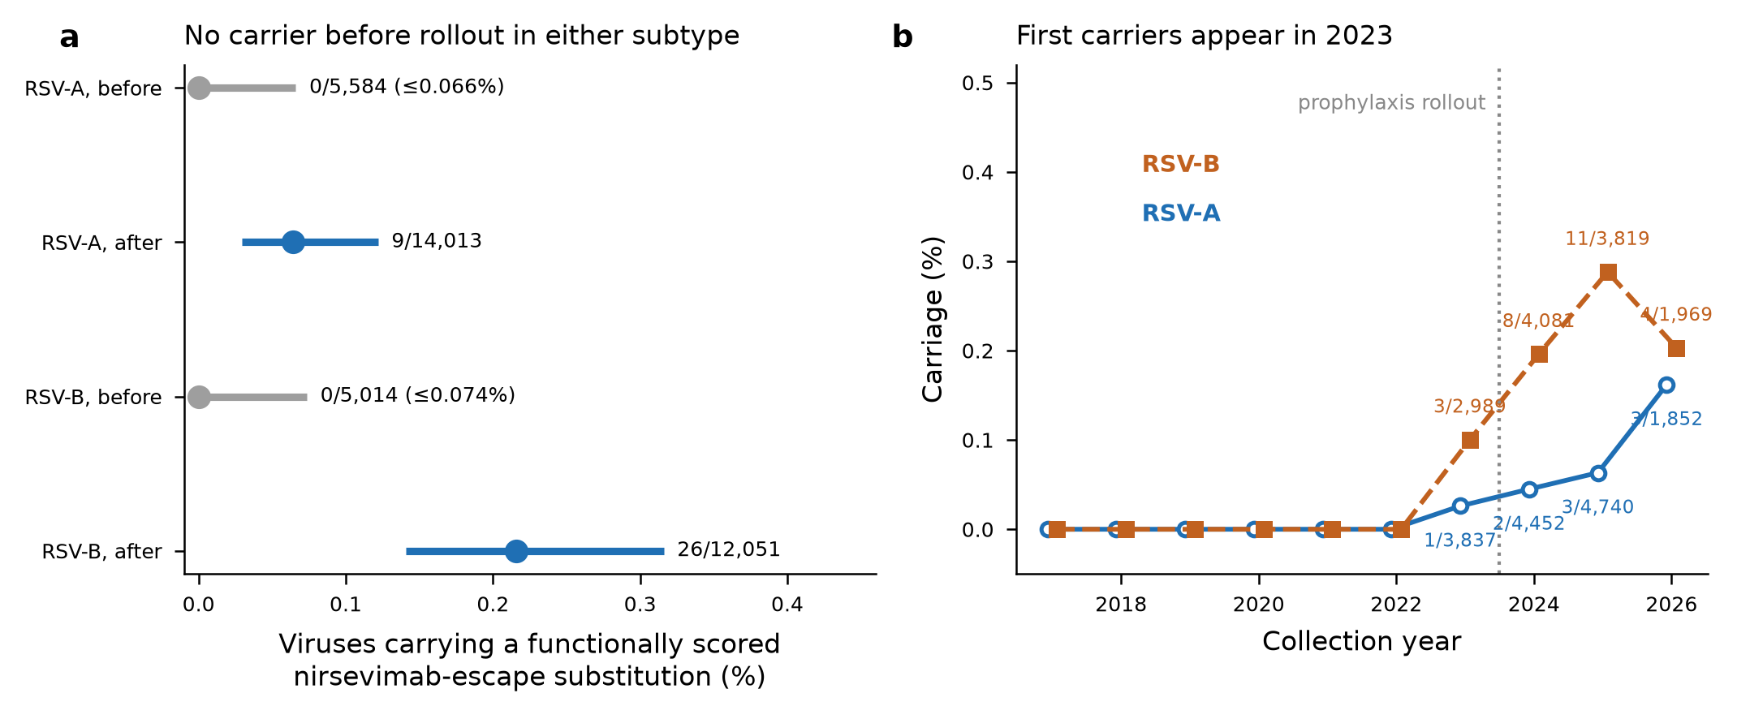
FIGURE 1 Records carrying a DMS-defined high-escape substitution, primary window.
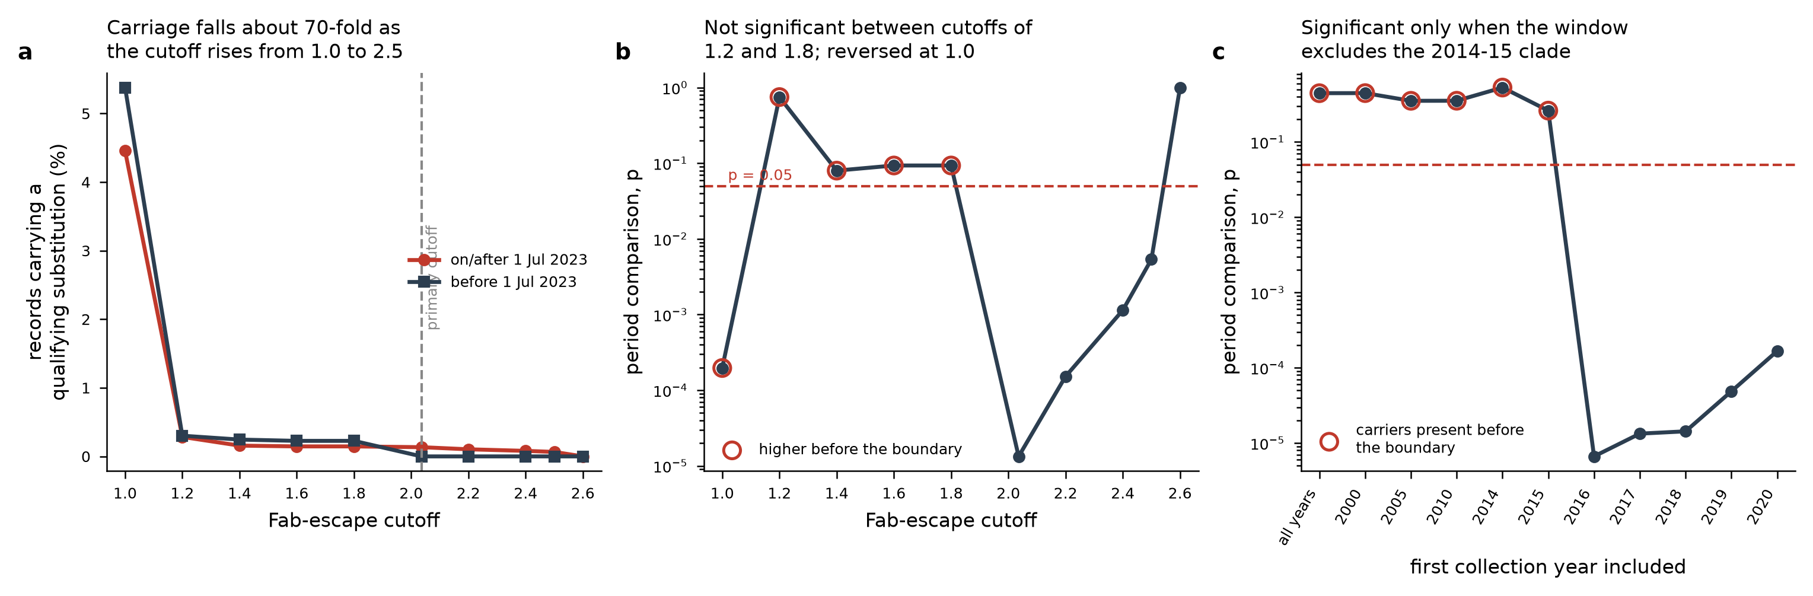
FIGURE 2 The period comparison depends on the threshold and the window.
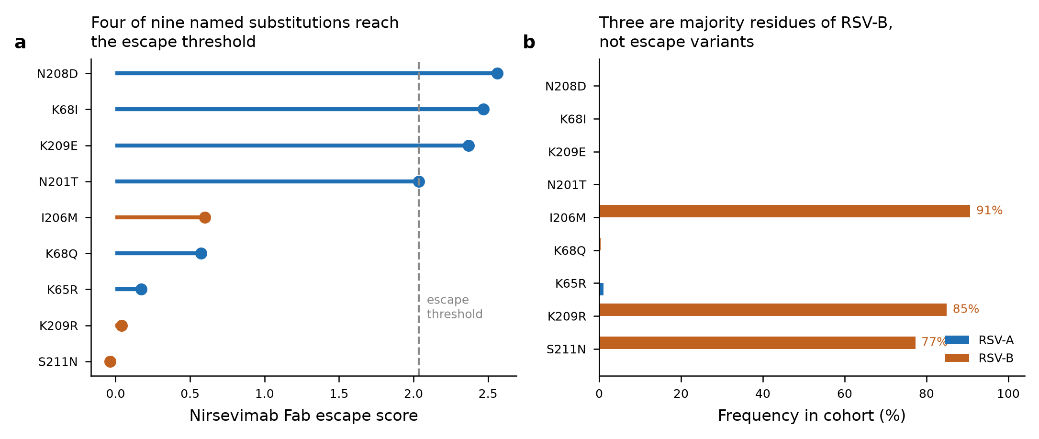
FIGURE 3 Named substitutions and their frequency in each subtype.
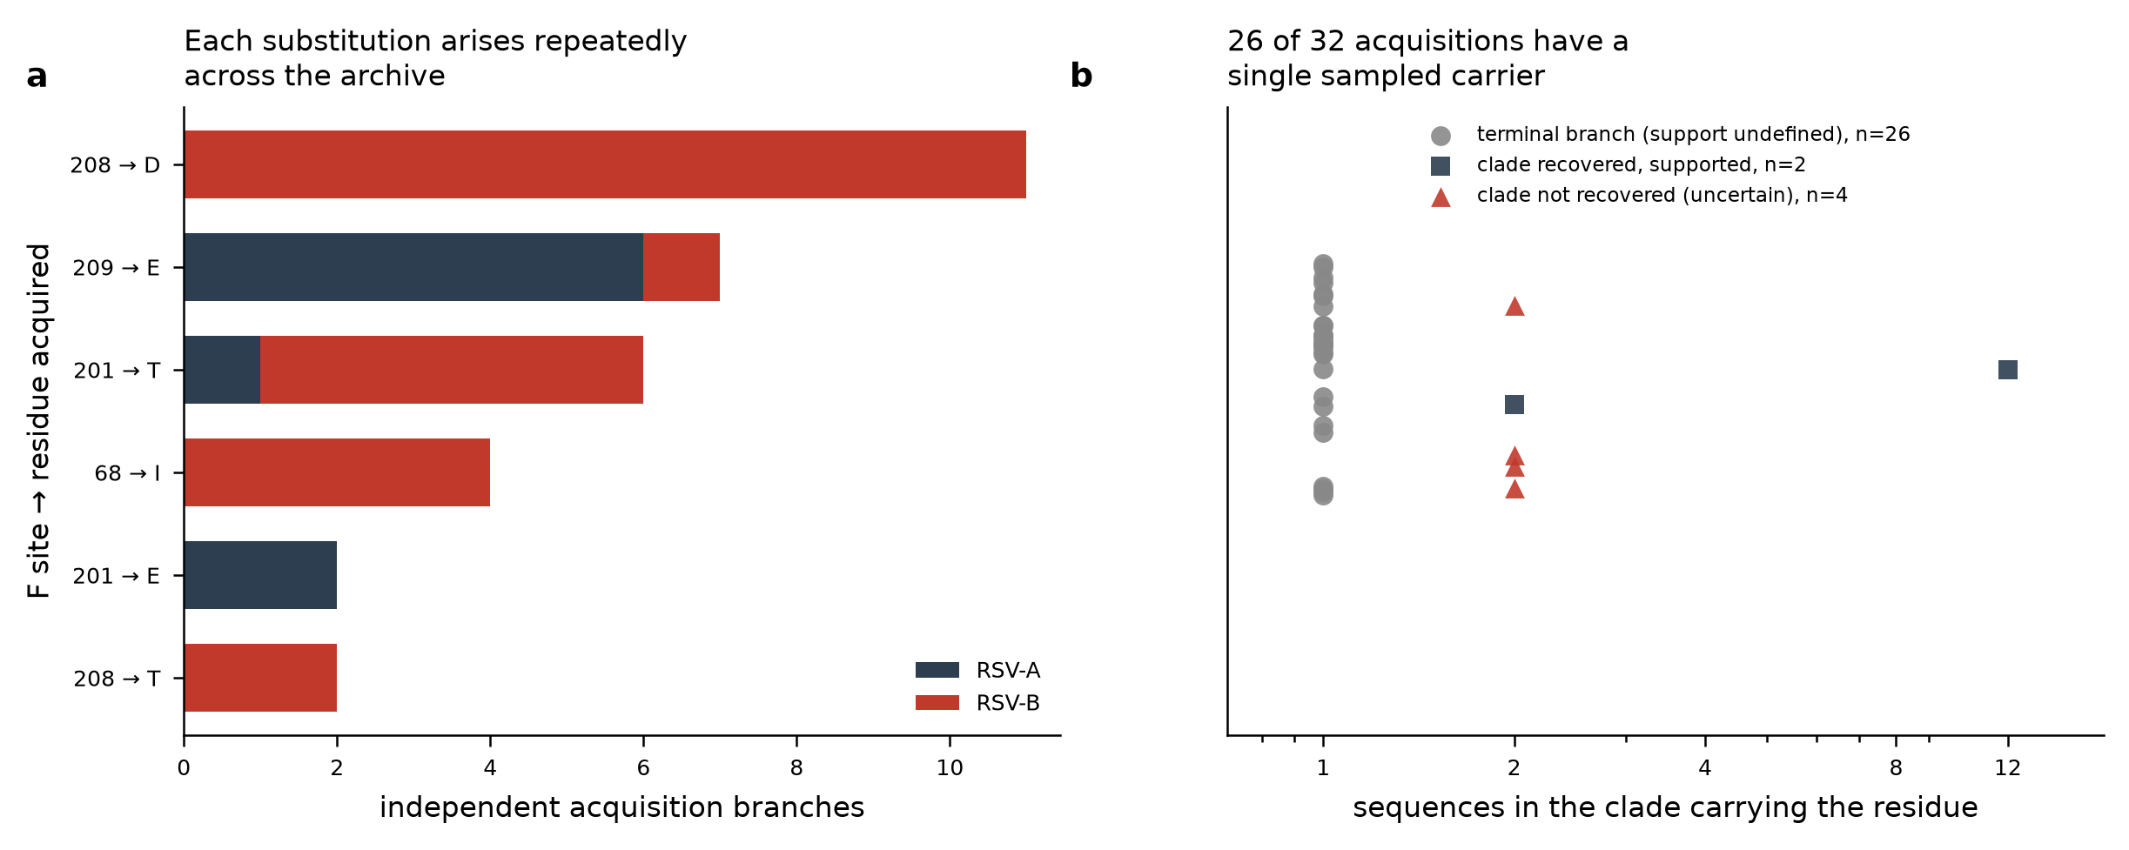
FIGURE 4 Reconstructed acquisitions across the full archive.
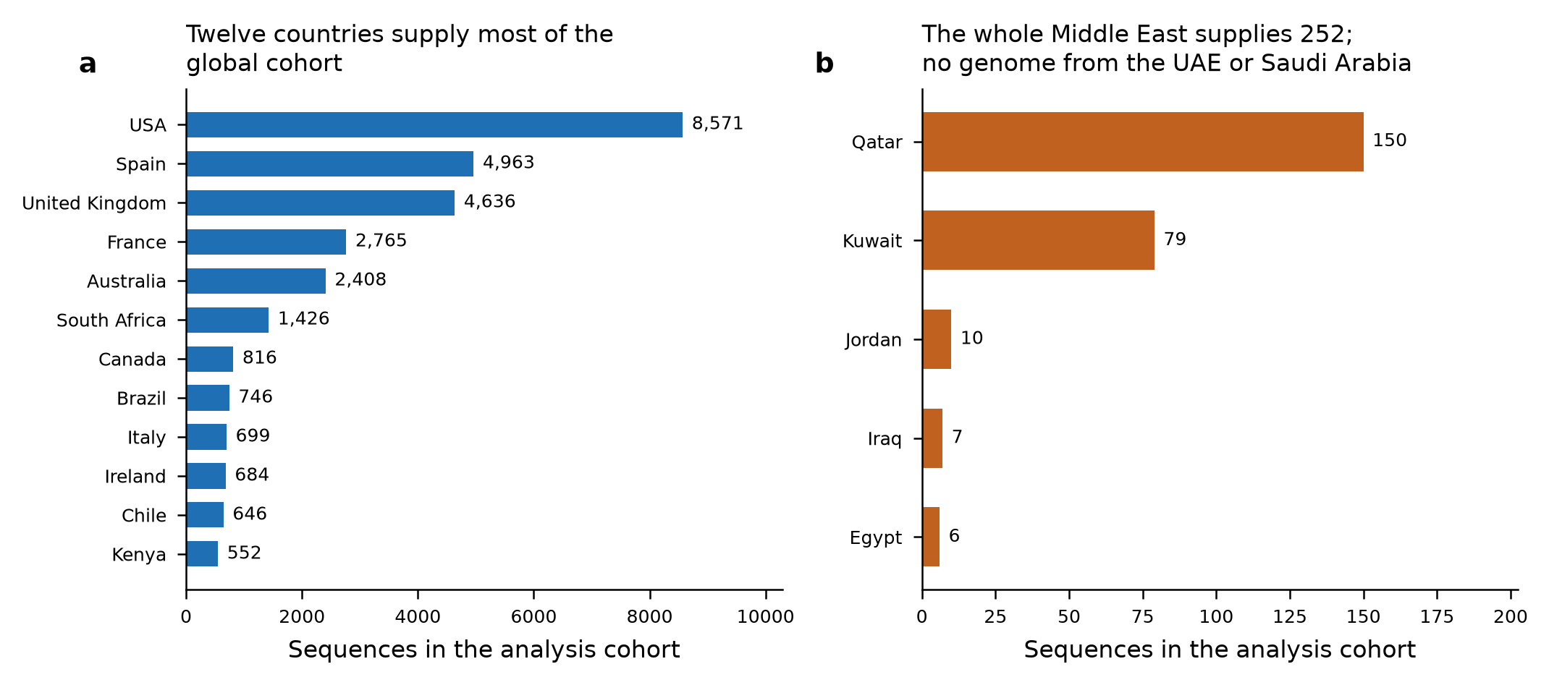
FIGURE 5 Sequencing coverage by country.

