**User Manual**

**Year:** 2021 **Semester:** Fall **Team:** 8

**Project:** Sink or be Sunk

**Creation Date:** ­11/17/2021 **Last Modified:** 11/18/2021

**Author:** Mitch Arndt **Email: arndt20@purdue.edu**

**Assignment Evaluation:**

|  |  |  |  |  |
| --- | --- | --- | --- | --- |
| **Item** | **Score (0-5)** | **Weight** | **Points** | **Notes** |
| **Assignment-Specific Items** | | | | |
| **Product Description** |  | x1 |  |  |
| **Product Illustration** |  | x2 |  |  |
| **Setup Instructions** |  | x3 |  |  |
| **Usage Instructions** |  | x3 |  |  |
| **Troubleshooting Instructions** |  | x3 |  |  |
| **Writing-Specific Items** | | | | |
| **Spelling and Grammar** |  | x2 |  |  |
| **Formatting and Citations** |  | x1 |  |  |
| **Figures and Graphs** |  | x2 |  |  |
| **Technical Writing Style** |  | x3 |  |  |
| **Total Score** |  | | |  |

**5: Excellent**  **4: Good 3: Acceptable 2: Poor 1: Very Poor 0: Not attempted**

**Comments:**

*Comments from the grader will be inserted here.*

# 1.0 Product Description

Are you tired of being cooped up at your house due to Covid restrictions? Missing spending time playing games with friends? Sink or be Sunk provides a touch free gaming experience through your WiFi Internet connection. The classic battleship experience is reinvigorated through haptic feedback, brilliant LED visuals, and an interactive LED display. Set up an account on the Sink or be Sunk website and invite your friends to join the experience. Play from your couch with the Sink or be Sunk game board or from your laptop with the online gaming platform. Experience the nostalgia of placing physical boats into your game board before duking it out with friends from across the globe to destroy all their ships before they get to yours! Navigate the game menus with an intuitive keypad that makes you the Admiral of the fleet. Battle to be the fiercest sailing force on all the waters; battle to Sink … or be Sunk!

# 2.0 Product Illustrations

## Sink or be Sunk Game Console

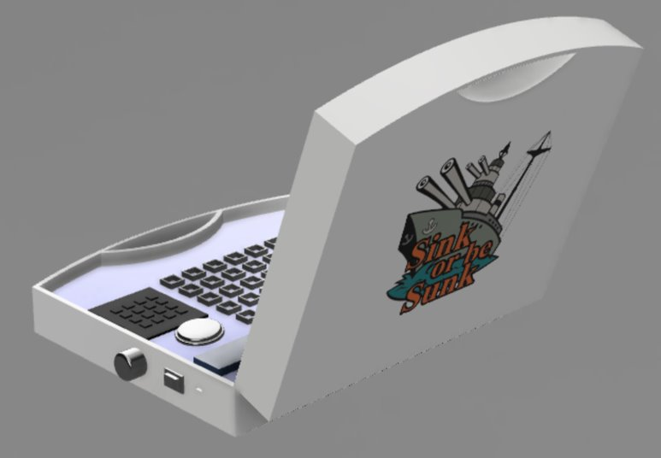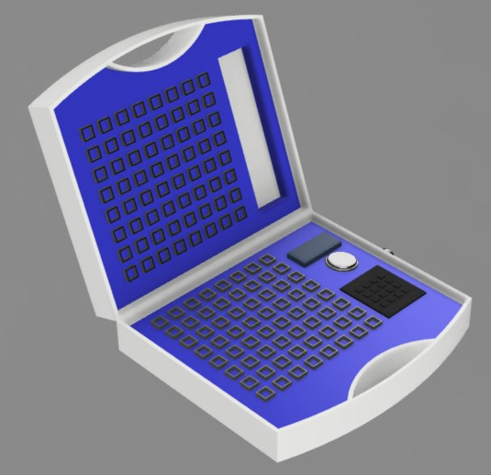

## Features

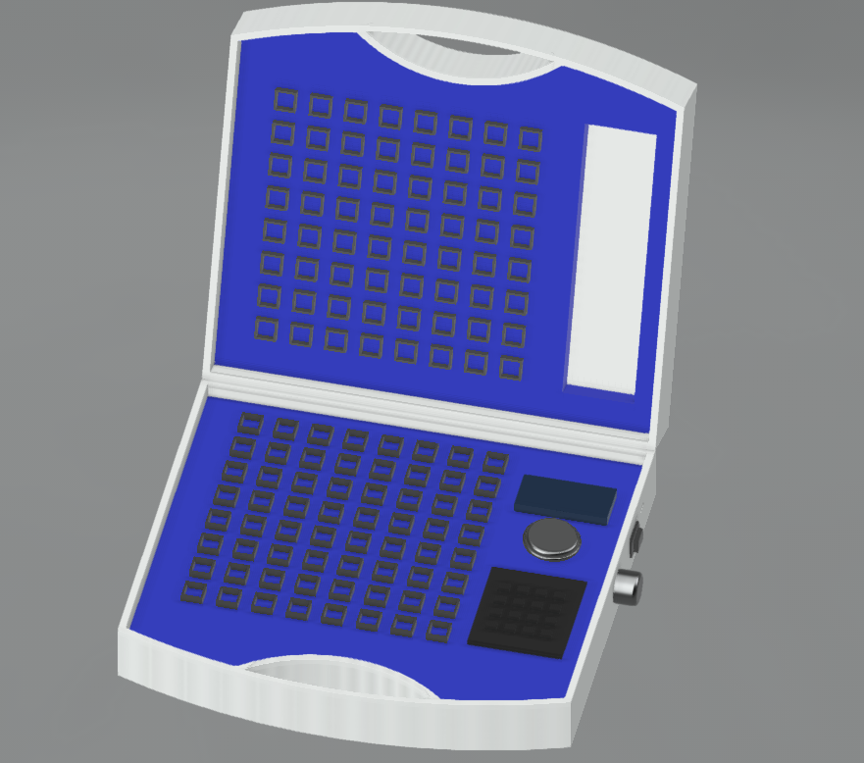

**Speaker**

**Attack Board**

**Ship Placement Pins**

**Control Panel**

**Volume Knob**

**Power Switch**

**Menu Display**

**Boat Storage**

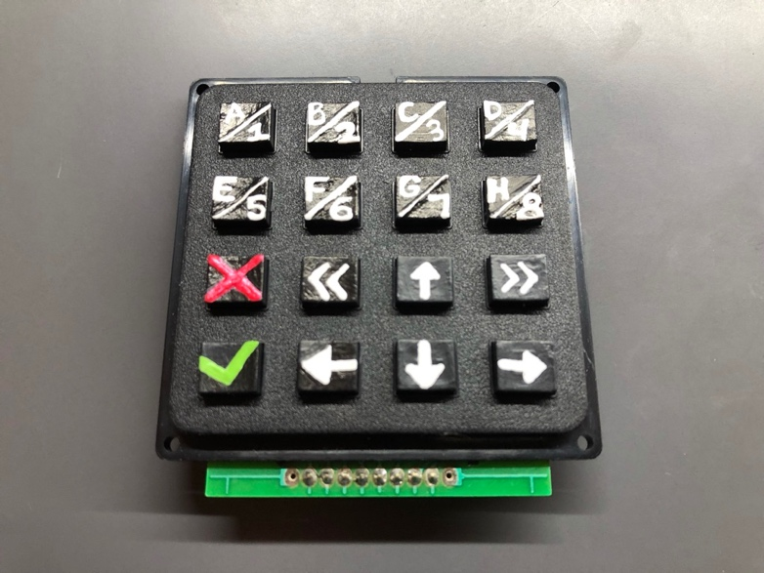

### Button Descriptions

* A/1 – During Gameplay, Selects Column A or Row 1
* B/2 – During Gameplay, Selects Column B or Row 2
* C/3 – During Gameplay, Selects Column C or Row 3
* D/4 – During Gameplay, Selects Column D or Row 4
* E/5 – During Gameplay, Selects Column E or Row 5
* F/6 – During Gameplay, Selects Column F or Row 6
* G/7 – During Gameplay, Selects Column G or Row 7
* H/8 – During Gameplay, Selects Column H or Row 8
* X – Cancel, Back
* ✓ – Enter, Confirm
* << – Page Left
* >> – Page Right
* ↑ – Scroll Up
* ↓ – Scroll Down
* → – Move Selection Right
* ← – Move Selection Left

# 3.0 Setup Instructions

## Connect to WIFI

This step needs to be completed every time that you move the board to a new WiFi Network.

1. Connect Sink or be Sunk Game Console to Power. You will see the following message displayed on screen.

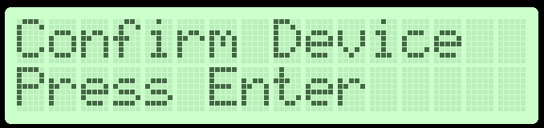

1. Download the ESP BLE Prov App from the Apple or Android Store
   1. <https://apps.apple.com/us/app/esp-ble-provisioning/id1473590141>
   2. <https://play.google.com/store/apps/details?id=com.espressif.provble&hl=en_US&gl=US>

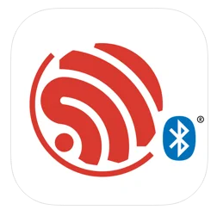

1. Open the Application and click “Provision Device”
2. Click “I don’t have a QR code”
3. Once your Bluetooth discovery finds your device, select the device
4. When prompted, enter the security pin “abcd1234”
5. Select your WIFI Network and enter the credentials
6. Congrats, your device is now connected to the internet!

## Device Pairing

1. Visit <https://sink-or-be-sunk.herokuapp.com/signup> to create account
2. Power on your Sink or be Sunk Game Console
   1. Use Page Left/Right keys to Navigate to the Device Pairing Page

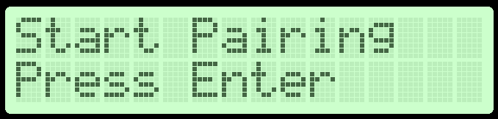

* 1. Press the Enter Key

1. Navigate to <https://sink-or-be-sunk.herokuapp.com/connect>
2. Search for your WIFI SSID (Name of your WIFI Network) and click Connect Device



1. On your Sink or be Sunk Game Console, you will now be prompted with the following message

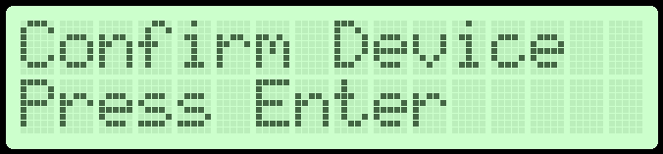

1. Press the Enter Key
2. You will now see a Pairing Success message in your browser. Congrats, you have just paired your device!

### Manage Friends

Note: You MUST have confirmed friends to play this game

1. After creating an account (see above), navigate to <https://sink-or-be-sunk.herokuapp.com/account>
2. Under the section “Manage Friends” enter your friends’ username

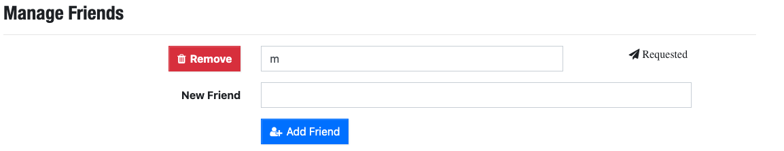

1. Your Friend will now need to accept your request on their account

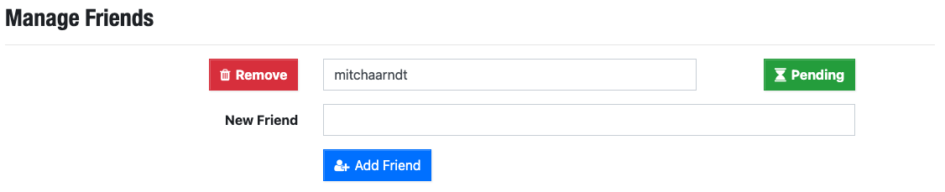

1. You have now added a new friend!

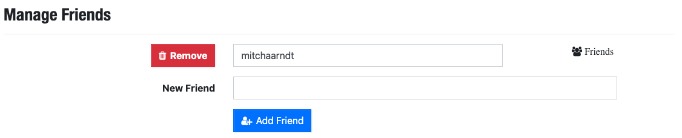

## 4.0 Usage Instructions

After connecting your Sink or be Sunk Game Console to power, pairing the device to your account, and adding your first friend, you are now ready to play! The game menu is displayed on the LED screen which provides all the necessary game information. Navigate through the menus using the buttons as described in section 2.0. The menus can be split into three difference categories depending on the state of gameplay. More information can be viewed below.

## Game Objective

* Goal is to sink the opponents ships before they sink yours
* Attack the opponents game board and see your hits indicated in red on the top screen.
* View the hits and misses from your opponent’s attacks indicated in red and white respectively on your bottom game board that holds your ships.
* Trade attacks back and forth until all ships of one player are gone.

### Game Setup

1. 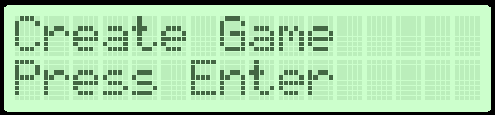
   1. Pressing the Enter key will start a new game on the server with you as the host
2. 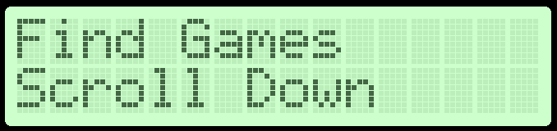
   1. Pressing the down/up keys will scroll through your list of friends
   2. Pressing enter on one of your friends will attempt to join their game
      1. Note: the friend must have already created a game as per #1 above before you can join their game
3. 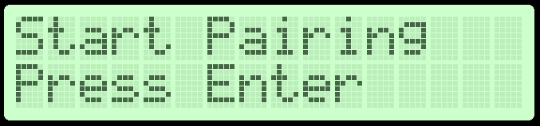
   1. Pressing Enter will put you Game Console into pairing mode (See Section 3.0 for more details on pairing device)

## Game Lobby

1. 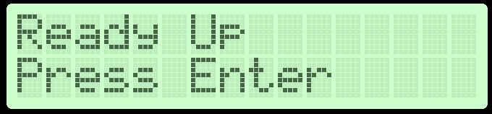
   1. Once all ships are placed, pressing enter will ready you up for the game. Once both players have ready-ed up, the game will automatically begin.
   2. 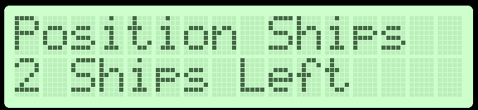
      1. If you have yet to position your ships, you will see the following message indicating that you need to position all your ships before you are able to ready up.
2. 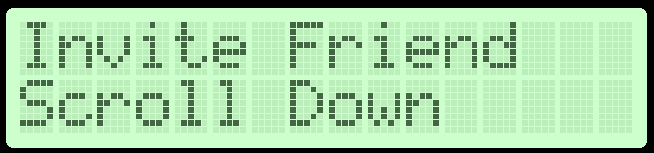
   1. Pressing the down/up keys will scroll through your list of friends
   2. Pressing enter on one of your friends will send an email inviting that friend to join your game

## In Game Action

1. 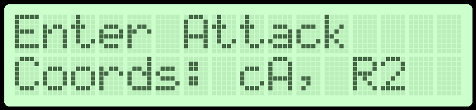
   1. This is the screen that you will spend the majority of your time as it is responsible for the gameplay
   2. Pressing the Right/Left Arrows will toggle between selecting the column or row for your attack. To indicate which is currently selected, the ‘C’ or ‘R’ will be in upper case for selected and lower case when not selected.
   3. When a column or row is selected, use the Up/Down Arrows to increment/decrement your attack position
      1. Additionally, you may use the 8 hot keys on the top half of the key pad. These are the buttons labeled with the column/row of the attack (ex: A/1)
      2. Pressing these buttons will instantly set your move to the indicated button for the currently selected row or column
   4. Pressing the Enter key will send your requested move to the server
      1. The server will response with a message on the display on whether your move was a hit, miss, sunk a ship, or an invalid move.
      2. When a valid move is made, you will see your board LEDs light up according to the result of the move and your screen with display a splash screen with the coordinates and result of the attack.
   5. After you make a move, wait for your opponent to make a move before you move again. Failing to wait will be considered an invalid move and will not update the game board.

## 5.0 Troubleshooting Instructions

*Why is my move showing as invalid?*

* Make sure that you have not done one of the following:
  + Made a move out of turn
  + Made a move that you have already made in the past (repeated move)

*Why am I unable to create a game?*

* Make sure that your device has been paired and you can see your unique device id on your Sink or be Sunk account page <https://sink-or-be-sunk.herokuapp.com/account> under Profile Information, Device. If you don’t have an id in the specified box, follow the device pairing instructions in section 3.0

*Why am I unable to join a game?*

* Make sure that you have successfully matched with a friend (see section 3.0 above). Sink or be Sunk requires that you have matched with friends to play a game.

*Why does my device tell me it’s not connected to WIFI after I already entered the WIFI password?*

* Under certain conditions such as a WIFI outage your device may reset its internal WIFI password. Follow the steps in section 3.0 to re connect your device to the internet

*What do all these buttons mean?*

* Check under section 2.0 to see what each button means. Also, under section 4.0 you can view how these buttons are used in standard gameplay.

*Why is my board not turning on even after I turn on the power switch?*

* Make sure that your battery is charged by plugging in your board to the micro-USB wall adapter.

My game isn’t responding to any of my inputs. What should I do?

* Check that you are pushing the game pad buttons firmly. This doesn’t mean that you need to smash the button, rather apply the force equal to a standard key press on a computer keyboard
* Check that your internet has not gone out.
* If all else fails, reset your device by pressing the reset button on the side or toggling on and off the power button.

*Didn’t find what you were looking for?*

* Email us your questions/concerns <https://sink-or-be-sunk.herokuapp.com/contact>