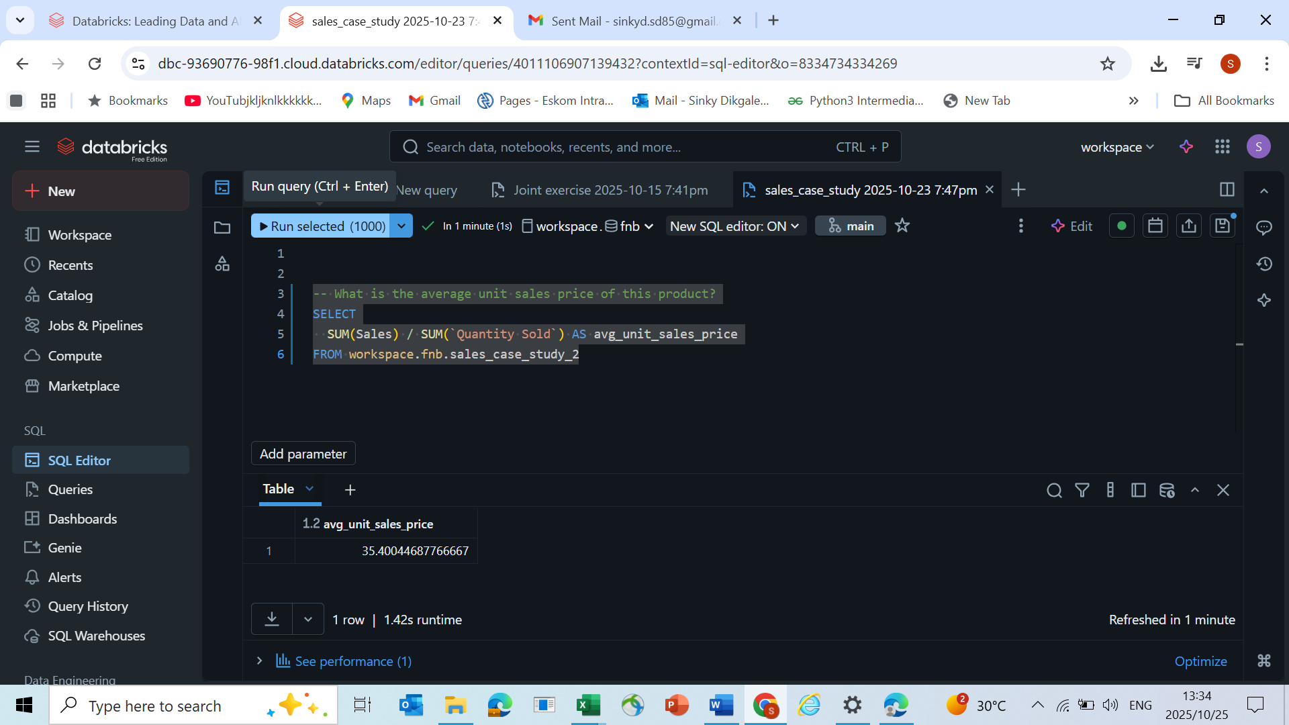

QUESTION 3

What is the daily % gross profit?

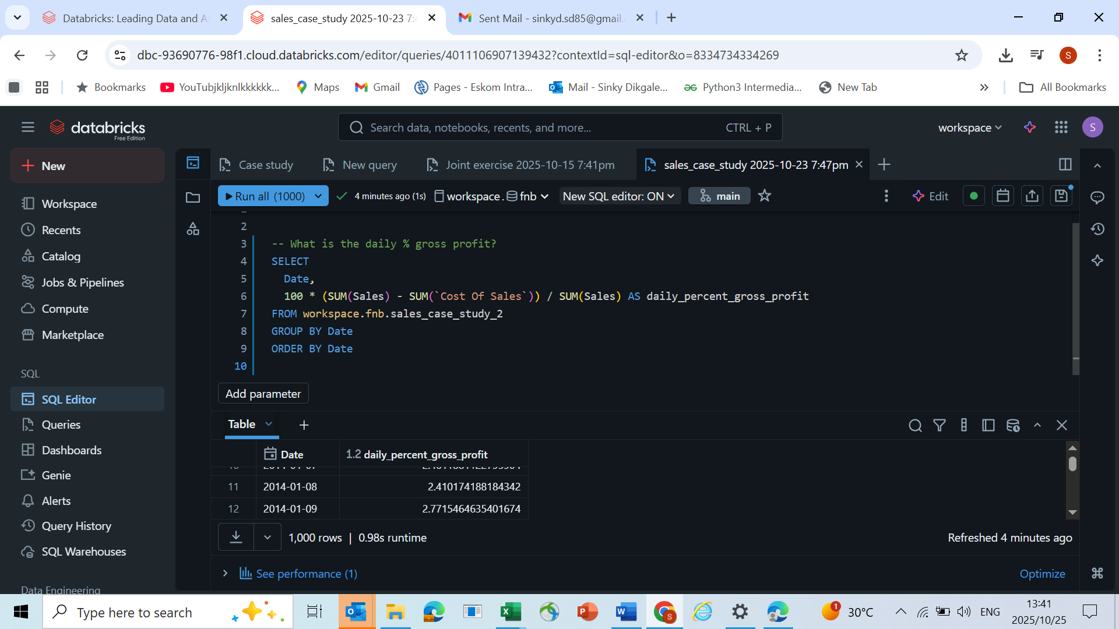

QUESTION4

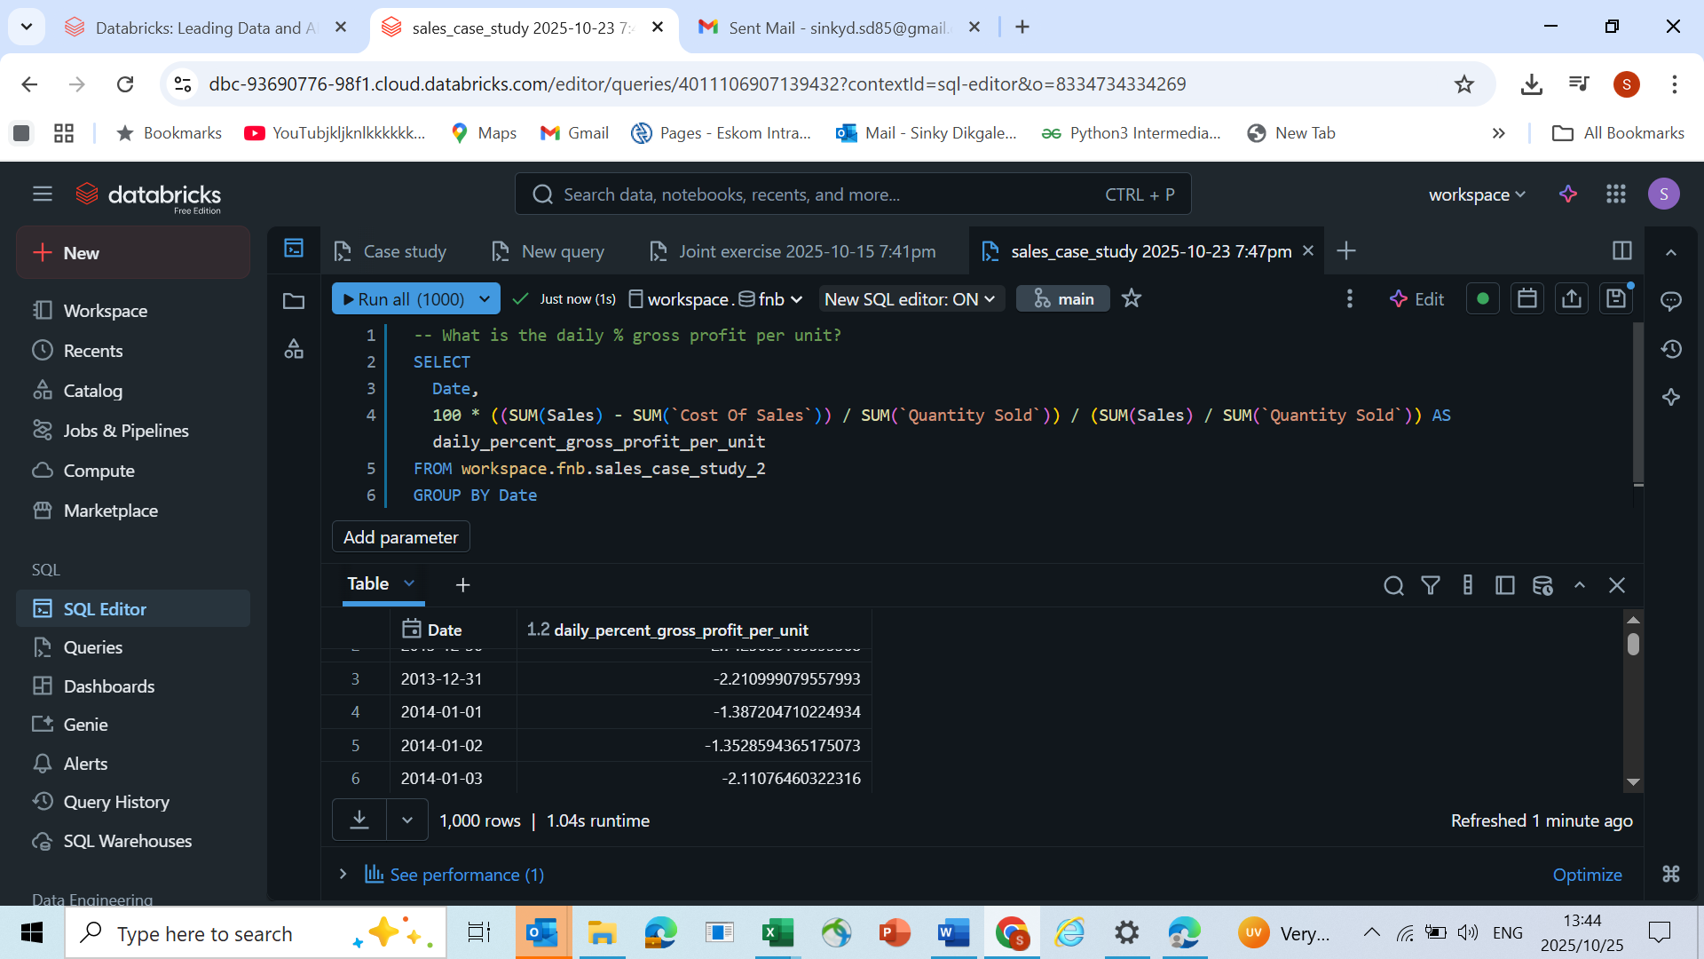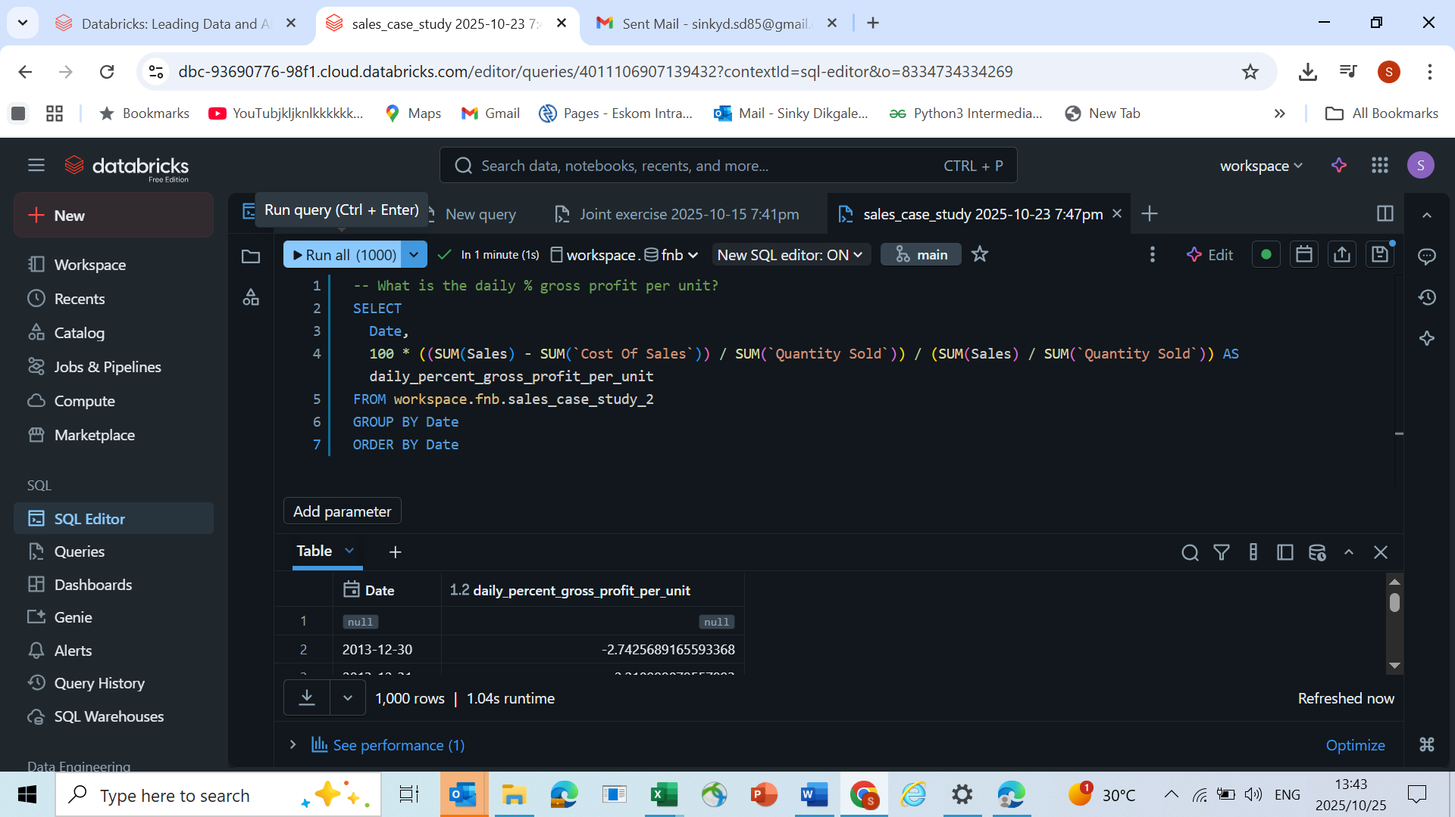

QUESTION5

Pick any 3 periods during which this product was on promotion/special:

o What was the Price Elasticity of Demand during each of these periods?

o In your opinion, does this product perform better or worse when sold at a

promotional price?